**Advanced Logistic in the Food Industry: a system engineering approach for a multi-layered solution**

Maria Teresa Gaudio1, Sudip Chakraborty2, Stefano Curcio3*

*1,2,3 University of Calabria, Laboratory of Transport Phenomena and Biotechnology, Department of DIMES, Cubo-42a, 87036 Rende (CS), Italy*

*\*Corresponding author E-Mail: stefano.curcio@unical.it*

**1.Introduction**

Final consumers are increasingly attentive to many aspects in our daily life. To achieve a sustainable in terms of both environmental footprint as well as the quality of the product new efficient and high performing systems is necessary. In this work the concept of "integrated logistics", which is able to account for all the phases and aspects of an innovative production system is optimized. This system also aims to combine the high quality and healthiness of the final product through process traceability, with the maximum possible environmental sustainability of the whole production process. It will not only reduce or eliminate hazardous waste or chemicals but also made ease of the whole logistics lines. In this context, food traceability is a key element for the safety and reliability of the entire food industry. It does not only respond to stringent regulations that differ from country to country, but it also requires ever greater access to data and information, making the processes of the supply-chain more complex and opening new market opportunities. Furthermore, the traceability of information along the supply-chain, “from fork to farm” and “from farm to fork”, is essential to combat fraud and guarantee the quality of final products addressing different aspects of SDGs, such as: Good health and well beings (SDG 3), clean and safe water (SDG6), reducing GHGs (SDG-7) including climate actions (SDG 13). As the global food & beverage sector is very complex, improving traceability practices is a challenge and the use of blockchain technology along with the use of IoT sensors and other digital technologies, represents a possible solution for food traceability systems.

**2. Methods**

A traceability system in a supply-chain requires all stakeholders to link the physical flow of products with a corresponding flow of information. Each stakeholder should be able to identify the direct source and direct recipient of the traceable elements in the process so that all the stakeholders can access the information at any time. Therefore, the "one step forward and one step back" approach should be applied, to allow all actors in the food supply-chain to collect, record, archive and share the minimal useful information for a smoother traceability.

The agri-food supply chain is a complex system because it has a complex behavior. In this system, interactions between parts show self-organization, in which local interactions give rise to new, non-local, emerging patterns. Therefore, a holistic approach made it possible to always analyze the entire system, using an approach by aspects (e.g. technological and economic).

The system engineering approach is focused on defining the needs and requirements of the entire system, in particular the requirements of the different actors of the supply-chain. In this regard, it was decided to start from the evaluation of the process stages of some agri-food supply-chains which characterize the Calabrian area. It may try to identify the main actors involved in the supply-chain through the main actions that they carry out, the resulting benefits and the problems.

In this research, we focused on different supply chains such as olive-oil supply-chain, wine supply-chain, tuna-fish supply-chain, ‘nduja supply-chain, dairy supply-chain, red-onion supply-chain. The analysis of the agri-food sectors has identified similar stakeholders in each supply-chain: Farmer, Producer, Packer, Distributor – who can be considered as actors of the company’s internal logistics – and Final Consumer at the end. So, the first step to develop this system was a need analysis of all the stakeholders in the supply-chain, both companies and customers, through some specific questionnaires dispensed by Google forms.

In particular, the customer’s point of view represents the driver for the realization of the real solution, because it provides objectives, needs and problems that will be transformed into requirements. In addition, legislative and environmental requirements were also taken into account.

Considering a high level of abstraction, the traceability system was considered and modelled in SysML using Papyrus tool. It has a requirements diagram as a core (see **Figure 1**) of the system that:

- it is able to “verify” the different test cases coming from the answer to the Google form by the single companies;

- it can be modelled by the identified and structured solution, also from the technological point of view;

- it is able to “refine” the agri-food supply-chain with each change that occurs.

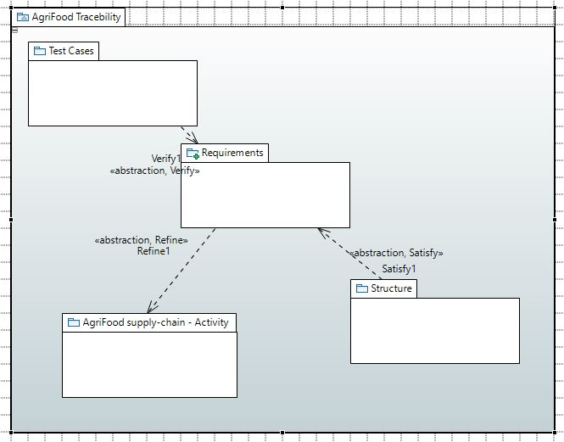

**Figure 1** Agri-Food Traceability System

In this way, the change of any requirement can be an opportunity to better model the system as a whole. Other changes identified when the system takes on a change in its behaviour, that is when an unexpected event occurs – e.g. a tampering of a product – it could be correct and/or sanctioned almost immediately or in any case faster than now.

A general traceability structure of a traceability system follows the definition and attribution by ISO 8402, UNI 10939, European Regulation n. 178/2002 and UNI 10939. It can correspond to a blockchain solution, where the following considerations about a traceability system have been taken into account:

- there is a need to store and share a ledger state;

- multiple potential writers exist;

- the assignment of the maintenance of the ledger to a group of selected actors and not to an external third party (in this case, further increasing the complexity of the supply-chain logistics);

- there is a need of public verifiability of the ledger where the asset nature is public.

To implement the blockchain solution, Hyperledger Fabric technology – an open-source project hosted by the Linux Foundation – was chosen, because it is the most scalable and easily integrable with other technological and hardware solutions, such as IoT sensors.

**3. Results and discussion**

From the requirements analysis, the consumer’s needs essentially identified in: clarity of information, safety and quality. They have been derived from the information on the label that the consumer considers most important when purchasing a product: net quantity, expiration date, ingredient list, conservation mode, batch of belonging, nutritional table, origin and provenance, headquarters of the production and packaging plant.

Given the features of the complex system, an open-permissioned blockchain could be implemented in Hyperledger Fabric. It can connect actors through a transparent, permanent, and shared record of food (e.g. origin and provenance, but also a specific characteristic of the product). The defined chaincode can be invoked by authorized participants in the supply-chain. All executed transaction records will be permanently saved in the ledger and all entities will be able to search for this information.

To meet the need for traceability of the agri-food supply-chain, a multi-layer network solution was developed. It was based on the integration of the blockchain technology and IoT devices.

*Layer-1* consists of selecting of the information to be trace in the specific supply-chain, through the requirement analysis. Thanks to this layer, the specific IoT devices are built and installed at the critical points identified along the supply-chain. *Layer-2* is the “Device Layer”, that is the external interface layer, where a cluster of IoT devices collects sensing data, performs local computing, sends the results for storage and subsequent analysis. All the IoT devices used are based on microcontroller (e.g. Arduino), because they are cheaper than others and can be powered in different ways, including the battery.

*Layer-3* is the “Network Layer”, where the different clusters of IoT devices distributed along the critical points of the supply-chain, perform data routing. Each IoT node corresponds to a unit of the supply-chain and also then, to a peer of the blockchain network. Generally, 4 IoT nodes are considered, one for each main unit of the supply-chain (Production, Processing, Distribution, Waste Management). *Layer-4* is the “Service Layer” and it consists in the data storage of all IoT data and an eventual unit of the Artificial Intelligence (AI) selection data. This layer is useful for reducing the size of the blockchain network. *Layer-5* is the “Platform Layer” and it is the real blockchain platform, where data is read, written and stored through query and invoke of a specific chaincode, which makes transactions take place.

The experimental measurements were carried out by first simulating the peer nodes with virtual machines in the cloud environment and then inserting the real data from the IoT devices. All to improve the cost-effectiveness of this solution and its adherence to the real supply-chain.

**4. Conclusions**

The agri-food supply-chain is a complex system. It has many different actors and many critical points, also depending on the specific product. Starting from an analysis of the needs of final consumers, it was possible to build a solution based on the stakeholder requirements. A technical solution based on the blockchain technology has been implemented in the Hyperledger Fabric open-source platform. A multi-layer networking solution was implemented with the interconnection of Hyperledger Fabric and IoT devices and compared with a simulated environment in a cloud platform. The use of the integrated multi-layer system guarantees greater securing of data coming from the IoT devices. At the same time, the use of the system engineering solution and the AI data selection system minimizes the size produced by the blockchain and the cost of the cloud environment. A large-scale application does not seem far off, thanks to this layered approach and its scalability.

**References**

1. INCOSE. 2015. Systems Engineering Handbook: A Guide for System Life Cycle Processes and Activities, version 4.0. Hoboken, NJ, USA: John Wiley and Sons, Inc, ISBN: 978-1-118-99940-0
2. Marianna Belotti, Nikola Božić, Guy Pujolle, Stefano Secci. A Vademecum on Blockchain Technologies: When, Which and How. Communications Surveys and Tutorials, IEEE Communications Society, Institute of Electrical and Electronics Engineers, 2019, 21 (4), pp.3796-3838. 10.1109/COMST.2019.2928178. hal-01870617
3. hyperledger-fabricdocs Documentation, Release master, <https://hyperledger-fabric.readthedocs.io/en/release-2.2/>