**Electrochemical sensor for H2O2 released from human THP-1 macrophages**

Astrid Sofia Fiorentino1*, Bernardo Patella1, Maria Rita Giuffrè2, Chiara Cipolllina2, Serena Di Vincenzo3,4, Maria Ferraro3,4, Elisabetta Pace4, Giuseppe Aiello1, Michele Russo5, Rosalinda Inguanta1

**1** *Engineering Department, Università degli Studi di Palermo, Viale delle Scienze, 90128 Palermo, Italy*

*2Ri.MED Foundation, 90133 Palermo, Italy*

*3Institute of Biomedical Research and Innovation, National Research Council, 90146 Palermo, Italy*

*4Institute of Translational Pharmacology, National Research Council, 90146 Palermo, Italy*

*5Dipietro Group, Siracusa, Italy*

*\*Corresponding author E-Mail: astridsofia.fiorentino@unipa.it*

**1.Introduction**

Reactive oxygen species (ROS) are by-products of aerobic metabolism. The superoxide anion (O2- ), hydrogen peroxide (H2O2) and hydroxyl radicals (OH-) are part of the ROS. ROS are usually indicative of oxidative stress, and high ROS concentration induces disease by damaging lipids, proteins and DNA[1][2][3][4].

Among ROS species, hydrogen peroxide is of interest due to its unique physiological property. H2O2 can cross biological membranes and is therefore more damaging to DNA than hydroxyl radicals[5]. For this reason, it is very important to measure and estimate oxidative stress, especially H2O2 levels. Current methods to measure ROS in cell cultures use fluorescent probes, colorimetric/fluorometric biochemical assays, or liquid chromatography coupled with mass spectrometry-based approaches[6][7]. These methods have limitations, such as the need to stain cells. In addition, fluorescence methods are not specific for a particular ROS, so they do not allow absolute quantification[8]. Recently, the electrochemical detection of H2O2 has been of great interest due to its many advantages, such as ease of use, low-cost instrumentation, suitability, high sensitivity and selectivity, rapid response and low cost chemical instruments[9][10][11][12][13]. Several electrode materials have been tested [14][8][15][16][17] and in particular, graphene oxide (GO) modified with metal nanoparticles (NPs) has been widely studied as active material for H2O2 detection[18][19]. In the present study, we show the fabrication and calibration of a nanostructured electrochemical sensor, based on rGO and Au-NPs, to measure H2O2 released from human THP-1 macrophages exposed to different treatments.

**2. Methods**

The fabrication of the rGO/Au-NPs-based electrode is realized by the method detailed in a previous study[20]. In particular, Indium tin oxide coated PET (ITO-PET) sheet was used as a substrate for sensor fabrication. ITO-PET was ultrasonically washed in pure isopropanol and deionized water for 10 min each. ITO-PET was used as working in an electrochemical cell manufactured by a stereolithography 3D printer (3D Form 3+ Low Force Stereolithography (LFS)™). The 3D printed cell is equipped with two channels with a diameter of 1 mm that allow the connection with a peristaltic pump which recirculates the electrolyte with a speed of 50 ml/min. All electrochemical measurements were carried out using a potentiostat/galvanostat (Solartron CellTest® System). The electrochemical co-deposition of rGO and Au-NPs was carried out in acetate buffer solution (ABS), containing 0.5 mg/ml GOx and 0.5 mM KAuCl4. A constant cathodic potential of 0.8 V vs. SCE was applied for 200 s. The electrodes were characterized using scanning electron microscopy (SEM, FEG-ESEM, FEI QUANTA 200), energy dispersive spectroscopy (EDS), X-ray diffraction and Raman spectroscopy. For the electrochemical detection a three-electrode cell was used where the working is the ITO-PET/rGO-Au-NPs electrode, the counter is a platinum wire and the reference is an SCE. The sensor was tested and calibrated using cell growth medium mixed with PBS as a blank in a 1:1 ratio.

**3. Results and discussion**

The co-electrodeposition of rGO and Au-NPs from an aqueous solution containing GO and HClAu4 as precursors, occurs following the reactions proposed in previous studies[21][22].

Figure 1 shows the SEM image of the rGO/Au-NPs-based electrode. The co-electrodeposition led to the formation of Au-NPs of about 33 nm that uniformly covered the electrode surface. The presence of rGO and Au NPs was confirmed by Raman spectroscopy and X-ray diffraction.

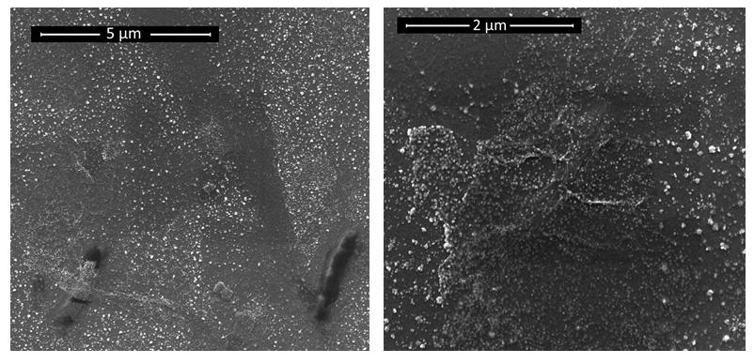

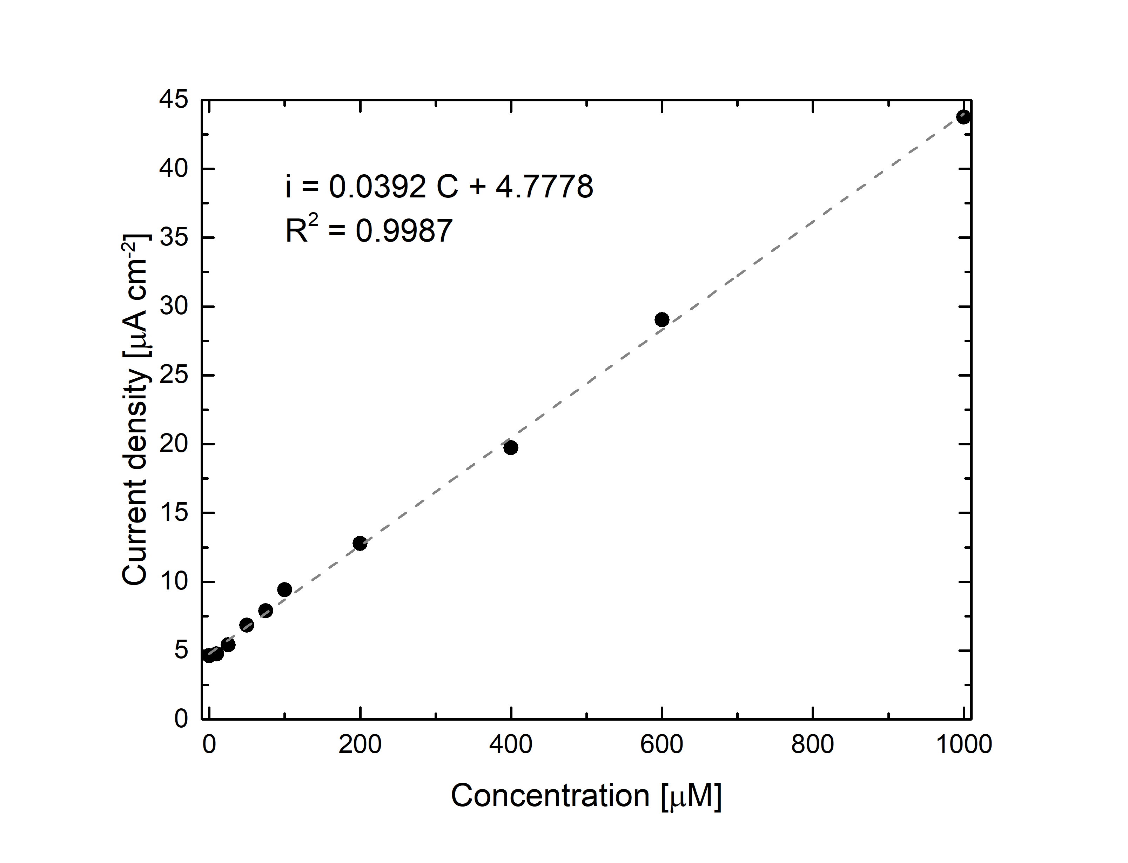

**Figure 1. A)** SEM images of the rGO/Au-NPs-based electrode; **B)** calibration curve of sensor for H2O2 detection.

Calibration was performed in blank solution where different concentration of H2O2 were inserted. The detection was carried out by chronoamperometric test at -0.8 V vs SCE. For each investigated H2O2 concentration three different tests were performed. Figure 1B shows the calibration curve of the electrode. A linear range from 10 to 1000 μM was obtained with a LOD and a sensitivity of 3.3S/b and 0.0392 μA μM− 1 cm-2, respectively. Sensor was also validated to measure H2O2 released from human THP-1 macrophages exposed to different treatments.

**4. Conclusions**

In this work an electrochemical sensor based on rGO and Au-NPs were used for the to detect H2O2 released from human THP-1 macrophages. The results are significant because they support the possibility of direct quantification of extracellular H2O2 release in order to monitor intracellular ROS levels with a fast, easy, reproducible and low-cost electrochemical method. This electrochemical sensor may have an easy use to implement in research laboratories where direct measurement of H2O2 in cell supernatants can replace current expensive and time-consuming biochemical and flow cytometry-based approaches. In addition, the future development of a sensor based on gold nanowires or nanotubes is envisaged in order to develop a sensor with a larger surface area and hypothetical higher sensitivity.

**References**

[1] C. E. Cross *et al.*, “Oxygen radicals and human disease. Davis conference,” *Ann. Intern. Med.*, vol. 107, no. 4, pp. 526–545, 1987, doi: 10.7326/0003-4819-107-4-526.

[2] M. Schieber and N. S. Chandel, “ROS function in redox signaling and oxidative stress,” *Curr. Biol.*, vol. 24, no. 10, pp. R453–R462, 2014, doi: 10.1016/j.cub.2014.03.034.

[3] Z. A. Wood, L. B. Poole, and P. A. Karplus, “Peroxiredoxin evolution and the regulation of hydrogen peroxide signaling,” *Science (80-. ).*, vol. 300, no. 5619, pp. 650–653, 2003, doi: 10.1126/science.1080405.

[4] T. Finkel, “Signal transduction by reactive oxygen species,” *J. Cell Biol.*, vol. 194, no. 1, pp. 7–15, 2011, doi: 10.1083/jcb.201102095.

[5] “P r o t e c t i v e effe c t of e r do st eine me t ab oli t e I a g a in st h y d r ogen pe r o x ide-ind u c ed o x id a t i v e DNA -d a m a ge in l u ng epi t heli a l c ell s,” vol. 1, pp. 700–706.

[6] Y. Zhang, M. Dai, and Z. Yuan, “Methods for the detection of reactive oxygen species,” *Anal. Methods*, vol. 10, no. 38, pp. 4625–4638, 2018, doi: 10.1039/c8ay01339j.

[7] M. Katerji, M. Filippova, and P. Duerksen-Hughes, “Approaches and methods to measure oxidative stress in clinical samples: Research applications in the cancer field,” *Oxid. Med. Cell. Longev.*, vol. 2019, 2019, doi: 10.1155/2019/1279250.

[8] A. Depeursinge *et al.*, “Fusing Visual and Clinical Information for Lung Tissue Classification in HRCT Data,” *Artif. Intell. Med.*, vol. 229, p. ARTMED1118, 2010, doi: 10.1016/j.

[9] B. Patella, C. Sunseri, and R. Inguanta, “Nanostructured Based Electrochemical Sensors,” *J. Nanosci. Nanotechnol.*, vol. 19, no. 6, pp. 3459–3470, 2019, doi: 10.1166/jnn.2019.16110.

[10] K. Dhara and D. R. Mahapatra, “Recent advances in electrochemical nonenzymatic hydrogen peroxide sensors based on nanomaterials: a review,” *J. Mater. Sci.*, vol. 54, no. 19, pp. 12319–12357, 2019, doi: 10.1007/s10853-019-03750-y.

[11] E. Anastasiou, K. O. Lorentz, G. J. Stein, and P. D. Mitchell, “Prehistoric schistosomiasis parasite found in the Middle East,” *Lancet Infect. Dis.*, vol. 14, no. 7, pp. 553–554, 2014, doi: 10.1016/S1473-3099(14)70794-7.

[12] H. Uǧuz *et al.*, “ce pte d M us pt,” *J. Phys. Energy*, vol. 2, no. 1, pp. 0–31, 2020.

[13] J. Huang *et al.*, “High-Linearity Hydrogen Peroxide Sensor Based on Nanoporous Gold Electrode,” *J. Electrochem. Soc.*, vol. 166, no. 10, pp. B814–B820, 2019, doi: 10.1149/2.1241910jes.

[14] N. Aydemir, J. Malmström, and J. Travas-Sejdic, “Conducting polymer based electrochemical biosensors,” *Phys. Chem. Chem. Phys.*, vol. 18, no. 12, pp. 8264–8277, 2016, doi: 10.1039/c5cp06830d.

[15] Y. H. Wang, K. J. Huang, and X. Wu, “Recent advances in transition-metal dichalcogenides based electrochemical biosensors: A review,” *Biosens. Bioelectron.*, vol. 97, pp. 305–316, 2017, doi: 10.1016/j.bios.2017.06.011.

[16] R. Zhang and W. Chen, “Recent advances in graphene-based nanomaterials for fabricating electrochemical hydrogen peroxide sensors,” *Biosens. Bioelectron.*, vol. 89, pp. 249–268, 2017, doi: 10.1016/j.bios.2016.01.080.

[17] Y. Wang *et al.*, “Electrochemistry and biosensing activity of cytochrome c immobilized in macroporous materials,” *Microchim. Acta*, vol. 175, no. 1–2, pp. 87–95, 2011, doi: 10.1007/s00604-011-0638-8.

[18] Y. Song, Y. Luo, C. Zhu, H. Li, D. Du, and Y. Lin, “Recent advances in electrochemical biosensors based on graphene two-dimensional nanomaterials,” *Biosens. Bioelectron.*, vol. 76, pp. 195–212, 2016, doi: 10.1016/j.bios.2015.07.002.

[19] K. Dhara, T. Ramachandran, B. G. Nair, and T. G. Satheesh Babu, “Au nanoparticles decorated reduced graphene oxide for the fabrication of disposable nonenzymatic hydrogen peroxide sensor,” *J. Electroanal. Chem.*, vol. 764, pp. 64–70, 2016, doi: 10.1016/j.jelechem.2016.01.011.

[20] B. Patella, A. Sortino, G. Aiello, C. Sunseri, and R. Inguanta, “Reduced graphene oxide decorated with metals nanoparticles electrode as electrochemical sensor for dopamine,” *FLEPS 2019 - IEEE Int. Conf. Flex. Printable Sensors Syst. Proc.*, pp. 1–3, 2019, doi: 10.1109/FLEPS.2019.8792267.

[21] M. Zhou *et al.*, “Controlled synthesis of large-area and patterned electrochemically reduced graphene oxide films,” *Chem. - A Eur. J.*, vol. 15, no. 25, pp. 6116–6120, 2009, doi: 10.1002/chem.200900596.

[22] G. Gotti, K. Fajerwerg, D. Evrard, and P. Gros, “Electrodeposited gold nanoparticles on glassy carbon: Correlation between nanoparticles characteristics and oxygen reduction kinetics in neutral media,” *Electrochim. Acta*, vol. 128, pp. 412–419, 2014, doi: 10.1016/j.electacta.2013.10.172.

[23] B. Patella *et al.*, “Electrochemical sensor based on rGO/Au nanoparticles for monitoring H2O2 released by human macrophages,” *Sensors Actuators, B Chem.*, vol. 327, no. April 2020, p. 128901, 2021, doi: 10.1016/j.snb.2020.128901.