**Novel process for *cyan* hydrogen production**

Alessandra Di Nardo1*, Maria Portarapillo1, Danilo Russo1, Almerinda Di Benedetto1, Giuseppina Luciani1, Gianluca Landi2, Giovanna Ruoppolo2

*1 Dipartimento di Ingegneria Chimica, dei Materiali e della Produzione Industriale, Università degli Studi di Napoli Federico II, P. le Vincenzo Tecchio 80, 80125, Napoli.*

*2 Istituto di Scienze e Tecnologie per l'Energia e la Mobilità Sostenibili STEMS-CNR, P. Le V. Tecchio 80, 80125, Napoli.*

*\*Corresponding author E-Mail: alessandra.dinardo@unina.it*

**1. Introduction**

Hydrogen is one of the main building blocks of the bulk and fine chemical industry as well as a promising energy carrier. The main advantages of hydrogen as an energy carrier are related to its high calorific value (HCV) and the absence of carbonaceous gases deriving from its combustion. However, most of hydrogen is currently produced from fossil fuels, via hydrocarbon reforming or pyrolysis processes or from renewable sources, via biological and thermochemical treatment of biomass and water splitting. Hydrogen production both from fossil fuels and from renewable sources shows several critical issues such as high operating temperature, high energy costs, limited yields, and selectivity.1

In this work, we propose a novel process for *cyan* hydrogen production. The proposed process is a combination of *blue* H2, derived from the traditional methane steam reforming with CO2 capture and storage, and *green* H2, produced by water electrolysis powered by renewable energy sources. More precisely, the proposed process combines H2 production from water splitting and CO2 capture and valorisation through the conversion of bio-derived chemicals to a high-value polymer, thus resulting in H2 production and waste valorisation.

A patent on the process of *cyan* H2 production has been submitted (submission number 102021000030875). It is based on redox cycles starting from bio-based organics and water under mild conditions, low pressure, and relatively low temperature. A solid catalyst is used which is a readily available and relatively cheap oxide with a wide range of industrial applications.

**2. Methods**

The process consists of a series of repetitive units, each composed by two consecutive steps in which organic reducing agent and water are charged alternately, as shown in Fig. 1. The gas phase is analyzed by gas chromatography (GC) technique, while the solid and liquid residue with FTIR and ATR-FTIR spectroscopy and TGA.

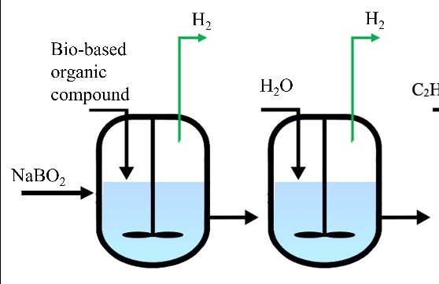

**Figure 1.** Scheme of the repetitive units in the *cyan* hydrogen production process.

**3. Results and discussion**

For two consecutive redox cycles, products consist of a gas phase stream rich and quite pure in hydrogen (as shown by GC analysis reported in Tab. 1), a solid residue composed by a mixture of the solid catalyst and an organic compound with high molecular weight, and a liquid phase that contains process intermediate products. The FTIR spectrum of the double-cycle residue shows the presence of bond vibrations typical of organic compounds, e.g., the stretching of the C-H bond in the zone 3000-2800 cm-1.

**Table 1.** GC analysis results.

**4. Conclusions**

The *cyan* hydrogen production process represents a totally innovative process. Surprisingly, starting from bio-based compounds and a by-product of low industrial interest, it is possible to produce a pure hydrogen stream under milder conditions than conventional processes and to capture the carbon in a high-value polymeric product.

**References**

1. *C.C. Elam, et al., Realizing the hydrogen future: the International Energy Agency’s efforts to advance hydrogen energy technologies, Int. J. Hydrog. Energy 28 (6) (2003) 601–607.*