**3D-CFD simulation of a vessel with inside catalytic filter candles for particulate abatement and tar steam reforming**

Andrea Di Carlo1, Elisa Savuto1, Alessandra Tacconi1, Alessandro Antonio Papa1, Bora Aydin2

*1 University of L’Aquila, Piazzale E. Pontieri 1, L’Aquila, Italy;*

*2 Walter Tosto S.p.A., Via Erasmo Piaggio 62, Chieti, Italy*

*\*Corresponding author E-Mail: andrea.dicarlo1@univaq.it*

**1.Introduction**

Biomass gasification is a very promising process to produce energy from agricultural wastes [1]. In order to meet the increasingly stringent environmental regulations, and increase the efficiency of biomass thermochemical conversion in useful gas and/or hydrogen syntheses, it is necessary to clean the product gas from particulate and tar [2]. The gas cleaning from dust is compulsory before any other treatments such as steam reforming of high molecular weight hydrocarbons (tar). Tar content in syngas produced in a fluidized bed gasifier ranges between 5 and 100 g/Nm3 [3] and may cause different problems. For example, in high temperature fuel cell units (i.e. SOFC) the catalysts might be deactivated as a consequence of carbon deposition. Therefore, the gas cleaning units play an important role, also for the fly ash removal. Furthermore, the presence of tar among the products of gasification reduces gas yield and conversion efficiency. Catalytic filter candles are an innovative solution for hot gas cleaning and conditioning. The main advantage of this concept, differently from the low temperature gas purification systems, is that it avoids tar condensation and the operating temperature is closer to the gasification temperature. Catalytic filter candles can be inserted directly in the freeboard of a fluidized bed biomass gasifier or in a separated vessel just downstream the gasifier. Characterization of catalytic ceramic candles in terms of gas flow field, particle separation and tar reforming exhibited at different operating conditions has been the subject of a previous work [4] addressed to 2D-CFD simulations. To by-pass technical problems related to the impregnation of Ni directly on the ceramic filters and to render the overall process more feasible in practice, commercial ceramic candles for particulate abatement at relatively high temperature could be filled with commercial pelletized steam reforming catalyst in their inner empty space. To verify this hypothesis, both experimental and simulation work is required. This work summarizes the results of one of the simulation tasks of the European project BLAZE[5]. The project aims to develop an innovative integrated biomass gasifier and fuel cell CHP plant to produce renewable electricity and heat. The CHP system integrates an innovative dual fluidized bed gasifier, hot gas cleaning and conditioning, industrialized solid oxide fuel cells (SOFC), and off-gas recirculation. This work partially summarizes the results of the 3D-CFD simulations carried out for the BLAZE project. In particular the simulations were carried out on a vessel with 6 ceramic filter candles inserted in, and with commercial pelletized steam reforming catalyst in the inner empty space of each candle, see the work of Savuto et al. [6] for more details about this configuration. The effect of temperature and the fluidized bed inventory was studied in order to evaluate the performance of the system in terms of gas composition and tar conversion. The aim is to obtain the optimal conditions for the effective syngas cleaning and conditioning within the limits required for the safe operation of the SOFC that will be used in the project. Deliverable 3.2 [7] of the BLAZE project gives an indication on the tolerable limit for toluene and naphthalene:

* the toluene concentration in the gas must be lower than 750 mg/Nm3, but preferably lower than 250 mg/Nm3
* the naphthalene concentration must be lower than 75 mg/Nm3, but preferably lower than 25 mg/Nm3

**2. Methods**

**Development of the model**

The system simulated by the model is the stainless steel vessel (0.3 m I.D. x 1.8 m H) realized by Walter Tosto SpA that will contain the 6 filter candles (0.06 m O.D., 0.04 m I.D. 1.5 m length) supplied by Pall Filtersystems GmbH. The six cylindrical catalytic candles are placed vertically and suspended from the top, for filtration and conditioning of the syngas.

The system was simulated in Fluent. The 3D domain simulated is shown in Figure 1.

|  |
| --- |
| Gas Outlet  Gas Intlet  Filter Candles |
| Figure 1-3D Domain simulated in Fluent |

The ceramic candles are defined as porous media made of alumina characterized by porosity and permeability. The inner empty space inside the candle was partially filled by an annular bed of catalyst pellets, leaving a cylindrical, internal hollow space of 20 mm diameter for the gas to flow towards the candle head, see the work of Savuto et al. [6] for more details about this configuration. The vessel is surrounded by a layer of 0.3 m of Insulfrax LT 128 ceramic blanket, an insulation material simulated as a solid region. The chemical species considered are typical of a steam gasification gas product: H2, CO, CO2, CH4, H2O, and benzene (C6H6), toluene (C7H8) and naphthalene (C10H8). The tar key compounds taken into account in this work are well representative of the overall, complex tar mixture, since they are found in major quantity in a typical syngas produced from biomass gasification.

The mass and momentum balances, given by the Navier-Stokes equations, chemical species and energy conservation equations are solved for the gas phase in the vessel volume, in the porous zone of the candle and in the porous volume of catalyst pellets.

**Vessel Region**

For the vessel region the following equations are solved for gas phase:

$$∇∙\left(ρ\vec{v}\right)=0 (1)$$

$$∇∙\left(ρ\vec{v}\vec{v}\right)= -∇p+∇∙(\overset{̿}{τ_{g}}) (2)$$

$$∇∙\left(\vec{v}\left(ρh\right)\right)=∇∙\left[\left(\overset{̿}{τ_{g}}∙\vec{v}\right)+k_{g}∇T\right]+S_{h} (3)$$

$$∇∙\left(\vec{v}ρy_{i}\right)=∇∙\left(D_{i}∇y_{i}\right)+S_{i} (4)$$

where i indicates each of the chemical species. S and Sh are the source (or sink) terms due to any reactions occurring in the vessel, if considered.

**Porous structure of the filter candle and bed of catalyst pellets inside the candle**

The continuity equation is equal to Eq.1.

The momentum balance is similar to Eq.2, modified to consider porosity (${ε_{c}}_{ }$) of the solid (candle and catalyst bed) with an extra source term composed of two parts: a viscous loss term, that depends on permeability α (Darcy law) and an inertial loss term (due to an inertial resistance factor C):

$$∇∙\left(ε_{c} ρ\vec{v}\vec{v}\right)= -ε_{c} ∇p+ε_{c} ∇∙(\overset{̿}{τ_{g}})-\left(\frac{μ}{α}+\frac{Cρ}{2}\left|\vec{v}\right|\right)\vec{v} (5)$$

Obviously, both α and C are different for the candle and for catalyst bed (see below).

The conservation of energy for the gas *g* is:

$$∇∙\left({ε_{c}}_{ }\vec{v}\left(ρh\right)\right)=∇∙\left[k_{eff}∇T\right]+\sum_{j}{r_{j}ρ_{cat}}\left(1-ε_{c}\right)ΔH_{j0} (6)$$

where *h* is the sensible enthalpy for an ideal gas, involving only the sensible heat, $Δ$*H*j0 is the enthalpy of reaction *j* and *keff*is the effective thermal conductivity computed as:

$$k_{eff}=ε_{c}k_{g}+\left(1-ε_{c}\right)k_{c} (7)$$

where *k* is the thermal conductivity of the gas phase *g* and of the catalyst/solid phase *c*.

The following chemical species balance was finally set:

$$∇∙\left(ε_{c}\vec{v}ρy_{i}\right)=∇∙\left(ε_{c}ρD_{i}∇y_{i}\right)+\sum_{j}{v_{ij}r_{j}ρ_{cat}\left(1-ε_{c}\right)M_{i}} (8)$$

In Eq. 6 and 8 $r_{j}$ is zero in the porous structure of the candle (where reactions can be considered negligible) and is different from zero only in catalyst bed.

The thermo-physical properties of the syngas were implemented in the model; its specific heat was calculated by the weighted average of the specific heat of its components.

The thermal conductivity and the viscosity of the syngas are polynomial functions of the temperature. A piecewise polynomial function was implemented to define the thermal conductivity and viscosity coefficients.

A *k-ε* model was adopted to model the gas turbulence in the freeboard of the simulated volume. The laminar flow model was used in the porous zones of the candle because the small pore diameters (in the order of 70 μm) guarantee very low Reynolds numbers (Re=0.05-0.07).

The chemical-physical parameters integrated in the model for the porous layer of the candle and for the catalyst pellets were obtained from typical properties of alumina (density: 3939 kg/m3, specific heat: 731.04 + 1.2119 T – 0.0007 T2 J/(kg K), thermal conductivity: 34.274 – 0.0644 T + 4E-5 T2 W/(m K) ). The porosity of the candle structure ( $ε_{cand})$ was set to 0.3, as reported by the manufacturer, while the porosity of the catalyst pellet ( $ε_{cat})$ was set to 0.4, as that measured experimentally. The permeability and the inertial resistance factor of the candle structure was obtained by experimental measures of the pressure drop, for different temperatures and filtration velocities. The Ergun equation was used instead to evaluate the same factors for the catalyst. The values adopted for the candles are reported in the following Table:

Table 1-Permeability and inertial resistance factor of the candle structure

|  |  |
| --- | --- |
| α (m-2) | 4.38E-12 |
| **C** | 2.88E8 |

The mass diffusivity of each component *Di* was calculated with the Wilke equation:

$$D_{i}=\frac{1}{\sum_{k≠i}^{ }{\frac{x_{k}}{D_{ki}}}} (12)$$

where *xk*are the molar fractions of different species.

The binary diffusion coefficient *Dik* was calculated using the Chapman and Enskog equation:

$$D_{ik}=0.0018583\sqrt{T^{3}\left(\frac{1}{M_{k}}+\frac{1}{M_{i}}\right)}\frac{1}{pσ_{ik}^{2}Ω_{ik}} (13)$$

where $σ$ and $Ω$ are the Lennard Jones parameters that can be found in Bird [8].

### Reactions rates

The chemical reactions of tar and methane steam reforming and water gas shift taking place in the catalyst bed inside the candles were considered in the model:

*CH4 + H2O ↔ 3H2+CO (R1)*

*CO+H2O ↔ H2+CO2 (R2)*

*C6H6+6H2O ↔ 9H2+6CO (R3)*

*C7H8+7H2O ↔ 11H2+7CO (R4)*

*C10H8+10H2O ↔ 14H2+10CO (R5)*

The reaction rate dependencies on concentrations (reaction order) and on temperature (activation energy) for the steam reforming of benzene and naphthalene were taken from Depner and Jess [9] that describes the catalytic conversion with a Nickel based catalyst (15% wt) in presence of H2O, H2 and traces of H2S.

Swierczynski et al. [10] gave apparent first order kinetic parameters for the steam reforming of toluene over a Ni based catalyst:

$$r_{R4}=A_{R4}∙e^{-{E_{R4}}/{RT}}c_{tol} (16)$$

For the steam reforming of methane (SMR-R1) and the water gas shift reaction (WGS-R2), the model of Numaguchi and Kikuchi [11] was used as the reference model:

$$r_{R1}=A_{R1}e^{-{E_{R1}}/{RT}}\frac{(p_{CH_{4}}p_{H2O}-p_{CO}{p_{H_{2}}}^{3}/K_{eq,R1})}{{p_{H_{2}O}}^{1.596}} (17)$$

$$r_{R2}=A_{R2}e^{-{E_{R2}}/{RT}}\frac{\left(p_{CO}p_{H2O}-\frac{p_{CO_{2}}p_{H_{2}}}{K_{eq,R2}}\right)}{p_{H2O}} (18)$$

### Insulation Region

The insulation region has been simulated as a solid body. The only equation solved for this zone is the energy equation:

$$∇∙\left(k_{ins}∇T\right)=0 (19)$$

where $k_{ins}$ is the thermal conductivity of the Insulfrax LT ceramic blanket used for insulation (average values between Insulfrax LT 96 and 128, respectively), as a function of temperature:

$$k_{ins}=2.05∙{10}^{-7}T^{2}+9.11∙{10}^{-5}T^{ }+5.26∙{10}^{-2} \frac{W}{mK} (20)$$

At the outer wall of the solid region a heat flux boundary condition with air at ambient conditions has been assumed:

$$k_{ins}{\left(\frac{∂T}{∂n}\right)}_{wall}=h_{amb}\left(T_{amb}-T_{wall}\right) (21)$$

$h_{amb}$ has been set to 5 W/m2K, typical value for air natural convection on vertical cylinder, and *Tamb=298 K.*

### Model validation

The experimental values obtained in the bench scale gasifier equipped with a catalytic candle in its freeboard were exploited for the validation of the model. An axisymmetric model, as already done in the past [4], was used to simulate half of the cylindrical reactor of the bench scale tests. The inputs to the simulation were gas and tar compositions obtained in a biomass steam gasification test with a non-catalytic candle [12]. The operating conditions were those used for the gasification tests: the reactor wall temperature was set to 900°C in order to reproduce the effect of the electric furnace used to heat the bench scale gasifier, the gas input temperature was set to 800°C, and the upward superficial gas velocity was set to 0.365 m/s that corresponds to a face filtration velocity of 100 m/h through the candle. Input composition and operating conditions are reported in Table 2.

Table 2 – Gasifier freeboard input compositions and operating conditions for simulation

|  |  |
| --- | --- |
| Input composition | |
| H2 (%vol dry, N2 free) | 40.04 |
| CO (%vol dry, N2 free) | 29.05 |
| CO2 (%vol dry, N2 free) | 22.35 |
| CH4 (%vol dry, N2 free) | 8.56 |
| H2O content (%) | 15.67 |
| C6H6 (g/Nm3) | 10.40 |
| C7H8 (g/Nm3) | 2.30 |
| C10H8 (g/Nm3) | 2.04 |
| H2S (ppmv) | 100 |
| Operating conditions | |
| T in (°C) | 800 |
| T wall (°C) | 900 |
| v in (m/s) | 0.365 |

Kinetic data for benzene, toluene, naphthalene, methane steam reforming and water gas shift found in literature provided the functional dependencies of the respective reaction rates as functions of the concentration of species and temperature (activation energies). The simulation outputs were compared with the results obtained in the experimental tests carried out in the bench scale reactor equipped with a ceramic candle filled with commercial Ni-catalyst pellets for steam reforming of hydrocarbons. The pre-exponential factors of the kinetic constant in each reaction rate expression were thus estimated to obtain simulation results close to the experimental outcomes. The chosen pre-exponential factors are reported in Table 3.

Table 3– Values of pre-exponential factors adopted in the chemical reaction rate expressions

|  |  |
| --- | --- |
| Reaction | Pre-exponential factor |
| CH4+H2O↔CO+3H2 | 235 kmol/m3 Pa−0,404/s |
| CO+H2O↔CO2+H2 | 1.39 E-6 kmol/m3 Pa−0,404/s |
| C6H6+6H2O↔6CO+9H2 | 1.68 E+5 s−1 |
| C7H8+7H2O↔7CO+11H2 | 4.47 E+11 s−1 |
| C10H8+10H2O↔10CO+14H2 | 4.63 E+10 s−1 |

Setting the pre-exponential factors to their respective values reported, simulation results eventually close to the experimental data were obtained at different operating temperature, as shown in the following Figure in term of tar concentration.

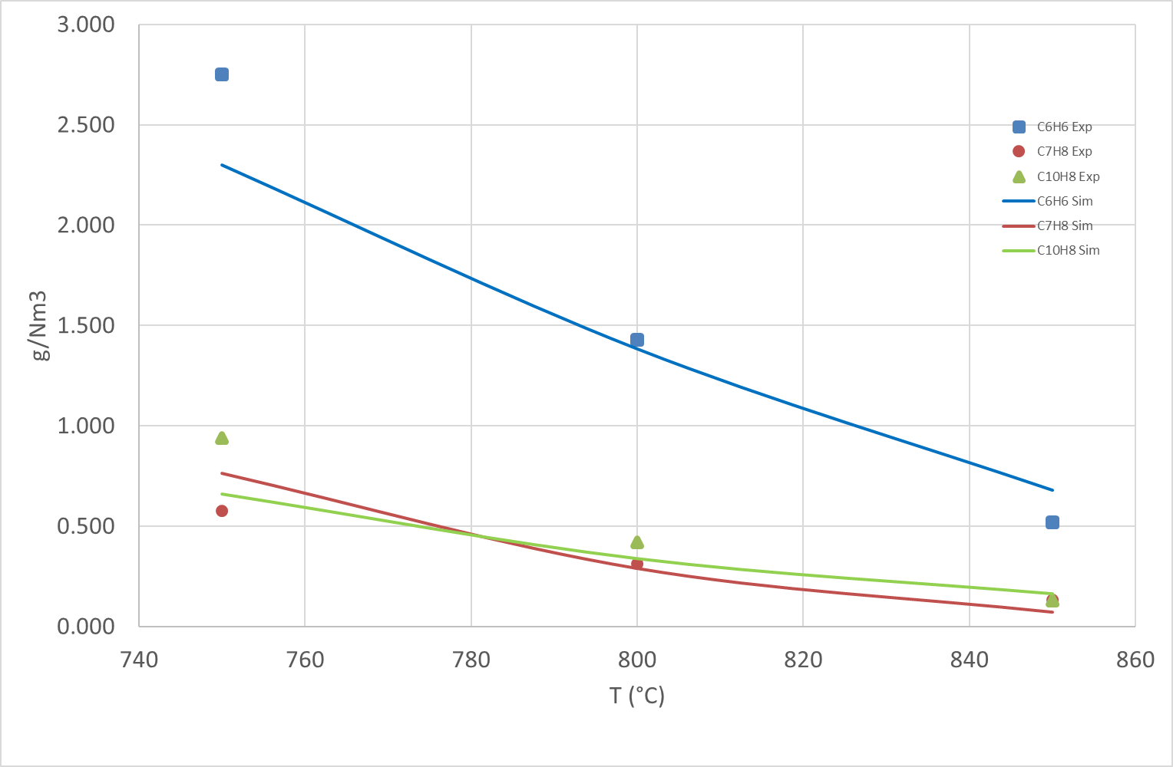

Figure 2– Comparison of experimental and simulation results

The Figure shows that there is very good correspondence between the simulation and experimental results.

### 3. Results and discussion

The 3D-CFD model was then used to simulate tar conversion in the vessel with the 6 commercial candles. The input data used for simulations were taken from the results recorded in the 100 kWth pilot scale dual fluidized bed gasifier. The input gas and tar composition are summarized in the next Table:

Table 4– Input data for simulations

|  |  |
| --- | --- |
|  | Input data |
| H2 (%vol, dry) | 35.2 |
| CO (%vol, dry) | 24.2 |
| CO2 (%vol, dry) | 20.2 |
| CH4 (%vol, dry) | 8.0 |
| H2O (%vol) | 24 |
| C6H6 (g/Nm3) | 6.3 |
| C7H8 (+1-ring)(g/Nm3) | 5.5 |
| C10H8 (+2-ring) (g/Nm3) | 5.4 |
| T gasification (°C) | 850 |
| T in vessel (°C) | 800-850-900 |

Results of simulations with the above mentioned input parameters are reported in

Figure 3.

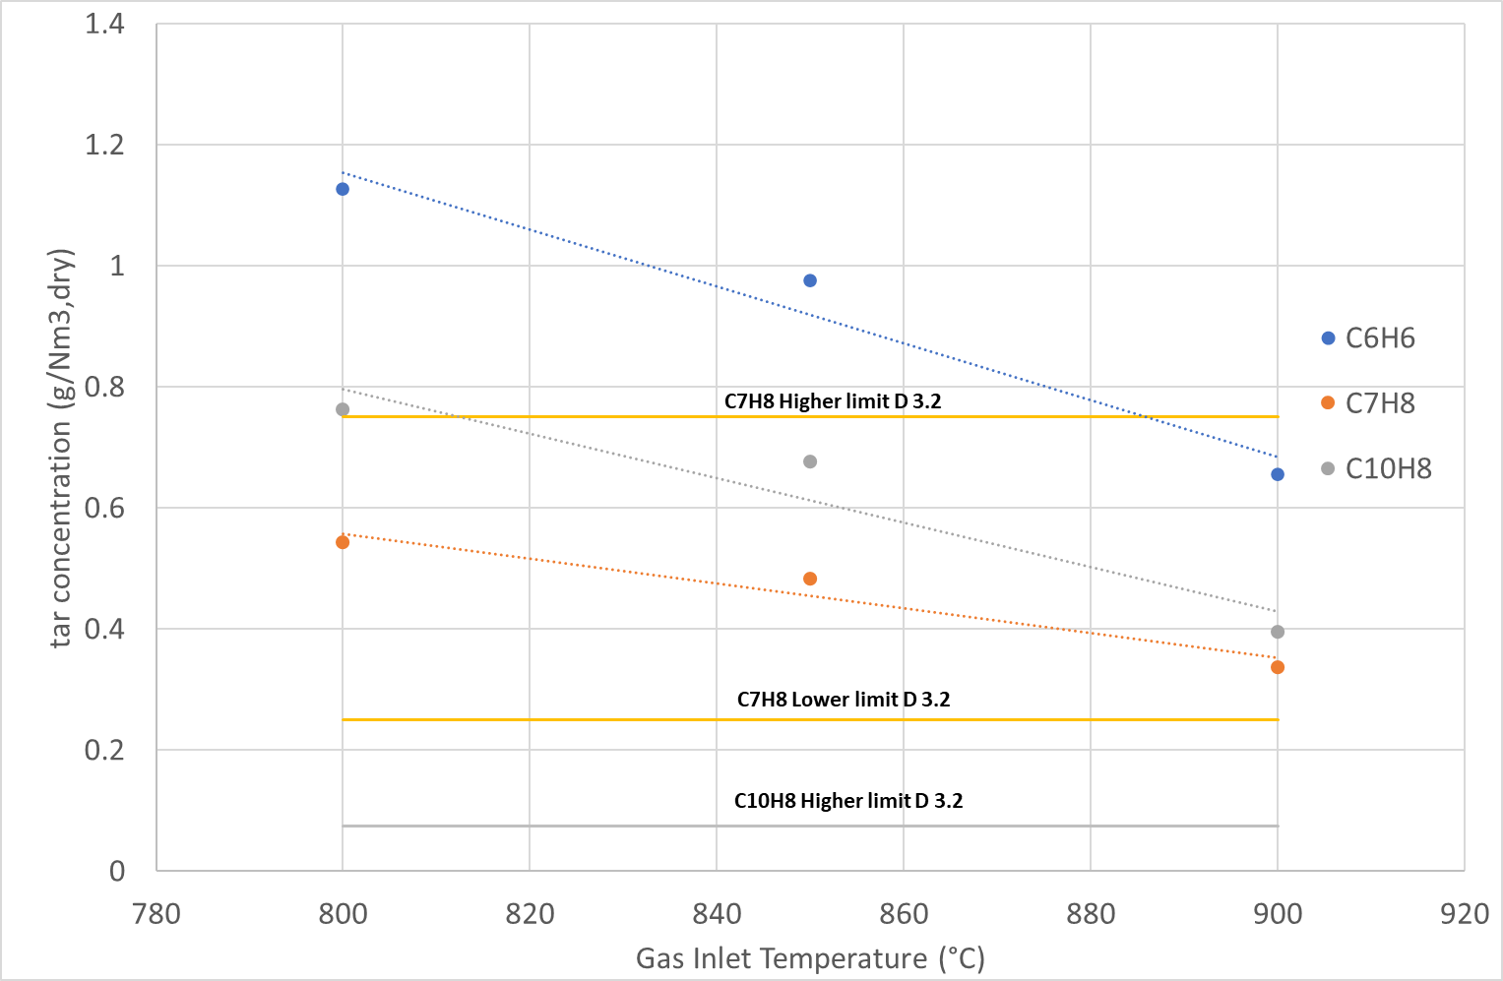

Figure 3-Results of the CFD simulations using the input of Table 4

The tar conversion yields obtained in this simulation are in the range of 80-90% at 800°C and increase to values higher than 90% at 900 °C. Naphthalene concentration is still too high at each temperature if compared with the required limits, while toluene is always lower than the higher limit.

Furthermore, it was observed that the temperature strongly drops along the reactor height due to the thermal dispersion with the external and because of the endothermic reactions that take place in the catalyst bed, these being probably the cause of the low tar conversion rate; tar steam reforming over Ni catalysts is in fact effective at temperatures much higher than 700 °C. Next Figure shows the temperature distribution at the inlet of the catalytic layer in the candles.

Figure 4-Temperature distribution at the inlet of the catalytic layer in the candles

Further simulations were carried out using a composition of the gas that can be obtained using dolomite in the bed. No experimental data on the pilot plant were available at that time for tar and gas composition when dolomite is used in the fluidized bed. Rapagnà et al. [13] carried out test, at the same bench scale test rig used in BLAZE project, test adding 20% of dolomite in a fluidized bed of olivine. The results showed that tar (without benzene) was reduced of a value between 68 and 76 %. Barisano et al. in the Deliverable 2.2 of BLAZE [14] demonstrated that adding 30% of dolomite in a fluidized bed of olivine, Benzene can be reduced of 19%, Toluene of 43% and hydrocarbons heavier than toluene of 52%. For the simulation it was assumed that the gas composition is the same of the previous one, while tar compounds were reduced using the data of Barisano et al.

Table 5– Input data for 2nd simulations, assuming dolomite in the bed

|  |  |
| --- | --- |
|  | Input data |
| H2 (%vol, dry) | 35.2 |
| CO (%vol, dry) | 24.2 |
| CO2 (%vol, dry) | 20.2 |
| CH4 (%vol, dry) | 8.0 |
| H2O (%vol) | 24 |
| C6H6 (g/Nm3) | 5.1 |
| C7H8 (+1-ring)(g/Nm3) | 3.1 |
| C10H8 (+2-ring) (g/Nm3) | 2.6 |
| T gasification (°C) | 850 |
| T in vessel (°C) | 800-850-900 |

Results of the simulations with the above mentioned input parameters are reported in the next figure.

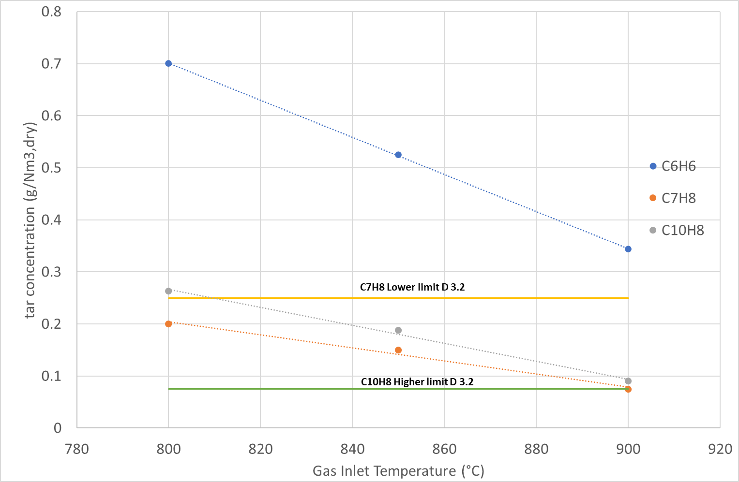

Figure 5-Results of the CFD simulations using the input of Table 5

The results show that naphthalene concentration is close to the higher limit for temperature of 900 °C, while toluene is always much lower than the lower limit. These results show that in order to meet the required limit for a safe operation of the SOFC the inlet temperature of the gas in the vessel with the filter candles should be higher than 900 °C, that is also higher than the operating temperature of the gasifier. A solution could be to inject small quantity of enriched air at the inlet of the filter candles vessel, to burn a really small portion of the gas and increase the temperature. This solution in anycase was not the one adopted for the project. To solve the problem a secondary catalytic reformer will be placed downstream the vessel of the filter candles. With this solution the contact time between gas and catalyst will be increased. In order to re-increase also the temperature of the gas, and thus improve the tar conversion, at the inlet of this secondary reactor, small quantity of enriched air will be injected. The evaluation of the performance of this new equipment is now in progress.

**4. Conclusions**

This work partially summarizes the results of the 3D-CFD simulations carried out for the BLAZE project. In particular the simulations were carried out on a vessel with 6 ceramic filter candles inserted in, and with commercial pelletized steam reforming catalyst in the inner empty space of each candle. The effect of the inlet gas temperature at the vessel was firstly investigated. The results showed that the tar conversion is really high between 80 to 90 %. Naphthalene concentration resulted still too high at each temperature if compared with the required limits, while toluene was always lower than the higher admissible limit. In order to find a solution, the same simulations were carried out again but with the tar concentration in the gas that can be obtained adding 30% of calcined dolomite in the bed. In this case the results show that naphthalene concentration is finally close to the higher limit for an inlet gas temperature of 900 °C, while toluene is always much lower than the admissible lower limit. In any case these results showed that in order to meet the required limit for a safe operation of the SOFC the inlet temperature of the gas in the filter candles vessel should be higher than 900 °C, that is also higher than the operating temperature of the gasifier. To solve this problem a secondary catalytic reformer will be placed downstream the vessel of the filter candles.

**References**

[1] R. Alipour Moghadam Esfahani, L. Osmieri, S. Specchia, S. Yusup, A. Tavasoli, A. Zamaniyan, H2-rich syngas production through mixed residual biomass and HDPE waste via integrated catalytic gasification and tar cracking plus bio-char upgrading, Chem. Eng. J. 308 (2017) 578–587. https://doi.org/10.1016/J.CEJ.2016.09.049.

[2] T.A. Milne, R.J. Evans, N. Abatzaglou, Biomass Gasifier “‘Tars’”: Their Nature, Formation, and Conversion, (1998). https://doi.org/10.2172/3726.

[3] P. Basu, Biomass Gasification, Pyrolysis and Torrefaction: Practical Design and Theory, 2013. https://doi.org/10.1016/C2011-0-07564-6.

[4] E. Savuto, A. Di Carlo, E. Bocci, A. D’Orazio, M. Villarini, M. Carlini, P.U. Foscolo, Development of a CFD model for the simulation of tar and methane steam reforming through a ceramic catalytic filter, Int. J. Hydrogen Energy. 40 (2015) 7991–8004. https://doi.org/10.1016/j.ijhydene.2015.04.044.

[5] H2020 BLAZE-Biomass Low cost Advanced Zero Emission small-to-medium scale integrated gasifier-fuel cell combined heat and power plant G.A. 815284, (n.d.). https://cordis.europa.eu/project/id/815284.

[6] E. Savuto, A. Di Carlo, A. Steele, S. Heidenreich, K. Gallucci, S. Rapagnà, Syngas conditioning by ceramic filter candles filled with catalyst pellets and placed inside the freeboard of a fluidized bed steam gasifier, Fuel Process. Technol. 191 (2019) 44–53. https://doi.org/10.1016/j.fuproc.2019.03.018.

[7] J.P. Ouweltjes, Deliverable D3.2-BLAZE Selection of Representative Syngas Compositions including Organic and Inorganic Contaminants-BLAZE GA 815284, 2019.

[8] R.B. Bird, W.E. Stewart, E.N. Lightfoot, Transport Phenomena, 2002. https://doi.org/10.1016/j.ijhydene.2006.08.059.

[9] H. Depner, A. Jess, Kinetics of nickel-catalyzed purification of tarry fuel gases from gasification and pyrolysis of solid fuels, Fuel. 78 (1999) 1369–1377. https://doi.org/10.1016/S0016-2361(99)00067-8.

[10] D. Świerczyński, S. Libs, C. Courson, A. Kiennemann, Steam reforming of tar from a biomass gasification process over Ni/olivine catalyst using toluene as a model compound, Appl. Catal. B Environ. 74 (2007) 211–222. https://doi.org/10.1016/j.apcatb.2007.01.017.

[11] T. Numaguchi, K. Kikuchi, Intrinsic kinetics and design simulation in a complex reaction network; steam-methane reforming, Chem. Eng. Sci. 43 (1988) 2295–2301. https://doi.org/10.1016/0009-2509(88)87118-5.

[12] A. Di Carlo, E. Savuto, A. Di Giuliano, A. Tacconi, A. Papa, S. Rapagnà, Deliverable 2.3-Tar catalysts selection and filter candles configurations and management to guarantee reliable and high efficiency particulate and tar abatement below SOFC limits-BLAZE GA 815284, 2021.

[13] S. Rapagnà, K. Gallucci, P.U. Foscolo, Olivine, dolomite and ceramic filters in one vessel to produce clean gas from biomass, Waste Manag. 71 (2018) 792–800. https://doi.org/10.1016/J.WASMAN.2017.07.038.

[14] D. Barisano, F. Nanna, A. Villone, E. Catizzone, Deliverable D2.2 Bio-syngas composition and contaminants that affect SOFC and related gasifier parameters and bed materials to reduce sofc hazardous effects, n.d.