**Multi-Objective Optimization of a Carbon Capture and Sequestration Chain Under Seismic Risk Constraints**

Daniel Crîstiu1, Federico d’Amore2, Paolo Mocellin1, Fabrizio Bezzo1*

*1 CAPE-Lab - Computer-Aided Process Engineering Laboratory, Department of Industrial Engineering, University of Padova, via Marzolo 9, IT-35131 Padova, Italy; 2 Politecnico di Milano, Department of Energy, via Lambruschini 4, IT-20156 Milano (Italy)*

*\*fabrizio.bezzo@unipd.it*

**1.Introduction**

Carbon dioxide (CO2) remains the primary anthropogenic greenhouse gas (GHG). It is expected that global surface temperature will surpass the limit established by the Paris Agreement of 2°C unless, in the near future, urgent actions are taken in reducing CO2 emissions on a global scale [1]. CO2 (carbon) capture and sequestration (CCS), which is a sequence of technologies targeted at cutting anthropogenic CO2 emissions, has been acknowledged as a key technology for decarbonizing carbon intensive industries. In particular, CO2 capture entails separating CO2 from a process stream using various methods depending on the industry and technology used, followed by a transport step of the captured CO2 from emission sources to areas suitable for sequestration in deep underground geological formations. Among the large stationary sources, cement plants, refineries and steel mills represent the most relevant sources of carbon dioxide emissions as part of the industrial sector around the world [2]. However, transporting CO2 via pipelines may raise public concern with respect the possibility of leakages. This is particularly critical in the Italian context as widespread seismic activity poses an additional requirement during the planning, installation, and operation of a CCS system, particularly with regards to pipelining. In this contribution, a mixed integer linear programming modelling approach is employed to perform a countrywide multi-objective optimisation for the adoption of a CCS network. The multi-objective optimisation aims at minimizing the total cost of the CCS network, while simultaneously minimizing the seismic risk which, considering the seismic profile of the Italian Peninsula, can represent a vulnerability for the installation and operation of a CCS system.

**2. Methods**

The location of industrial plants and their corresponding annual CO2 emissions in 2019 are taken from EEA (2020) database. The dataset of CO2 emitting nodes *n* is subdivided into 23 cement plants (*c*), 7 refineries (*r*) and 2 steel mills (*s*), selected in such way to account for at least 80% of the emissions from each sector. A comprehensive explanation of the modelling approach can be found in [3]. The CO2 transportation is achieved through onshore or offshore pipelines, while the sequestration stage takes into account both onshore and offshore sites. The seismicity-related parameters over the entire Italian peninsula are averaged into seismic areas and are used to calculate the risk specific to each pipeline in the transport stage.

The MILP model is formulated as minimizing total cost *TC* [€/year] and the total risk *TR* [ruptures/year]:

|  |  |  |  |  |
| --- | --- | --- | --- | --- |
| $$objectve=min⁡\{TC;TR\}$$ |  |  |  | (1) |

The TC is a sum of capture (*TCC* [€/year]), transport (*TTC* [€/year]), and sequestration stages (*TSC* [€/year]):

|  |  |  |  |  |
| --- | --- | --- | --- | --- |
| $$TC=TCC+TTC+TSC$$ |  |  |  | (2) |

*TR* is the sum of all the repair rates *RRn,n’* [ruptures/year] concerning the pipelines of the transport stage:

|  |  |  |  |  |  |
| --- | --- | --- | --- | --- | --- |
| $$TR=\sum_{n}{\left({RR}_{n,n'}\right)}$$ |  |  |  |  | (3) |

**3. Results and discussion**

The CPLEX solver in GAMS software was used to solve the MILP multi-objective optimization problem. The Pareto optimal solution allows assessing how the CCS chain configuration changes when moving from a purely economic optimization to the solution where seismic risk is minimized. As a matter of example, by equally weighting the cost and the risk functions into the objective function, a trade-off is found between the two conflicting objectives: the resulting infrastructure is illustrated in Figure 1 for a carbon capture target of 50%.

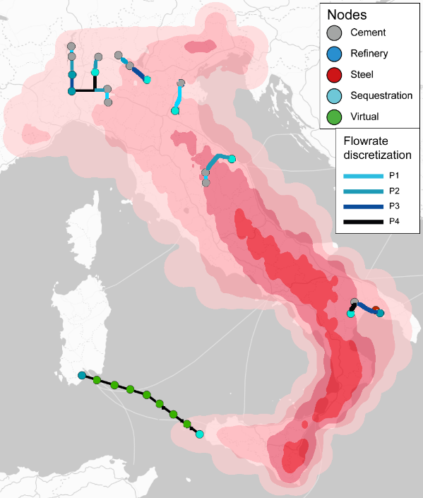

**Figure 1.** Trade-off configuration for the CCS supply chain.

This configuration gives a Total Risk of 2.36 ruptures/year with a Total Cost of 81.3 €/t of CO2. By analysing the three components of the Total Cost, the significant contribution is seen in the capture step which accounts for 64.8 €/t of CO2, while the transportation and sequestration costs give the value of 9.2 €/t of CO2, respectively 7.2 €/t of CO2.

**4. Conclusions**

For decarbonizing the Italian industry, a countrywide carbon capture and sequestration supply chain was optimized through a mixed integer linear programming framework. The model aimed at minimizing simultaneously the total cost (economic objective) and the total seismic risk (risk objective) by means of a multi-objective framework capable of providing useful insights to investors and policy makers.

**References**

1. IPCC, 2021: Climate Change 2021: Report of the Intergovernmental Panel on Climate Change. Cambridge University Press. In Press.
2. EEA, 2020, European Pollutant Release and Transfer Register, https://prtr.eea.europa.eu/#/pollutantreleases.
3. F. d’Amore, M.C. Romano, F. Bezzo, J. Clean. Prod., 65 (2021) 99-116.