**Sorption-enhanced gasification in dual interconnected fluidised beds – Behaviour of limestone-based sorbents**

Antonio Coppola1, Fabio Montagnaro2*, Piero Salatino3, Fabrizio Scala1,3

*1 STEMS, Consiglio Nazionale delle Ricerche, 80125 Napoli*

*2 DSC, Università degli Studi di Napoli Federico II, 80126 Napoli*

*3 DICMaPI, Università degli Studi di Napoli Federico II, 80125 Napoli, Italy*

*\*Corresponding author E-Mail:* [*fabio.montagnaro@unina.it*](mailto:fabio.montagnaro@unina.it)

**1. Introduction**

Sorption-Enhanced Gasification (SEG) is a promising technology that can be based, Figure 1, on the use of Ca-based sorbents (like limestone) to selectively remove CO2 from the gasification environment for production of a hydrogen rich syngas [1–3]. The SEG process benefits from the extensive understanding of the “calcium looping” process, a post-combustion technique aimed at removing CO2 from combustion flue gas [4–6]. Calcium looping is most typically carried out in a Dual Interconnected Fluidised Bed (DIFB) reactor system, where the Ca-based sorbent is cycled between a carbonator, where it captures CO2 from flue gas, and a calciner where the sorbent releases CO2 and is regenerated for another cycle. Design of sorbent looping processes in DIFB reactors must consider: 1) sorbent deactivation (i.e., decay of CO2 capture performance) over repeated cycling; 2) loss of sorbent material due to elutriation, that may be enhanced by attrition and fragmentation. The aim of this study was to investigate the performance of six different commercial limestones in terms of sorbent performance and attrition/fragmentation tendency under simulated SEG conditions.

**2. Methods**

The experimental campaign was carried out in a batch-operated lab-scale DIFB reactor, electrically heated. The six sorbents were different limestones coming from different parts of Europe. A synthetic gas including air, CO2 and N2, was used to simulate SEG conditions. A “test” consisted of ten complete cycles of calcination/carbonation. Calcination was performed at 850°C fluidising the bed with a stream of 10% CO2 (balance air) so as to simulate oxidising conditions typical of the combustor-calciner. In the carbonation stage, the temperature was kept at 650°C and the CO2 concentration was set at 10% (balance nitrogen) to account for reducing conditions typical of the gasifier-carbonator. Operating conditions are summarised in Table 1. During each carbonation stage, the CO2 concentration at the exhaust was continuously monitored to calculate the CO2 specific capture performance. The sorbent attrition rate was determined by working out the mass of fines elutriated at the exhaust and collected in the filters, for each calcination and carbonation stage. After a test, each exhaust sorbent sample was sieve-analysed to obtain the particle size distribution and the fraction of generated fragments.

**3. Results, discussion and concluding remarks**

The preliminary characterisation of the six sorbents presented in this abstract shows that three of them (termed EBW, CZA and SAR) have good CO2 capture performance (Figure 2), coupled with a limited production of both in-bed fragments and elutriable fines, while the sorbent named TAR is the worst in terms of the three features listed above. While results here presented can be useful for the determination of the make-up of fresh sorbent required for steady operation, and for optimal design and operation of sorption-enhanced gasification, further work is currently being carried out and concerns: i) the morphological (via SEM analyses) and porosimetric characterisation of the samples, in order to explain the features observed here; ii) the study of the impact fragmentation tendency of these sorbents, under a variety of impact velocity conditions.

**Table 1.** Main operating conditions for simulated SEG tests.

|  |  |  |  |  |
| --- | --- | --- | --- | --- |
|  | Temperature, °C | Duration, min | %vol. CO2 (balance) | Fluidisation velocity, m/s |
| Calcination | 850 | 10 | 10 (air) | 0.5 |
| Carbonation | 650 | 10 (N2) |

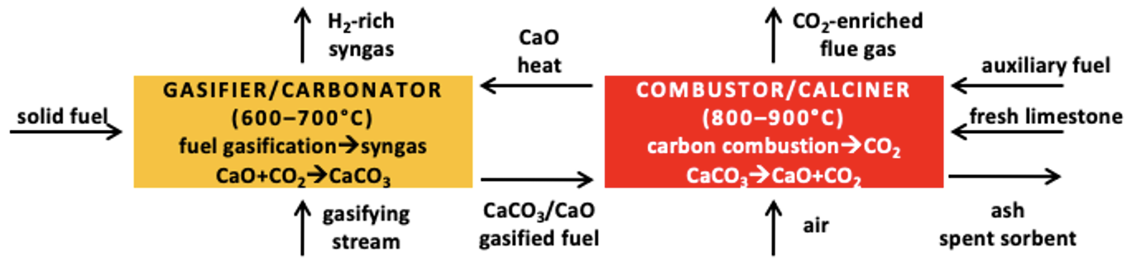

**Figure 1.** Sorption-enhanced gasification in dual interconnected fluidised beds reactor.

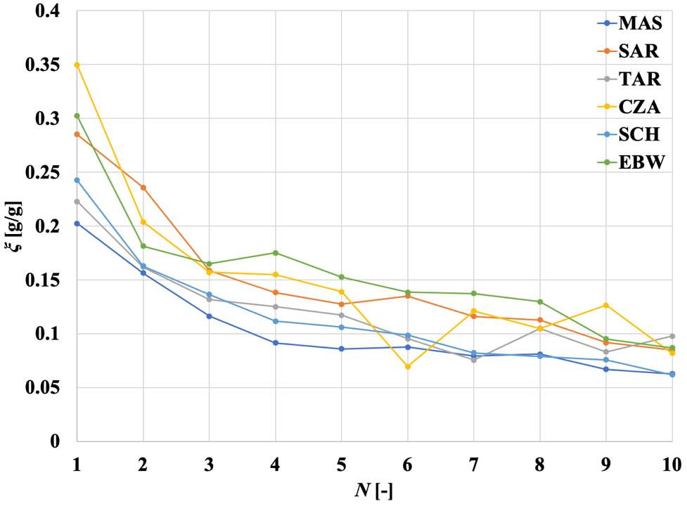

**Figure 2.** CO2 specific capture performance *ξ* as a function of *N*, the number of carbonation stage, for DIFB-SEG tests (six different limestones).

**References**

1. A. Di Giuliano, K. Gallucci, P.U. Foscolo, Ind. Eng. Chem. Res. 59 (2020) 6840–6854
2. A.M. Parvez, S. Hafner, M. Hornberger, M. Schmid, G. Scheffknecht, Renew. Sust. Energy Rev. 141 (2021) 110756
3. A. Coppola, A. Sattari, F. Montagnaro, F. Scala, P. Salatino, AIChE J. (2022) <https://doi.org/10.1002/aic.17588>
4. N. Rodríguez, M. Alonso, J.C. Abanades, AIChE J. 57 (2011) 1356–1366
5. A. Perejón, L.M. Romeo, Y. Lara, P. Lisbona, A. Martínez, J.M. Valverde, Appl. Energy 162 (2016) 787–807
6. A. Coppola, O. Senneca, F. Scala, F. Montagnaro, P. Salatino,Fuel 268 (2020) 117371