Mixotrophic cultivation of Phaeodactylum tricornutum and value-added compounds extraction through a biorefinery concept

Caterina Celi^{1*}, Debora Fino¹, Francesco Savorani¹
¹ Politecnico di Torino, DISAT, Corso Duca degli Abruzzi 24, 10129, Torino, Italy
*Corresponding author E-Mail: caterina.celi@polito.it

1.Introduction
Microalgae are photosynthetic organisms that own the possibility to produce high value phytochemicals and have the capacity to utilize CO₂ as a feedstock, potentially enabling economic and environmentally sustainable manufacturing solutions. (Butler, 2020) They have been extensively studied during the past years, firstly for the chance of biofuels production and then also for the extraction of valuable compounds, such as proteins, polysaccharides, polyunsaturated fatty acids (PUFAs), pigments, and sterols, widely used in pharmaceutical, nutraceutical, cosmetic and food sectors.
However, despite their advantages in high biomass productivity, photosynthetic efficiency, and adaptability to grow in a wide variety of substrates without depleting fertile lands, few industries based on these organisms have arisen, mainly because of the high costs to bear. The great demands in terms of materials and energy needed for their production and downstream processing, with the harvesting and dewatering steps being the most energy-intensive, prevented the microalgae-based industries to effectively establish themselves worldwide. Even more so when the industrial process is designed to obtain a sole product to be placed on the market.
In this context, biorefinery can be proposed as a valid approach towards sustainability and circular economy since it can increase production efficiency and economic feasibility by valorizing all biomass components. Such a strategy involves the building of several facilities close to each other to take advantage of the potential synergies arising from this set of processes. (Branco-Vieira, 2020) A microalgae-based biorefinery would then rely on a process chain starting from the optimization of biomass production to the development of a platform able to generate a wide range of products, such as bulk chemicals, food supply, bioactive compounds, and oils, exactly as occurs for petroleum-based processes. (Gilbert-López, 2015)
Nowadays, even if microalgae are mostly employed as feeding in aquaculture sector, there are anyhow some industries where they are grown to produce value-added products for feed and food market: e.g., astaxanthin, ß-carotene, phycocyanin, fatty acids. Even if less commercially competitive, these microalgae-based molecules own specific advantages over standard synthetic alternatives: for instance, from a chemical point of view, synthetic molecules are only available in specific isomers, which are generally much less effective than natural variants for certain applications, such as in infant formula, fish pigment enhancers or dietary supplements (Enzing, 2014).
Some industries have specialized in the commercialization of one particular compound extracted from an algae source, but as underlined before, complete utilization of microalgae for multiple compounds extraction instead of the sole product is pivotal to increase the economic feasibility of bioactive compounds production from these natural sources.
Other studies have already focused on the possibility of multiple compounds production from microalgal biomass, such as Thalassiosira weissflogii, Scenedesmus obliquus, Isochrysis galbana, Staurosirella pinnata and Phaeodactylum tricornutum (Marella, 2020; Amorim, 2020; Vieira, 2021; Zhang, 2018; Savio, 2020), but very few of them employed green extraction techniques. Therefore, this project shall focus on the comprehensive utilization of microalgal biomass to obtain diverse valuable products in a multi-stage cascade extraction based on sustainable technologies.
Marine diatoms are the most productive and adaptive microalgae, and account for 20% of global carbon fixation; among them, Phaeodactylum tricornutum is one of the most studied species. This is a marine pennate diatom belonging to the class of Bacillariophyceae of Heterokontophyta, containing about 36.4% of proteins, 26.1% of carbohydrates, 18.0% of lipids and 15.9% of ash on a dry weight basis, under normal growth conditions (Zhang, 2018). It is a commercially viable species for large-scale cultivation and can accumulate a large spectrum of marketable products, such as fucoxanthin, EPA, DHA and chrysolaminarin, which have been shown to be beneficial for human health.
P. tricornutum is a successful photoautotroph, converting sunlight energy into reduced carbon via photosynthesis, but it is also capable of mixotrophic growth on glucose, acetate, fructose, and glycerol; while heterotrophic growth via sugar fermentation in the dark is not possible, except upon metabolic engineering. Even if phototrophic growth could be a cheap way to produce biomass since only sunlight is used as an energy source, it is often limited by the difficulties in optimizing light penetration, gas diffusion, and temperature control. Therefore, mixotrophic cultivation making use of cheap and easily available carbon sources, represents an interesting alternative, having the potential to attain high biomass concentration while maintaining high contents of the photosynthesis-related compounds, that are usually lost under heterotrophic conditions. Glycerol appears to be the most suitable organic carbon source for P. tricornutum, leading to the highest biomass and EPA productivities. In fact, mixotrophy with glycerol mimics typical responses of N-starvation resulting in increases in TAGs, but also in biomass without loss of photosynthetic capacity due to nutrients’ depletion (Butler, 2020).
2. Methods
P. tricornutum from Culture Collection of Algae and Protozoa (CCAP 1055/18, axenic culture of CCAP 1055/1) is cultivated mixotrophically with glycerol and in optimized enriched seawater artificial seawater (ESAW), which showed higher biomass yield than other conventional medium for diatoms (Villanova, 2021). Laboratory-scale photobioreactors of 2 L total working volume have been designed adapting a bubble column reactor system, which allows to obtain a certain degree of control over the lighting and temperature (Wang, 2019). Column reactors (10 with 200 mL working volume) are placed in a glass tank with a thermostatically controlled water bath; the light penetration is assured through two fluorescent lamps placed at the two sides of the tank (Fig. 1). The air and CO₂ mix (1% v/v CO₂) is supplied to the photobioreactors using flowmeters and the rising of gas bubbles is responsible for the gas exchange and the mixing in each reactor. Optimal growth conditions for P. tricornutum are maintained as: 21°C; pH=8÷8.50; 496 µmol/m²s of light intensity; light-dark cycle: 16:8 hours; final glycerol concentration of 4.6 g/L.

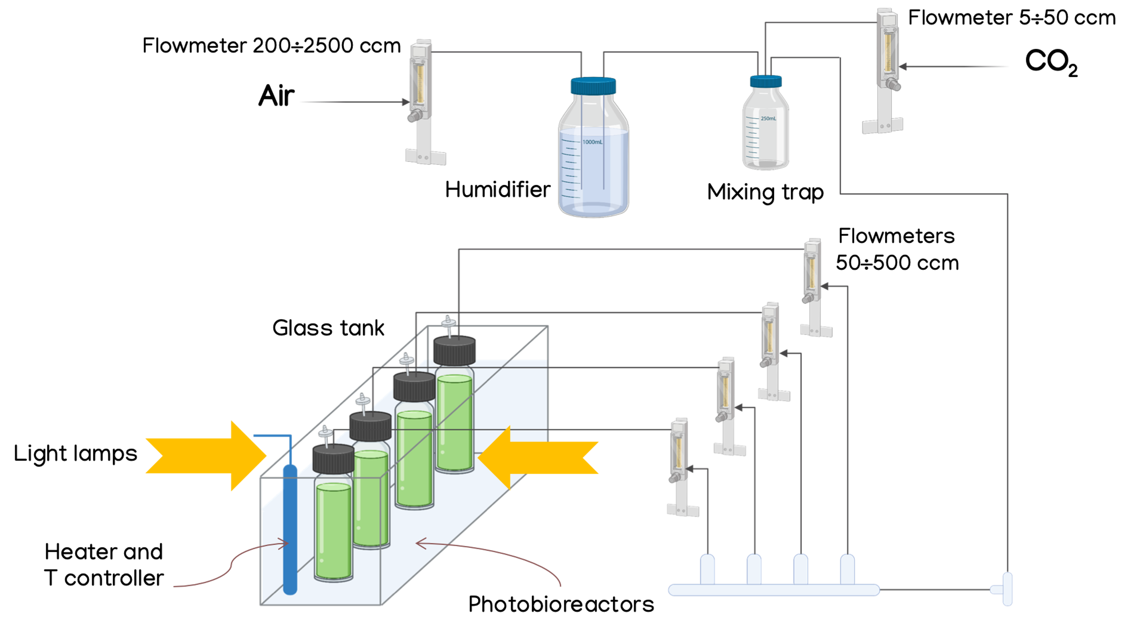

Fig.1 Tank with bioreactors for algae culturing, adapted from Wang et al. (2019)

To monitor algal growth, daily samples are taken to measure (i) OD at 750 nm in a spectrophotometer, (ii) cell density through a Thoma chamber and (iii) dry cell weight (DCW) after filtration through GF/C Whatman filters and drying oven of biomass.
A Design of Experiment will be carried out to find optimal culture conditions: two levels and three factors full factorial will be developed. The factors to be investigated in the DoE are Light intensity (low level of 150 µmol/m²s and high level of 400 µmol/m²s), Temperature (low level of 20 °C and high level of 25°C) and Glycerol concentration for mixotrophic culture (low level of 0.05 M and high level of 0.1 M). The influence of these factors on biomass productivity, biomass maximum specific growth rate and biochemical composition (carbohydrates, lipids, proteins, pigments) will be studied in order to find the best operative conditions to obtain a high-value compounds rich biomass and the highest biomass productivity.
After cultivation step, dried biomass shall be characterized by lipid extraction and quantification with Bligh & Dyer method followed by GC-MS for fatty acids analysis; pigments extraction and quantification by spectrophotometric methods and use of equations for chlorophyll a and c; proteins quantification through elemental analysis and N-factor; carbohydrates extraction and quantification HPLC analysis.
Furthermore, different advanced environmentally friendly techniques shall be tested to design the optimal cascade extraction to exhaust all achievable compounds and fractionate microalgal biomass into valuable isolated fractions. For instance, microwave-assisted extraction (MAE), ultrasound-assisted extraction (UAE), pressurized liquid extraction (PLE), supercritical fluid extraction (SFE), and the use of enzymes, ionic liquids, or deep eutectic solvents will be considered for this purpose. With this regard, an interesting approach could be to design the extraction steps in increasing order of polarity (as done by Gilbert-López, 2015), by modulating extractive conditions and solvents used, so that different extracts are obtained in the various steps.
3. Conclusions
It is worth to stress that the extraction procedures targeted to specific compounds must not compromise the integrity of the other fractions to be extracted with the next steps; moreover, the solvents used must fulfill regulations related to the product’s final use. If the latter can be true for GRAS (generally recognized as safe) solvents, the same can not be said with confidence for novel substances, such as ionic solvents and deep eutective solvents, whose toxicity should be still investigated, especially if the target market is pharmaceutical, nutraceutical or cosmetic. Lastly, the economic aspect should not be underestimated: even if biorefinery approach could allow to enhance economic viability, the selection of extraction techniques shall be performed carefully to not engrave overly on the total investment, which could occur in the case of using enzymes that are known to be very expensive.
Hence, taking account of the previous observations, results on extraction tests using citated tecniques will be used to design the best cascade extraction suitable for P. tricornutum, aimed at valorizing all algal biomass components to their maximum extent; the possibility to develop a final valorization of the residual biomass intended to power upstream processes will also be evaluated.
References
[1] Thomas Butler, Rahul Vijay Kapoore, Seetharaman Vaidyanathan, Phaeodactylum tricornutum: A Diatom Cell Factory, Trends in Biotechnology, Volume 38, Issue 6, 2020, Pages 606-622
[2] Monique Branco-Vieira, Sergio San Martin, Cristian Agurto, Marcos A.V. Freitas, António A. Martins, Teresa M. Mata, Nídia S. Caetano, Biotechnological potential of Phaeodactylum tricornutum for biorefinery processes, Fuel, Volume 268, 2020, 117357
[3] Bienvenida Gilbert-López, José A. Mendiola, Javier Fontecha, Lambertus A. M. van den Broek, Lolke Sijtsma, Alejandro Cifuentes, Miguel Herreroa and Elena Ibáñez, Downstream processing of Isochrysis galbana: a step towards microalgal biorefinery, Green Chemistry, 2015, 17, 4599
[4] Christien Enzing, Matthias Ploeg, Maria Barbosa, Lolke Sijtsma, Microalgae-based products for the food and feed sector: an outlook for Europe, Jrc Scientific and Policy Reports, 2014, Report EUR 26255 EN
[5] Thomas Kiran Marella, Archana Tiwari, Marine diatom Thalassiosira weissflogii based biorefinery for co-production of eicosapentaenoic acid and fucoxanthin, Bioresource Technology, Volume 307, 2020, 123245
[6] Matheus Lopes Amorim, Jimmy Soares, Bruno Bezerra Vieira, Willian Batista-Silva, Marcio Arêdes Martins, Extraction of proteins from the microalga Scenedesmus obliquus BR003 followed by lipid extraction of the wet deproteinized biomass using hexane and ethyl acetate, Bioresource Technology, Volume 307, 2020, 123190
[7] Bruno Bezerra Vieira, Jimmy Soares, Matheus Lopes Amorim, Paula Viana Queiroz Bittencourt, Rita de Cássia Superbi, Eduardo Basílio de Oliveira, Jane Sélia dos Reis Coimbra, Marcio Arêdes Martins, Optimized extraction of neutral carbohydrates, crude lipids and photosynthetic pigments from the wet biomass of the microalga Scenedesmus obliquus BR003, Separation and Purification Technology, Volume 269, 2021, 11871
[8] Wenyuan Zhang, Feifei Wang, Baoyan Gao, Luodong Huang, Chengwu Zhang, An integrated biorefinery process: Stepwise extraction of fucoxanthin, eicosapentaenoic acid and chrysolaminarin from the same Phaeodactylum tricornutum biomass, Algal Research, Volume 32, 2018, Pages 193-200, ISSN 2211-9264
[9] Saverio Savio, Serena Farrotti, Debora Paris, Esther Arnaìz, Israel Díaz, Silvia Bolado, Raul Muñoz, Carlo Rodolfo, Roberta Congestri, Value-added co-products from biomass of the diatoms Staurosirella pinnata and Phaeodactylum tricornutum, Algal Research, Volume 47, 2020, 101830
[11] Qichen Wang, Haixin Peng, Brendan T. Higgins, Cultivation of Green Microalgae in Bubble Column Photobioreactors and an Assay for Neutral Lipids. J. Vis. Exp. (143), 2019, e59106
[12] Valeria Villanova, Dipali Singh, Julien Pagliardini, David Fell, Adeline Le Monnier, Giovanni Finazzi and Mark Poolman (2021) Boosting Biomass Quantity and Quality by Improved Mixotrophic Culture of the Diatom Phaeodactylum tricornutum. Front. Plant Sci. 12:642199

