**A circular economy approach for olive oil industry: from olive pomace to microalgal biomass**

Alessandro Alberto Casazza*, Patrizia Perego, Attilio Converti

*1 Department of Civil, Chemical and Environmental Engineering, via Opera Pia 15, 16145 Genova, Italy*

*\*Corresponding author E-Mail: alessandro.casazza@unige.it*

**1.Introduction**

The circular economy is defined by the European parliament as “a model of production and consumption, which involves sharing, leasing, reusing, repairing, refurbishing and recycling existing materials and products as long as possible” [1]. This allows an extension of the life cycle of a product to be reused, thus adding a further value to it and reducing wastes. In this context, particular attention must be paid to olive oil production residues [2]. Olive oil production, which is a major industrial field in the Mediterranean countries, reached 1924 Mg in the season 2019/2020, while the worldwide production was around 3207 Mg [3]. In this work olive pomace was used to recover high added value compounds and produce biogas by anaerobic digestion. Moreover, in order to satisfy the circular economy concept, the digestate from the latter process was used as medium for the microalga *Chlorella vulgaris* growth. The microalgal biomass represents an important source of chemicals, and in the future, its use will be increasingly significant.

**2. Methods**

***2.1 Polyphenols extraction***

Polyphenols were extracted from the olive pomace (OP) of Taggiasca cultivar by means of a High Pressure High Temperature Extractor (HTPE) (model 4560, PARR Instrument Company, Moline, IL, USA). HPTE was selected because of better results obtained in polyphenols recovery if compared with other extraction methodologies [4]. Extraction parameters were selected based on previous works [2]. During the extraction, pressure and temperature inside the reactor reached 25 bar and 180 °C, respectively***.*** Total polyphenols were quantified using a modified version of the Folin-Ciocalteu method [5].

***2.2 Olive pomace anaerobic digestion***

The digestion process was carried out in a bioreactor with a total volume of 6 L and a working volume of 5 L. After an initial period of acclimatization of the Anaerobic Digestion (AD) microorganisms present in the inoculum, the OP was fed to the bioreactor. Initially it was anaerobically co-digested with activated sludge and subsequently mono-digested alone (15 g of OP three times per week).

***2.3 Chlorella vulgaris growth using digestate as a culture medium***

*Chlorella vulgaris* CCAP 211 (Culture Collection of Algae and Protozoa, Argyll, UK) was used at an initial concentration of 0.2 g/L in 0.6 L column photobioreactors. Different concentration of digestate (25 and 50% v/v) in Bold Basal Medium were tested. *C. vulgaris* concentration was determined by optical density (λ = 625 nm) measurements using a UV-Vis spectrophotometer (Lambda 25, PerkinElmer) and a calibration curve, and the Chemical Oxygen Demand (COD) removal efficiency was quantified [6]. The microalga lipid content was quantified following the method described by Converti et al. [7].

**3. Results and discussion**

After the extraction at 180 °C, an ethanolic solution rich in polyphenols was obtained. The concentration of total polyphenols in the HPTE extract, expressed as caffeic acid equivalents (CAE) per unit volume, was 19.2 mgCAE/mL. Concentrations of 3.59, 0.51, 0.23, 0.18 and 0.08 mgCAE/mL were found by High Performance Liquid Chromatography (HPLC, model 1260, Agilent) for oleuropein, tyrosol, caffeic acid, coumaric acid and apigenin, respectively. At the same time, OP anaerobic digestion led to a considerable biogas production, which achieved about 6.5 L using 40 g of dry OP (Figure 1).

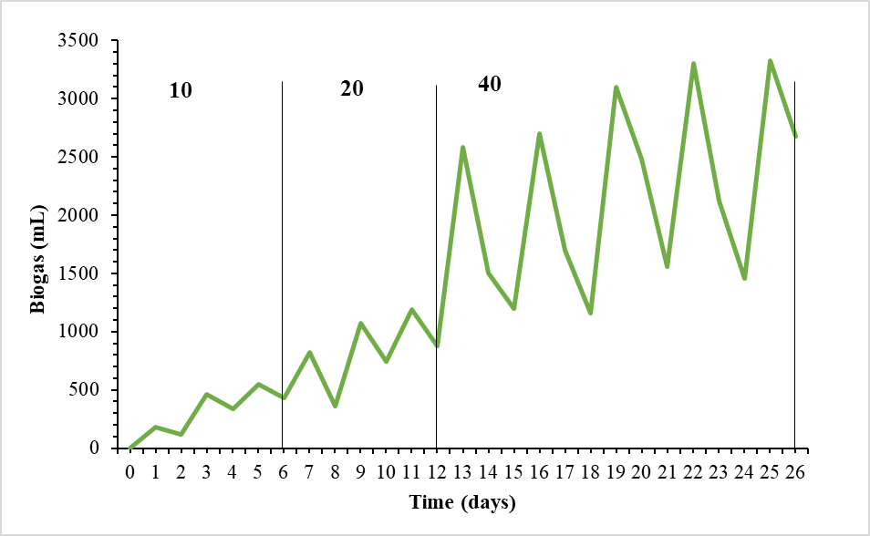

**Figure 1.** Biogas production obtained by feeding the anaerobic digester every three days with 10, 20 and 40 g of dry olive pomace.

The digestate resulting from the anaerobic treatment was mixed with the Bold Basal Medium (25 and 50 % v/v) and used as medium to cultivate *C. vulgaris* in column photobioreactors. Although the microalga was able to grow mixotrophically using both organic compounds present in the waste and carbon dioxide, its final concentrations, ranging from 1.0 to 1.4 g of dry biomass per L of medium (gDB/L), were quite lower than those achieved in the control runs (2.0 gDB/L). A possible negative influence of the digestate on the growth of the microalga can be supposed because the digestate can prevent light from deeply entering the culture medium. In addition, Merchuk and Wu [8], after applying a three-stage structured model integrating photosynthesis and photoinhibition to a column photobioreactor, demonstrated that cell productivity (*νDB*), defined as the biomass produced per unit time and surface, is related to: the height of the column (*H*), the distance between adjacent column installations (*d*), the column diameter (*Dc*), the biomass concentration at the beginning (*X0*) and at the end of the growth (*Xf*) (Eq. 1).

|  |  |
| --- | --- |
| $$ν_{DB}= \frac{D_{c}^{2}H(X_{f}-X_{0})}{(D_{c}+d)^{2}∆t}$$ | **Eq.** **1** |

As for the COD, the results showed a significant reduction in this parameter over time. In fact, after 20 days the COD decreased from 1500 and 750 mgO2/L in the photobioreactors containing 50% and 25% v/v of digestate to final values of 477 and 269 mgO2/L, respectively.

**Conclusions**

Olive pomace can be successfully used for the recovery of high added value compounds and for the production of biogas by anaerobic digestion. Moreover, the digestate can be further treated using microalgae, obtaining a waste with a less environmental impact and high added value biomass.

**References**

1. M. Smol, P. Marcinek, J Duda, D. Szołdrowska, Resources. 9 (2020), 5.
2. B. Aliakbarian, A.A. Casazza, P. Perego, Food Chem. 128 (2011), 704-710.
3. IOC, https://www.internationaloliveoil.org/worlds-olive-oil-production-has-tripled/. 01/04/2021.
4. A.A. Casazza, B. Aliakbarian, S. Mantegna, G. Cravotto, P. Perego, J. Food Eng. (2010), 100, 50-55.
5. A.A. Casazza, M. Pettinato, P. Perego, Sep. Purif. Technol. (2020), 240, 116640.
6. E. Spennati, S. Mirizadeh, A.A. Casazza, C. Solisio, A. Converti, Algal Res. (2021), 60, 102519.
7. A. Converti, A.A. Casazza, E.J. Ortiz, P. Perego, M. Del Borghi, Chem. Eng. Process. (2009), 48, 1146-1151.
8. J. Merchuk, X. Wu, J. Appl. Phycol. (2003), 15, 163-170.