**Enhancing fluidized operations in heterogeneous catalysis through dynamically structured pulsed reactors**

Davide Cafaro1, Daniele Micale1, Riccardo Uglietti1, Kaiqiao Wu2, Mauro Bracconi1, Marc-Olivier Coppens2 and Matteo Maestri1*

*1Laboratory of Catalysis and Catalytic Processes, Dipartimento di Energia, Politecnico di Milano, Via la Masa 34, 20156 Milano (Italy);*

*2Centre for Nature Inspired Engineering, Department of Chemical Engineering, University College London, Torrington Place, London WC1E7JE (United Kingdom)*

*\*matteo.maestri@polimi.it*

**1.Introduction**

The coupling between heterogeneous catalysis and fluidization technologies is pivotal to tackle the challenges to achieve a sustainable economy. On the one hand, the peculiarity of this reactor technology (i.e., homogeneous reactive environment, the motion of the solid phase) can promote the development of novel processes [1] aimed at the valorization of the natural resources and the CO2 capture. On the other hand, the complex fluid dynamics of conventional fluidized units is strongly influenced by the reactor size hampering their design and scale up. In particular, the motion of the bubbles strongly affects both conversion and selectivity since it causes a wide distribution of the gas-particle contact time and thus it must be properly managed to maximize the performances of such units.

A possible solution to face these problems is to achieve a dynamically structured bed by injecting a pulsed inlet gas flowrate [2]. Accordingly, an ordered bubble pattern is experienced providing additional degrees of freedom in their design and scale-up [2,3]. Despite the potential of such fluidization technique [3], its combination with catalytic processes has not already been analyzed in the literature. Thus, this work aims at investigating dynamically structured fluidized reactors in the context of heterogeneous catalysis by means of a multiscale Euler-Lagrange approach.

**2. Methods**

The numerical investigation of catalytic pulsed fluidized beds is performed by adopting a multiscale reactive particle tracking methodology [4], sketched in Figure 1. This CFD-DEM framework is based on the coupling between the LIGGGHTS® DEM code for the tracking of the solid materials and the catalyticFOAM [5] framework for the solution of the governing equations for non-isothermal catalytic reactive flows. By adopting this numerical framework, it is possible to provide insights into the interplay between macro-scale transport phenomena, particle-scale gas-solid and solid-solid interactions, considering also elementary steps at the catalyst sites, leading to predictions in agreement with experimental evidence [6]*.*

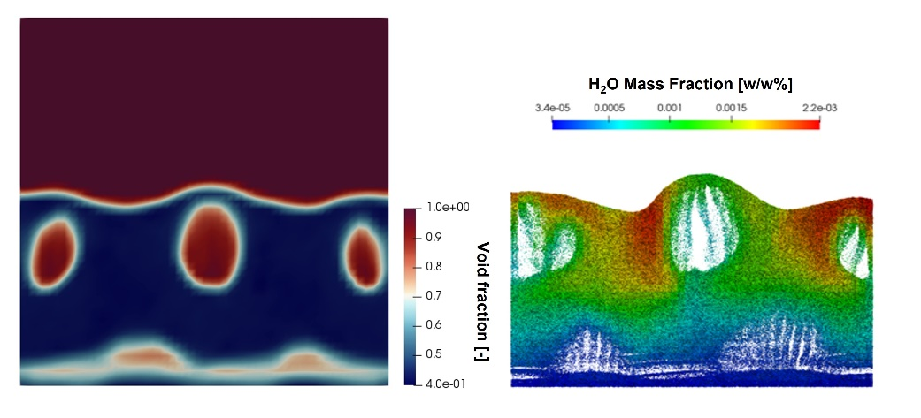

**Figure 1.** Maps of the void fraction (left) and water mass fraction in the solid catalyst (right) computed by the multiscale particle tracking methodology [4].

**3. Results and discussion**

A pseudo-2D lab-scale reactor configuration [2] has been investigated in this work by adopting a sinusoidal inlet flow rate. The hydrogen oxidation over Pt at ambient temperature in diluted conditions with oxygen as limiting reactant has been used as benchmark process to reproduce units working under almost isothermal conditions. First, the effect of the pulsation frequency on the bubble size (Figure 1a) has been analysed. The flow pulsation determines the generation of an ordered pattern of bubbles [2] whose dimensions decrease with the increment of the frequency, asymptotically reaching the value of the non-pulsed unit for a frequency higher than 13 Hz. At the same time, the pulsation also affects the solid mixing in the reactor. Indeed, Figure 1(b) shows the evolution over time of the Lacey’s mixing index [6], which ranges from 0 (unmixed system) to 1 (ideal, perfect mixing). An enhancement of the mixing rate with frequency (shifting the emulsion phase towards a CSTR behavior) is observed up to 9 Hz. Then, the mixing decreases since the bed structure is gradually lost, approaching the non-pulsed condition. The complex interplay between the afromentioned parameters influences the reactive behavior of the bed. The higher bubble dimension with respect to the non-pulsed configuration leads to a lower conversion in the whole range of investigated frequencies. In particular, the O2 conversion decreases from 5 Hz to 7 Hz, due to more pronounced mixing, leading to a more pronounced CSTR-like behavior of the emulsion phase, despite the smaller bubble diameter which favors the bubble-emulsion mass transfer. Thus, the minimum of the conversion is observed at a frequency of 7 Hz, where the limited decrease in bubble size is counterbalanced by the high mixing. Then, an increment of the conversion is experienced for higher frequency since both the bubble diameter and the mixing efficiency decrease.

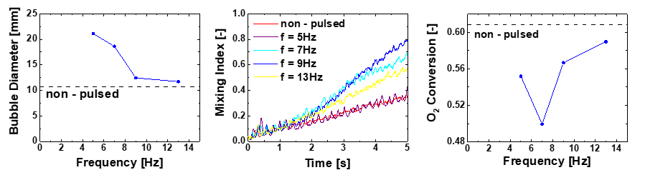

**Figure 2.** Catalytic pulsed fluidized bed investigation: impact of the pulsation frequency on bubble size (left), particle mixing (middle) and O2 conversion (right).

**4. Conclusions**

This fundamental investigation highlights the strong relationship between the pulsation frequency and the overall catalytic performance in a dynamically structured fluidized bed, reflecting the intrinsic multiscale behavior of this system. In particular, the higher mixing rate and the more careful control of the gas-solid contact time with respect to the conventional fluidized units make this fluidization concept promising for the management of processes affected by selectivity issues (i.e., Oxidative Coupling of Methane) or characterized by strong exothermicity (i.e., methanation).

**Acknowledgments**

European Union’s Horizon 2020 research and innovation programme under G.A. no. 814416 (ReaxPro) is gratefully acknowledged.

**References**

1. F. Raganati, V. Gargiulo, P. Ammendola, M. Alfe, R. Chirone, Chem. Eng. J. 239 (2014) 75-86
2. K. Wu, L. de Martìn, M.-O. Coppens, Chem. Eng. J. 329 (2017) 4-14
3. V. Francia, K. Wu, M.-O. Coppens, Chem. Eng. Sci. 248 (2022) 117189
4. R. Uglietti, M. Bracconi, M. Maestri, React. Chem. Eng. 5 (2020) 193-396
5. M. Maestri, A. Cuoci, Chem. Eng. Sci. 96 (2013) 106-117
6. N.G. Deen, G. Willem, G. Sander, J.A.M. Kuipers, Ind. Eng. Chem. Res. 49 (2010) 5246-5253