**Electrical conductivity of basil based sauces for MEF processing**

Oriana Casaburi1, Aldo Romano1, Cosimo Brondi1, Francesco Marra1*

*1 Dipartimento di Ingegneria industrial, Università degli studi di Salerno*

*\*Corresponding author E-Mail: fmarra@unisa.it*

**1.Introduction**

The principle of moderate electric field (MEF) heating involves the passage of an alternating electric current (AC) through an electrically conductive material placed between two electrodes which has inherent resistance and as a result generates heat internally within the material [1]. The extent of power dissipated as heat in the material depends on the electrical conductivity of the product, and the electrical field strength applied. Generally, all food materials which contain water in excess of 30% and dissolved ions can sufficiently conduct electricity [2]. In literature. the electrical conductivity range between 0.01 S/m to 10 S/m is considered as satisfactory with optimum heat transfer efficiency experienced up to 5 S/m [3.

In this work, the heating behavior of heterogeneous complex food systems -such as sauces based on basil- undergoing MEF has been analyzed, with a focus on the dependence of electrical conductivity on the sauce composition.

**2. Methods**

2.1 Sample preparation

Samples of basil based sauces were prepared according with compositions reported in table 1.

Table 1. Compositions of the different samples.

|  |  |  |  |  |  |
| --- | --- | --- | --- | --- | --- |
| Sample | Basil % [g/g] | Oil % [g/g] | Salt % [g/g] | Water* % [g/g] | Other components % [g/g] |
| A1 | 6.88 | 10.00 | 0.75 | 75.99 | 6.38 |
| A2 | 13.75 | 20.00 | 1.50 | 51.98 | 12.77 |
| A3 | 20.63 | 30.00 | 2.25 | 27.97 | 19.15 |
| A4 | 27.50 | 40.00 | 3.00 | 3.97 | 25.53 |
| B1 | 13.75 | 32.77 | 1.50 | 51.98 | 0 |
| B2 | 13.75 | 20.00 | 1.50 | 64.75 | 0 |
| B3 | 13.38 | 20.00 | 1.87 | 64.75 | 0 |
| B4 | 26.52 | 20.00 | 1.50 | 51.98 | 0 |
| C1 | 7.23 | 10.52 | 2.31 | 79.94 | 0 |
| C2 | 15.76 | 22.93 | 1.72 | 59.59 | 0 |
| C3 | 25.97 | 37.78 | 1.02 | 35.23 | 0 |
| D1 | 7.34 | 10.68 | 0.80 | 81.17 | 0 |
| D2 | 6.02 | 25.58 | 1.92 | 66.49 | 0 |
| D3 | 4.03 | 47.81 | 3.59 | 44.58 | 0 |
| E1 | 7.34 | 10.68 | 0.80 | 81.17 | 0 |
| E2 | 18.56 | 9.23 | 2.03 | 70.18 | 0 |
| E3 | 37.82 | 6.75 | 4.13 | 51.30 | 0 |

*Water already contained inside the basil.

2.2 MEF system

The used MEF system is depicted in figure 1

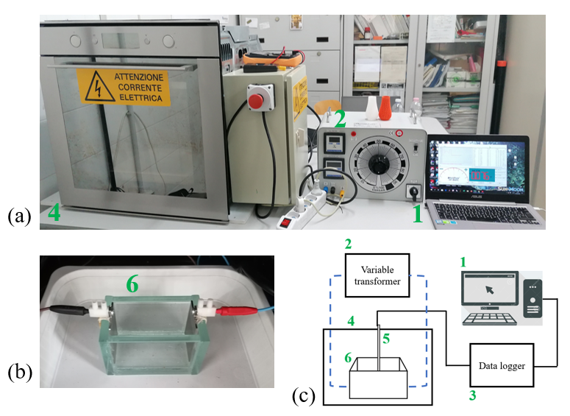

Figure 1. Pictures of the adopted MEF system and instrumentation: (a) assembly of the MEF heating equipment, showing the (1) data acquisition system, (2) the variable transformer and (4) the insulated chamber. (b) Detail of the (6) MEF cell with the electrodes. (c) Schematic diagram of the experimental setup representing the insertion of (5) the thermocouple into the cell.

2.3 Measurement of electrical conductivity

The electrical conductivity (σ) was evaluated from temperature, voltage and current data recorded at 2.5s intervals. Voltage and current readings were acquired by using a digital multimeter (model PicoLog, Pico Technology, UK) and a data acquisition software. Electrical conductivity was calculated according to the following equation:

|  |  |
| --- | --- |
| $$σ= \frac{I}{V} \frac{L}{A}$$ | (1) |

where I is the current passing through the food item, V is the applied voltage, L is the length between the electrodes and A is the area of the electrodes occupied by the sample. The ratio L/A is known as the cell constant of the MEF heating unit. The cell constant of the MEF heater was 60.1 m-1 when filled with a mass of 200 g. The cell was calibrated by using several aqueous solutions of NaCl in deionized water (concentrations were 1%, 2.5% and 5% w/w respectively).

**3. Results and discussion**

The change in σ with the temperature and the composition is shown in Figure 2. As the change in the electrical conductivity is independent of the applied ΔV/L, the set of data obtained ad the several applied voltage gradients (5.00 V/cm, 6.00 V/cm and 7.00 V/cm) are reported together. For all the considered samples, the electrical conductivity shows a positive linear dependence on temperature, which is a typical effect attributed to a reduced drag for the ions’ movement within the medium [4].

(a)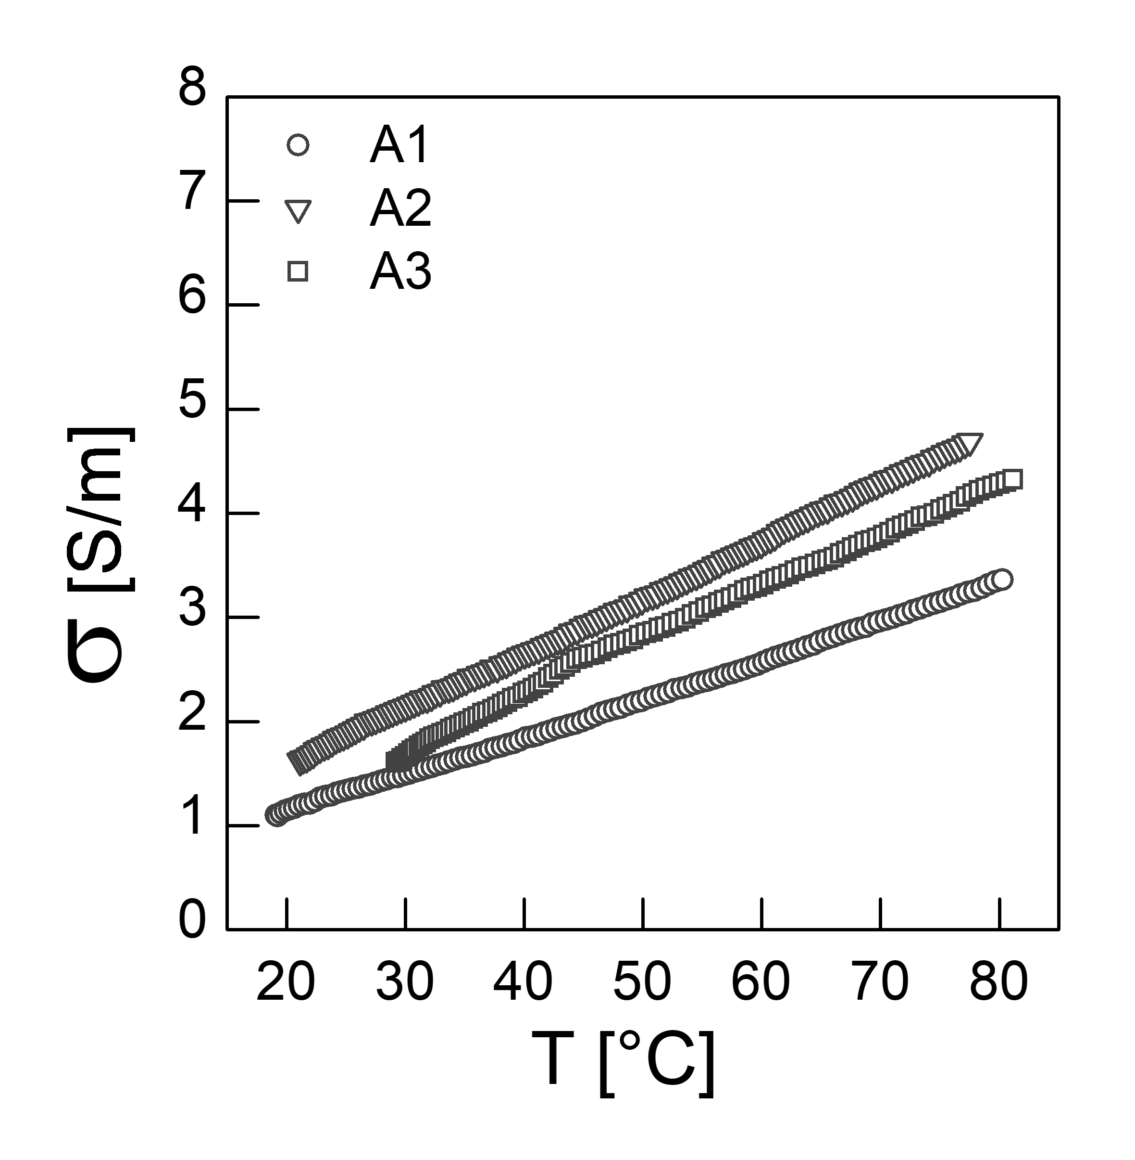(b)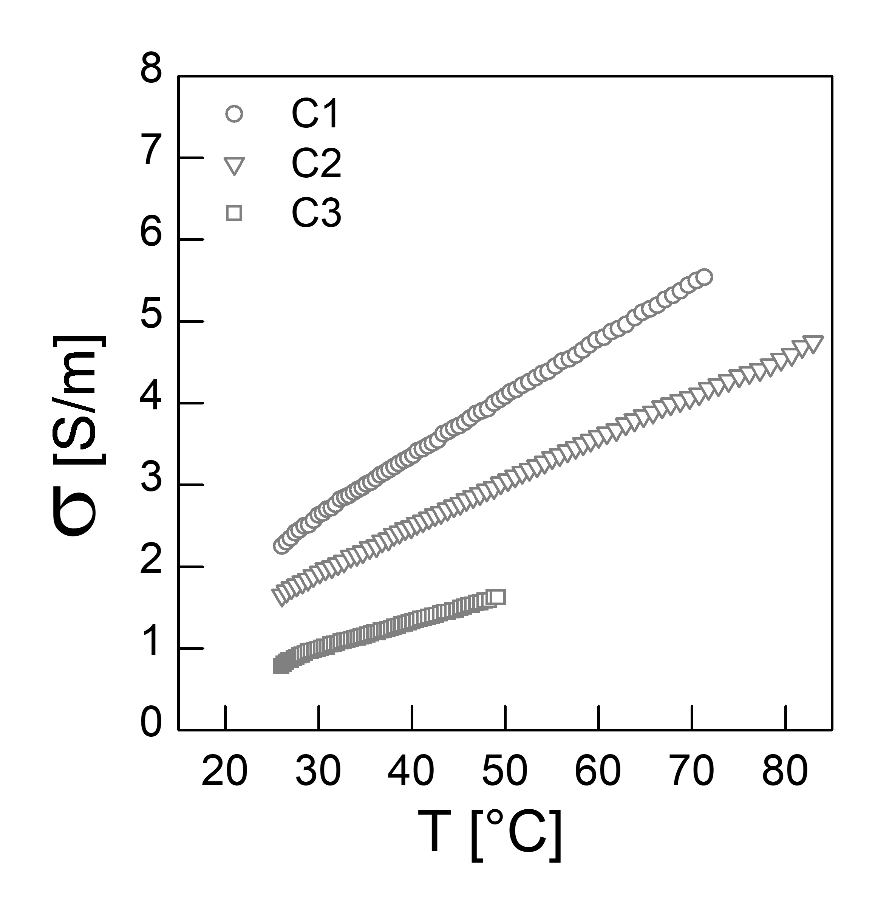(c)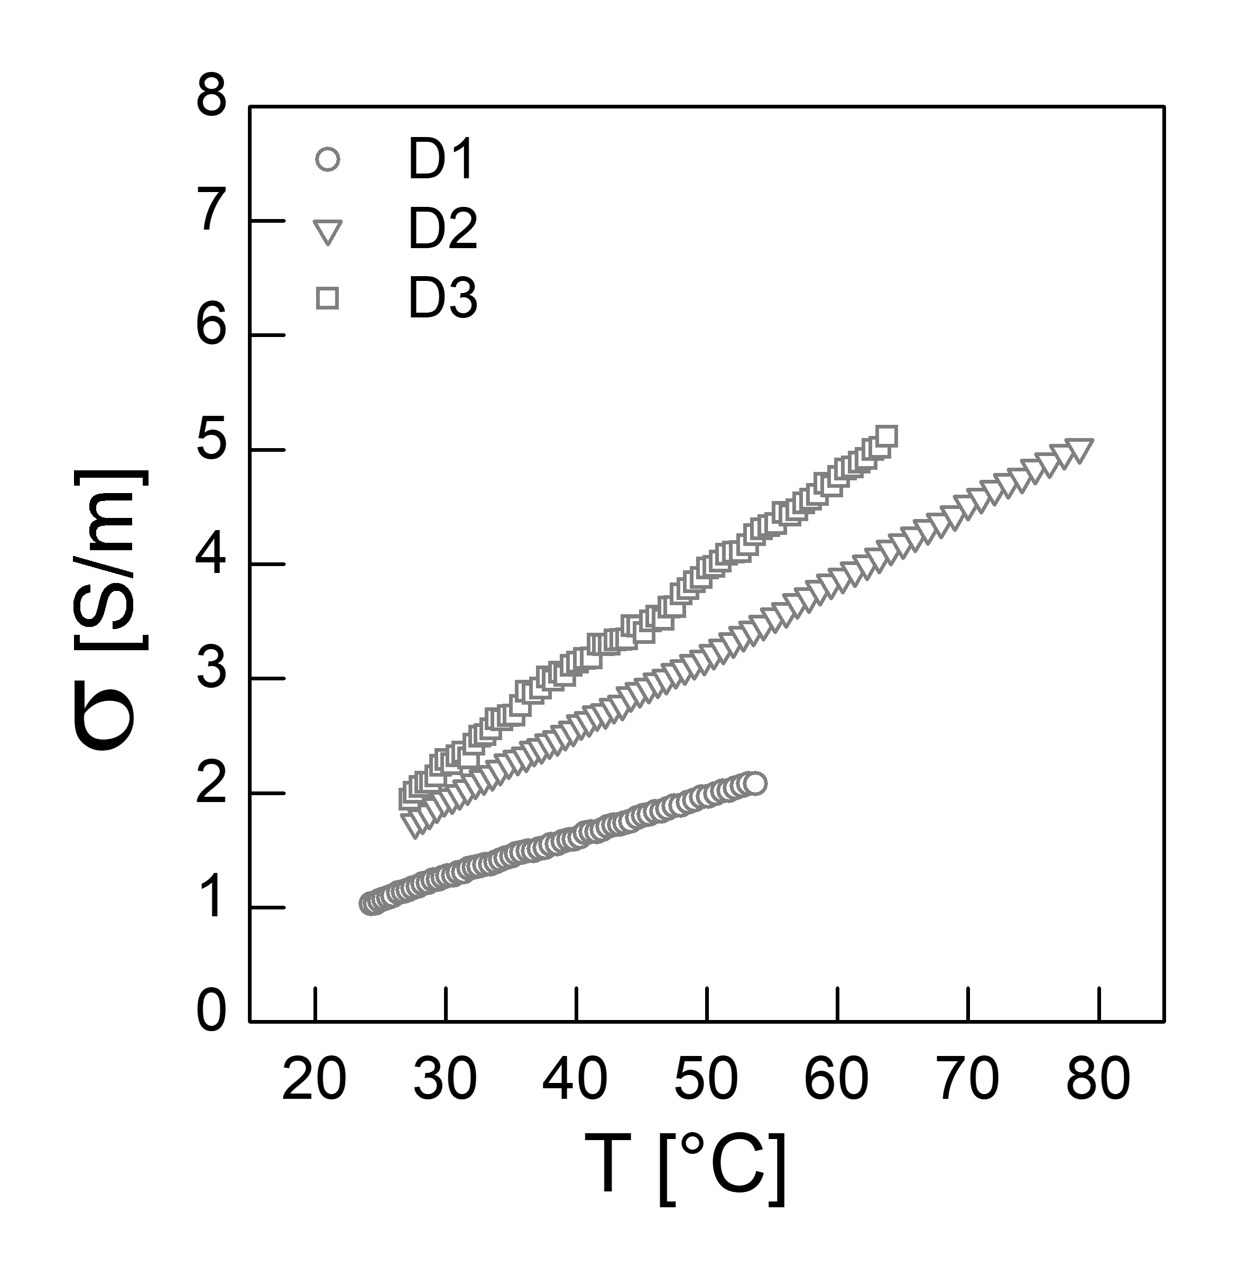(d)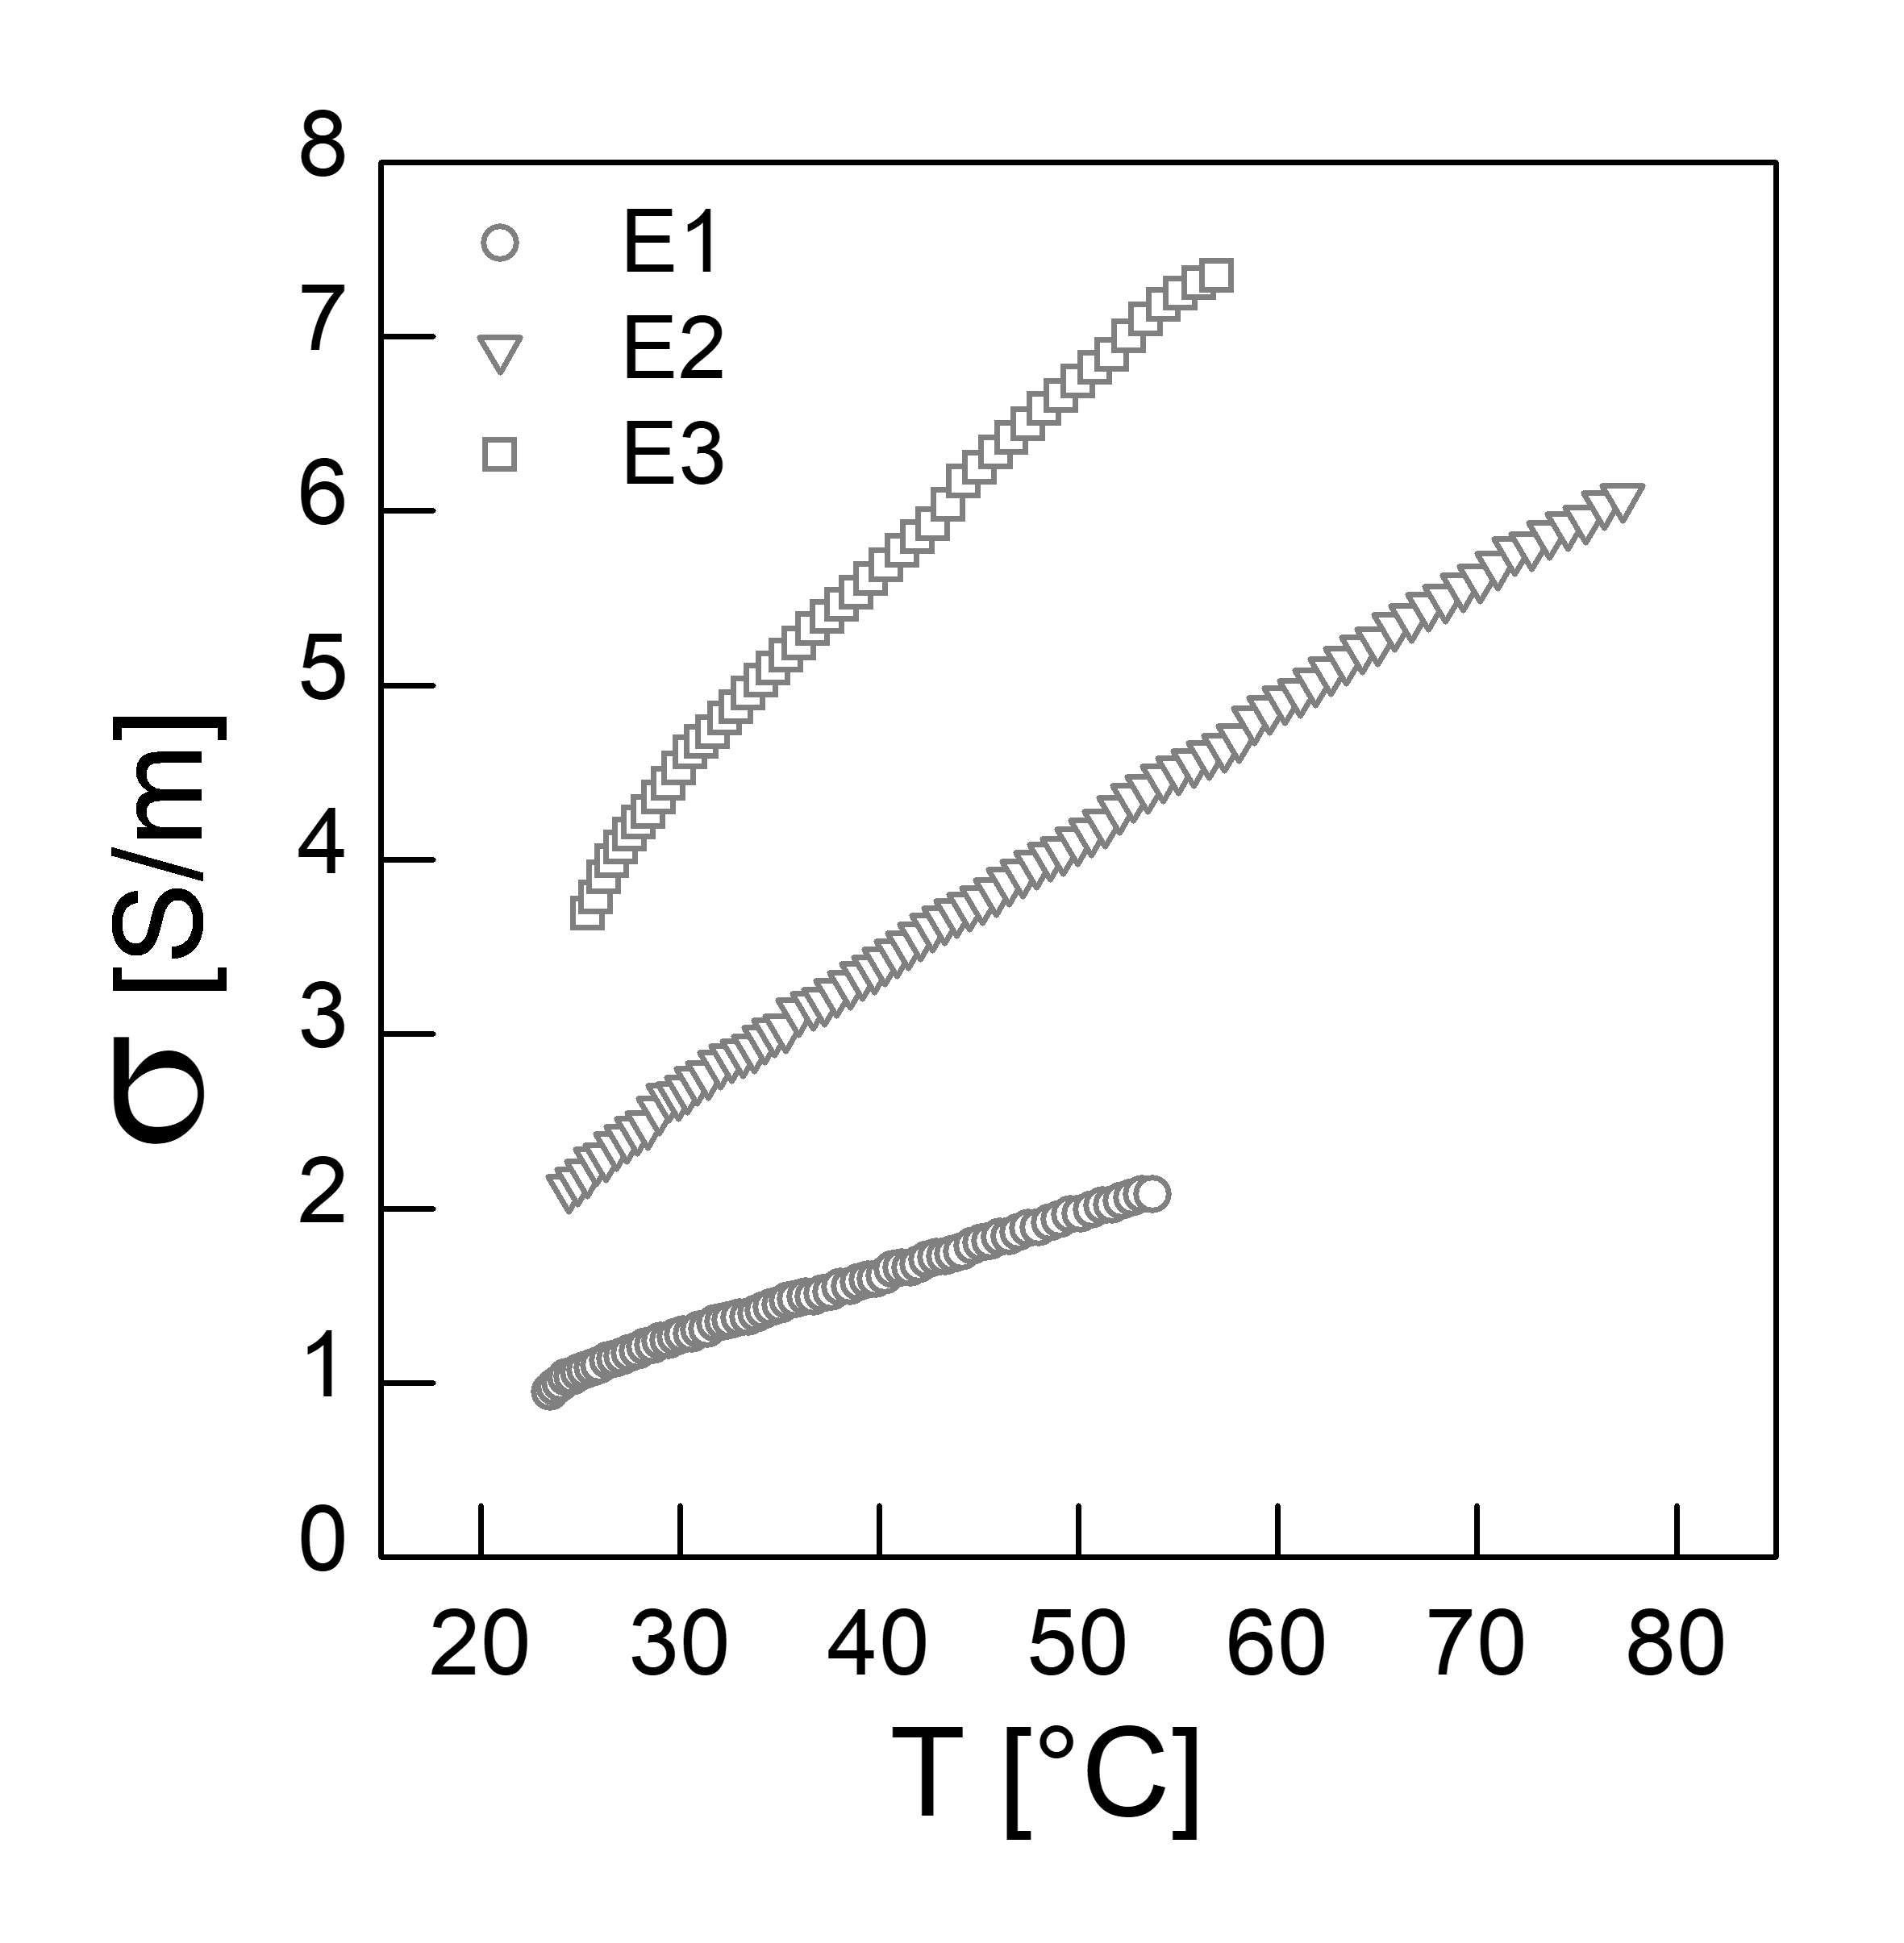

**Figure 2.** Electrical conductivity of (a) diluted pesto sauces and of basil suspension in oil-water emulsions: (b) competing effect between O/W and B/W at same S/W, (c) competing effect between O/W and S/W at same B/W, (c) competing effect between B/W and S/W at same O/W.

**Experimental data were linearly fitted by linear equation:**

|  |  |
| --- | --- |
| $$σ= σ_{0}+mT$$ | (2) |

**where $σ_{0}$ and $m$ respectively represent the intercept and the slope of the linear model. Results of the fitting procedure are reported in Table 2. R2 values indicate a good agreement between the measured values and the linear fitting procedure. A1 is characterized by the lowest values of the electrical conductivity, while A2 has the highest values and A3 has intermediate values between A1 and A2. Indeed, it can be observed that $m$ goes from 0.0365 S/(m °C) to 0.0537 S/(m °C) (for A1 and A2 respectively). In practice, the fat content and the vegetable solid particles are characterized by a lower electrical conductivity than liquids for particulate foods. For this reason, A2, diluted with 50% of deionized water, is characterized by higher values of electrical conductivity, as a lower fat concentration leads to a minor degree of resistance to the electrical current. A3 still has higher values of electrical conductivity than A1, characterized by higher amounts of the non-conductive phase. C1 is the sample that has the highest values of electrical conductivity. As ratios basil/water and oil/water increase, the electrical conductivities of C2 and C3 progressively decrease, according the increasing amount of the oil and basil components. D1 is characterized by the lowest values of electrical conductivity. As the ratios oil/water and salt7water increase, also the electrical conductivities of D2 and D3 progressively increase, according the increasing amount of the salt component. E1 is characterized by the lowest values of electrical conductivity. As B/W and S/W increase, also the electrical conductivities of E2 and E3 progressively increase, according the increasing amount of the salt component.**

Table 2. Parameters obtained from fitting of the experimental data by Equations 5.

|  |  |  |  |
| --- | --- | --- | --- |
| Sample | $σ_{0}$ [S/m] | [S/(m °C)] | R2 |
| A1 | 0.394 | 0.0365 | 0.999 |
| A2 | 0.507 | 0.0537 | 0.999 |
| A3 | 0.221 | 0.0512 | 0.997 |
| C1 | 0.483 | 0.0716 | 0.999 |
| C2 | 0.334 | 0.0530 | 0.999 |
| C3 | 0.037 | 0.0341 | 0.996 |
| D1 | 0.193 | 0.0355 | 0.999 |
| D2 | 0.008 | 0.0644 | 0.999 |
| D3 | 0.003 | 0.0833 | 0.999 |
| E1 | 0.174 | 0.0360 | 0.998 |
| E2 | 0.406 | 0.0744 | 0.999 |
| E3 | 1.088 | 0.1132 | 0.994 |

**4. Conclusions**

Electrical conductivity of basil based sauces is influenced by relative ratios among basil, oil, water, and salt content. Some of the tested formulations showed a good heating behavior thanks to their electrical conductivities. This work demonstrated the applicability of heating assisted by moderate electric fields to complex heterogeneous food systems such as basil based sauces .

**Acknowledgments**

This study has been supported by the ERA-NET SusFood2 project, “Improving Sustainability in Food Processing using Moderate Electric Field (MEF) for Process Intensification and Smart Processing (MEFPROC).

**References**

1. Sastry, S. 2008. Ohmic Heating and Moderate Electric Field Processing. Food Science and Technology International, 14, 419-422
2. Samprovalaki, K., Bakalis, S. &amp; Fryer, P. J. In: Yannotis, S. & Sunden, B. (eds.) Heat Transfer in Food Processing: Recent Developments and Applications. Southampton: Wit Press., 2007, pp.159-186
3. Zell Zell, M., Lyng, J. G., Cronin, D. A. &amp; Morgan, D. J. 2009. Ohmic heating of meats: Electrical conductivities of whole meats and processed meat ingredients. Meat Science, 83, 563-570
4. Darvishi H., Khostaghaza M.H., Najafi G., 2013, Ohmic heating of pomegranate juice: Electrical conductivity and pH change, Journal of the Saudi Society of Agricultural Sciences, 12, 101-108