**Microwave-assisted hydrothermal preparation of photocatalytic fibrous membranes for water treatment**

Carlo Boaretti, Jiayi Yin, Michele Modesti, Alessandra Lorenzetti, Alessandro Martucci, Martina Roso*

*Dipartimento di Ingegneria Industriale (DII), Università degli studi di Padova*

*\*Corresponding author E-Mail: martina.roso@unipd.it*

**1.Introduction**

Photocatalysis represents a widely recognized promising technique in the context of advanced oxidation processes for the oxidative degradation of organic pollutant for air and water purification. In this field the traditional benchmark is represented by TiO2 which has been deeply investigated over the years in order to exploit its potential and solve issues related to its efficient employment [1]. From this point of view the use of TiO2 nanoparticles for liquid phase treatment of polluted water can be problematic due to the necessity of recovery after use with additional costs for separation. Therefore, the use a substrate for its immobilization is a convenient strategy to overcome this problem and electrospun polymeric nanofibers have proved to be a flexible solution for this purpose [2]. On the other hand, the control of the morphology, crystal phase and correct exposition of the photocatalyst on the surface of such membranes plays a pivotal role on their performance. Microwave-assisted hydrothermal method, which combines the hydrothermal synthesis of nanomaterials from precursors in aqueous solution and the efficient heating of microwaves [3], can assist the synthesis and efficient deposition of TiO2 particles on the surface of electrospun fibers to produce core-shell fibrous membranes. For this reason, in this study we investigated the effect of the different process parameters involved in the hydrothermal synthesis of TiO2 particles (acidity of precursor solution, heating temperature and treatment time) on the surface of electrospun PVDF nanofibers for the production of photocatalytic fibrous membranes. The effect of such parameters was considered in relation to the final structure (morphology, TiO2 crystalline phase and loading) and photocatalytic activity (photodegradation of organic dye and photocatalytic stability over multiple cycles) of the composite fibrous membranes.

**2. Methods**

PVDF nanofibrous substrate was obtained by conventional electrospinning equipment. For the microwave-assisted hydrothermal synthesis titanium butoxide was hydrolyzed in an aqueous H2SO4 solution at different molarities (1,2 and 3 M). The PVDF membrane was than soaked in this solution and treated under microwave heating at different temperatures (100, 120 and 140°C) and treating times (0.5, 1 and 2h) to induce the precipitation and crystallization of TiO2 particles. The obtained membranes were characterized by scanning electron microscopy, infrared spectroscopy, x-ray diffraction, thermogravimetry. The membrane with the more uniform and homogeneous core-shell structure was further characterized by diffuse reflectance spectroscopy (DRS) and surface area measurement. The photocatalytic performance of the obtained membranes was evaluated by photo-oxidation of organic dye in liquid phase using a cylindrical quartz reactor equipped with a UVC lamp, using a 32 mg sample of membrane which was added to a 200 ml of a 2.5 mg/l solution of methyl orange (MO). The degradation was monitored by UV-vis spectroscopy using the characteristic absorption of MO at 465 nm after calibration with known concentrations. The membrane with the best performance was tested multiple time for performance stability evaluation.

**3. Results and discussion**

The mechanism for the production of TiO2 particle can be divided into two step: hydrolysis of titania precursor followed by condensation under hydrothermal conditions which induces the formation of polymeric nuclei by olation and oxolation reaction. Once reaching a critical dimension such nuclei are stabilized and induce the formation of titania particle which can be formed on the surface of the membrane. The SEM images of the samples revealed that the 2 M acidic precursor solution was the only concentration that effectively produced a uniform coverage of TiO2 particles on the surface of PVDF nanofibers with a smooth morphology and a core-shell structure (Figure 1). For the other concentrations tested only partial coverage was achieved with a tendency to the formation of particle clusters. The amount of titania deposited increased both over time and by increasing the treatment temperature.

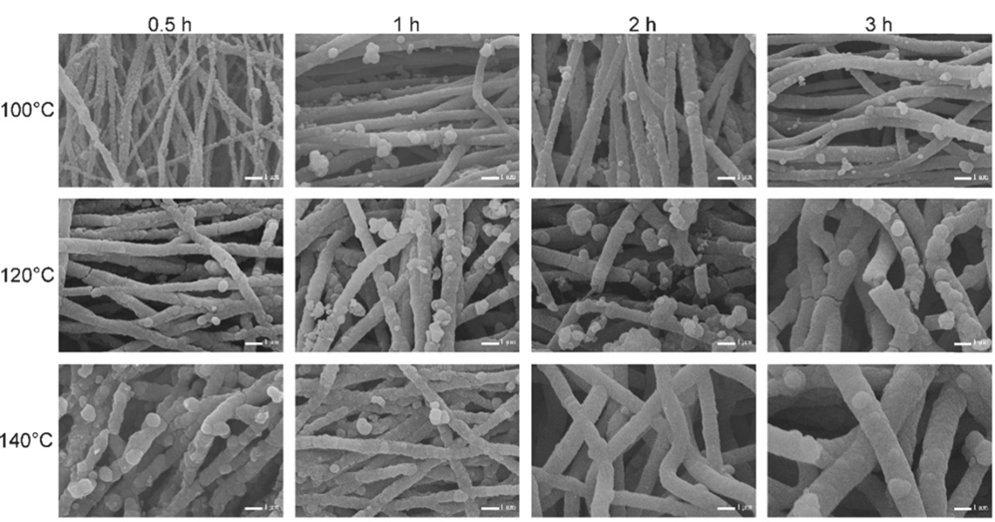

**Figure 1.** SEM images of PVDF-TiO2 fibrous membranes produced by a 2M precursor solution (scale bar: 1 µm)

XRD measurement revealed the presence of anatase as main crystal phase of the titania formed along with a minor content of rutile. The relative amount of the two polymorph is dependent on temperature and time. Low temperature tends to provide higher content of rutile which decreases over time. At 120°C only anatase is formed. In this last case the optical properties measured by DRS showed absorption limit and band gap energy in accordance to characteristic values of pure anatase phase. Photocatalytic experiment in liquid phase showed that although UV can to some extent induce degradation of methyl orange the combination with the membrane is capable to reach a 95% degradation after 200 minutes. The normalization of the data on the basis of the catalyst content (Figure 2) revealed that the best performance can be achieved for the membrane obtained at 120°C with a 2M solution and treated for 2 h.

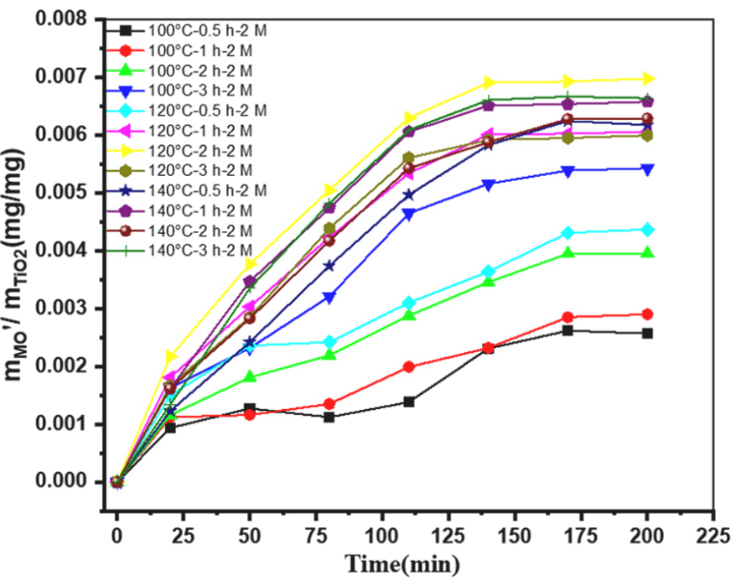

**Figure 2** – The mass of MO degraded per mass of the different membranes as a function of time

The membrane was tested up to 5 cycles of degradation showing negligible variation in photocatalytic activity and no variation on the morphology of the core-shell structure thank to the high interaction between the polymeric core and the TiO2 shell.

**4. Conclusions**

In this work we investigated a microwave-assisted hydrothermal method as a rapid and easy method for the deposition of TiO2 particles on the surface of PVDF electrospun membrane to obtain core-shell fibrous membranes with photo-oxidation activity. The analysis of the acidity of the precursor solution revealed that optimum coverage of the fibers with smooth morphology can be obtained from 2 M solution. Although anatase was the predominant crystal phase the temperature influenced the rutile content both at 100 and 140°C, while at 120°C only anatase phase was observed. The obtained PVDF-TiO2 core shell membranes showed good photocatalytic performance towards methyl orange degradation thanks to the high contact surface with the dye. The membranes also showed performance stability of multiple testing cycles and no leaching effect showing a good potential for organic pollution treatment in liquid phase.

**References**

1. K. Nakata, A. Fujishima, J. Photochem. Photobiol. C: Photochem. Rev (2012) 169-189
2. M. Modesti, M. Roso, C. Boaretti, S. Besco. D. Hrelja, P. Sgarbossa, A. Lorenzetti, Appl. Catal. B 144 (2014) 216-222
3. L.Y. Meng, B. Wang, M.G. Ma, K.L. Lin, Mater. Today Chem. 1-2 (2006) 2016-2027