Experimental Study on VOCs Production during High Monomer Content Emulsion Polymerizations

Marco Barozzi¹, Luca Leopardi², Carlo Bottinelli², Jacopo Ghezzi², Anita Barni², Sabrina Copelli¹*
¹ Università degli Studi dell’Insubria, Department of Science and High Technology, via Valleggio 9, Como (CO), IT
² ICAP-SIRA Chemicals and Polymers S.p.A., via Filippo Corridoni 19, Parabiago (MI), IT
* Corresponding author E-Mail: sabrina.copelli@uninsubria.it

1. Introduction
Emulsion polymerizations are chemical reactions exploited for the synthesis of countless products, including adhesives for textile and labeling applications, colloids, synthetic rubbers, and plastics. The possibility of working with monomers in an aqueous medium offers a series of advantages, the main one is reducing the massive use of toxic solvents. However, such processes bring along several concerns, such as hard batch reproducibility, uncomplete conversions and particle size control^{[1]}. These reactions have been object of massive research for what concerns both modeling^{[2]} and optimization^{[3]} aspects. Concerning the optimization, the reduction of the Volatile Organic Compounds (VOCs) content is crucial for whatever latex synthesis as it can compromise the health of the product final users ^{[4]}. For this reason, many works regarding the control of VOCs generation in such polymerization processes^{[5]} have been reported. Some studies have proposed a VOCs monitoring by enhancing monomer conversion with the introduction of a post-polymerization step^{[6]}, which consists mainly in the addition of organic radical initiators which can migrate into the micelles/polymer particles and promote free monomer content reduction. Other works have investigated the use of devolatilization to physically separate VOCs from the latex ^{[7]}. However, some reactions involve high boiling point VOCs, which cannot be removed by simple devolatilization. In this work, the effect of nitrogen fluxing on VOCs production on an industrial polymer, which is used as adhesive, was investigated. A high monomer content (about 55% w/w) polymer based on 2-ethylhexyl acrylate was proposed. Samples of reacting mixture were taken overtime and analyzed with a Gas Chromatography - Flame Ionizator Detector.
2. Reaction studied
The polymer studied within this work is produced via an emulsion polymerization process involving a high solids content (about 55% w/w). The main reactants are reported in the following: demineralized water (45% w/w), 2-ethylhexyl acrylate (2EEA, 49.5% w/w), acrylonitrile (1.12% w/w), anionic and nonionic surfactants (1.85% w/w). The reaction is exothermic, and the process is operated according to a semi-batch recipe. Radical generation is promoted using two initiators, ammonium persulfate and sodium bisulfite, dosed separately. At first, monomers, surfactants and water are mixed to form a stable pre-emulsion which will be dosed overtime. The reactor is loaded with water (10% w/w) containing 2.5% w/w of surfactants, and reactor temperature is kept at 82 °C. Then, the pre-emulsion is loaded in parallel with the aqueous initiator solutions over a dosing time of 280 min. After dosing, reaction is kept under temperature control for 30 min. After this, conversion is enhanced with the use of a post-polymerization process, which is carried out by dosing two solutions of an organic initiator, mixture of tert-Butyl hydroperoxide and Sodium formaldehyde sulfoxylate, for 60 min. The total amount of organic initiators is 2.1% w/w.
2. Methods
The experimental setup is reported in Figure 1.
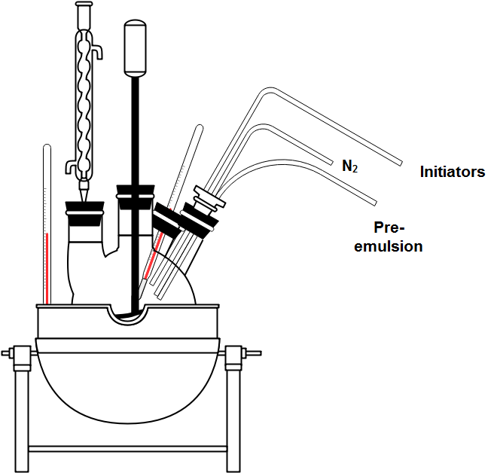
Figure 1. Scheme of the experimental setup
All the experiments were performed in a 5 L glass laboratory reactor. Recipes are formulated to synthesize 2 kg of latex per batch. Temperature control is manual using a controlled hot water bath. Pre-emulsion is prepared in a 1L glass flask with a magnetic stirrer at high speed. Pre-emulsions are very stable and do not separate during dosing. Dosing is performed using ISMATEC pumps. Nitrogen is introduced through a small rubber tube located at the top of the reactor. Thanks to a condenser, it is possible to both purge nitrogen and condense most of the vapors. Samples are taken with the use of a syringe: 10 g of latex are taken with each sample. Considering the potential high amount of residual monomer, samples required quenching, which was performed by adding 0.24 g of an aqueous solution saturated with 4-methoxy phenol. Samples were added with Dimethyl sulfoxide and sent to a Gas Chromatography – Flame Ionizator Detector (FC-FID) for analysis.
Substances analyzed are residual 2EEA and acrylonitrile, acetone, 2-ethylhexanol, 2-ethylhexyl acetate and tert-Butanol (tBuOH). Acetate is used because, as it is present in the reagent with a well-known composition and it is stable during the reaction, it is an index of the reliability of the sample. For each reaction, 5 samples were taken from the reactor according to Table 1:
Table 1. Samples characterization.
# sample | Reference | Reaction time
1 | Half dosing | 180 min
2 | End of dosing | 280 min
3 | Before post-polymerization | 310 min
4 | After post-polymerization | 370 min
5 | Finale product | 400 min
Redundant samples were not considered to avoid excessive changes in latex composition. The experimental campaign was carried out with the aim of studying the impact of introducing a nitrogen flux on the total VOCs production. 4 tests under different operating conditions were carried out, with a standard recipe synthetized in parallel (8 tests). In this way, it was possible to validate the reliability of the results. In tests a-b-c, nitrogen flux was activated after dosing (that is, after 280 min), with values equal to 10-50-60 L/h, respectively, resulting in about 3.3-16.7-20 exchanges/h on the gas phase, respectively. In test d, a nitrogen was plugged to the reactor from the beginning of reaction, with a flowrate of 50 L/min.
3. Results and discussion
Figure 2 reports the results on the final products for all the tests performed. In general, the use of nitrogen positively influences the VOCs content, showing a significative reduction. The most affected substances are A2EE, CAN, while tBuOH and 2ethylhexanol are mildly affected. It is interesting to notice how tert-Butanol reduction is not strictly enhanced increasing the total nitrogen supplied (ref. test d). One possible reason can be that, as tBuOH it is generated mainly during post-polymerization, it remains trapped within the polymer particles, making it harder to be stripped from the aqueous phase.
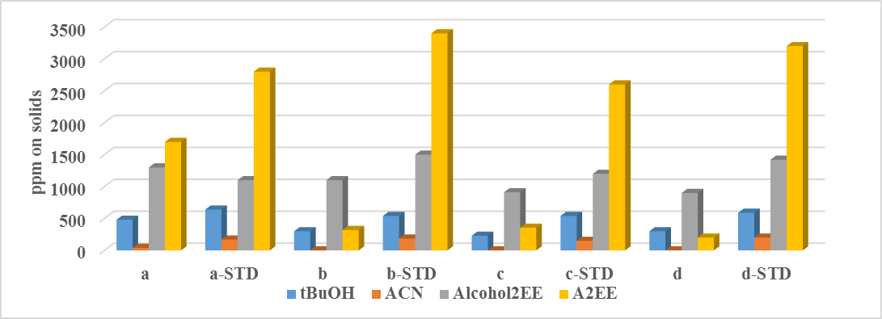
Figure 2. VOCs content in all the tests
Figure 3 shows the concentration of A2EE and CAN as a function of time for tests c and d. A2EE (B.P. 214°C) content is effectively reduced but such a reduction is most likely associated with the reduction of the oxygen content in the solution. Oxygen acts as a radical inhibitor, as it interacts with hydroquinone which is added to all monomers to prevent their auto-polymerization during storage. ACN (B.P 77°C) concentration is strongly reduced using high nitrogen fluxes as a consequence of a pure stripping effect.
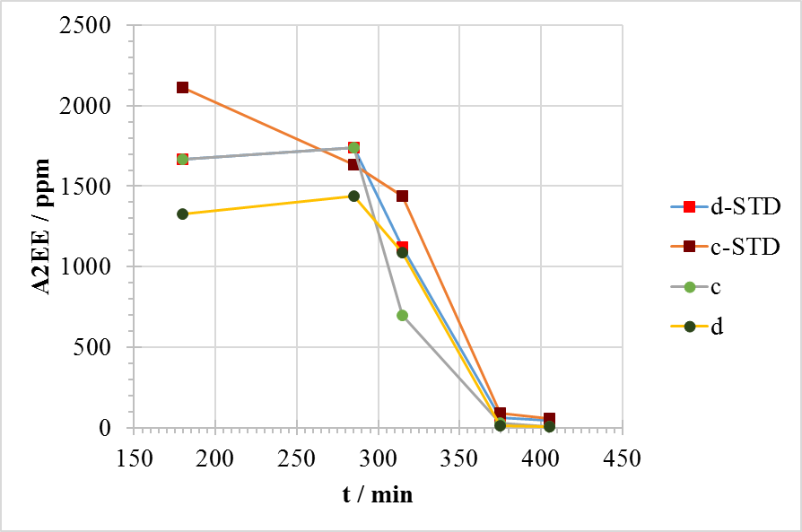  A | 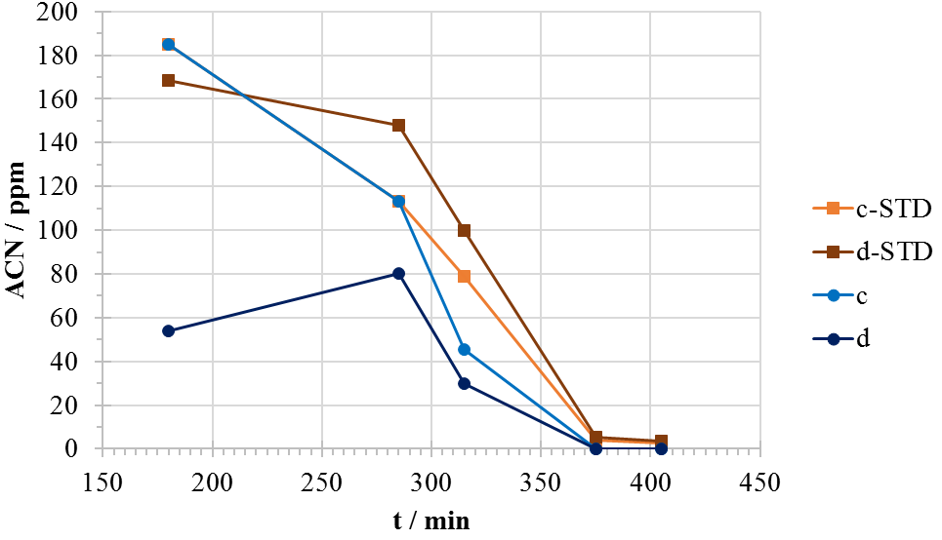  B
Figure 3. A2EE (a) and ACN (b) content for tests c and d (ppm are evaluated on the solids)
Concerning 2-ethylexanol (B.P. about 185 °C) content, the ratio between alcohol and 2-ethylexyl acetate on the pure monomer was tested and it was equal to 0.8. As acetate is basically inert, its concentration can be used to detect more precisely the amount of alcohol generated during the process. It can be noticed that only test d showed a noticeable reduction in the alcohol content, which is noticed already over the course of dosing. Alcohol can be generated by a lot of reactions, but the most likely reaction is the hydrolysis, which can occur both on pure monomer and on polymer chains.
Finally, latexes were tested for their applicability, according to the standards for total solid content, viscosity, pH and specific adhesivity (D 3330/D 3330 M; D6195 – 03; D 3654/D 3654M – 02).
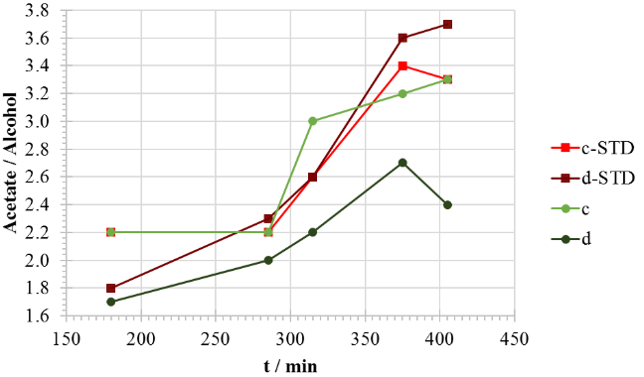
Figure 4. Acetate/alcohol ratio on tests c and d
Table 2 reports the results for tests c and d. Almost each analysis is in accordance with the acceptability standards. The only exception is represented by test d, whose viscosity is slightly lower than the minimum limit value.
Table 1. Accordance to standards for tests c and d
 | Range | c | c-STD | d | d-STD
Solids content (%) | 54,0 - 56,0 | 55,9 | 55,4 | 55,6 | 55,4
Brookfield Viscosity (mPa·s R3/V20) | 600 - 3000 | 2100 | 1800 | 474 | 1654
pH | 5,5 - 7,0 | 6,4 | 6,5 | 6,2 | 6,1
Peel (steel) (g/25mm) | 300 - 700 | 365 | 380 | 360 | 440
Shear (steel) 15X20 mm (h) | 5 - 50 | 5 C | 5 C | 3 C | 9 C
Quick Stick (steel) (g/25mm) | - | 390 | 370 | 435 | 410
4. Conclusions
In this experimental work, the impact of nitrogen flows on an emulsion polymerization was investigated. From results, it was noticed that nitrogen effectively reduces VOCs content. Possibly, this reduction is a combination of stripping and chemical effects. Tert-Butanol, despite being a light compound, is not particularly affected. ACN is eliminated with high nitrogen flows, but it is more likely stripped, as it is a low boiling VOC. 2-ehtylexanol is the most critical substance, its content is unaffected in most cases, showing a small reduction (about 30%) by using nitrogen during dosing. Working under these conditions allows to synthetize latexes which comply with industrial requirements except for the low viscosity of test d. Future works will investigate the impact of additional variables on VOCs generation, such as starting pH, particles diameter before post-polymerization and different working conditions, such as temperature and dosing times.
References
- P- A. Lovell, F. Joseph Schork, Fundamentals of Emulsion Polymerization, Biomacromolecules, 2020, 21 (11), 4396-4441
- S. Copelli, M. Dente, G. Bozzano, M. Barozzi, Simplified modeling and main constitutive parameters estimation for industrial emulsion copolymerization processes, Chem. Eng. J., 2018, 335, 988–1003
- S. Copelli, M. Barozzi, N. Petrucci, V. Casson Moreno, Modeling and process optimization of a full-scale emulsion polymerization reactor Chem. Eng. J., 2019 358,1410–1420
- A. De San Luis, C. C. Santini, Y. Chalamet, V. Dufaud, Removal of Volatile Organic Compounds from Bulk and Emulsion Polymers: A Comprehensive Survey of the Existing Techniques, Ind. Eng. Chem. Res. 2019, 58, 11601−11623
- R. Salazar, P. Ilundain, D. Alvarez, L. Da Cunha, Ma. J. Barandiaran, and J. M. Asua, Reduction of the Residual Monomer and Volatile Organic Compounds by Devolatilization, Ind. Eng. Chem. Res. 2005, 44, 4042-4050
- P. Ilundain, L. Da Cunha, R. Salazar, D. Alvarez, M. J. Barandiaran, J. M. Asua, Postpolymerization of vinyl acetate containing latexes. J. Appl. Polym. Sci. 2002, 83, 923.
- R. J. Albalak, E. W. Merrill, J. M. Zielinski, J. L. Duda, A. V. Yazdi, E. J. Beckman, M. Favelukis, S. T. Lee, A. Tukachinsky, T. Chechik, Y. Talmon, Z Tadmor, Polymer Devolatilization; Marcel Dekker Inc: New York, 1996.

