**The colors of hydrogen: a process simulation-based comparison of different production processes**

Elena Barbera1*, Andrea Mio2, Marco Disnan2, Alessandro Massi Pavan2, Alberto Bertucco1, Maurizio Fermeglia2

*1 Department of Industrial Engineering, University of Padova, Via Marzolo 9, 35131 Padova, Italy;*

*2 Department of Engineering and Architecture, University of Trieste, Via Valerio 10, 34127 Trieste, Italy.*

*\*Corresponding author E-Mail: elena.barbera@unipd.it*

**1.Introduction**

Over the last decades there has been an accelerated growth in human energy consumption. The global average primary energy use has significantly increased, by about 42%, from 2000 to 2019, passing from 122073 to 173340 TWh. This, together with the need of a strong reduction in fossil fuels consumption in order to reach the objectives of greenhouse gases emissions for 2030, as indicated by recent reports of IPCC [1] and EIA [2], has put an increasing pressure on the energy sector. Since energy production from renewable sources is not dispatchable due to their fluctuating nature, great attention is given to energy storage and energy carrier systems. Hydrogen is one of the most suitable energy carriers for several applications, such as heavy transportation and logistics. It can be produced from different feedstock and according to different processes, each one identified by a color.

Decisions on the best strategies to pursue in this regard should be based on indicators able to summarize different aspects of the different routes, such as energetic efficiency, economic considerations, but also environmental impacts. These aspects can be quantified according to suitable indicators, namely the Energy Return on Energy Investment (EROEI), the Levelized Cost of Hydrogen (LCOH), and a thorough Life Cycle Assessment (LCA). In order for the analysis to be meaningful, it needs to be based on detailed and coherent process simulation-based mass and energy balances with reference to a specific production target

This work aims at providing reliable operating data for different hydrogen production processes, in order to obtain all the information needed for subsequent energetic, economic, and environmental assessments. Specifically, process simulations are developed to compare different hydrogen production pathways, each one defined by the appropriate color: (i) grey hydrogen, produced from natural gas using steam methane reforming (SMR); (ii) blue hydrogen, which is like the grey one but integrated with carbon capture and storage (CCS); and (iii) green/yellow hydrogen, produced by water electrolysis using electricity from renewable sources or grid electricity, respectively. In the latter case, different types of electrolyzers are simulated and compared, namely Alkaline Electrolysis Cells (AEC), Proton Exchange Membrane Electrolysis Cells (PEMEC), and Solid Oxide Electrolysis Cells (SOEC).

The analysis is carried out with reference to a daily hydrogen production corresponding to the estimated consumption required by the port of Trieste, taken as a case study, with the goal to feed fuel cells train locomotors and tugboats handled inside the port area. The production processes are sized according to the desired daily requirement, possibly avoiding the need to store high amounts of hydrogen within the port.

**2. Methods**

Process simulations were carried out using Aspen Plus v. 12.1. The software was used to develop the process flowsheet for each hydrogen production process considered, and perform material and energy balances, physical property estimations, design/rating calculations, sensitivity analysis and process optimization. In addition heat integration by pinch analysis and economic analysis evaluation were performed with Aspen Energy Analyzer and (AEA) and Aspen Process Economics Analyzer (APEA) tools, respectively.

**3. Results and discussion**

Process flowsheets were developed for hydrogen production via SMR with and without CCS (grey and blue hydrogen) and via water electrolysis according to AEC, PEMEC and SOEC electrolyzers (green and yellow hydrogen). For the latter, electrochemical models to describe the stack performances were included by means of user unit models. The target daily hydrogen production was estimated to be about 800 kg/d. The Aspen Plus process flowsheets for SMR, AEC and SOEC are displayed in Figure 1, as an example.

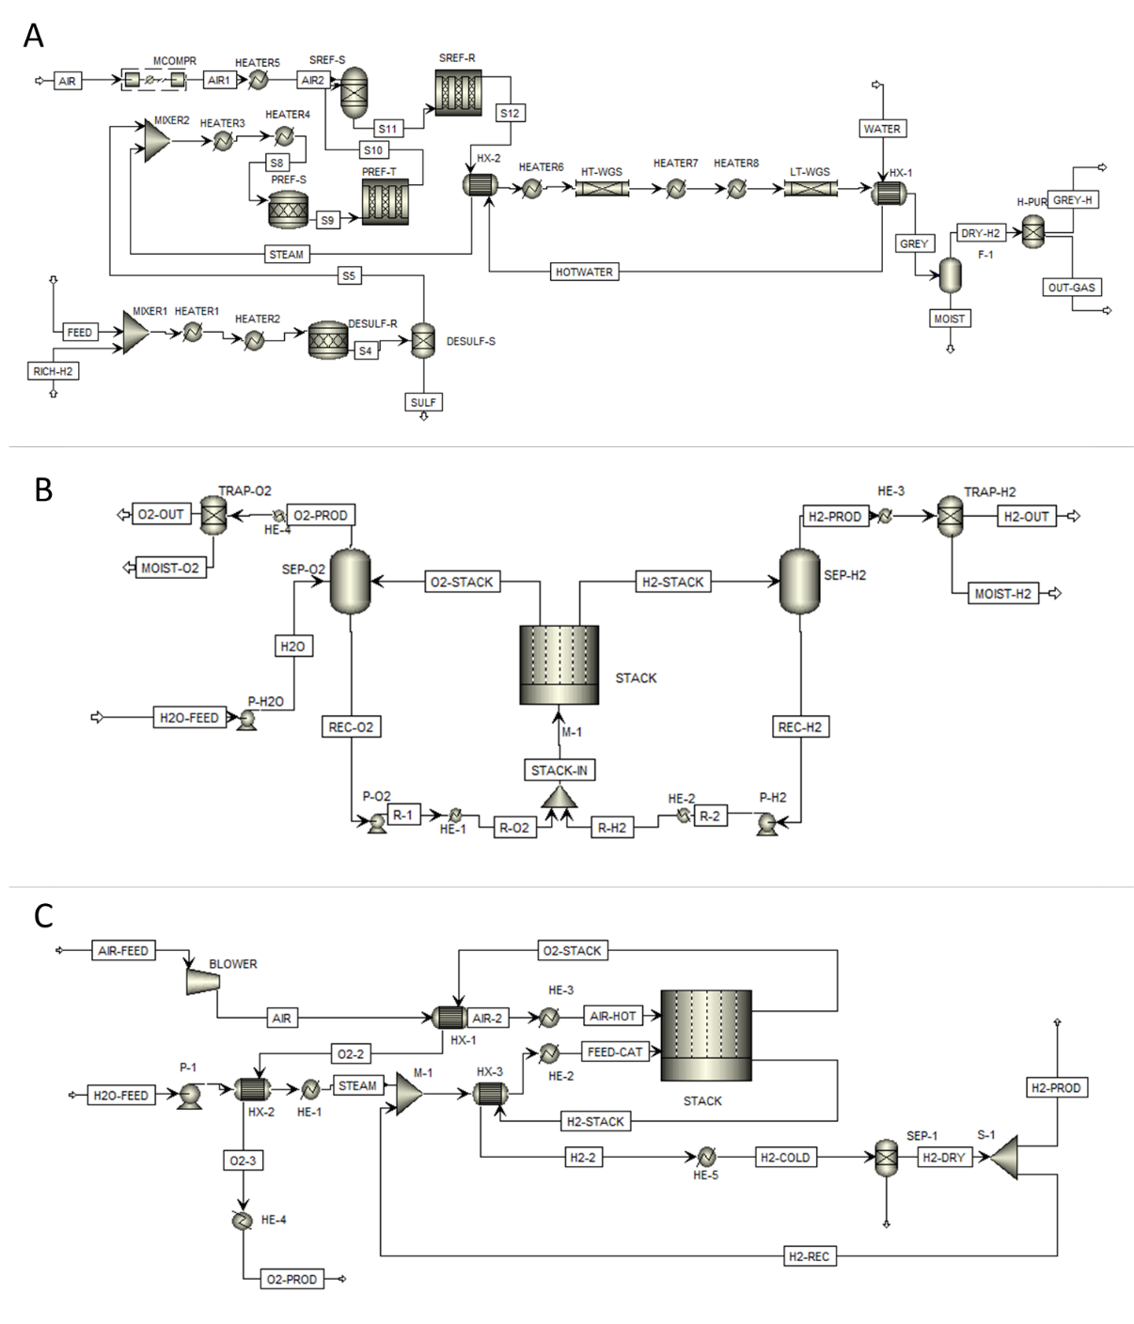

**Figure 1.** Aspen Plus Flowsheet of SMR (A), AEC (B) and SOEC (C)

The data obtained from process simulations were then elaborated in order to derive the inputs required for the evaluation of the EROEI, LCOH and LCA indicators, according to Table 1.

|  |  |  |  |  |
| --- | --- | --- | --- | --- |
|  |  | EROEI | LCOH | LCA |
| **Gross energy output** | **kW** | x | x | x |
| **Power energy requirement** | **%** | x |  | x |
| **Thermal energy requirement** | **%** | x |  | x |
| **Net energy output** | **kW** | x | x | x |
| **Total plant cost (TPC)** | **€** |  | x |  |
| **Share of investment costs due to operation and maintenance (so&m)** | **%** | x |  |  |
| **Fixed operation and maintenance costs (FO&MC)** | **€/kW/year** |  | x |  |
| **Variable operation and maintenance costs (VO&MC)** | **€/kWh** |  | x |  |
| **Total amount of solvent (for CCS)** | **kg** |  |  | x |

**4. Conclusions**

The data obtained by means of process simulations allowed a detailed estimation of the energy duties required for the production of hydrogen at a desired scale. Preliminary results indicate that green hydrogen is likely to be the preferred route.

**References**

1. https://www.ipcc.ch/report/sixth-assessment-report-cycle/ AR6 IPCC 2021 report. Accessed on December 7, 2021.
2. https://www.iea.org/reports/net-zero-by-2050 IEA (2021), Net Zero by 2050, IEA, Paris, Accessed on December 7, 2021.