Computational Modelling of the Solid Electrolyte Interface (SEI) in Lithium-ion Batteries and Its Impact on Long-Term Battery Aging
Luca Banetta¹, Graziano Frungieri², Agnese Marcato¹, Gianluca Boccardo¹,
Silvia Bodoardo¹, Daniele Marchisio¹
1 Dipartimento di Scienza Applicata e Tecnologia, Politecnico di Torino, Corso Duca degli Abruzzi 24, 10129 Torino(TO);
2 Lehrstuhl für Systemverfahrenstechnik, TUM School of Life Sciences, Technische Universität München, Gregor-Mendel-Straße 4, 85354 Freising, Germany.
*Corresponding author E-Mail: luca.banetta@polito.it

1.Introduction
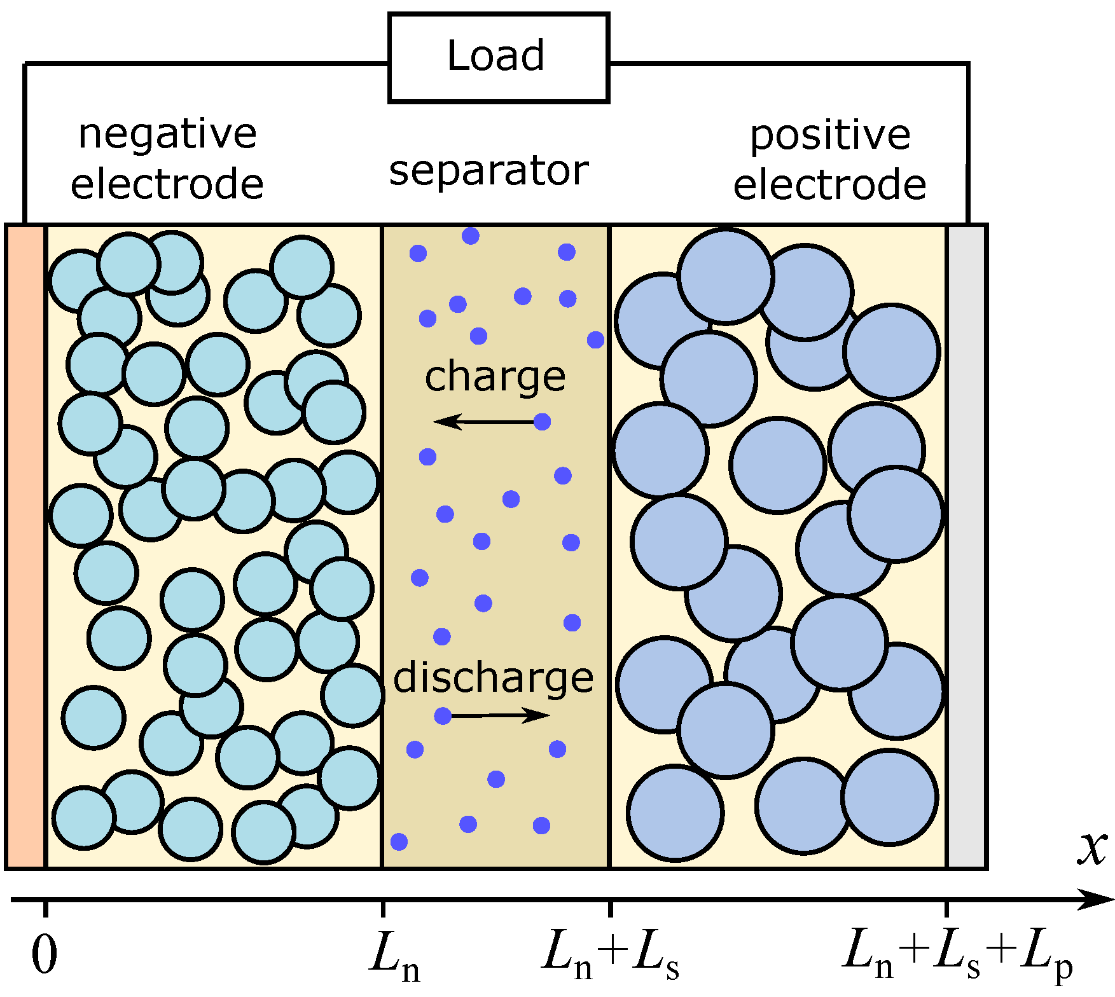
During the last three decades, lithium-ion batteries have become the choice of power source for most portable electronic devices [1].
Figure 1: Simplified representation of a Li-ion battery: the small blue dots represent the lithium ions Li⁺ moving in the electrolyte (image taken from [2]).
A simplified representation of a Li-ion battery is shown in Figure 1. What follows is a brief explanation on the basic functioning of this category of energy storage devices during discharges cycle under galvanostatic conditions, where a constant current i_{tot} is drained from the system. The lithium ions, which are initially stored in the anode, deintercalate, diffuse out in the electrolyte, reach the cathode/electrolyte interface, and intercalate into the cathodic material. At the same time, electrons will be taken from the anodic current collector thanks to the oxidation of the anodic material, and travel through the load to the cathodic current collector, where they will reduce the cathodic material.
On the other hand, during a galvanostatic charge cycle, the application of an external work will reverse the motion of Li⁺, which will deintercalate from the cathode and intercalate into the anode, and of the electrons as well.
Despite the remarkable scientific advancement of the last years, the degradation phenomena occurring in lithium ion batteries are unfortunately still far from being well understood: one of the main problem affecting battery life is, in fact, the continuous growth of a passivation layer known as the Solid Electrolyte Interface (SEI) at the Anode/Electrolyte Interface (AEI) during charge cycles: this event takes place if the anodic potential φ_{s,a} is located outside the stability window of the electrolyte ( typically 1 V < φ_{e} <4.5 V) [3]. This scenario is inevitable for graphite, the most frequent choice for the anodic material due to its reliability when it comes to safety, which will be used in the current work.
As mentioned earlier, Li⁺ will move from the cathode towards the anode into the electrolyte during charge cycles: when the lithium ions approach the AEI, a portion of them will not intercalate, but undergo interfacial reduction reactions together with high dielectric components dissolved into the electrolyte. This reactive path will allow the passivation layer to grow, which causes a progressive degradation of the battery performance, as a result of the loss of cyclable lithium ions (capacity fade) and of the increased resistance to their motion (impedance rise).
In this work the authors will analyse the impact of the growth dynamics of the Solid Electrolyte Interface (SEI) on the performance of a lithium-ion battery over a short series of charge/discharge cycles by using a 3D- time resolved (4D) electrochemical model. Across the project, we have adopted different geometries of increasing complexity to represent the morphology of a battery, which is featured by a graphitic anode (Li_{x} C) and a NCAO (Li_{x} Ni_{y} Co_{z} Al_{1-y-z} O₂) cathode.
2. Methods
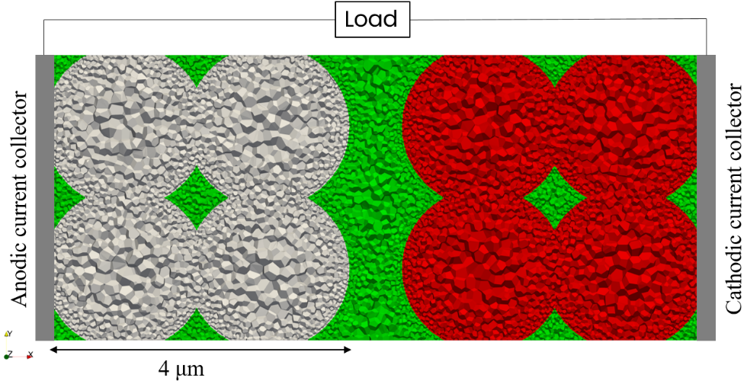
Figure 2: Slice of the computational grid representing one of the considered systems. Different colours represent the two electrodes and the electrolyte, in particular the anodic (grey) and cathodic structures (red), and the surrounding electrolyte (green).
The 4D model is based on Fluent (Ansys-CFD) lithium-ion electrochemical model: the simulation domain has been decomposed through a polyhedral computational grid; an example of a slice of one of the geometries adopted in this work is presented in Figure 2. The mass and charge conservation equations associated to the transport lithium ions across the electrodes and the electrolyte are numerically solved for each cell by adopting a finite-volume methodology. All the transport equations must be naturally closed by adopting the proper boundary conditions. First, the current collectors will be impermeable to any flux of Li⁺ coming from either the fluid or the solid phase. Afterwards, at every electrode/electrolyte interface the flux of Li⁺ j_{tot} exchanged between the different phases will be modelled by adopting the well-known Butler-Volmer kinetics:
$$j_{tot}=\frac{i_{0}}{F}\left[\exp\left(\frac{ F}{ 2RT }\right)-exp\left(-\frac{F}{2RT }\right)\right], (1)$$
where i₀ is the exchange current density and F the Faraday constant. Finally, η is the overpotential which allows the transition of Li⁺ from one phase to the other, which is defined as:
$= {}_{s}- {}_{e}-U. \left(2\right)$
In Eq. (2) φ_{s} and φ_{e} are the electrode and electrolyte potentials, respectively, while U is the open circuit potential of the anodic or cathodic half-cell reaction.
Finally, φ_{s} will be constrained to zero at the anode/anodic current collector interface (φ_{s,a} = 0 V), meanwhile a constant current density i_{tot} is allowed to cross the cathode/cathodic current collector interface to represent the galvanostatic conditions: it will assume a negative value during discharge cycles and a positive one during charge ones.
The novelty of this approach relies on the description of the local growth dynamics of the SEI at the Anode-Electrolyte Interface during each charge cycle: every cell composing the AEI is coupled with a user-defined-function which describes the temporal increase of the SEI growth as a function j_{s}, the fraction of j_{tot} which undergoes the interfacial reduction kinetics:
$$\frac{dδ(x) }{dt}= - \frac{j_{s}}{{ρ_{SEI}}/{M_{SEI}}}, (3)$$
where ρ_{SEI} and M_{SEI} represent the average density and molecular weight of the SEI; here j_{s} is supposed to be the 5% of the overall Li⁺ flux approaching the AEI.
The impact of the passivation layer on the impedance rise is, instead, described by a local contact resistance R_{F} (x), which depends on the local thickness δ(x) of the SEI and its thermal conductivity κ_{SEI}:
$$R_{F}\left(x\right)= R_{SEI}+ \frac{δ\left(x\right)}{κ_{SEI}}, (4)$$
which will impact the anodic overpotential in the Butler-Vomer kinetic equation related to the trenspassing of the AEI by Li:
$$= {}_{s}- {}_{e}-U-R_{F} F{ j}_{tot}. \left(5\right)$$
3. Results and discussion
Here, we briefly propose the main results obtained in the project. As mentioned in the introduction, a series of geometries with increasing complexity have been adopted, which are proposed in the Supporting Images. In Figure S1 we propose a 2D domain, where the electrodes are composed of 3 circles of radius R_{p} = 1 μm and they are located 1 μm away from each other. In Figure S2 it is showed a simplified 3D geometry, in which each electrode is now composed of 8 compenetrating spheres with R_{p}= 1 μm 1μm apart from each other as well. Finally, we have adopted a realistic 3D battery morphology, which is showed in Figure S3: here, the electrodes have been reconstructed by using experimental information on the Particle Size Distribution and porosity of commercial electrodes: in this case the particles assume an average particle size R_{p,av} = 5 μm and separated by 10 μm.
A series of simulations has been conducted to make sure that the model reliably describes the functioning of a battery during a series of galvanostatic charge/discharge cycles with different values of current density. In particular, i_{tot} is expressed as a C-rate: given the total capacity of the battery C_{tot}[Ah], a C-rate equal to X C is the value of i_{tot}, which is necessary to complete a full discharge/charge of the system in 1/X hours.
In Figure 4, we present the different concentration profiles of Li⁺ obtained at 2C during different stages of a discharge cycle.
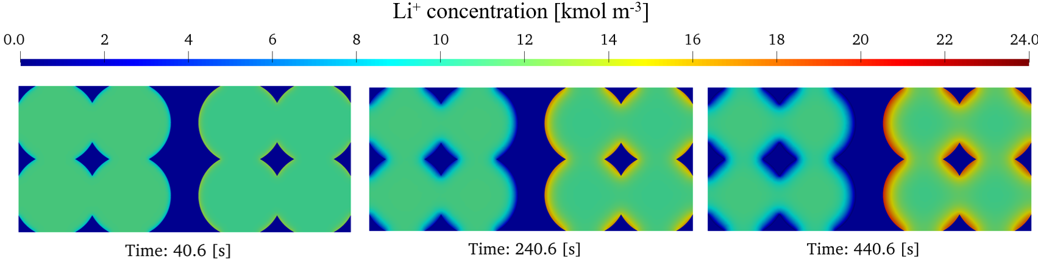
Figure 4: Temporal variation of the Li⁺ concentration across a slice of the 3D simplified geometry at different stages of a discharge cycle at 2C.
It can be appreciated the depletion of Li⁺ from the anode on the left side of each image: this phenomenon naturally starts at the surface of the electrodes and keeps propagating towards the core of each anodic particle. At the same time, the intercalation of the Li⁺ on the cathode at the right end of the images can be observed, where the Li⁺ starts accumulating at the surface of this electrode and starts diffusing into the particles.
In Figure 5, we instead propose the charge/discharge curves computed at two different C rates. They show the temporal trend of the cell voltage V, formally defined as the difference between the cathodic φ_{s,c} and the anodic electric potential φ_{s,a}
$$V= {}_{s,c}- {}_{s,a}, (6)$$
V can be interpreted as the driving force for the motion of Li⁺ from the anode to the cathode during the discharge, allowing the battery to provide energy to the load.
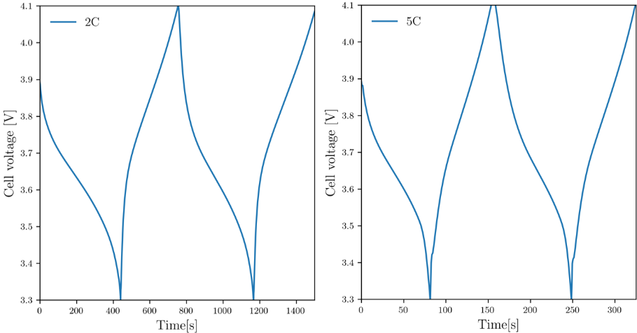
Figure 5: Charge/discharge curves for a simplified 3D geometry at the considered C-rates.
Overall, during the discharge energy is taken from the system and electrons are flowing through the external load, with parallel motion of Li⁺ from the anode and their subsequent intercalation of Li⁺ in the cathode, as previously showed in Figure 4. During the discharge the cell voltage keeps decreasing due to increasing mass transport limitations: since the diffusion of Li⁺ in the particles is slow, these cations start accumulating on the most external areas of the cathodic material, getting closer and closer to the Li⁺ solubility limit. This phenomenon translates into an increasing resistance to the intercalation of new Li⁺, which ultimately causes V to decrease in a non-linear way until a cut-off voltage of 3.3 V is reached: the decision to stop the discharge at this specific value derive from the fact that reaching lower voltages can lead to structural collapses of the electrodes.
At this point, the current within the system is reversed and a charge is begun, where the cell voltage is allowed to increase thanks to the application of an external work until an upper limit of V_{lim} = 4.1 V is achieved; it is not recommended to charge to higher values than V_{lim} because an overcharge of the system can cause unstable conditions, which ultimately lead to dangerous phenomena, including thermal runaway reactions.
It can be noticed that the temporal scale at which the cell voltage varies from the cut-off voltage to the upper limit depends on the C-rate: increasing its value leads to a much quicker decrease of the cell voltage during discharges. This happens because a higher discharge current causes the surface of the particles to saturate quicker with respect to lower C-rates, so the internal resistance to the intercalations of new Li⁺ increases over a smaller time-span. This ultimately causes the battery to release a much smaller amount of energy per cycle under higher C-rates.
Figure 4 and 5 indicates that the 4D model correctly represents the behaviour of the cell voltage during a series of discharges and charges as widely reported in the literature [4]; the natural next step will be the description of the impact of the local SEI growth dynamics on the overall cell performance.
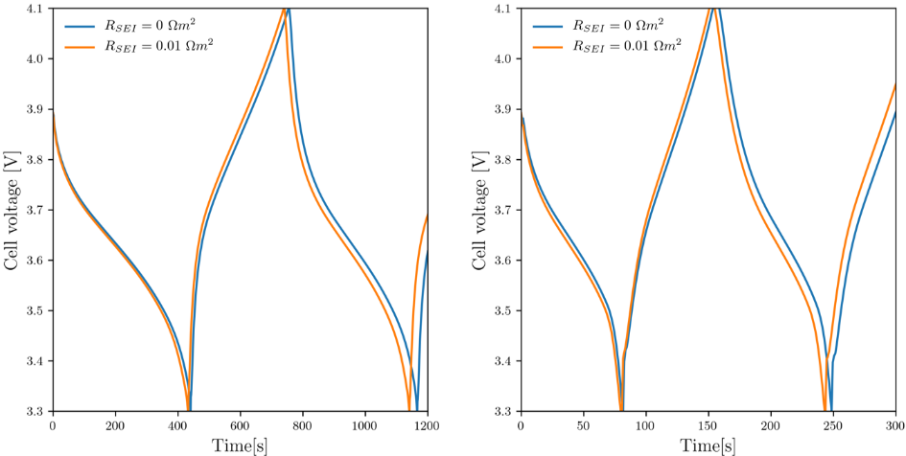
Figure 6: Charge/Discharge curves for a simplified 3D geometry with C-rates of 2C (left) and 5C (right) considering and neglecting the impedance rise provided by the SEI.
In Figure 6 we propose the impact of the impedance rise provided by the SEI growth dynamics on the temporal trends of the cell voltage at the aforementioned C-rates: an initial value of R_{SEI} = 0.01 Ω m² has been chosen. To the authors’ knowledge, this is the first time that a rigorous 4D model describes the impact of local SEI growth dynamics on the performance of a lithium-ion battery instead of considering uniform average values as previously done in the literature [4].
We can clearly see that the presence of the passivation layer causes the cell voltage of the lithium-ion battery to decrease: this happens because the growing SEI offers an ulterior resistance to the motion of Li⁺ inside the system described by the resistivity R_{F}, which affects the flux of Li⁺ at the AEI by modifying the anodic overpotential in Eq.(5), which subsequently affects j_{tot} according to Eq.(1): basically, the de-intercalation from the anode will be hindered during a discharge, which leads to a degradation of the battery performance since the cut-off cell voltage is reached at an earlier time with respect to a system which neglects the presence of the SEI.
Moreover, it can be noticed that the time difference between the reach of the cut-off voltage between the systems with R_{SEI} = 0 Ω m² and R_{SEI} = 0.01 Ω m² gets wider as the cycles progress. This happens because the thickness of the SEI increases at every charge cycle according to Eq.(3): the increase of δ(x) leads to an increase of R_{F}(x) according to Eq.(4), which magnifies the impedance rise provided by the SEI for every subsequent discharge, with the ultimate effect of a progressive loss of battery performance between one discharge cycle and the other.
4. Conclusions
In this work, the authors have proposed preliminary results of a rigorous 4D model, among them the Li⁺ concentration profiles inside the electrodes during a complete discharge cycle at 2C. Next, two different charge/discharge curves at 2C and 5C have been proposed, highlighting the reliability of the model to reproduce the fundamental functioning of a lithium-ion battery, in particular the inverse proportion between the C-rate and the amount of energy that can be provided by the battery. Finally, it has been highlighted for the first time the impact of the local SEI growth dynamics on the battery performance by comparing the temporal trend of the cell voltage of a series of charge/discharge cycles at different C-rates including and excluding the impact of the SEI: the presence and continuous growth of the passivation layer causes the time the cell voltage takes to reach the cut-off limit from fully charged conditions to be shorter as we progress from one discharge cycle to the other. This is a clear sign of a gradual loss of battery performance due to the increasing impedance rise provided by the passivation layer.
The main issue of this 4D model is its high computational cost, so the authors are also exploring other options to describe long term battery aging. A future alternative is the development of a surrogate model based on the use of a Convolutional Neural Networks (CNN). The authors will follow the same workflow adopted in a previous project focused on the prediction of colloidal filtration in porous media [5]. The idea is based on the launch of several simulations of the 4D model under different operating conditions for both the anode and the cathode. Their outputs, which will be the temporal profiles of Li⁺ concentration across the battery and of R_{F} at the AEI, will be used to create a dataset, which will subsequently be used to train the CNN. The goal is to reproduce, and subsequently predict, the long-term battery aging as it is described by the 4D model but without the necessity of extreme computational efforts.
Acknowledgements
The authors acknowledge support from the European Union's Horizon 2020 research and innovation programme under Grant Agreement No. 957189.
References
- W. Aiping, K. Sanket, L. Hong, S.Siqi, Q. Yue, Review on modeling of the anode solid electrolyte interphase (SEI) for lithium-ion batteries, npj Computational Materials 15 (2018) 1-26.G.F.Froment, K.B.Bishoff, Chemical Reactor Analysis and Design, second ed., Wiley, New York, 1990.
- R. T. Sibatov, V.V. Svetukhin, E.P. Kitsyuk, A.A. Pavlov, Fractional Differential Generalization of the Single Particle Model of a Lithium-ion Cell, Electronics 8 (2019) 650.
- B. Horstmann, F. Single, A. Latz, Review on multi-scale models of solid-electrolyte interface formation, Current opinion in Electrochemostry, The Electronic Technology, E-Publishing Inc., New York, 2009, pp. 181–304.
- A. Lamorgese, R. Mauri, B. Tellini, Electrochemical-thermal P2D aging model of a LiCoO₂/graphite cell: Capacity fade simulations, Journal of Energy Storage 20 (2018) 289-297.
- A. Marcato, G. Boccardo, D.L. Marchisio, A computational workflow to study particle transport and filtration in porous media: Coupling CFD and deep learning, Chemical Engineering Journal 417 (2021) 128936.

Supporting Images

Figure S1: Simplified 2D geometry, where the different colours represent the anode (green), electrolyte (grey) and cathode (red).
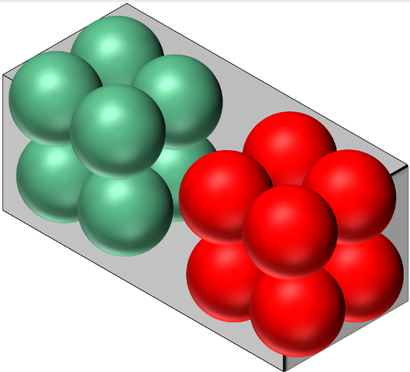
Figure S2: Simplified 3D geometry, where the different colours represent the anode (green), electrolyte (grey) and cathode (red).
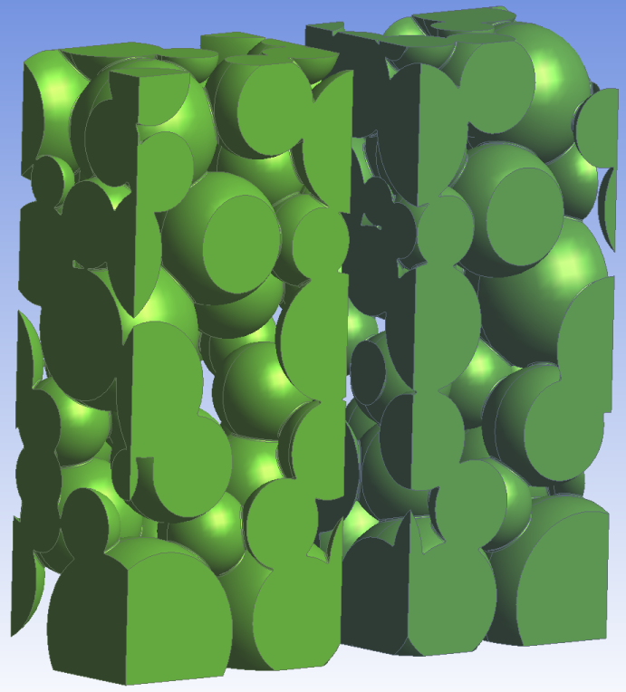
Figure S3: Visualization of the realistic 3D geometry: the electrodes are composed of particles with an average R_{p,av} = 5 μm located 10μm away from each other.

