**TURBOFLUX: A Mobile Transportable Unit to Produce Formulations for the Chemical and Health Sectors**

Riccardo Bacci di Capaci*, Gabriele Pannocchia, Chiara Galletti, Elisabetta Brunazzi

*Department of Civil and Industrial Engineering, University of Pisa, Italy*

*\*Corresponding author E-Mail: riccardo.bacci@unipi.it*

**1. Introduction**

The COVID-19 emergency has put the Italian process industry and the various chemistry sectors in front of several crucial challenges [1]. Nevertheless, this unheard-of health pandemic has provided the opportunity for many chemical industries to enter new sectors, developing the ability to rapidly reconvert production and certify products, making efforts to adapt to the regulations in force. The pandemic has also revealed many major vulnerabilities, and it is clear how the need for process intensification is how much ever relevant [2]. Modular chemical process intensification indeed proves an attractive concept because factory-built modular plants can be easily distributed, repositioned, and stacked in parallel to achieve scale, while process intensification can overcome the inherent loss of economies of scale associated with a smaller process [3, 4].

This abstract is related to a recent project funded by Tuscany Region that aims to develop an innovative plant (called TURBOFLUX) to produce in continuous mode a set of specific formulations for the chemical and health sectors to face possible future sanitary pandemics. The recent COVID-19 emergency has now passed its most critical phase and has in the meantime become endemic, making the Italian production of surgical medical devices, such as sanitizing gel, settle on stable levels. Nevertheless, developing a plant with minimal complexity, but with peculiar features of high flexibility, modularity, agility, and availability, is very attractive for the very variable market of the future, especially for crisis areas or when rapid installation and start-up are required.

The project activities have concerned so far the analysis of rheological and physical/chemical properties of the substances of interest, the selection and analysis of the modular elements of the tubular flow reactor, and the run of a series of numerical simulations with CFD techniques. Furthermore, the work will focus on the definition and development of the automation software and the control system, the prototype integration and realization, and functional and performance tests in simulated and operational scenarios.

The desired formulations of TURBOFLUX are produced from a limited number of basic components in liquid state, directly inflow by means of a series of static mixing devices [5, 6] installed within the pipeline housed in a containerized mobile unit. The plant is specifically designed for three main types of final products: i) alcohol-based disinfectants; ii) synthetic environmental sanitizers; iii) modified acrylic resins. It is to be noted that the above-mentioned formulations are usually obtained in traditional batch-type processes; however, with the aid of static mixers, production can efficiently take place in continuous mode.

The plant consists of two maritime containers arranged adjacent by the long side, with standard dimensions. The first container includes the static mixing system and the pumps for the various components and the obtained formulate, as well as a buffer tank for temporary storing; the second container hosts the kegging machine for the final product and the control panels with external access in a safe area. In particular, the static mixing zone of the plant consists of a series of 5 parallel pipes connected by vertical curves, for a total of around 18m length, as shown in Figure 1. The main vector fluid is fed into the primary pipe and a series of secondary smaller pipes is used to introduce the additives to obtain the various final products.

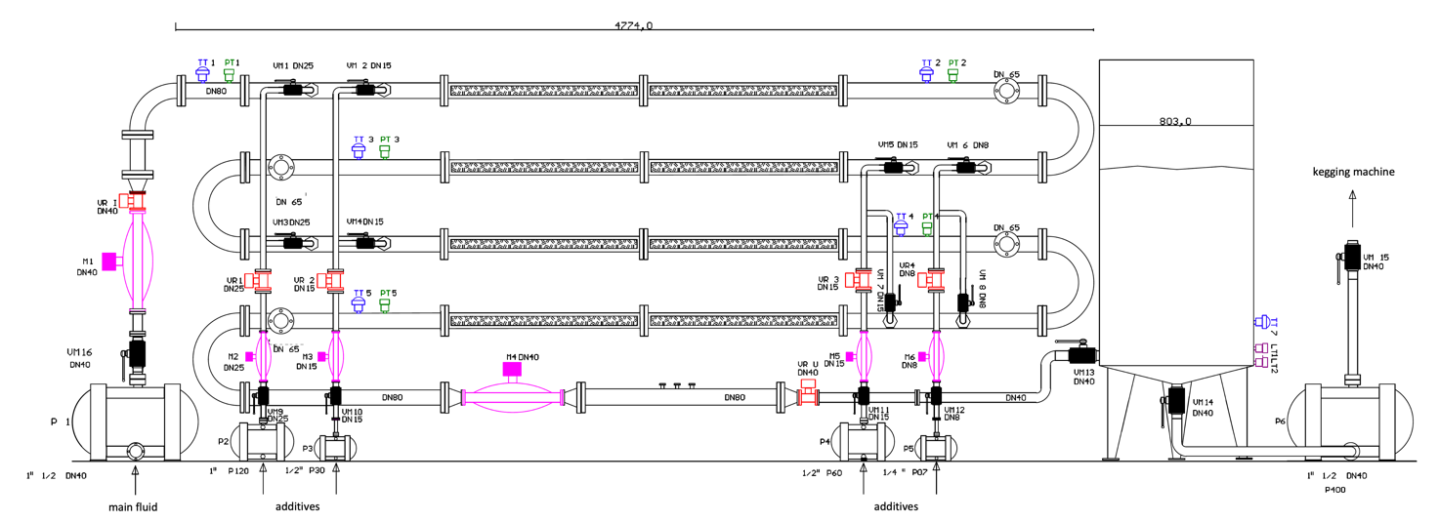

**Figure 1.** Sketch of the mixing zone of the TURBOFLUX system.

The main pipe represents the mixing and reaction environment: the first four sectors are used for feeding, mixing and reaction; the final sector is a calm zone to allow the product stabilization, the quality monitoring, and the properties control. Each component is fed with a dedicated volumetric pump and several mass flow meters are installed to guarantee a high precision in dosages. The relative quantitative and the procedure of injection of the various components are established in advance, according to the recipe developed for each final product. For every component, a control valve and two splitting valves are provided, so that the same additive can be fed in two different sectors of the pipe. The feedback basic control is guaranteed by a ratio logic between the main and the various additive flow rates. In addition, given the practical and economic difficulty of obtaining reliable real-time measures of product quality, an inferential system for monitoring and controlling the main performance variables will be adopted.

**2. Methods**

The present abstract reports only some results of the extensive CFD simulations carried out for the development of the hardware architecture of the tubular flow reactor. In details, the most suitable types of static mixer for the scopes were investigated and a series of operative conditions were evaluated. The simulation of a small portion of the real pipe, corresponding to the injection and the mixing area of an additive fluid with the main vector fluid, is here discussed. Despite being simplified, this preliminary model has anyway allowed one to analyze the influence of the main operating parameters and of the specific geometric configurations on the performance of mixing phenomena.

The studied geometry (see Figure 2) is characterized by a length L = 800 mm and an injection pipe far 50 mm from the inlet of the main pipe, with an inner diameter of 25mm and inclined by 45°. The various static mixing devices are installed 50 mm far from the additive inlet to ensure a premixing space, so that they cover only the last 700 mm of the overall geometry.

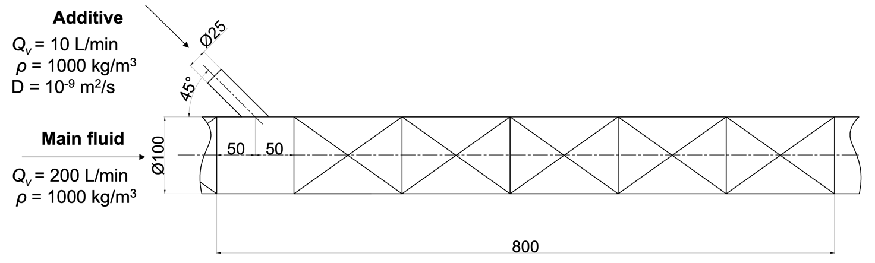

**Figure 2.** Sketch of the simplified geometry under study.

Note that the mixing of an ideal main fluid and an additive fluid, assumed as a tracer (scalar), is considered. The main fluid is a liquid with a density of 1000 kg/m3 and different values of viscosity, according to the specific case study. The additive fluid has the same physical properties, and a molecular diffusivity in the main fluid equal to D = 10−9 m2/s. Therefore, ideal scenarios are investigated, since density and viscosity of the resulting mixture are assumed constant throughout all the mixing pipe.

The numerical model was developed with the commercial CFD code ANSYS Fluent v. 19, based on finite volume methods. The basic idea is to have a flexible numerical model, useful to investigate the effect of different design aspects on the mixing process and the pressure drops. The final objective is indeed to define the best configuration of the static mixer as to maximize mixing while limiting pressure drops, for different fluids. To this purpose, the numerical model is obtained by assembling different sections, each of them reproducing an inlet section, a kind of static-mixer, and an outlet section. Then, the resulting reactor length is covered by placing together the different elements as a "lego"-like assembly so to analyze different reactor configurations. The overall geometry can be easily modified by adding, removing, or replacing only some specific blocks. Polyhedral meshes with prismatic layers at the walls are generated for each block. The prismatic layers at the wall are needed in the turbulent regime to ensure the correct resolution on the wall boundary layer. Grid independence test was performed on a shorter geometry; 2 mm was set as the optimal grid dimension and then used in subsequent studies for both laminar and turbulent regimes. In this manner between 2.6 and 3.7 millions of cells were needed depending on the reactor configuration. Navier-Stokes equation and a transport equation for the tracer were solved; more specifically, in turbulent conditions, Reynolds-averaging was applied by closing Reynolds stresses with the RNG $κ-ϵ$ model. The convective terms were discretized by a second-order upwind scheme. In laminar regime, the pressure-velocity coupling algorithm was treated with the SIMPLE algorithm, while in turbulent regime a pseudo-transient coupled scheme was adopted.

**3. Results and discussion**

Different reactor configurations were analyzed by assembling different blocks and related computational grids to cover the length L = 800 mm. As shown in Figure 3, three different assembled geometries, for five levels of fluid viscosity (5, 50, 100, 500, 1000 cP) were tested, that is, five levels of Reynolds number, ranging from mid turbulent to pure laminar regime.

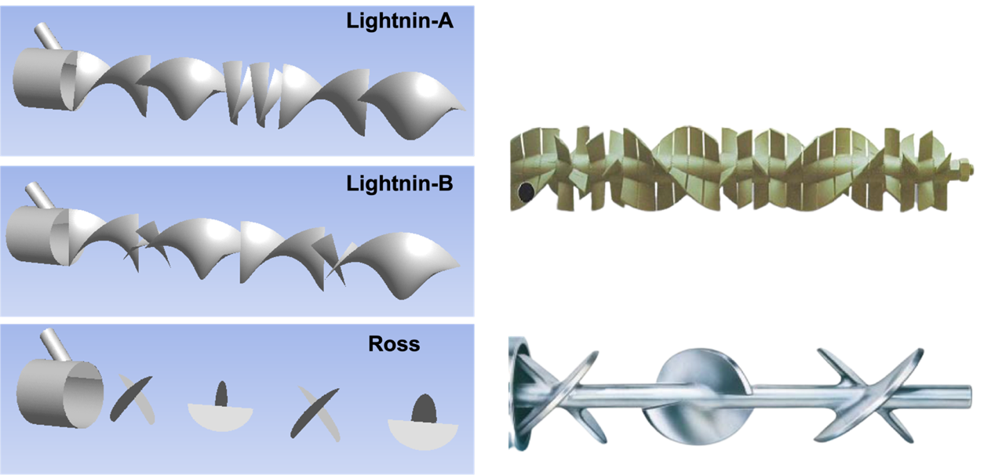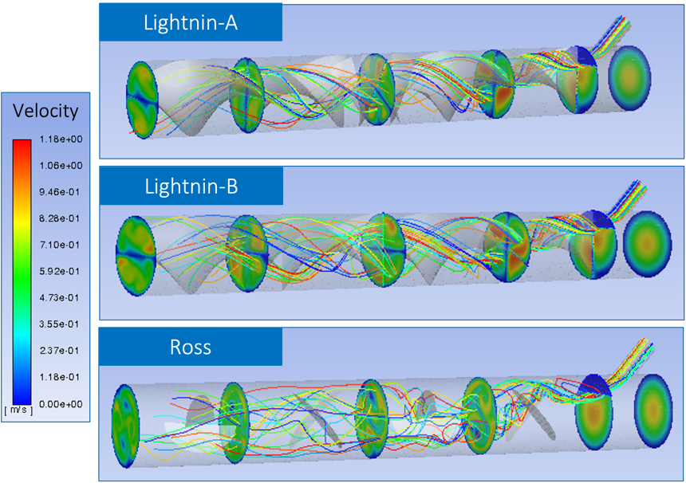

**Figure 3.** Assembled geometries; left) layouts built in Fluent; right) corresponding velocity fields.

Only some of the results of the extensive CFD study are here presented. Among others, the activities concerned the analysis of the beneficial effect of an entry bulkhead, and a comprehensive investigation of concentration and velocity fields (Figure 3); however, details are omitted for the sake of brevity. The various results were aggregated and compared by using two suitable performance indices, that is, the mixing degree (*δm*) and the pressure drops (*ΔP*). Figure 4 summarizes the results at the outlet section of the pipe: values of the mixing degree normalized over pressure drops, for the different operating conditions and different geometries are here reported.

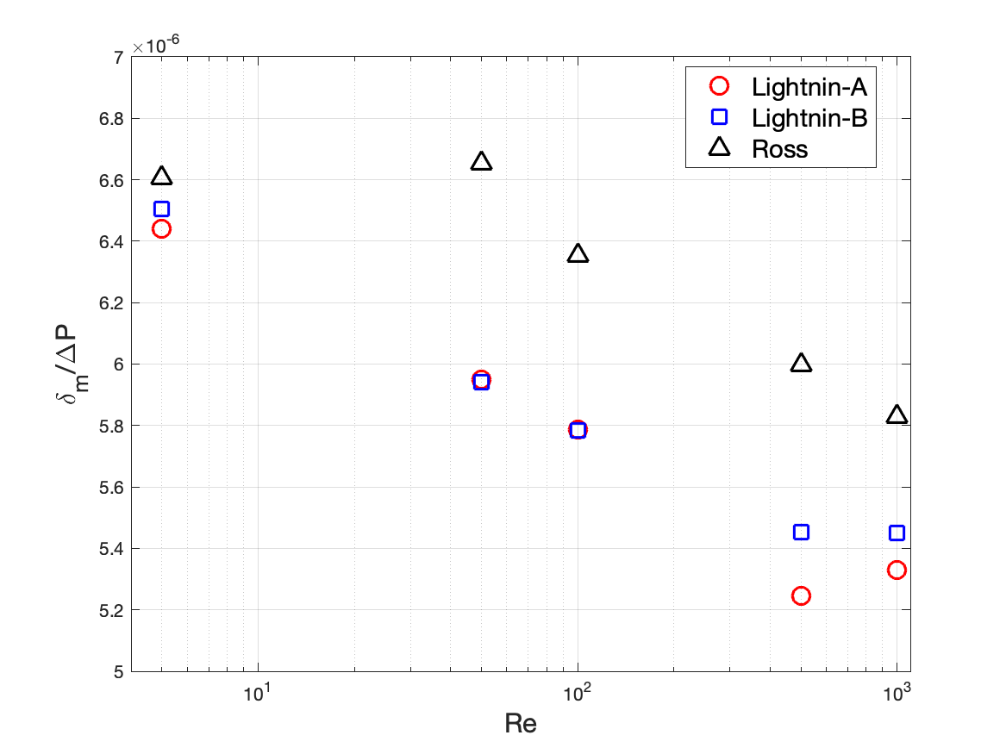

**Figure 4.** Mixing degree vs. pressure drops for different Reynold numbers and geometries.

The Ross geometry proves to guarantee higher mixing degree than the two Lightnin configurations for all the tested flow regimes, but it also produces higher pressure drops; nevertheless, keeping the ratio *δm*/*ΔP* as the main key performance index, Ross reveals the best geometry for the scopes.

**4. Conclusions**

An innovative plant to produce in continuous mode a set of specific formulations for the chemical and health sectors to face possible future sanitary pandemics is here presented. Some results of the extensive CFD investigation of a section of pipe equipped with different typologies of static mixers are illustrated. This study aims to help the design of the flow tubular reactor to be hosted in a transportable plant unit. The mixing of the main flow rate of a carrier fluid with the injection of an additive component was studied, in which physical properties are the same for both fluids. Three different configurations of static mixers were tested and compared in terms of mixing degree and pressure drops. The Ross proves to outperform the two Lightnin configurations for all the tested flow regimes. As future developments, the mixing of real fluids with actual physical properties is to be considered to obtain more reliable indications for the plant run. In addition, different operating conditions will be tested to derive performance correlations to be used for the definition of a practical 1D model to be used as a digital twin of the real process.

**References**

1. M. Galimberti. SCI: la chimica ai tempi del Covid. Sfide e risposte, year V, n. 2, Online (March/April 2021).
2. D. Sengupta, P. Yelvington. Advanced manufacturing progress: Modular, intensified processes promote resilient manufacturing, online (June 2020). <https://www.aiche.org/resources/publications/cep/2020/june/advanced-manufacturing-progress-modular-intensified-processes-promote-resilient-manufacturing>.
3. A. Stankiewicz, T. Van Gerven, G. Stefanidis. The Fundamentals of Process Intensification, John Wiley & Sons, 2019.
4. R. Gani, et al. A multi-layered view of chemical and biochemical engineering, Chemical Engineering Research and Design 155 (2020) A133–A145.
5. G. Forte, F. Alberini, E. Brunazzi. Effect of residence time and energy dissipation on drop size distribution for the dispersion of oil in water using KMS and SMX+ static mixer, Chemical Engineering Research and Design 148 (2019) 417–428.
6. G. Forte, A. Albano, M.J.H. Simmons, H.E., Stitt, E. Brunazzi, F. Alberini. Assessing Blending of Non-Newtonian Fluids in Static Mixers by Planar Laser-Induced Fluorescence and Electrical Resistance Tomography, Chemical Engineering and Technology 42-8 (2019) 1602–1610.