Flow features in a T-microchannel with cylindrical obstacles mixing water and ethanol
Matteo Antognoli*, Sara Tomasi Masoni, Roberto Mauri, Chiara Galletti, Elisabetta Brunazzi
Dipartimento di Ingegneria Civile e Industriale, Università di Pisa, Largo Lucio Lazzarino 2, Pisa 56122, Italy
*Corresponding author E-Mail: matteo.antognoli@phd.unipi.it
1. Introduction
Microfluidic reactor technology has become very attractive for a wide range of applications and research fields, such as engineering, chemistry, and biology [1-2]. Microreactors can manage with precise control fluids constrained in a small channel for a specific residence time. They also offer lower consumption of energy and raw materials, thereby increasing safety and economy. Regardless, considering the small sizes involved, the flow is inevitably laminar, so the fluid mixing mainly depends on molecular diffusion, which is usually a slow process. Therefore, it is necessary to devise the reactor geometry to enhance mixing [3-4]. The simplest passive micromixer has a T-shape, where two inlet flows join the main mixing channel through T-shaped branches. The complex flow regimes occurring in T-shaped microchannels have been investigated in detail through experiments and numerical simulations [5]. Recently, inserting obstacles such as cylindrical pins (pillars) into a T-microchannel has been a strategy to promote the chaotic advection and, thus, mixing and heat and mass transfer for the intensification of the yield and selectivity of chemical reactions and the reduction of energy cost in electronics cooling [6-9]. However, most of the studies on mixing in microreactors with obstacles are often limited in observing water mixtures that have limited use in practical applications, or the investigations can lack experimental results to validate the numerical ones.
The design of a T-microchannel with sequences of 20 cylindrical obstacles that differ in diameter dimension and position, was optimized for mixing water mixtures in [10]. The design approach based on the IAF (Interfacial Amplification Function) showed superior performance for efficiency and robustness compared to the Greedy and FIF (Final Interface Function) geometries.
In this work, experiments and CFD simulations were carried out on the IAF geometry using in addition to water-water (W-W) mixtures also water-ethanol (W-E) mixtures often employed in practical applications. Optical and numerical visualizations allowed us to gain insight into the flow behavior around the pillars for several Reynolds numbers. The numerical predictions were compared to measurements of depth-averaged concentrations to understand how physical properties affect the fluid dynamics at several sequence locations, observing the mixing progress. Eventually, a performance evaluation shows the efficiency and robustness of the device. These findings are relevant for processes dealing with the mixing of water and ethanol, such as the production of lipid particles, whose uniformity -- essential for the drug delivery purpose and cell targeting -- depends on the mixing quality.

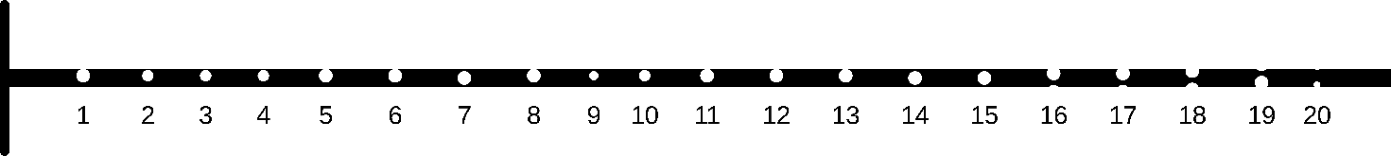
Figure 1. Sketch of the T-microchannel with pillars (distance between obstacles is reduced).

2. Methods
The experimental setup consisted of a syringe pump (KD Scientific syringe pump Gemini 88) provided of BD syringes of 30 mL, piping and luer lock fittings, an optical microscope (Nikon ECLIPSE 80i model) equipped with a magnifying lens of 4ⅹ, a high-speed camera (Optomotive Velociraptor HS model), a computer for the image processing, and a microfluidic device. The latter was made of PDMS and glass by adopting soft lithography and plasma etching techniques. The T-channel has an outlet cross-section of 200$×$50 µm², and it contains 20 pillars of the IAF sequence obtained in [10]. The geometry is represented in the sketch of Fig. 1. The inlet channel width is 100 µm. The mixing channel length is about 23 mm, and the pillar diameter ranges within 75-150 µm.
Bidistillated water (CAS 7732-18-5, Titolchimica S.p.A.) and ethanol (VWR International S.A.S. CAS 64-17-5, content 99.97% v/v) were used for the experiments. Due to the hydrophobic channel surface, the surfactant SDBS (sodium dodecyl benzenesulfonate, CAS 25155-30-0, Sigma Aldrich) was dissolved in water at 0.5% to minimize the wettability difference between the ethanol and the water over the channel surface. The food dye Ponceau Red (E124) was employed to distinguish the two fluids in the flow visualizations from the top of the device using a low dye concentration to keep unchanged the fluid properties.
The CFD software Fluent ANSYS 19.2 was exploited to simulate the mixing in the microchannel by using the finite volume method. The fluid is incompressible, and the process takes place at isothermal conditions; thus, the governing equations consist of the Navier-Stokes equations and the transport equation for the mass-fraction of ethanol (Φ_{E}). The physical properties of the water-ethanol mixture varying the mass-fraction of ethanol were implemented in the CFD code through a bespoke subroutine. Indeed, this mixture has a non-ideal behavior as pictured in Fig. 2, showing the non-dimensional density ($\hat{ρ}$) and viscosity ($\hat{µ}$), which are referred to the density and viscosity of water at 20°C, as a function of the mixture composition.

. 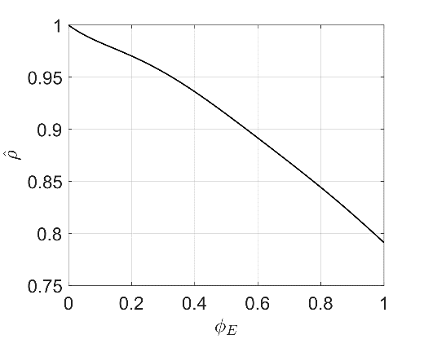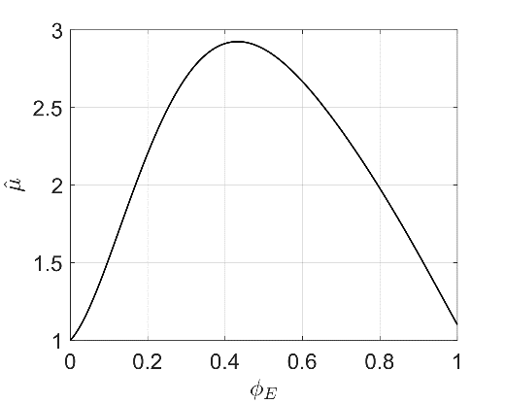
Figure 2. Non-dimensional density and viscosity of the water-ethanol system as a function of the ethanol mass-fraction.

A steady solver with a second-order upwind scheme was used, and the pressure-velocity coupling was treated with the SIMPLE algorithm. The convergence was ensured reaching normalized residuals below 10⁻⁹. The computational grid is unstructured and formed by hexahedral elements, that are more refined near each pillar region. Hence, the minimum cell size is about 1.25$×$1.6 µm², and the maximum one is 1.25$×$3.3 µm². More details on the grid features and the independence from the solution are provided in [10].

3. Results and discussion
The W-W mixture is observed at Re=40 and compared with the W-E mixture at the same inlet volumetric flow rate; specifically, the Reynolds number (Re) is evaluated by considering the physical properties of water also in the W-E mixture. The experimental and numerical results show a fine agreement both at the beginning of the sequence (for instance at pillars 1-2 on the top panel of Fig. 3) and further down in the sequence (for instance at pillars 14-15 on the bottom panel of Fig. 3). The flow appears similar in both the mixtures at the beginning of the pillar sequence. However, moving to the end of the channel, differences in the flow pattern between the two mixtures are observed. Indeed, the W-W mixture shows recirculations behind pillars 14 and 15 in Fig. 3, that are not present in the W-E case, where, instead, the flow remains attached to the pillar.
The formation of a viscosity layer at the fluid interface in the W-E system (see Fig. 4) may explain such a flow behavior. The pillars improve the mixing of the incoming fluids as a result of which however the viscosity of the mixture increases, and the formation of recirculations behind the obstacles is hindered. The effective Reynolds number of the mixture decreases along the channel as the mixing progresses.

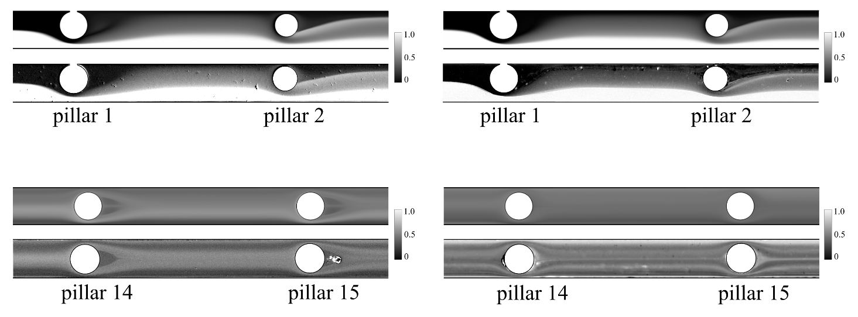
Figure 3. Top visualization of the device with experimental (top line) and numerical (bottom line) depth-averaged concentration fields for the W-W (on the left panel) and W-E (on the right panel) systems at pillar 1-2 and 14-15 at Re=40.
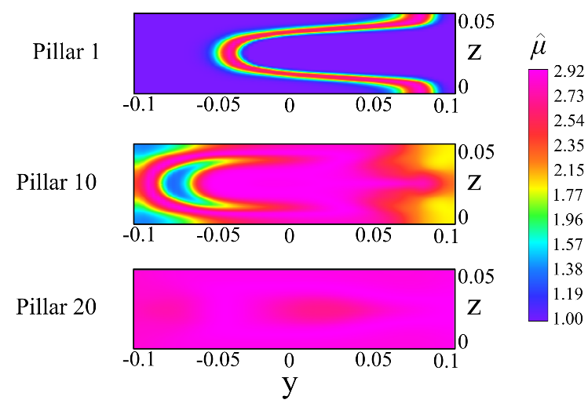
Figure 4. Cross-sectional contours of the non-dimensional viscosity of the W-E mixture for Re=40 at several channel locations.

For Re = 40, effective mixing is obtained, the values of the mixing index (MI, which is defined as $1- \frac{σ}{σ_{max}}$, where $σ$ is the standard deviation of the component mass-fraction field over a cross-section and $σ_{max}$ is $σ$ when the flow is completely segregated) are equal to about 85% for both mixtures. Nonetheless, the inertial forces lose intensity compared to the viscous forces in the W-E system, and the effective Reynolds number (Re*_{outlet}) becomes 13 at the outlet section.
Similar results are observed for higher Reynolds numbers, as denoted in Table 1. On the contrary, mixing efficiencies are below 80% at Re=10. In particular, the W-E mixture achieves a value in Re*_{outlet} that is very close to 1 and corresponds to the condition of Stokes flow. Hence, compared to the water-water case and with the same volumetric flow rates at the T-microchannel inlet, in the case of water-ethanol, the predominance of viscous forces over inertial ones hinders the progress of the mixing along the channel.

Table 1. Mixing efficiencies of three cases (Re=10, 40, 80) for the W-W and W-E system and corresponding values of the Reynolds number of the water-ethanol mixture at the end of the microchannel (Re*_{outlet}).
Re | 10 | 40 | 80
MI^{W-W} | 75.6 % | 84.2 % | 81.5%
MI^{W-E} | 63.55 % | 85.3 % | 83.4 %
Re*_{outlet} | 3.50 | 13.0 | 26.1

4. Conclusions
Numerical simulations and experimental visualizations provided an insightful analysis of the flow induced by pillars in a T-microchannel to mix water and ethanol. The alteration of the physical properties during the mixing process significantly affects the flow features, the Reynolds number of the mixture, and the mixing performance of the microreactor. The results of this study may support the optimization of the reactor design to improve the yield of chemical reactions and the quality of the products, e.g., to produce particles by using the flash precipitation method.

References
- K.S. Elvira, R.CR Wootton, A.J. DeMello, Nature chemistry 5 no. 11 (2013) 905-915
- I. Rossetti, M. Compagnoni, Chemical Engineering Journal 296 (2016) 56-70
- N.-T. Nguyen, Z. Wu, Journal of Micromechanics and Microengineering 15 no. 2 (2005) R1-R16
- J.M. Ottino, S. Wiggins, Science 305 no. 5683 (2004) 485-486
- A. Mariotti, C. Galletti, R. Mauri, M.V. Salvetti, E. Brunazzi, Chemical Engineering Journal 341 (2018) 414-431
- S. Zhang, N. Cagney, T. Lacassagne, S. Balabani, C.P. Naveira-Cotta, M.K. Tiwari, Chem. Eng. J. 397 (2020)
- J. Wang, N. Zhang, J. Chen, V.G. J. Rodgers, P. Brisk, W.H. Grover, Lab Chip 19 (2019) 3618–3627
- H.S. Santana, D.S. Tortola, J.L. Silva Jr., O.P. Taranto, Chem. Eng. J. 302 (2016) 752–762
- A. Renfer, M.K. Tiwari, T. Brunschwiler, B. Michel, D. Poulikakos, Exp. Fluids. 51 (2011) 731–741
- M. Antognoli, D. Stoecklein, C. Galletti, E. Brunazzi, D. Di Carlo, Lab Chip 21 (2021) 3910–3923

