**Eco-sustainable design of hybrid redox-active materials**

**to remove (micro)plastics from water**

Paola Amato1*, Marica Muscetta1, Claudio Imparato1, Aurelio Bifulco1, Mariacristina Cocca2, Raffaele Marotta1, Giuseppe Vitiello1, Antonio Aronne1

*1 Dipartimento di Ingegneria Chimica, dei Materiali e della Produzione Industriale, Università degli Studi di Napoli Federico II, P.le Vincenzo Tecchio 80, 80125, Napoli.*

*2* *Institute for Polymers, Composites and Biomaterials, Italian National Research Council -Via Campi Flegrei 34, 80078 Pozzuoli, NA, Italy*

*\*Corresponding author E-Mail: paola.amato@unina.it*

**1. Introduction**

Plastic waste has become a highly abundant and growing problem across global environments, as a result of increasing plastic manufacture, disposal and anthropogenic activities. In particular, microplastics (plastic particles <5 mm) are highly dispersive and have now caught both scientific and public awareness [1]. Due to their small size, microplastics can be discharged into the environment from wastewater effluents, causing damages to aquatic ecosystems. Therefore, the definition of solutions to deal with this threat is indeed of great interest. In this context, the green photocatalytic removal of microplastics from water, activated by visible and/or solar light can be a sustainable strategy. The main photocatalysts used for the photocatalytic degradation of (micro)plastics are TiO2 and ZnO. TiO2 has been widely used because of its high stability, non-toxicity and low cost. However, TiO2 has a wide bandgap (3.0–3.2eV) and only the short-wavelength ultraviolet light (UV) stimulates its electron transition. ZnO (bandgap energy = 3.37 eV) is also widely used in the treatment of dye wastewater because of his high catalytic activity, non-toxicity, photostability, tunable size. To improve the effective sunlight utilization of photocatalysts, various modification techniques, such as using dopants must be investigated [2]. Moreover, the adsorption of suitable organic molecules has been proposed as a versatile photosensitization strategy, alternative to doping [3].

The aim of this work is thus to design and realize new eco-compatible hybrid materials:

1. Hybrid photocatalysts consisting of semiconductor oxides combined with a bioavailable organic component and/or derived from biomass (i.e. humic acids), thus able to generate ROS under the effect of UVA/solar radiation.

2. Organic-inorganic hybrid catalysts consisting of semiconductor oxides functionalized with bioavailable organic molecules (i.e. organic ligands) capable of stabilizing ROS through the formation of charge-transfer complexes without the need for irradiation, resulting therefore active in dark or in conditions of ordinary brightness.

These materials will be tested for the degradation of polymeric samples through Advanced Oxidation Processes (AOP), taking advantage of their ability of ROS production.

**2. Methods**

Specifically, humic acid sodium salt (low molecular weight humic acid model molecule) and dibenzoylmethane (DBM, organic ligand) have been used to functionalize the semiconductor oxides (ZnO and TiO2). Bare/hybrid ZnO and TiO2 have been tested on polymeric samples like LLDPE (linear low-density polyethylene) and PLA (polylactic acid). To investigate the photocatalytic properties, different glass supports were coated with about 0.4 mL of a 5 mg / mL suspension of each bare and hybrid photocatalyst samples. Then, these supports were dried in an oven for 30 minutes at 90 °C. Then, to perform photocatalytic tests, the polymeric films were opportunely wrapped around the supports on which each type of nanocatalyst was deposited. All the sets of slides with each nanocatalyst were placed in a bath containing water and equally exposed to the UV lamp:

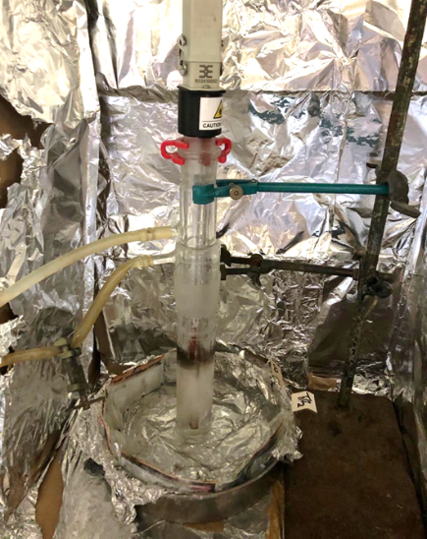

**Figure 1**. Images of the used UVA/Vis lamp.

To investigate the capability of production of ROS and their stabilization without the need for irradiation, the polymeric films chosen were coated with about 0.4 mL of a 5 mg / mL suspension of TiO2-DBM at room light in presence of air.

**3. Results and discussion**

Preliminary characterizations of the polymeric films treated with the hybrid materials prepared have been realized by using ATR and SEM analysis which show promising results in terms of changes that can be ascribed to the activity of ROS generated.

**4. Conclusions**

Investigating the ROS degradation behavior of (micro)plastics is beneficial to better understand their elimination and to develop novel technologies for their removal. Although these materials show satisfactory polymers degradation efficiency, the identification of intermediates, reusability of the materials, and the application cost are still worthy of further exploration.

**References**

1. Alice A. Horton, David K.A. Barnes, Microplastic pollution in a rapidly changing world: Implications for remote and vulnerable marine ecosystems, Science of The Total Environment, Volume 738, 2020, 140349, ISSN 0048-9697
2. Jianhua Ge, Zhiping Zhang, Zhuozhi Ouyang, Mengxin Shang, Peng Liu, Huang Li, Xuetao Guo, Photocatalytic degradation of (micro)plastics using TiO2-based and other catalysts: Properties, influencing factor, and mechanism,

Environmental Research, Volume 209, 2022, 112729, ISSN 0013-9351

1. Ritacco, I., Imparato, C., Falivene, L., Cavallo, L., Magistrato, A., Caporaso, L., Farnesi, M., Aronne 2100629, A., Spontaneous Production of Ultrastable Reactive Oxygen Species on Titanium Oxide Surfaces Modified with Organic Ligands. Adv. Mater. Interfaces 2021, 8, 2100629.