Design and in vivo applications of decorated nanogels for selective drug delivery in spinal cord injury
Filippo Pinelli¹*, Filippo Rossi¹
¹ Department of Chemistry, Materials and Chemical Engineering “Giulio Natta”, Politecnico di Milano, via Mancinelli 7, 20131, Milan, Italy
*Filippo Pinelli E-Mail: filippo.pinelli@polimi.it

1.Introduction
The spinal cord injury (SCI) is an invalidating disease that involves the spinal cord or the nerves connecting the spine to the central and peripheral nervous system. This disease is characterized by the primary SCI, that is the consequence of the primary traumatic event, and by the consequent inflammatory response, characterized by the activation of microglia/macrophages/astrocytes, the cells of the central nervous system, that leads to an aggravation of the pathology, causing neurodegeneration and persisting pain state [1]. A possible therapeutic approach is represented by the possibility to modulate the inflammatory response through the selective release of drugs in the damaged zone. Recent studies in polymer science and nanotechnologies show an increased interest for the nanogels (NGs), a new class of colloidal systems that can be used as carriers of drugs to treat SCI [2].
2. Methods
In this work we synthetized properly functionalized nanogels structures so that cells, especially astrocytes, involved in the inflammatory response of SCI, can selectively internalize them. This kind of devices represent a valuable tool in the treatment of the inflammatory response of SCI thanks to the possibility to release drugs and active molecules in situ once the nanocarrier has been internalized. The nanogels were synthesized using polyethylene glycol (PEG) and polyethyleneimine linear (PEI), after having functionalized the PEI with a chromophore using a “click” reaction. This functionalization is essential for being able to constantly trace the nanogels during the biological assays [3]. Two different chromophores and at the same time many different coating strategies (functionalization) of the nanogels were developed and tested: the 3-bromopropylamine hydrobromide was demonstrated to be the most effective coating molecule both during preliminary study and during in vitro and in vivo tests.

3. Results and discussion
The synthetized nanogels were characterized through dynamic light scattering analyses, to investigate their physical properties, and through drug release tests together with in vitro and in vivo biological assays. We demonstrated how the coating on the nanogels structure does not decrease the drug release ability of the carrier. The in vitro tests proved that the functionalized nanogels were able to be selectively internalized in mouse astrocytes and their degradation promoted drug release: the selective internalization in activated astrocytes respect to microglia and neurons is a pivotal aspect for the efficacy of this kind of device for the treatment of the inflammatory state of the spinal cord injury [3-4]. In vivo subsequent assays on diseased mouse confirmed the result obtained in vitro and the potentiality of this kind of surface functionalization.

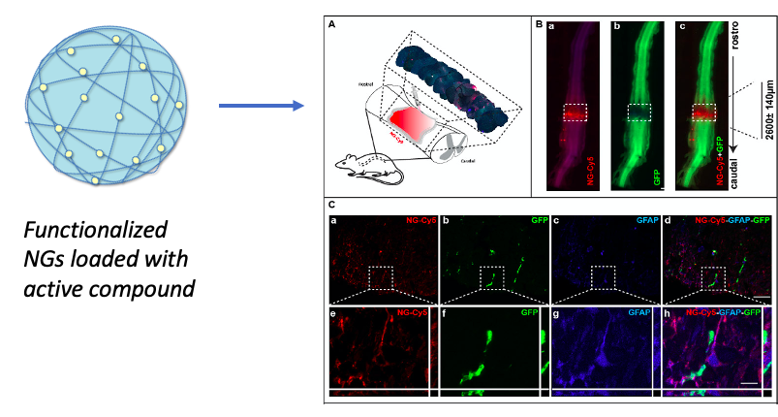
Figure 1. Schematization of the functionalized nanogels (NGs) loaded with active compound (on the left). On the right their applications in spinal cord injury are reported together with the results of the in vivo biological assays on diseased mouse (Fig.A). The co-localization of the NGs and the astrocytes markers (Fig.B and C) confirms their internalization.
4. Conclusions
In this work we successfully developed nanogels structures for drug delivery, characterizing their frameworks and their features. Moreover, we demonstrated their efficacy as selective devices for the treatment of the cells of the central nervous system in the spinal cord injury inflammatory state.
References
- Thuret S., Moon L. D F, Gage F. H Nat. Rev. Neurosci. 7, 628, (2006).
- Papa S., Veneruso V. et al. J.Control Release 330, 218, (2021).
- Pinelli F., Pizzetti F. et al. Coll. Surf. A, 614, 126164, (2021).
- Vismara I., Papa S. et al. ACS Nano 14, 360, (2020).

