**Rational scale-up in multiphase APIs syntheses**

Filippo Nanto1*, Dario Ciato2, Paolo Canu1

*1 University of Padua, Department of Industrial Engineering, Via Marzolo 9, Padua, 35131, Italy;  
 2 Lundbeck Pharmaceuticals Italy, Quarta Strada 2, Padua, Italy.*

*\*Corresponding author E-Mail:* [*filippo.nanto@phd.unipd.it*](mailto:filippo.nanto@phd.unipd.it)

**1.Introduction**

In the pharmaceutical industry batch processes prevail, often involving the presence of solid phases, making the rate of mass transport and the multiphase flow controlling features, affecting their efficiency [2]. Solids can be found as catalysts, reagents, or products, where they could undergo dissolution, precipitation, and crystallization. Moreover, processes are brought to the industrial scale replicating conditions demonstrated at the laboratory scale, without rational scale-up and optimization [3]. The application of common procedures to manufacture large-scale batches may also overlook the impact of physical steps, such as the dissolution time of key reagents [4]. Quantitative tracking of composition in batch experiments (or industrial runs) is also routinely carried out by HPLC, measuring the product quality based on relative quantities, with methods such as the Liquid Chromatography Area Percentage (LCAP) [5,6]. This approach is convenient and swift when evaluating the product fraction, which often needs to be in a defined ratio, but it does not give an indication on the absolute quantity of single species, revealing the impact of mass-transfer limited processes, that selectively add and remove species from the liquid phase usually sampled. This work investigates the impact of LCAP in underestimating the interaction of reaction kinetics and dissolution rate of the key reactant, in representative synthetic step of a proprietary API.

**2. Methods**

The reaction has been investigated at 2 different scales (500 mL, 170 L, lab and pilot, respectively), batchwise. The synthetic cascade starts from an intermediate (M6), which undergoes two hydrogenation steps in methanol/acetic acid, supported by a Pd/C solid catalyst. Two different groups, say A and B, are reduced, leading to two competitive paths, where the reduction of A before B is alternative to the opposite sequence. One reduction step leads to isomers, so the final product is always a mixture of two stereoisomers, called R and S, in a fixed ratio of a. This hydrogenation is carried out at a pressure of 9 bar, where hydrogen is fed semi-batchwise, by sparger placed at the bottom, to keep the pressure constant. The quantification of species inside the liquid phase was carried out through HPLC analysis, using either LCAP or calibration lines, for absolute quantities estimation.

**3. Results and discussion**

Reagent M6 is charged inside the reactors, at the beginning of the process, as a solid powder. From the state of the art, developed inside the industrial facility, a complete dissolution of M6 in the solvent mixture was reported. During the first experiment in the pilot plant a LCAP method was adopted, to follow the species concentration over time. The profile for M6 showed an unusual plateau after 20 minutes, reported in Figure 1a. Instead, by analyzing the absolute quantities (calibration lines) for M6, the concentration in the liquid phase shows an increase during the first 50 minutes, suggesting that a dissolution process was affecting the kinetics of M6 consumption, being on a comparable characteristic time. This finding is in contrast with the established company knowledge of the process. In addition to delaying the conversion, a lower availability of M6 in the liquid phase may affect the selectivity, preferentially supporting one of the 2 reaction paths. The evidence of dissolution, a physical process, affecting the overall process rate must be properly investigated in scaling-up, where fluid dynamics (thus reactor and impeller geometry) will become the key controlling factor.

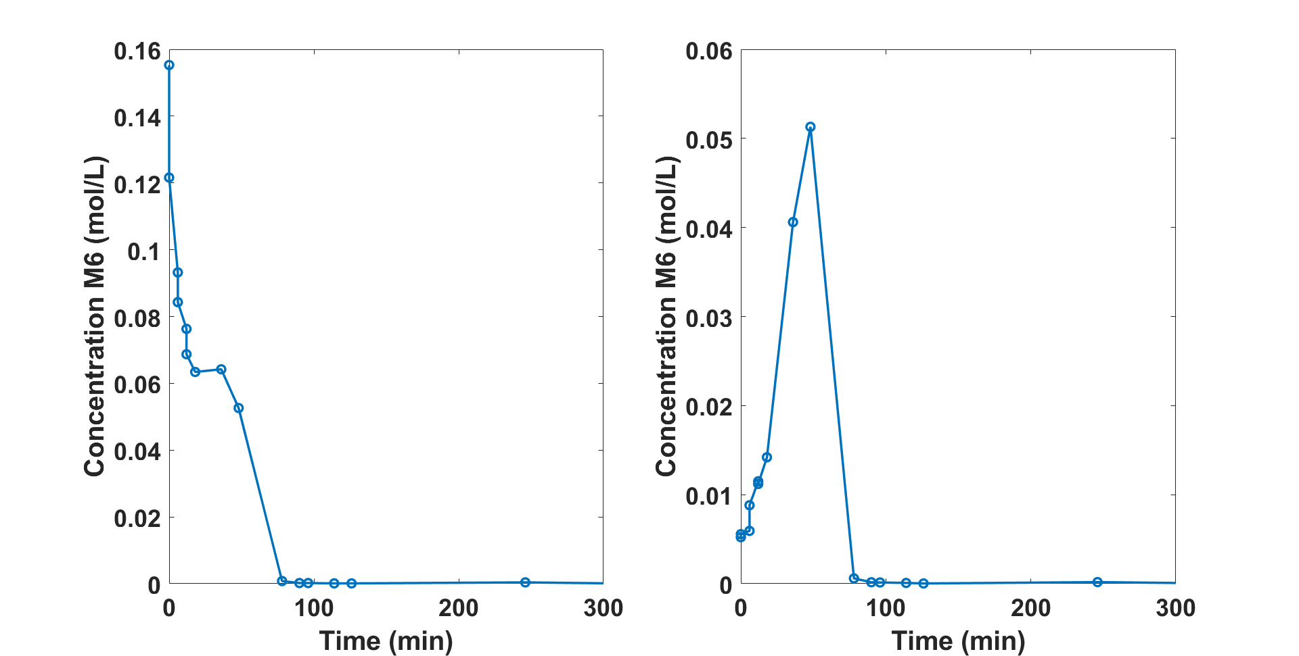

**Figure 1.** left, Concentration of M6 over time with LCAP method. Right,Concentration of over time M6 via HPLC absolute area

The finding calls for an investigation of the kinetics of dissolution. It was investigated at a laboratory scale, maintaining geometrical similarity and reactor operation as close as possible to the pilot. The M6 dissolution kinetics was measured and correlated with the Noyes-Whitney eq., estimating *KLa* at a defined temperature, as shown in Figure 2. Combination of the dissolution rate with reaction kinetics allows to identify a quantitate kinetic model that more appropriately describe the chemistry of the synthesis, as shown in Figure 3.

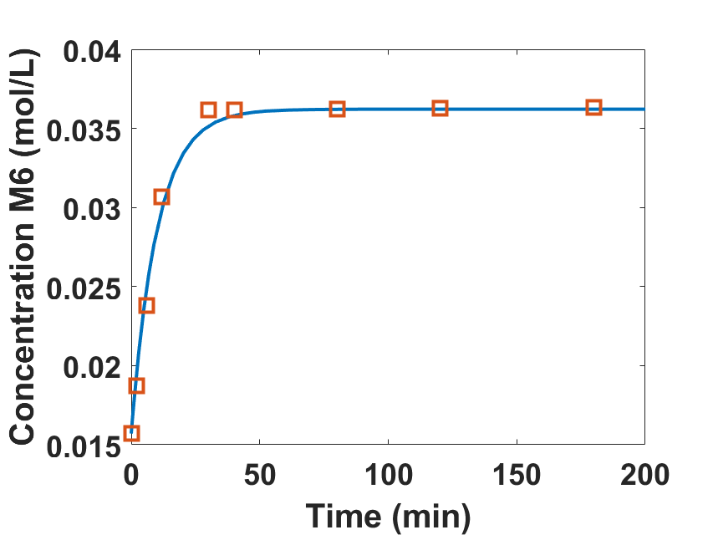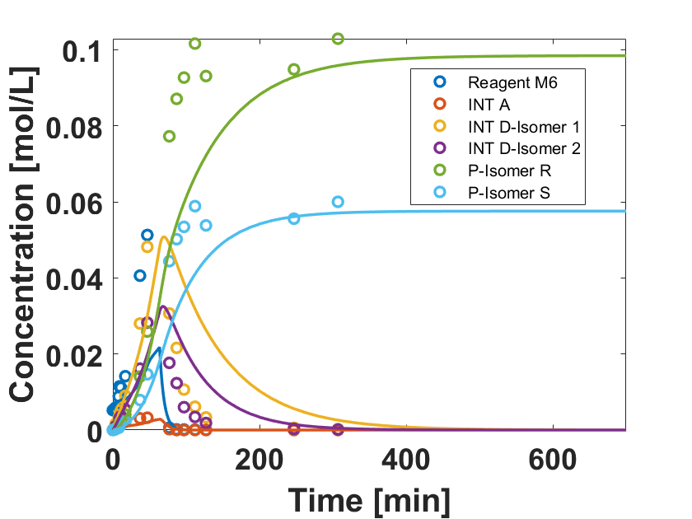

**Figure 2.** M6 dissolution profile at laboratory scale **Figure 3.** Process data fitted by new kinetic model

**4. Conclusions**

Established practices in pharmaceutical industry, such as LCAP method, can lead to underestimate the impact of physical processes, perhaps controlling the batch time significantly. Here the overlook of a critical dissolution step was spotted. Physical processes of heat and mass transfer are the key factors in scaling-up/down multiphase syntheses, and to properly identify the actual chemical kinetics.

**References**

1. R.A Sheldon, (2007) Green Chemistry, 9 (12), 1273-1283
2. C.L. Burcham, A.J. Florence, M.D. Annu. Rev. Chem. Biomol. Eng., 9 (2018), 253-281
3. K. Pandey et al., International Journal of Current Research and Review, 12 (2020), 188-192
4. V. Koganti, et al., AAPS PharmSciTech, (2010), 1541-1548, 11(4)
5. N.S. Marzijarani et al., Organic Process Research and Development, (2021), in Press
6. C. Bottecchia et al., Organic Process Research and Development, (2021), in Press