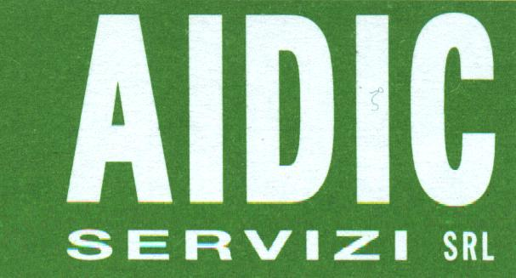

Via Giuseppe Colombo, 81/A
I-20133 Milano, Italy

TRANSFER OF COPYRIGHT AGREEMENT

Authors:

Title of Paper:

Full name , address, phones and e-mail of author who undersigns this Agreement.

Author's name

Address

Voice Phone :

e-mail :

Statements:

1. The Undersigned, desiring to publish the above paper in the publication
Chemical Engineering Transaction, Vol.44, 2015
by AIDIC Servizi S.r.l.
hereby transfers the copyright in the above paper to AIDIC Servizi S.r.l..
2. The Undersigned retains the following rights in the paper:
a) All proprietary rights over than copyright, such as patent rights.
b) The right to reproduce, have reproduced, revise, adapt, prepare derivative works, present orally or
distribute the above paper for such purpose as teaching (including multiple copies for classroom use),
scholarship or research.
3. The Undersigned warrants that the manuscript is the author's original work. If the work was prepared jointly,
the undersigned agrees to inform co-authors of the terms of this agreement. The Undersigned further warrants
that the work has not been published before. The Undersigned also warrants that the manuscript contains no
libellous or unlawful statements, and does not infringe on the right of others.
4. This Agreement is in act if the above quoted Paper will be accepted for the publication on Chemical Engineering Transaction, Vol.44, 2015

Authorised Signature :

Date :
For AIDIC Servizi use only
Manuscript no:
Received :

