Paper Title
Name(s) Surname(s)¹, Name(s) Surname(s)^{2,*}, Name(s) Surname(s)³
¹Affiliation
²Affiliation
³Affiliation

*Corresponding author – e-mail:

TOPIC: abstract subtopic, for example: 1.3 Molecular-level understanding of reactions (https://www.aidic.it/escre2027/page.php?pipe=testotopics)
Abstract. The text of the abstract

1. Title of section
To submit your paper, please refer to the conference web: https://www.aidic.it/escre2027/index.php . The language of the publication as well as of the conference is English. The abstract can not exceed 2 pages.

2. Title of section
To submit your paper, please refer to the conference web: https://www.aidic.it/escre2027/index.php . The language of the publication as well as of the conference is English. The abstract can not exceed 2 pages.

2.1. Title of sub-section
To submit your paper, please refer to the conference web: https://www.aidic.it/escre2027/index.php . The language of the publication as well as of the conference is English. The abstract can not exceed 2 pages.

2.2. Title of sub-section
References in the body of the text can be cited by using numbers in square brackets.
For example: [1] for a single reference, [2,3] for two references, [4–6] for more than two references, [1,4–6] for non-consecutive references, and so on.
For references style, please refer to the last section of this template. For cases not listed there, please refer to standard (e.g., Harvard-based) styles.

3. Title of section
Figures (as images, please do not embed figures from external software) and tables are located in the appropriate place in the manuscript. They can be full-column or full-page wide.
In the body of the text, please write “Table X”, “Figure Y”, example: Table 3 illustrates…as reported in Figure 2.
Formatting of figures and tables is left to the choice of the Authors; please choose readable font sizes for figures; examples are provided below.

Table 1. Particle size distribution: absolute and cumulative fraction.

Size interval [μm] | d_{i} [μm] | x_{i} [–] | Σx_{i} [–]
0–200 | 100 | 0.15 | 0.15
200–400 | 300 | 0.25 | 0.40
400–600 | 500 | 0.50 | 0.90

This is an example for a figure (Figure 1), with a blank line before and after the figure, and a blank line after the caption.

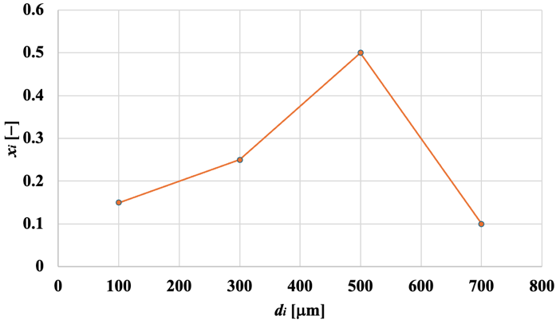

Figure 1. Absolute particle size distribution for the reference data reported in Table 1.

4. Title of section
Equations, properly prepared through an equation editor if possible, will be left-aligned, with the corresponding number right-aligned, for example:

$d_{Sauter}=\frac{1}{\sum_{i}{\frac{x_{i}}{d_{i}}}}$ (1)

Leave a blank line before and after equations. If there are several consecutive equations, they can be written without a blank line in between, for example:

$τ=-μ\frac{dv}{dx}$ (2)
$τ_{w}=\frac{\left|∆P\right|R}{2L}$ (3)

Use italics to indicate variable quantities, both in equations and in the text (while constant quantities, units, parentheses and mathematical operators should not be italicised; vectors are set in bold). To indicate the equation in the text, write Eq. (N), unless at the beginning of a sentence. Examples follow. Equation (1) represents the formula for the evaluation of the mean Sauter diameter, d_{Sauter}, where x_{i} is the absolute mass fraction of particles having mean diameter d_{i}. Data have been post-processed according to the use of Eqs. (2–3). The values for the dynamic viscosity μ have been used in Eq. (2).

Acknowledgement
This section will also include reference to funding, if applicable.

References
Example for Journal papers:
[1] Reynolds, O. (1883) An experimental investigation of the circumstances which determine whether the motion of water shall be direct or sinuous, and of the law of resistance in parallel channels. Proc. R. Soc. Lon., 35, 84–99 (or article number alternative to page numbers).
[2] Buddenberg, J.W., Wilke, C.R. (1949) Calculation of gas mixture viscosities. Ind. Eng. Chem., 41, 1345–1347.

Example for Books:
[3] Lamb, H. (1895) Hydrodynamics. Cambridge University Press, p. 522 (or pp. 521–523, or Chapter 11, etc.).
[4] McCabe, W.L., Smith, J.C., Harriott, P. (2001) Unit Operations of Chemical Engineering. McGraw-Hill.

