Leveraging Digital Twin Modeling for Anaerobic Digesters using Anaerobic Digestion Model No. 1 (ADM1) and Neural Network within the Pyomo Framework
Mayowa F. Oladele,^{a,b} George M. Bollas^{a,b}
ªUniversity of Connecticut, Department of Chemical and Biomolecular Engineering, Storrs, CT, USA
^{b}Pratt & Whitney Insitute for Advanced Systems Engineering, Storrs, CT, USA
george.bollas@uconn.edu
Abstract
Harnessing the power of physics-based modeling and machine learning, this study delves into the development of a digital twin model for anaerobic digesters. The integration leverages the Anaerobic Digestion Model No. 1 (ADM1) in tandem with a Neural Network (NN) algorithm, implemented within Pyomo, an open-source optimization modeling language in Python. Central to this work is a sensitivity analysis conducted on eleven key practical measurements crucial for estimating ADM1 input variables. The results show that measurements such as Particulate Chemical Oxygen Demand (COD_{p}), Volatile Fatty Acids (VFA), and Total Organic Carbon (TOC) have a significant influence on biogas production. This insight gives a better understanding of anaerobic digester dynamics and strengthens the predictive accuracy and control capabilities of digital twin models, marking a significant stride toward the optimization of waste-to-energy processes.
Keywords: Digital Twin, Anaerobic Digestion, ADM1, Neural Network, Sensitivity Analysis.
  - Introduction
In the pursuit of sustainable waste management and energy generation, anaerobic digestion (AD) has emerged as a promising technology. Its unique ability to merge waste treatment with energy production positions AD as a suitable option for methane capture and renewable energy (Curry and Pillay, 2012). However, the efficacy of the AD process is marred by inherent instabilities under specific operating conditions, that can lead to process failure, impacting biogas production and overall system efficiency. In response to these challenges, the integration of digital twin technology emerges as a transformative solution, providing unparalleled insights into AD system dynamics and a means to mitigate operational uncertainties. By harnessing digital twin capabilities, operators and researchers can gain a comprehensive understanding of the underlying processes, identify potential points of failure, control and predict AD system performance under various operational scenarios (Therrien et al., 2020).
This study presents a nuanced approach to building a digital twin for the AD process, combining the mechanistic insight of Anaerobic Digestion Model No. 1 or ADM1 (a physics-based model) and the adaptability of a Neural Network algorithm (data-driven model) implemented in Pyomo. Integrating the ADM1 into the digital twin however poses two challenges: characterization of the influent variables and calibration of numerous parameters (Fatolahi et al., 2020; Girault et al., 2012). These challenges can lead to inaccurate predictions. To address the first challenge, a sensitivity analysis is conducted on practical measurements used to characterize ADM1 inputs. This analysis identifies key measurements impacting biogas production (output of interest), leading to a more accurate and reliable AD system. Our methodology sheds light on the development of the digital twin, particularly emphasizing the sensitivity analysis conducted on the practical measurements needed for the ADM1 inputs.
  - Digital Twin Integration and Implementation
2.1 Anaerobic Digestion Model No. 1 (ADM1)
The core of our digital twin architecture is the ADM1, a well-established physics-based model developed by the International Water Association (IWA) task group. ADM1 is implemented as a differential algebraic system (DAE), encompassing 28 dynamic state variables and 19 biochemical rate processes (Batstone et al., 2002). This model serves as the foundation for capturing fundamental biochemical reactions and processes within the anaerobic digester, providing a comprehensive framework for understanding system dynamics.

2.2 Neural Network (NN) Integration
To complement the strengths of ADM1, a NN is integrated into the digital twin. Trained on historical data from a specific AD system of interest, the NN captures subtle nuances and non-linear relationships that may be challenging for ADM1. The NN introduces adaptability, enabling the digital twin to dynamically adjust to evolving operational conditions and enhance overall predictive accuracy throughout the entire life cycle of the AD system.

2.3 Digital Twin Architecture
The digital twin is constructed by stacking the outputs from both ADM1 and NN into a unified network. We automatically update the weights for each model to ensure accurate representation and responsiveness to changing conditions. The system input (X) and output (Y) collected over a time interval are utilized as a training set (X, Y) to continually train and update the digital twin, adjusting the weights ($w_{physi} and w_{nn}$) for both the physics-based and data-driven components.
The NN employs a multi-layer feed-forward architecture with $k$ hidden layers. The structure incorporates activation functions for non-linearity, with weights ($w$) and biases ($b)$ initialized at random. The final output ($q_{nn}$) is calculated by combining outputs from each layer, contributing to the overall prediction. The final output of the digital twin is the sum of the contributions from both ADM1 and NN.

2.4 Pyomo Framework Implementation
The digital twin is implemented within the Pyomo framework, a powerful optimization modeling language capable of handling the intricate constraints associated with AD operation. ADM1 equations are represented using the Pyomo.DAE package, facilitating the modeling of differential equations and applying discretization (finite differences) to convert the equations to algebraic form. The Ipopt solver was used for solving these equations.
The NN component is specifically implemented using the Optimization and Machine Learning Toolkit (OMLT), an open source-software package integrated also with Pyomo. OMLT enables the transformation of pre-trained machine learning models, including NNs, into the Pyomo algebraic modeling language. The OmltBlock, a Pyomo block, is utilized to create input/output objects and constraints, linking the surrogate model to the broader optimization problem. OMLT supports NNs through interfaces such as ONNX and Keras, providing a seamless integration with Pyomo’s optimization approaches.
This integrated digital twin, combining the strengths of ADM1 and NN within the Pyomo framework, offers a powerful tool for understanding, optimizing, and predicting the dynamics of AD processes throughout their life cycle.
  - Characterization of ADM1 Input variables
In characterizing the input variables of the ADM1, practical measurements of the feedstock entering the anaerobic digestion system are crucial for estimating the model input variables. However, not all of these practical measurements are analyzed in wastewater treatment plants and hence, existing literature provides six methods to characterize the ADM1 input variables based on the available measurements (Girault et al., 2012, 2020; Lübken et al., 2015). These methods include physico-chemical analysis (Lübken et al., 2007), elemental analysis (Kleerebezem and Van Loosdrecht, 2006), anaerobic respirometry (Girault et al., 2020), physico-chemical analysis combined with online gas curve calibration procedure (Girault et al., 2020), conversion of other measurement to the ADM1 inputs required (Nopens et al., 2009), and elemental analysis for high solids waste, also known as the transformer model(Zaher et al., 2009). This study focuses on the transformer model, by conducting a sensitivity analysis to understand the model responses to input variations.

3.1 Transformer Model
The transformer model, an upgrade over elemental analysis measurements, was developed based on principles of mass balance of macronutrient elements (carbon, hydrogen, oxygen, and phosphorus [CHNOP]), Chemical Oxygen Demand (COD) and charge intensity. Developed with the specific aim of generating detailed ADM1 inputs, the transformer model considers 11 practical measurements: particulate COD, COD_{s} – VFA, volatile fatty acid, total organic carbon, organic nitrogen (N_{org}), total ammonia nitrogen, organic phosphorus (TP-orthoP), orthophosphate, total inorganic carbon, total alkalinity, and Fixed Solid (FS). Calculations involve simple differences between existing measurements, as described by Zaher et al. (2009), making the transformer model a practical and well-understood way to generate ADM1 inputs.
  - Sensitivity Analysis
Due to the limited availability of measurements for the ADM1 transformer model inputs, a sensitivity analysis was conducted to evaluate the impact of the 11 key practical measurements on biogas production. Each sensitivity analysis involved varying one input variable while keeping others at baseline values. The results of this analysis are shown in Figures 1 and 2.
Figure 1 shows that biogas production exhibited higher sensitivity to particulate COD, volatile fatty acid, and total organic carbon compared to CODs – VFA. Specifically, Figure 1A shows a decrease in biogas production with an increase in particulate COD. The same trend is observed in Figure 1C where biogas production decreases with an increase in volatile fatty acid, aligning with common understanding of AD systems where an accumulation of volatile fatty acid leads to a decrease in the pH and biogas production. Figure 1D shows that a decrease in total organic carbon also decreases biogas production. While higher total organic carbon content generally supports increased biogas production due to more organic matter for microbial breakdown and conversion into methane and carbon dioxide, an optimal total organic carbon threshold exists depending on the type of organic matter being digested and exceeding it can result in reduced biogas production. Figure 1B indicates relative insensitivity of biogas production to changes in CODs – VFA.
In Figure 2, organic nitrogen, organic phosphorus, and total ammonia nitrogen are identified to have a relatively significant influence on biogas production. Figures 2A, 2B, and 2C depict increased biogas production with decreasing values of organic nitrogen, organic phosphorus, and total ammonia nitrogen, respectively. Generally, elevated organic nitrogen levels can induce ammonia toxicity, inhibiting methanogen activity, while excessive organic phosphorus can lead to struvite formation, reducing reactor volume and biogas production. Conversely, Figure 2D shows low sensitivity to changes in orthophosphate.
Furthermore, the analysis showed that biogas production exhibited low sensitivity to total inorganic carbon, total alkalinity, and Fixed Solid. Incremental values of total alkalinity, and Fixed Solid, as well as decreasing total inorganic carbon values, showed negligible impact on biogas production. While these observations are pivotal, visual representations of these plots are omitted due to their inconsequential influence on biogas production.

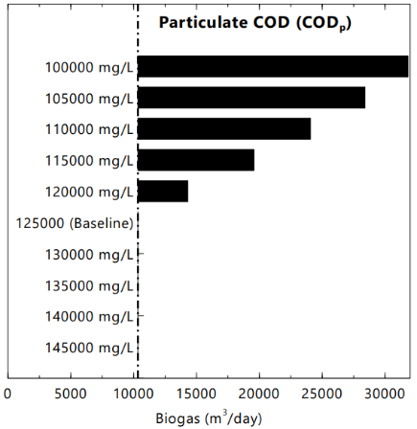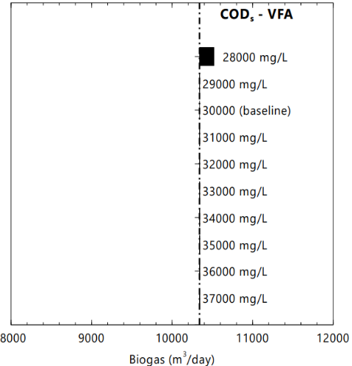
- (B)

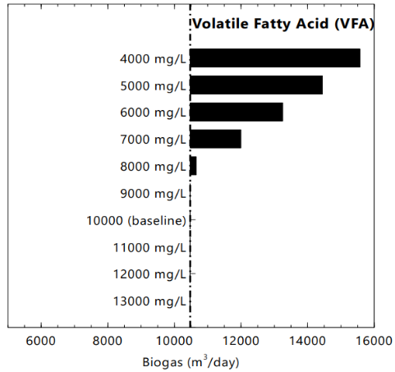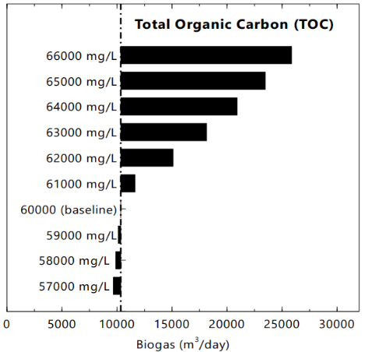
(C) (D)
Figure 1: Sensitivity analysis of biogas production with respect to (A) COD_{p}; (B) COD_{s} – VFA; (C) VFA; (D) TOC

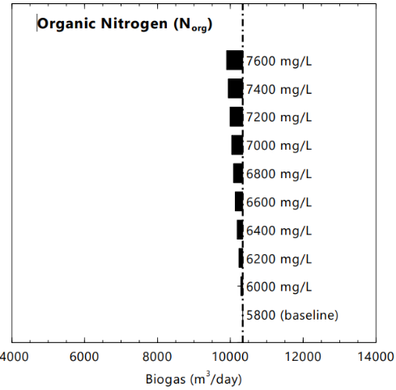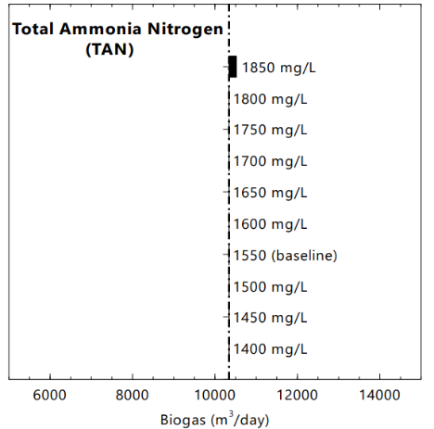
(A) (B)

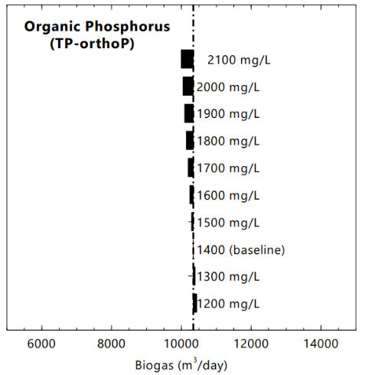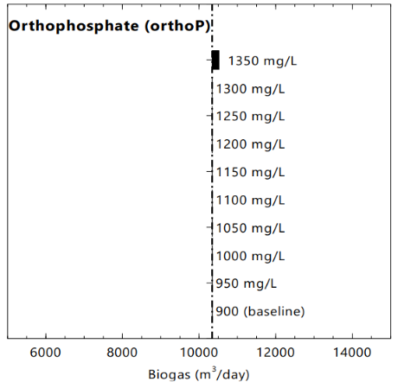
(C) (D)
Figure 2: Sensitivity analysis of biogas production with respect to (A) N_{org}; (B) TAN; (C) TP-orthoP; (D) orthoP

These sensitivity analysis results provide valuable insights into the most important practical measurements influencing biogas production within the AD system. Particulate COD, Volatile Fatty Acids, and Total Organic Carbon were observed to have the highest impact on biogas production, emphasizing the necessity for accurate characterization to optimize and predict biogas production effectively.
  - Conclusion
This study underscores the significance of leveraging a digital twin in the context of anaerobic digesters, using the Anaerobic Digestion Model No. 1 (ADM1) within the Pyomo framework. A pivotal aspect of this study is the sensitivity analysis conducted on key practical measurements of the ADM1 transformer model, which is crucial for estimating ADM1 input variables. The result highlights the significant influence of particulate COD, Volatile Fatty Acids, and Total Organic Carbon on biogas production. This insight enriches our understanding of anaerobic digester performance and helps the predictive accuracy and control capabilities of AD digital twin models. Despite the challenges in ADM1 integration, particularly in input characterization, this study addresses these challenges and lays the groundwork for future research endeavors aimed at optimizing these important measurements.

Acknowledgment
This study was supported by the U.S. Department of Energy’s Office of Energy Efficiency and Renewable Energy (EERE) under the Advanced Manufacturing Office, Award Number DE-EE0009497.

References
Curry, N., Pillay, P., 2012. Biogas prediction and design of a food waste to energy system for the urban environment. Renew Energy 41, 200–209.
Fatolahi, Z., Arab, G., Razaviarani, V., 2020. Calibration of the Anaerobic Digestion Model No. 1 for anaerobic digestion of organic fraction of municipal solid waste under mesophilic condition. Biomass Bioenergy 139.
Girault, R., Bridoux, G., Nauleau, F., Poullain, C., Buffet, J., Steyer, J.P., Sadowski, A.G., Béline, F., 2012. A waste characterisation procedure for ADM1 implementation based on degradation kinetics. Water Res 46, 4099–4110.
Girault, R., Steyer, J.-P., Zaher, U., Sadowski, A.G., Nopens, I., Béline, F., Zak, A., Kujawski, O., Holm, N.C., Rönner-Holm, S.G.E., n.d. Influent fractionation and parameter calibration for ADM1: Lab-scale and full-scale experiments.
IWA Task Group for Mathematical Modelling of Anaerobic Digestion Processes., 2002. Anaerobic digestion model no. 1 (ADM1). IWA.
Kleerebezem, R., Van Loosdrecht, M.C.M., 2006. Waste characterization for implementation in ADM1. Water Science and Technology 54, 167–174.
Lübken, M., Kosse, P., Koch, K., Gehring, T., Wichern, M., 2015. Influent fractionation for modeling continuous anaerobic digestion processes. Adv Biochem Eng Biotechnol 151, 137–169.
Lübken, M., Wichern, M., Schlattmann, M., Gronauer, A., Horn, H., 2007. Modelling the energy balance of an anaerobic digester fed with cattle manure and renewable energy crops. Water Res 41, 4085–4096.
Nopens, I., Batstone, D.J., Copp, J.B., Jeppsson, U., Volcke, E., Alex, J., Vanrolleghem, P.A., 2009. An ASM/ADM model interface for dynamic plant-wide simulation. Water Res 43, 1913–1923.
Therrien, J.D., Nicolaï, N., Vanrolleghem, P.A., 2020. A critical review of the data pipeline: How wastewater system operation flows from data to intelligence. Water Science and Technology.
Zaher, U., Buffiere, P., Steyer, J. ‐P., Chen, S., 2009. A Procedure to Estimate Proximate Analysis of Mixed Organic Wastes. Water Environment Research 81, 407–415.

