A Novel Vapor Recompressed Batch Extractive Distillation for Ethanol Dehydration

Sidharth Sankar Parhia, Gade Pandu Rangaiahb and Amiya K Janaa*

aDepartment of Chemical Engineering, Indian Institute of Technology Kharagpur, India−721302

bDepartment of Chemical and Biomolecular Engineering, National University of Singapore, Singapore-117585

* Corresponding author. *E-mail address*: [akjana@che.iitkgp.ac.in](mailto:akjana@che.iitkgp.ac.in) (A. K. Jana).

Abstract

This work proposes a novel batch extractive distillation (BED) by introducing vapor recompression in selected stages of batch operation, for ethanol dehydration using ethyl glycol. To optimize BED for multiple conflicting objectives related to economics, production and environmental impact, a mixed-integer nonlinear multi-objective optimization problem is formulated and solved using the elitist non-dominated sorting genetic algorithm. One optimal design from the generated Pareto-optimal front is selected by multi-criteria decision making. Then, a novel selective vapor recompressed BED (S-VRBED) is developed for BED. Retrofitting BED to S-VRBED lowers energy consumption and CO2 emissions by 58%, and the investment made for the compressor is recovered in 5.7 years.

**Keywords**: Batch extractive distillation, Retrofitting, Selective vapor recompression, Multi-objective optimization, Ethanol dehydration

* 1. Introduction

Despite very low thermodynamic efficiency, distillation is widely used for separating liquid mixtures. Among various technologies for improving efficiency of distillation, heat integration of reboiler and condenser via a motor-driven vapor recompression (VRC) heat pump is attractive. However, reported studies are mostly on separation of liquid mixtures in a continuous column. Recently, our group has successfully employed VRC for batch distillation (BD) (Parhi et al., 2019). Distillation is dominant for ethanol recovery from fermentation broth to ≈ 95 wt% ethanol; then, azeotropic distillation with cyclohexane, extractive distillation (ED) with ethyl glycol (EG) or adsorption with molecular sieves is used for subsequent dehydration to > 99.5 wt% ethanol (Singh and Rangaiah, 2017). ED offers versatility with a range of entrainers (solvents). There are studies on batch ED (BED) for ethanol dehydration; but, VRC is uncommon in BEDs, due to its high capital cost (CAPEX) despite high energy savings. To reduce the investment, this work proposes different VRC schemes; they avoid operation at a high compression ratio. Hence, they will be beneficial from both economic and environmental perspectives.

Design of any process including BED should be optimized. BED optimization is a mixed-integer nonlinear programming problem with continuous (reboiler duty, reflux ratio, RR etc.) and integer variables (number of trays, feed tray etc.). Further, optimization of an unsteady process like BED is challenging, complex and requires a robust global optimizer like genetic algorithm (GA). Thanks to advancements, e.g., elitist non-dominated sorting GA (NSGA-II), and computational power, multi-objective optimization (MOO) of BD has been studied recently (Parhi et al., 2019).However, MOO of BED has not been explored extensively. Barreto et al. (2011) reported this considering only continuous variables to maximize profit while minimizing environmental impact, for the separation of chloroform and methanol with water as the entrainer. We suggested a MOO strategy to optimize BED and vapor recompressed BED (VRBED) for separating azeotropic mixture of acetone and methanol using water as the entrainer (Parhi et al., 2020). These studies on MOO and VRC for BED are limited to separating mixtures of two products using a cheaper entrainer such as water.

However, for dehydration of a desirable component (ethanol in this case) using a suitable but expensive entrainer such as EG, a different strategy is required considering objectives related to economics, environment, production and entrainer recovery. This is because both product and entrainer recovery are equally important in ethanol dehydration. Moreover, the same type of VRC cannot be used for all BEDs; because of high CAPEX, traditional VRC may not be economical. To address this issue, the present work proposes a novel selective VRC. **In summary**, main contributions and novelty of this study are as follows. Firstly, a unique MOO problem is articulated considering competing objectives of economics, production, entrainer recovery and CO2 emissions for ethanol dehydration in BED. Secondly, a variable speed VRC is introduced to retrofit the optimal BED and assess its benefits for ethanol dehydration. Thirdly, a novel selective VRBED (S-VRBED) is suggested to reduce CAPEX for VRC.

* 1. Working Principle and Process Modeling

A typical BED (Fig. 1a) has a reboiler at the bottom, a distillation tower in the middle and a total condenser with a reflux drum at the top. The working procedure of BED, its modeling and simulation, associated thermodynamic model and operating conditions are described elsewhere (Parhi et al., 2020). Proposed VRBED schemes are developed below.

C:\Users\Sidharth\Dropbox\IIT KHARAGPUR PHD WORKS\PhD writings\SEVENTH PAPER\combined graphf.tif

**Figure 1.** Schematic diagram of BED (plot 1a) and VRBED (plot 1b)

**VRBED*:*** VRC, one effective solution for reducing CO2 emissions, uses internal heat to minimize external energy requirement. As shown in Fig. 1b, column overhead vapor stream (at *TNT*) is compressed to increase both pressure and temperature, and then it is used to vaporize the liquid in the reboiler (at *TB*). Driving force (Δ*T*) for heat transfer in the reboiler was taken as 15°C. The compressed vapor condenses in the reboiler, giving its latent heat for boiling the reboiler content. A throttling valve depressurizes the condensed vapor before channelling it to the reflux drum. Thus, latent heat of the overhead vapor is used to reduce the hot utility required at the reboiler. Compressor duty (*QComp*) in VRC is computed using Eq. 1 in Parhi et al. (2020).

A***variable speed operating policy*** is formulated for VRBED for optimum utilization of internal heat. Inputs and outputs of BED (i.e., reboiler duty, feed composition and product purity) are same for both VRBED and BED. Complete condensation of compressed vapor in the reboiler is assumed provided that the required thermal driving force is maintained during the operation. For this, two operating criteria, namely, constant thermal driving force and constant reboiler duty (*QR*) are proposed; to satisfy them, an open-loop control policy that computes three manipulated variables, namely, compression ratio (CR), *VNT* and external heat input to the reboiler (*QE*), is devised. ***First operating criterion:*** A variable-speed compressor is used to ensure column operation at *ΔTT = TNTC - TB* = 15○C during the entire batch process. For this, the compressor is operated below or at maximum CR (by varying CR at every time step of 0.0008 h with the change in top and reboiler temperatures). ***Second operating criterion:*** In BED, the entire heat input to the reboiler is supplied externally. In VRBED, latent heat, *QCV = λVNT* of the compressed overhead vapor reduces *QE* to the reboiler according to: *QR = QE + QCV*. Here, there are two scenarios. In the *First Scenario* (*QCV* > *QR*), overhead vapor is split into two fractions. One fraction (*VNTC*) is fed to the compressor and then condensed in the reboiler, and the other fraction (*VNT1*) is sent to the condenser, which is operated with reduced coolant flow rate, and no external steam is needed in the reboiler. In the *Second Scenario*(*QCV* < *QR*), all the overhead vapor (*VNTC*) is compressed for use in the reboiler. The deficit heat (*QR - QCV*) is provided by steam to the reboiler, and the condenser operation is not required. Thus, VRC reduces steam required in the reboiler and coolant needed in the condenser; but, it requires a compressor that is typically operated by a motor. This raises a query whether VRBED saves total energy or not compared to BED. Another important issue is the compressor’s high CAPEX that can make retrofitting a BED with VRC uneconomical. To address this, a novel **S-VRBED** is proposed and investigated later in this paper.

* 1. Quantitative Performance Assessment and Optimization Strategy

Total annual cost (TAC) and total annual production (TAP) (Parhi et al., 2020) are implemented for techno-economic analysis of the considered schemes. TAC is the sum of operating cost, OPEX ($/a) and 20% (i.e., payback period, PBP = 5 years) of CAPEX ($) that includes additional 10% for working capital. For BED, both TAP of required product and entrainer recovery are often important. Hence, TAP of the desired product and total annual entrainer recovery (TAER) are included for performance analysis. TAP is the product collected per batch multiplied by number of batch cycles per annum (based on 8000 working hours and 30 minutes of batch setup time). Similarly, TAER is computed based on the amount of entrainer recovered per batch in the reboiler. Efficiency of entrainer usage (*EoEU*), equal to molar ratio of total ethanol collected to total entrainer used, and CO2 emissions are also included as objectives in MOO. In BED, steam is employed in reboiler; VRBED additionally uses electricity for compressor. CO2 emissions in steam generation are based on equations in Parhi et al. (2020) and it is 51.1 kg CO2/GJ of electricity.

**Optimization Strategy**: Due to the nonlinearity and presence of both continuous and discrete decision variables, BED optimization is challenging. Hence, a 3-step procedure is developed for BED optimization. In the first step, significant decision variables impacting objectives are identified by sensitivity analysis and then MOO problem is formulated. The second step deals with optimizing BED using NSGA-II in MATLAB. This gives a set of non-dominated solutions. Such sets obtained from several runs of NSGA-II are pooled and subjected to non-dominated sorting to find the 'true' Pareto-optimal front. In the final step, one optimal solution from this front is selected by a multi-criteria decision making (MCDM) method, namely TOPSIS (Technique for Order of Preference by Similarity to Ideal Solution), available in an MS Excel program. Weights required for TOPSIS are found by the entropy method (Parhi et al., 2019).

* 1. Case Study, BED Optimization and Retrofitting

The case study is separation of ethanol and water that form a minimum-boiling azeotrope with 89.4 mol% ethanol at 78.28oC and 1 atm. For BED, a MOO problem is formulated to minimize CAPEX ($), OPEX ($/a) and CO2 emissions (t/a), while maximizing TAP of ethanol (kmol/a), *EoEU* and TAER (kmol/a). Constraints are: purity of ≥ 99.5% for both ethanol and water, and ≥ 99.9% for EG. Decision variables with their lower/upper bounds are: no of trays (20/80), feed tray (15/75), reboiler duty (0.3/30 GJ/h), RR during ethanol production (0.01/10), RR during slop-cut discharge (0.01/10), RR during water collection (0.01/30), entrainer feed rate (1/500 kmol/h) and weir height (25.4/101.6 mm).

MOO problem along with model equations for BED (Parhi et al., 2020) was solved 4 times using NSGA-II. Each optimization run generated 50 non-dominated solutions after 200 generations. The 200 solutions thus obtained are subjected to non-dominated sorting to find the “true’ Pareto-optimal front having 68 non-dominated solutions. Trends of objectives and decision variables are not discussed here due to space constraint. TOPSIS with entropy weights for objectives is used for selecting one optimal solution from the Pareto-optimal front. The optimal configuration of BED, thus chosen, is: 20 trays (plus reboiler and condenser), RR of 0.184, 0.304 and 0.185 during ethanol production, slop-cut discharge and water collection, respectively, constant reboiler duty of 2.02 GJ/h throughout batch operation, 5.52 kmol/h of EG entering at tray 17 and weir height of 76.2 mm. The transient composition profile for the optimal BED is presented in Fig. 2a. A quasi-steady state under total reflux (Step 1) is achieved in 0.94 h; ethanol in the reflux drum reached 99.984 mol% at the end of start-up phase (Step 1). In Step 2, ethanol is continuously collected in the product tank for 0.364 h, and this is halted when the average ethanol purity in the tank no longer exceeds 99.5 mol%. Then, slop-cut (Step 3) starts and continues for 0.223 h. With the progression of this step, ethanol concentration in the column decreases, and water concentration in the top section increases gradually. Finally, in Step 4, highly concentrated water is collected in the tank at the top having a maximum concentration of 99.97 mol% and then it reduces due to the removal of water from the column. This final step proceeds for 0.17 h till the concentration of water in its tank is more than 95 mol%. Taking the total batch time of 1.693 h for 4 steps and 0.5 h for batch preparation, unloading and cleaning, 3,648 (= 8,000/(1.693+0.5)) batches can be performed in one year. This means BED is operated for only 6176 (= 1.693×3648) h annually with TAP of 28.96×3648 = 105,655 kmol/a. Difference between *TB* and *TNT* (Fig. 2b) is ≈ 20oC for half the batch operation and attains a maximum of 98.33oC at 1.52 h (in Step 3). Saturation temperature of steam should be 15oC more than the maximum reboiler temperature of 198oC; that is, it should be 213oC.

**Retrofitting BED to VRBED and S-VRBEDs**:Optimal BED is retrofitted to VRBED and five S-VRBEDs. All these schemes are such that dynamics of product quantities, purities and annual operational hours are the same as those of the optimum BED. VRBED is formulated based on two operating criteria: Δ*TT* = 15oC and *QR* = 2.02 GJ/h, stated earlier. Following the CR profile (Fig. 2c), a variable speed compressor is operated to maintain Δ*TT* = 15oC. Providing fixed *QR* is met by supplying the requisite *Q*E according to the profile (Fig. 2d) for retrofitted VRBED; second scenario (*QCV < QR*) occurs during the first half of the batch operation, and first scenario (*QCV > QR*) occurs in ethanol production phase. Further, in VRBED case (Fig. 2c), CR of 8.62 reached at 1.28 h significantly increases compressor’s CAPEX and TAC that make retrofitting BED to VRBED is uneconomical. This inspired us to propose different S-VRBEDs, which involve selective use of VRC in one or more steps of BED operation. Based on this, five S-VRBEDs are proposed and assessed; these are added to the optimal BED, selected by TOPSIS with entropy weights. As shown in Fig. 2c, maximum CR is in Step 2, and so VRC addition in this step is unlikely to be economical. Five S-VRBEDs are: S1-VRBED with VRC in only Step 1 of the batch operation; S2-VRBED with VRC in Steps 1, 3 and 4; S3-VRBED with VRC based on average CR of 2.97 (Fig. 2c) in all steps; S4-VRBED with VRC based on average CR of 4.03 (Fig. 2c) in product withdrawal Steps 2 to 4; and S5-VRBED with VRC based on average CR of 3.12 (Fig. 2c) in the last two Steps of 3 and 4. Thus, S3-, S4- and S5-VRBED are based on average CR of VRBED. When the required CR goes beyond the average, these schemes work like a BED.

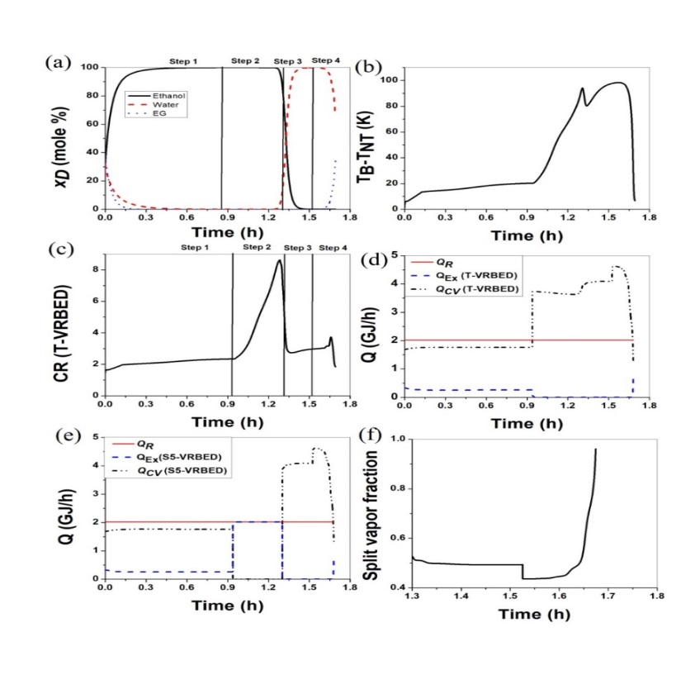

**Figure 2.** Transient profiles of distillate composition (plot 2a for BED & VRBED), temperature difference (plot 2b for BED & VRBED), CR (plot 2c for VRBED), *QCV, QR* & *QE* of VRBED (plot 2d), *QCV, QR* & *QE* for S5-VRBED (plot 2e) and overhead vapor split to compressor for S5-VRBED (plot 2f).

* 1. Selection of Retrofitting and Performance Assessment

Three criteria: reduction in CO2 emissions, PBP and amount of product (ethanol) per dollar (PPD), are considered for selecting the best scheme out of the proposed ones. This is because TAP of ethanol, *EoEU* and TAER are same for the schemes. Reduction in CO2 emissions, PBP and PPD of six retrofitted schemes (VRBED and five S-VRBEDs) are compared in Fig. 3, which clearly shows the trade-off among these criteria. Hence, one of these schemes is chosen using TOPSIS with entropy weights. The chosen scheme is S5-VRBED with VRC based on the average CR of 3.12 in Steps 3 and 4. For this scheme, *QCV* and *QE* profiles are in Fig. 2e. Like VRBED, first scenario (*QCV > QR*) occurs in Steps 3 and 4, and it requires splitting overhead vapor 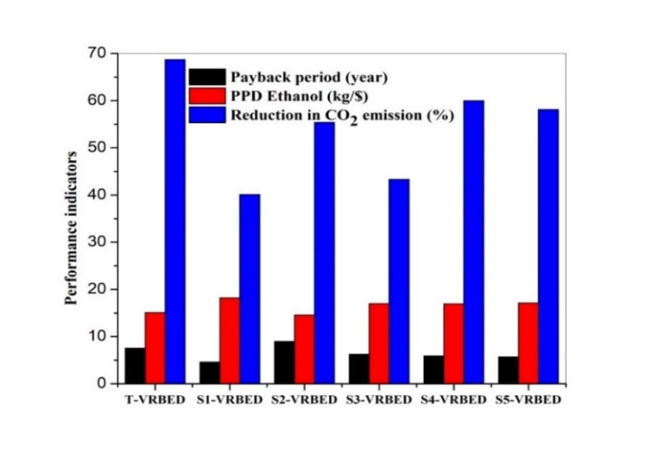according to the profile in Fig. 2f.

**Figure 3.** Performance indicators of six retrofitted schemes.

Results show that substantial CAPEX for compressor addition in VRBED (i.e., 116.2% of CAPEX for optimal BED) is the main obstacle to using traditional VRC. This is overcome in the proposed selective VRCs. For the chosen S5-VRBED, CAPEX is 20% lower than that of VRBED (although it is higher for both VRBED and S5-VRBED than that of BED). OPEX is reduced for both VRBED (by 68%) and S5-VRBED (by 56.4%) compared to optimal BED. Further, retrofitting optimal BED to VRBED or S5-VRBED lowers CO2 emissions by 68.7% or 58.1%, respectively. VRC, however, incurs an additional investment as reflected in TAC increase and lower PPD of ethanol. Hence, PPD of ethanol for VRBED and S5-VRBED is reduced by 15.5 and 4.1%, respectively, over BED. The chosen S5-VRBED has PBP of 5.7 years for compressor’s CAPEX, which seems high, but it reduces CO2 emissions by 58.1%. Enterprises are actively addressing environmental concerns to improve their sustain-ability and not just economics. Hence, PBP of 5.7 years for S5-VRBED is acceptable.

* 1. Conclusions

This work proposes a novel way to retrofit BED by selective VRC in some steps of batch operation, to reduce CO2 emissions without compromising economics. It is illustrated for the dehydration of ethanol using EG entrainer. For this, BED is optimized for six objectives. From the "true" Pareto-optimal front found, one optimal solution is selected using TOPSIS with entropy weights. Then, to improve sustainability, 5 different retrofits (S-VRBEDs) of optimal BED are proposed along with VRBED. The best retrofit is chosen by TOPSIS with entropy weights considering three criteria. All the retrofitted VRBEDs reduce both OPEX and CO2 emissions. VRBED requires substantial CAPEX for the compressor, which is addressed by S-VRBEDs. The chosen retrofitting of BED to S5-VRBED requires 62.9% of CAPEX of VRBED for compressor. It reduces CO2 emissions by 58.1% with a PBP of 5.7 years for compressor’s CAPEX but increases TAC by 4.3%. Proposed S-VRBEDs can be applied to any existing or new BD systems.

References

A.A. Barreto, I.R. Donis, V. Gerbaud, X. Joulia, Multi-objective optimization of three-phase batch extractive distillation, Computer Aided Chem. Eng., 29, 562 (2011).

S.S. Parhi, A. Pramanik, G.P. Rangaiah, A.K. Jana, Evolutionary algorithm based multi-objective optimization of vapor recompressed batch extractive distillation: Assessing economic potential and environmental impact, Ind. Eng. Chem. Res., 59, 5032 (2020).

S.S. Parhi, G.P Rangaiah, A.K. Jana, Optimizing reboiler duty and reflux profiles of vapor recompressed batch distillation, Sep. Purif. Technol., 213, 553 (2019).

A. Singh, G.P. Rangaiah, Review of technological advances in bioethanol recovery and dehydration, Ind. Eng. Chem. Res., 56, 5147 (2017).