**Performance evaluation of several reverse osmosis process configurations for the removal of N-nitrosomethylethylamine (NMEA) from wastewater**

Mudhar Al-Obaidia,b, Alanood Alsarayrehc, Iqbal M. Mujtabad

aTechnical Institute of Baquba, Middle Technical University, Baquba 32001, Iraq

bTechnical Instructor Training Institute, Middle Technical University, Baghdad 10074, Iraq

cChemical Engineering Department, Mu’tah University, Al Karak 61710, Jordan

dChemical Engineering Department, University of Bradford, Bradford BD7 1DP, UK.

[*I.M.Mujtaba@bradford.ac.uk*](mailto:I.M.Mujtaba@bradford.ac.uk)

Abstract

Reverse Osmosis (RO) process has been extensively used for the elimination of toxic contaminants from wastewater. Development of an appropriate RO process in terms of process configuration (design) and operating conditions is essential for the effective removal of contaminants. For the first time, this study investigates different RO configurations for effective elimination of NMEA from wastewater using model based techniques. These configurations include series, parallel, and tapered RO process. Using a complete process model, simulation of different RO configurations is carried out for a given set of operating conditions and the best RO configuration is selected. The tapered configuration of retentate-permeate reprocessing design of RO process has been found to be more effective in terms of removal of NMEA from the wastewater despite its high energy consumption.

**Keywords**: Reverse Osmosis, Wastewater treatment, N-nitrosomethylethylamine (NMEA), Modelling, Simulation, Performance Analysis.

1. Introduction

Reverse osmosis (RO) is a water purification technique utilised in wastewater treatment and water desalination. Harmful particles are eliminated by RO using a semipermeable membrane (Osorio et al., 2022). N-nitrosomethylethylamine (NEMA), is a member of the N-nitrosamine family, was regarded as a human carcinogenic chemical based on the US EPA and IARC classifications (IARC, 1987). According to statistics, 250x10-6 ppm of NMEA is the cancer risk limit as stipulated by the US EPA, IRIS (USEPA, 1993). As a result, several water authorities worldwide are subjected to regulations on the maximum permissible level of NEMA concentration in reclaimed water and drinking water for human consumption.

Given their high hydrophilic properties and lower molecular weight, the N-nitrosamine family members NDMA (N-nitrosodimethylamine), NMEA, and NPYR (N-nitrosopyrrolidine) are thought to be resistant to total elimination through the RO process (Alaba et al., 2017). There has been a great deal of studies done in the open literature on the removal of the most-stubborn NDMA molecules utilising the RO process (Fujioka et al., 2014; Al‐Obaidi et al., 2018a, 2018b; Takeuchi et al., 2018; Szczuka et al., 2020). In this regard, only Fujioka et al. (2014) conducted the related research on the removal of NEMA (molecular weight 88.06 g/mol) from wastewater using the spiral wound RO process. In this context, Fujioka et al. (2014) employed a single stage RO treatment system consisting of three membrane modules of ESPA2-4040 spiral wound elements linked in a series. The results showed that the NEMA rejections are 72%, 82%, and 87.2%, respectively, for 4, 6.51, 10.1 atm of feed pressure. Fujioka et al. (2014) considered only a lab-scale RO process and did not consider different RO configurations, which is the focus of this study. Accordingly, four distinct RO process configurations of six membrane modules are proposed. Using a simulation-based model, the optimal design will be selected while considering a fixed set of the inflow conditions (temperature, flow rate, concentration, and feed pressure). The performance metrics of the selected configuration will be compared against the results of Fujioka et al. (2014) to demonstrate the significance of this study.

1. Modelling of a spiral wound module

Al-Obaidi et al. (2018d) developed a mathematical model to assess the impact of inlet conditions on the performance metrics of RO process for desalination. Compared to the previous models developed by Al-Obaidi et al. (2018a,b,c), Al-Obaidi et al. (2018d) established an inclusive model that characterises the influence of water temperature on the water and solute transport parameters of the membrane. In the current study, the same model was calibrated to systematically envisage the performance of different configurations of RO process towards the removal of NEMA from wastewater. Table 1 presents the comprehensive model that was coded and solved using gPROMS software.

1. Model Validation

The model estimations are compared against those collected data of Fujioka et al. (2014) of three spiral wound modules connected in a series. Table 2 and 3 show the marginal errors between the model estimations and experimental data of the studied performance indicators. This in turn assures the robustness of the model. Thus, it is fair to utilise the model to measure the performance of different configurations of RO process towards the removal of NMEA from wastewater. However, it should be noted that there is a considerable discrepancy between the model prediction and experimental data particularly at low operating pressure (Table 3). This can be attributed to the assumption made during the development of this model. This is the validity of Da Costa et al. (1994) who provided relationships between the spacer characteristics and pressure drop in the feed channel. Accordingly, different values of feed spacer characteristic A* and n (dimensionless) (Eq. 6 of Table 1) were investigated for each feed spacer. Seemingly, these values do not accurately fit the conditions of very low pressure of RO process.

1. Proposed configurations of multistage RO process

Fig. 1(A, B, C, and D) depicts the proposed configurations of RO system under investigation for the elimination of NMEA from wastewater. Six spiral wound modules of RO process are considered to propose four different configurations (configuration A: series, configuration B: parallel, configuration C: tapered 3:2:1 of retentate-retentate reprocessing design (RR), and finally configuration D: tapered 3:2:1 of retentate-permeate reprocessing design (RP)). Note, configuration D (Fig. 1) is characterised by the existence of an energy recovery device (ERD) that is installed between the second and third stages to ensure an effective treatment of the permeate in the third stage. This is utilised to increase the reprocessing permeate pressure (1 atm) to a higher value in order to sustain sufficient driving power within the third stage's membranes and throughout the stages that follow. The design features of the spiral wound membrane element (made by Hydranautics, Oceanside, CA., USA) and the maximum limits of inlet conditions are provided in Table 4. Table 5 presents the water transport parameter and NEMA solute transport parameter of the membrane used.

Table 1. Model of RO system (Al-Obaidi et al., 2018d)

|  |  |  |
| --- | --- | --- |
| No. | Model equation | Description |
| 1 | $Q_{p}= {NDP}_{fb} A_{w(T)}$ | Permeate flow rate ($Q_{p}$) |
| 2 | $$A_{w(T)}= A_{w(25 ºC)} {TCF}_{p} F_{f}$$ | Water transport parameter of membrane ( $A_{w(T)})$ |
| 3 | ${TCF}_{p}=\exp\left[0.0343 \left(T-25\right)\right]$ $<25 °C$ ${TCF}_{p}=\exp\left[0.0307 \left(T-25\right)\right]$ $>25 °C$ | Temperature correction factor of permeate |
| 4 | $${NDP}_{fb}=P_{fb}-P_{p}-π_{b}+π_{p}$$ | Net driving pressure of feed and brine (${NDP}_{fb}$) |
| 5 | $P_{fb}=P_{f}-\frac{{∆P}_{drop,E}}{2}$ | Feed-brine pressure ($P_{fb}$) |
| 6 | ${∆P}_{drop,E}=\frac{{9.8692x{10}^{-6} A^{*}ρ}_{b} {U_{b}}^{2} L }{2d_{h} {Re}_{ }^{n}}$ | Pressure drop along membrane length (${∆P}_{drop,E}$) |
| 7 | ${{Re}_{ }}_{ }=\frac{ρ_{b }d_{h }Q_{b}}{t_{f} W μ_{b}}$ | Reynolds number ($Re$) |
| 8 | $Q_{b}=\frac{Q_{f} + Q_{r}}{2}$ | Bulk flow rate in the feed channel ($Q_{b}$) |
| 9 | $Q_{f}=Q_{r}+Q_{p}$ | Mass balance |
| 10 | $Q_{f}{ C}_{f}-Q_{r} C_{r}=Q_{p} C_{p}$ | Solute balance |
| 11 | $$π_{b}=0.7994 C_{b} \left[1+0.003 \left(T-25\right)\right]$$ | Osmotic pressure in the brine ($π_{b}$) |
| 12 | $$π_{p}=0.7994 C_{p} \left[1+0.003 \left(T-25\right)\right]$$ | Osmotic pressure in the permeate ($π_{p}$) |
| 13 | $$C_{b}=\frac{C_{f}+C_{r}}{2}$$ | Bulk concentration ($C_{b}$) |
| 14 | $$C_{r}=C_{f} {\left[1-Rec\right]}^{-Rej}$$ | Retentate concentration ( $C_{r})$ |
| 15 | $$C_{p}=\frac{C_{f}}{Rec} {\left[1-(1-Rec)\right]}^{\left(1-Rej\right)}$$ | Permeate concentration ($C_{p}$) |
| 16 | $C_{w}=C_{p}+\left(\frac{C_{f}+C_{r}}{2}-C_{p}\right)\exp\left(\frac{Q_{p}/A_{m}}{k}\right)$ | Solute concentration on the membrane wall ($C_{w}$) |
| 17 | $J_{w}=\frac{B_{s }Rej }{\left(1-Rej\right)}$ and $Q_{s}\text{= }B_{s(T) }\left(C_{w}-C_{p}\right)$ | Water flux ($J_{w}$) and solute flux ($Q_{s}$) |
| 18 | $B_{s(T)}= B_{s(25 ºC)} {TCF}_{s}$ | Solute transport parameter of membrane ( $B_{s(T)})$ |
| 19 | ${TCF}_{s}=1+0.05\left(T-25\right)$ $<25 °C$ ${TCF}_{s}=1+0.08\left(T-25\right)$ $>25 °C$ | Temperature correction factor of solute ${TCF}_{s}$ |
| 20 | ${Rej}_{ }=\frac{C_{f}-C_{p}}{C_{f}}$ | Solute rejection ($Rej$) |
| 21 | $k_{ }={0.664 k_{dc }}^{ }{Re}_{b}^{0.5} {Sc}^{0.33} \left(\frac{D_{b}}{d_{h}}\right){\left(\frac{2d_{h}}{L_{f}}\right)}^{0.5}$ | Mass transfer coefficient ($k_{ }$) |
| 22 | $$Sc=\frac{μ_{b} }{ρ_{b }D_{b}}$$ | Schmidt number ($Sc$) |
| 23 | $Rec=\frac{Q_{p}}{Q_{f}}=\frac{{ (C}_{r}-C_{f})}{( C_{r}-C_{p})}$ | Water recovery ($Rec$) |
| 24 | ${SEC}_{RO}=\frac{Pf Qf}{Qp εpump}$ | Specific energy consumption (${SEC}_{RO}$) |
| 25 | $ρ_{b}=498.4 m_{f}+\sqrt{\left[248400 m_{f}^{2}+752.4 m_{f }C_{b }\right]}$ and $m_{f}=1.0069-2.757x{10}^{-4} T$ | The physical property: Density ($ρ_{b}$) |
| 26 | $D_{b}=6.725x{10}^{-6} exp⁡(0.1546{x10}^{-3} C_{b}-\frac{2513}{T+273.15})$ | The physical property: Diffusivity ${(D}_{b}$) |
| 27 | $μ_{b}=1.234x{10}^{-6} exp⁡(0.0212 C_{b}+\frac{1965}{T+273.15})$ | The physical property: Viscosity ($μ_{b}$) |
| $F_{f} (-):$ fouling factor=1 for a new membrane); $P_{f} and P_{p}$ (atm): feed and permeate pressure; $U_{b}$ (m/s): bulk velocity; $d_{h}$ (m): hydraulic diameter of feed spacer channel; $t_{f}$ (m): feed channel height; $W$ (m): membrane width; $k_{dc }$ (-): constant; $L_{f}$ (m): length of filament in the spacer mesh; $εpump$ (-) pump efficiency; | | |

Table 2. Comparison of experimental (Fujioka et al., 2014) and model predictions of retentate flowrate and product concentration (operating conditions: 2.43x10-3 m³/s, 250x10-6 ppm, 10.1 atm, and 20 °C)

|  |  |  |  |  |  |
| --- | --- | --- | --- | --- | --- |
| Experimental $Q_{r}^{Exp.}x{10}^{3}$ (m³/s) | Theoretical $Q_{r}^{The.}x{10}^{3}$ (m³/s) | Relative error% | Experimental $C_{p}^{Exp.}x{10}^{8}$ (ppm) | Theoretical $C_{p}^{The.}x{10}^{8}$ (ppm) | Relative error% |
| 2.23 | 2.27 | 1.79 | 3.19 | 3.00 | 5.95 |

Table 3. Experimental and modelled rejections of NEMA at three inlet pump pressures and fixed 2.43x10-3 m³/s, 250x10-6 ppm, and 20 °C

|  |  |  |  |
| --- | --- | --- | --- |
| Pressure (atm) | Experimental rejection% | Theoretical rejection% | Relative error% |
| 4 | 72.2 | 64.52 | 10.62 |
| 6.51 | 82.1 | 79.73 | 2.87 |
| 10.1 | 87.2 | 87.99 | -0.90 |

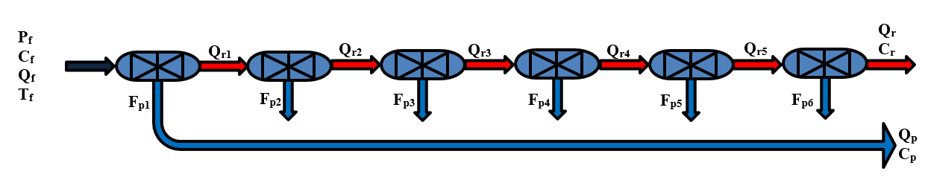

**A**

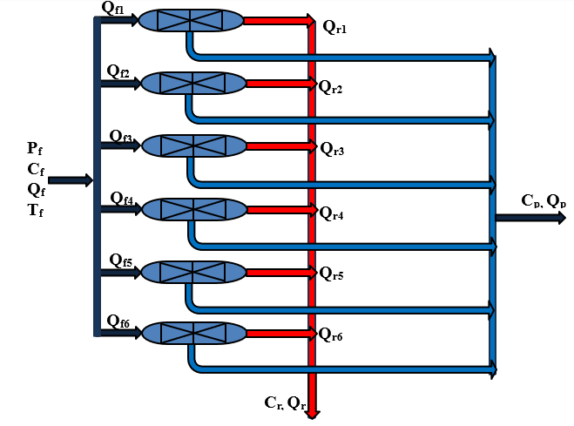

**B**

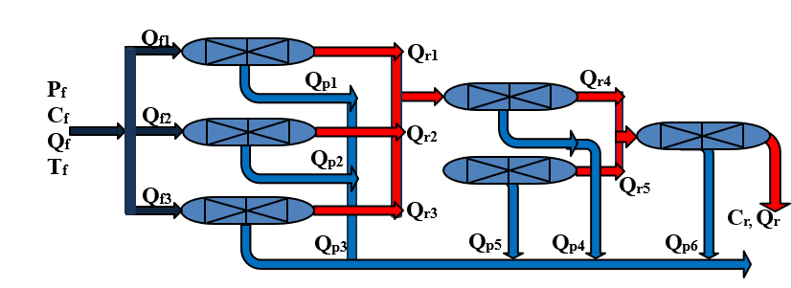

**C**

**D**

Fig. 1. Proposed configurations of RO system

Table 4. Design features of the spiral wound membrane module (Fujioka, 2014)

|  |  |  |  |
| --- | --- | --- | --- |
| Feature | Value | Feature | Value |
| Type | ESPA2-4040 | Diameter (m) | 0.1003 |
| Thickness of feed spacer () | 6.6x10-4 | Pump and ERD efficiencies | 80%, 80% |
| Active area A ($m^{2}$) | 7.9 | Max. pump pressure (atm) | 41.05 |
| Length L ($m$) | 0.9 | Max. and Min. feed flowrate (m3/s) | 0.001, 0.005 |
| Width W ($m$) | 8.7778 | Max. temperature (°C) | 45 |
| Length of filament in the spacer mesh $L_{f}$ (m) | | | 0.006 |

Table 5. Membrane transport parameters of NMEA (Fujioka et al., 2014; Al-Obaidi et al., 2018c)

|  |  |  |
| --- | --- | --- |
| Compound | Water transport parameter $A_{w}x10⁶$ (m/s atm) at 20 °C | Solute transport parameter $B_{s}x{10}^{6}$ (m/s) at 20 °C |
| NMEA | 1.0730 | 1.14 |

1. Assessment of the proposed configurations of RO system

The current study focuses on evaluating the performance indicators of four proposed configurations of RO process (Figure 2) working at a unique set of inlet conditions of 250x10-6 ppm (feed concentration), 10 atm (feed pressure), 2.43x10-3 m3/s (feed flow rate), and 20 ºC (feed temperature). The proposed configurations are specifically designed within six membrane modules and therefore they represent the twice size of the design of Fujioka et al. (2014). Please note that Fujioka et al. (2014) utilised three modules (same membrane area and design parameters) in a series configuration. Table 5 presents the associated results of the performance metrics of each proposed configuration for the selected inlet conditions. Table 6 ascertains the prosperity of configuration D (321 Tapered RP) as it gains the highest removal of NEMA of 98.79% and the lowest product concentration compared to other tested configurations, including the design of Fujioka et al., 2014. Interestingly, this is a clear improvement of NMEA removal compared to that of 87.2% obtained by Fujioka et al., 2014. However, configuration D has got the lowest productivity and the highest specific energy consumption. The lowest product concentration of configuration D is obtained due to feeding low concentration streams into stage 3, which improves the RO system efficiency. However, the low quantity of feed water of stage 3 can explain the reason of low productivity of the configuration D. This clarification explains the demerit of configuration D as it has got a highest specific energy consumption than the other configurations. In this context, it should be noted that parallel configuration has been introduced as the compromise configuration of having a high removal of NMEA of 89.13%, the maximum productivity, and the lowest specific energy consumption.

Table 6. Summary of the results of the proposed configurations (A, B, C, and D) for the removal of NMEA from wastewater

|  |  |  |  |  |  |
| --- | --- | --- | --- | --- | --- |
| Configuration | Cp plant (ppm) | Cr plant (ppm) | Rej (-) | Productivity (m3/day) | SEC (kWh/m3) |
| A: Series | 3.75E-08 | 2.74E-07 | 84.99 | 21.423 | 3.447 |
| B: Parallel | 2.72E-08 | 2.92E-07 | 89.13 | 33.220 | 2.223 |
| C: 321 Tapered RR | 2.78E-08 | 2.90E-07 | 88.89 | 32.181 | 2.295 |
| D: 321 Tapered RP | 3.00E-09 | 2.57E-07 | **98.79** | 5.542 | 6.257 |
| Fujioka et al. (2014): Series of three elements | 3.19E-8 | 2.68E-7 | 87.2 | 16.819 | 4.435 |

1. Conclusions

In this study, the removal of NMEA organic compound from wastewater was evaluated considering four different proposed configurations of RO process. This is the first attempt to appraise the performance metrics of six spiral wound membrane modules of RO process configured as series, parallel, tapered of retentate-retentate design and tapered of retentate-permeate design, towards the removal of NMEA. Also, in terms of size of the process, it is one-fold times bigger than the lab scale RO process of Fujioka et al. (2014) Systematically, the comparison was made using a mathematical model of the process with considering a fixed set of inlet conditions. The tapered configuration retentate-permeate design was found to be the best due to its remarkable removal efficiency of 98.79% compared to 87.2% that can be found in open literature.

References

A. Szczuka, N. Huang, J.A. MacDonald, A. Nayak, Z. Zhang, W.A. Mitch, 2020. N-Nitrosodimethylamine formation during UV/hydrogen peroxide and UV/chlorine advanced oxidation process treatment following reverse osmosis for potable reuse. Environmental Science & Technology, 54(23), pp.15465-15475.

H. Takeuchi, N. Yamashita, N. Nakada, H. Tanaka, 2018. Removal characteristics of N-nitrosamines and their precursors by pilot-scale integrated membrane systems for water reuse. International journal of environmental research and public health, 15(9), p.1960.

IARC, IARC monographs on the evaluation of carcinogenic risks to humans: Overall evaluations off carcinogenicity: An updating of IARC monographs volumes 1-42: Supplement 7, International agency for research on cancer, 1987.

M.A. Al‐Obaidi, C. Kara‐Zaïtri, and I.M. Mujtaba, 2018a. Simulation of full‐scale reverse osmosis filtration system for the removal of N‐nitrosodimethylamine from wastewater. Asia‐Pacific Journal of Chemical Engineering, 13(2), p.e2167.

M.A. Al-Obaidi, J.P. Li, S. Alsadaie, C. Kara-Zaïtri, and I.M. Mujtaba, 2018b. Modelling and optimisation of a multistage reverse osmosis processes with permeate reprocessing and recycling for the removal of N-nitrosodimethylamine from wastewater using species conserving genetic algorithms. Chemical Engineering Journal, 350, pp.824-834.

M.A. Al-Obaidi, C. Kara-Zaïtri, and I.M. Mujtaba, 2018c. Simulation and optimisation of spiral-wound reverse osmosis process for the removal of N-nitrosamine from wastewater. Chemical Engineering Research and Design, 133, pp.168-182.

M.A. Al-Obaidi, A.A. Alsarayreh, A.M. Al-Hroub, S. Alsadaie, and I.M. Mujtaba, 2018d. Performance analysis of a medium-sized industrial reverse osmosis brackish water desalination plant. Desalination, 443, pp.272-284.

P.A. Alaba, Y.M. Sani, S.F. Olupinla, W.M.W. Daud, I.Y. Mohammed, C.C. Enweremadu, O.O. Ayodele, 2017. Toward N-nitrosamines free water: Formation, prevention, and removal. Critical reviews in environmental science and technology, 47(24), pp.2448-2489.

S.C. Osorio, P.M. Biesheuvel, E. Spruijt, J.E. Dykstra, A. van der Wal, 2022. Modeling micropollutant removal by nanofiltration and reverse osmosis membranes: considerations and challenges. Water Research, p.119130.

T. Fujioka, S.J. Khan, J.A. Mcdonald, A. Roux, Y. Poussade, J.E. Drewes, L.D. Nghiem, 2014. Modelling the rejection of N-nitrosamines by a spiral-wound reverse osmosis system: Mathematical model development and validation. Journal of Membrane Science, 454, 212–219.

T. Fujioka, 2014. Assessment and optimisation of N-nitrosamine rejection by reverse osmosis for planned potable water recycling applications.

USEPA, Integrated Risk Information System (IRIS), http://www.epa.gov/iris/ (1993).