Recycling Rare Earth Elements from End-of-Life Electric and Hybrid Electric Vehicle Motors

Christopher Laliwala, Ana Torres*

Department of Chemical Engineering, Carnegie Mellon University, Pittsburgh 15213, PA, USA

* aitorres@cmu.edu

Abstract  
The United States is working to decarbonize its electric grid and end-use sectors through a transition to clean energy technologies. However, this transition presents significant challenges, including the reliance on rare earth elements (REEs) to produce these technologies. Therefore, strengthening rare earth supply chains is imperative for the U.S. as it strives to reduce carbon emissions. One approach to enhancing these supply chains is through the extraction of REEs from end-of-life (EOL) products. This study proposes a superstructure-based approach to find the optimal pathway for recovering REEs from the permanent magnets of EOL electric and hybrid electric vehicle (EV and HEV) motors. The superstructure is optimized by maximizing the net present value (NPV) over a 15-year period. To establish the base case optimal result, these projections are used with the assumption that the plant recycles 10 % of all EOL EVs and HEVs in the U.S. each year. The results show that the pathway consisting of automatic disassembly, hydrogen decrepitation, and acid-free dissolution extraction is promising for the recovery of REEs.

**Keywords**: Recycling, rare earth elements, process design, and optimization.

* 1. Introduction

The climate crisis poses one of humanity's most significant challenges in the twenty-first century, with the Earth already exceeding pre-industrial levels by 1.1 °C (UNFCCC, 2021). Urgent action is imperative to prevent further escalation, and scientific research emphasizes the need to limit global temperature rise to within 2 °C, preferably 1.5 °C above pre-industrial levels (UNFCCC, 2021). This necessitates prioritizing the decarbonization of energy and our economy by transitioning to clean energy technologies like solar panels, wind turbines, and electric vehicles. In the United States, significant legislative measures, such as the “Bipartisan Infrastructure Law”, represent an unprecedented investment of over $430 billion by 2031, targeting reducing carbon emissions across sectors (Steinberg et al., 2023).

Electrification initiatives heavily rely on rare earth elements (REEs). In the global context, most REEs are sourced through mining, with limited to negligible contributions from recycling processes (Smith et al., 2022). Nonetheless, recycling has many advantages compared to conventional mining practices, presenting a pragmatic solution to the environmental concerns associated with the disposal of EOL products. Furthermore, EOL products contain notable concentrations of valuable REEs, such as neodymium, praseodymium, and dysprosium, potentially making them economically attractive as a feedstock. Lastly, recycling processes circumvent potential waste management issues associated with mined feedstocks, as the REEs frequently co-occur with radioactive elements like thorium and uranium in ore deposits (Smith et al., 2022).

In this paper, we develop an optimization-based framework to find the best processing pathway for the recovery of rare earth elements from EOL products. The methodology employed the following steps. Firstly, the projected quantity of REEs available for recycling from EOL EV and HEV motors' Rare Earth Permanent Magnets (REPM) (Blast et al., 2014; Argonne National Laboratory, 2023), along with the projected prices of rare earth oxides (REOs) (Hykawy & Chudnovsky, 2021) over the plant’s lifetime were estimated and used to inform the model. Next, a superstructure was constructed containing all possible processing pathways, and the optimal pathway was found by maximizing the net present value (NPV) over a 15-year period, assuming that the plant recycles 10 % of the available EOL EVs and HEVs in the U.S. each year. Finally, a sensitivity analysis was conducted to evaluate the impact of different parameters on the venture's profitability and the optimal processing pathway.

* 1. Processes for the recovery of REEs from permanent magnets

As schematized in Figure 1, rare earth recycling from permanent magnets comprises four primary processing stages: disassembly, demagnetization, leaching, and extraction. Each stage contains several potential processes, represented as nodes in the superstructure. The naming convention for the nodes is *<stage number, node number>,* where *1* represents the disassembly stage, *2* the demagnetization stage, *3* the leaching stage, and *4* the extraction stage.

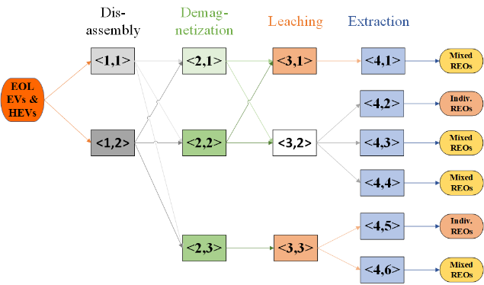

Figure 1. Simplified scheme of the superstructure with processing options for EOL EV & HEV motors’ REPM to REOs.

In the disassembly stage, two processes are considered: manual disassembly, where REPMs are removed from EOL vehicle motors by manual labor *<1,1>* (Blast et al., 2014), and automatic disassembly *<1,2>*, which employs robots for automation (Blast et al., 2014). For demagnetization, three processes are explored: hydrogen decrepitation *<2,1>*, involving the reaction of REPM powder with hydrogen gas at 170 °C for 3 hours to produce a demagnetized, friable material (Walton et al., 2015); heating the magnets to 350 °C for 30 minutes followed by milling *<2,2>* (Klemettinen et al., 2021); and heating the magnets to 950 °C for 15 hours to create rare earth oxides and iron oxides followed by milling *<2,3>*, which results in iron precipitation during the subsequent selective leaching process (Vander Hoogerstraete et al., 2014). The leaching stage presents two potential processes: acid dissolution using sulfuric acid *<3,1>* (Lyman & Palmer, 1993), and selective leaching with hydrochloric acid *<3,3>* (Vander Hoogerstraete et al., 2014), which follows high-temperature heating and milling. In selective leaching, iron precipitates as iron(III) hydroxide. Node *<3,2>* is blank and represents skipping the leaching stage.

In the extraction stage, six processes are examined. The first method, hydrometallurgical extraction *<4,1>* (Lyman & Palmer, 1993), precipitates REEs as REE-sodium double salts to separate them from iron. Subsequent steps involve reactions with oxalic acid and calcination to produce mixed REOs, with the iron-containing leachate being treated with ammonium sulfate to precipitate it out of the solution as iron jarosite. The next two processes use supercritical CO2 to separate REEs from iron (Azimi et al., 2023), with the first process employing solvent extraction (Yoon et al., 2015) for the separation of dysprosium and neodymium followed by oxalic acid precipitation and calcination to produce individual REOs *<4,2>* (Nawab et al., 2022). The second process involves skipping solvent extraction and utilizing oxalic acid precipitation and calcination to produce mixed REOs *<4,3>* (Nawab et al., 2022). In the fourth method, acid-free dissolution extraction *<4,4>*, REPM powder is dissolved in an aqueous solution of copper(II) nitrate, followed by oxalic acid precipitation to produce rare earth oxalates and iron-ammonium oxalates (Chowdhury et al., 2021). The rare earth oxalate precipitates are then filtered from the soluble iron-ammonium oxalates. Finally, the rare earth oxalates are calcined to produce mixed REOs. The fifth and sixth processes follow selective leaching and therefore do not require REE-iron separation. The fifth method involves solvent extraction (Yoon et al., 2015) for dysprosium-neodymium separation followed by oxalic acid precipitation and calcination *<4,5>* (Nawab et al., 2022), while the sixth method directly precipitates the REEs with oxalic acid and calcines them to obtain a mixture of REOs *<4,6>* (Nawab et al., 2022).

* 1. Optimization problem formulation

To describe the model, mass balance and logical constraints were formulated. The mass balance for a generic node is illustrated in Figure 2 and includes three sequential steps: convergence of inlet flows from different upstream nodes, processing, and separation of outlet flows to different downstream nodes. Components in the feedstock, intermediates, and products were tracked. The specific equations are as defined in Eq. (1-3).

|  |  |
| --- | --- |
| $$\sum_{k=1}^{K^{in}}{F_{i,j,k,c,t}^{in}}=F_{i,j,c,t}^{in} ∀i∈I,j∈J_{i},c∈C,t∈T$$ | (1) |
| $$F_{i,j,c,t}^{out}=a_{i,j,c}*F_{i,j,c,t}^{in} ∀i∈I,j∈J_{i},c∈C,t∈T$$ | (2) |
| $$F_{i,j,c,t}^{out}=\sum_{k=1}^{K^{out}}{F_{i,j,k,c,t}^{out}} ∀i∈I,j∈J_{i},c∈C,t∈T$$ | (3) |

Here, $F_{i,j,c,t}^{in}$ represents the flow of component $c$ entering node $<i,j>$ in year $t$, and $F_{i,j,c,t}^{out}$ the correspondent outlet flow, $a_{i,j,c}$ is the yield of component $c$ leaving node $<i,j>$, $I$ is the set of all stages in the superstructure, $J_{i}$ is the set of all nodes in stage $i$, $C$ is the set of tracked components, and $T$ is the set of all years the plant is in operation. A binary variable $y_{i,j}$ is introduced to model the selection of node $<i,j>$. Logical constraints relating processes at different stages, such as $y_{3,2}=y_{4,2}+y_{4,3}+y_{4,4}$ were added as needed and are not specified here due to limitations in space. Big M constraints relate the flow through a unit to its selection, as shown in Eq. (4), where $M^{i,j}$ represents the maximum inlet flow rate for node $<i,j>$.

|  |  |
| --- | --- |
| $$F_{i,j,c,t}^{in}≤y_{i,j}*M^{i,j} i∈I,j∈J_{i},c∈C,t∈T$$ | (4) |

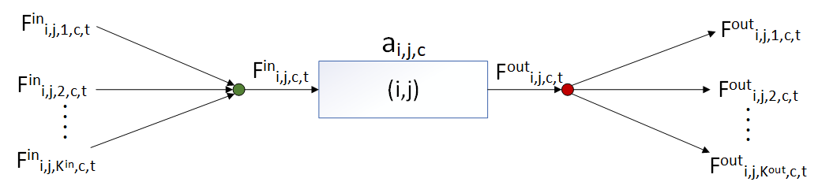

Figure 2. Mass balance for generic node .

* + 1. Objective function

The goal of the optimization problem was to maximize the NPV over the plant's lifetime, as shown in Eq. (5-6) (Seider et al., 2017). Here, $CF_{n}$ is the cash flow in year $n$, $LT$ is the plant’s life in years, and $IR$ is the interest rate.

|  |  |
| --- | --- |
| $NPV=\sum_{n=1}^{LT}{\frac{CF_{n}}{{\left(1+IR\right)}^{n}}}$ | (5) |
| $$CF_{n}=Profit_{n}-\left(CAPEX_{n}+OPEX_{n}\right)$$ | (6) |

CAPEX and OPEX calculations for each processing option included in the superstructure were carried out using the methodology described by Seider et al. (2017). When available, costing information and values for the parameters $a_{i,j,c}$ were taken from preliminary techno-economic analyses in the literature. There were cases, such as acid dissolution, selective leaching, hydrometallurgical extraction, oxalic acid precipitation, and solvent extraction, where costing data could not be found in the literature as a consequence of the data being proprietary and the relative immaturity of certain processes. In these scenarios, a process flowsheet was designed, modelled, and simulated in Aspen Plus. The purchased cost of equipment and the cost of utilities were found using Aspen Process Economic Analyzer, after which the methodology described by Seider et al. (2017) was followed to calculate CAPEX and OPEX. In all cases, individual reactions were modelled based on conversions and yields from bench-scale experiments found in the literature. e-NRTL was used to estimate thermodynamic properties, which allowed us to estimate solid precipitation. To preserve the linearity of the model, piecewise linear functions were used to relate costing equations to flow rates. This was done by sampling 6 points spanning the range of flow rates entering the process in the base case.

The MILP optimization problem is then: maximize NPV, subject to Eqs. 1-4, 6, logical relations, and CAPEX and OPEX (linear) relations as a function of the size of the technology. The decision variables are , , and .

* 1. Results

The resulting MILP optimization problem was coded in Pyomo and solved using a personal laptop (12th gen i9, 2.50 GHz and 32 GB RAM). The decision variables are the processing options to be included and their sizing. As was mentioned in the Introduction section, the base case assumed that the plant recycles 10 % of all EOL EVs and HEVs in the U.S. each year. The optimal pathway was found to consist of automatic disassembly, hydrogen decrepitation, and acid-free dissolution extraction and resulted in a positive NPV. Among the processing stages, acid-free dissolution extraction dominated CAPEX expenses, accounting for 95 % of the cost, followed by the disassembly step, which accounted for 4 %. Additionally, the acid-free dissolution step also dominated OPEX expenses, accounting for ~99 %. These results suggest the need for focusing on further optimization of the acid-free dissolution process. Next, we found the optimal solution for different plant sizes and the projected REO prices. The results from these analyses can be seen in Figure 3. The NPV was found to be positively correlated to both the plant size and the REO prices, and the optimal pathway never changed. The NPV break-even point was found to occur at ~10 % of the initial estimate for EOL vehicles available for recycling and at ~28 % for the REO prices.

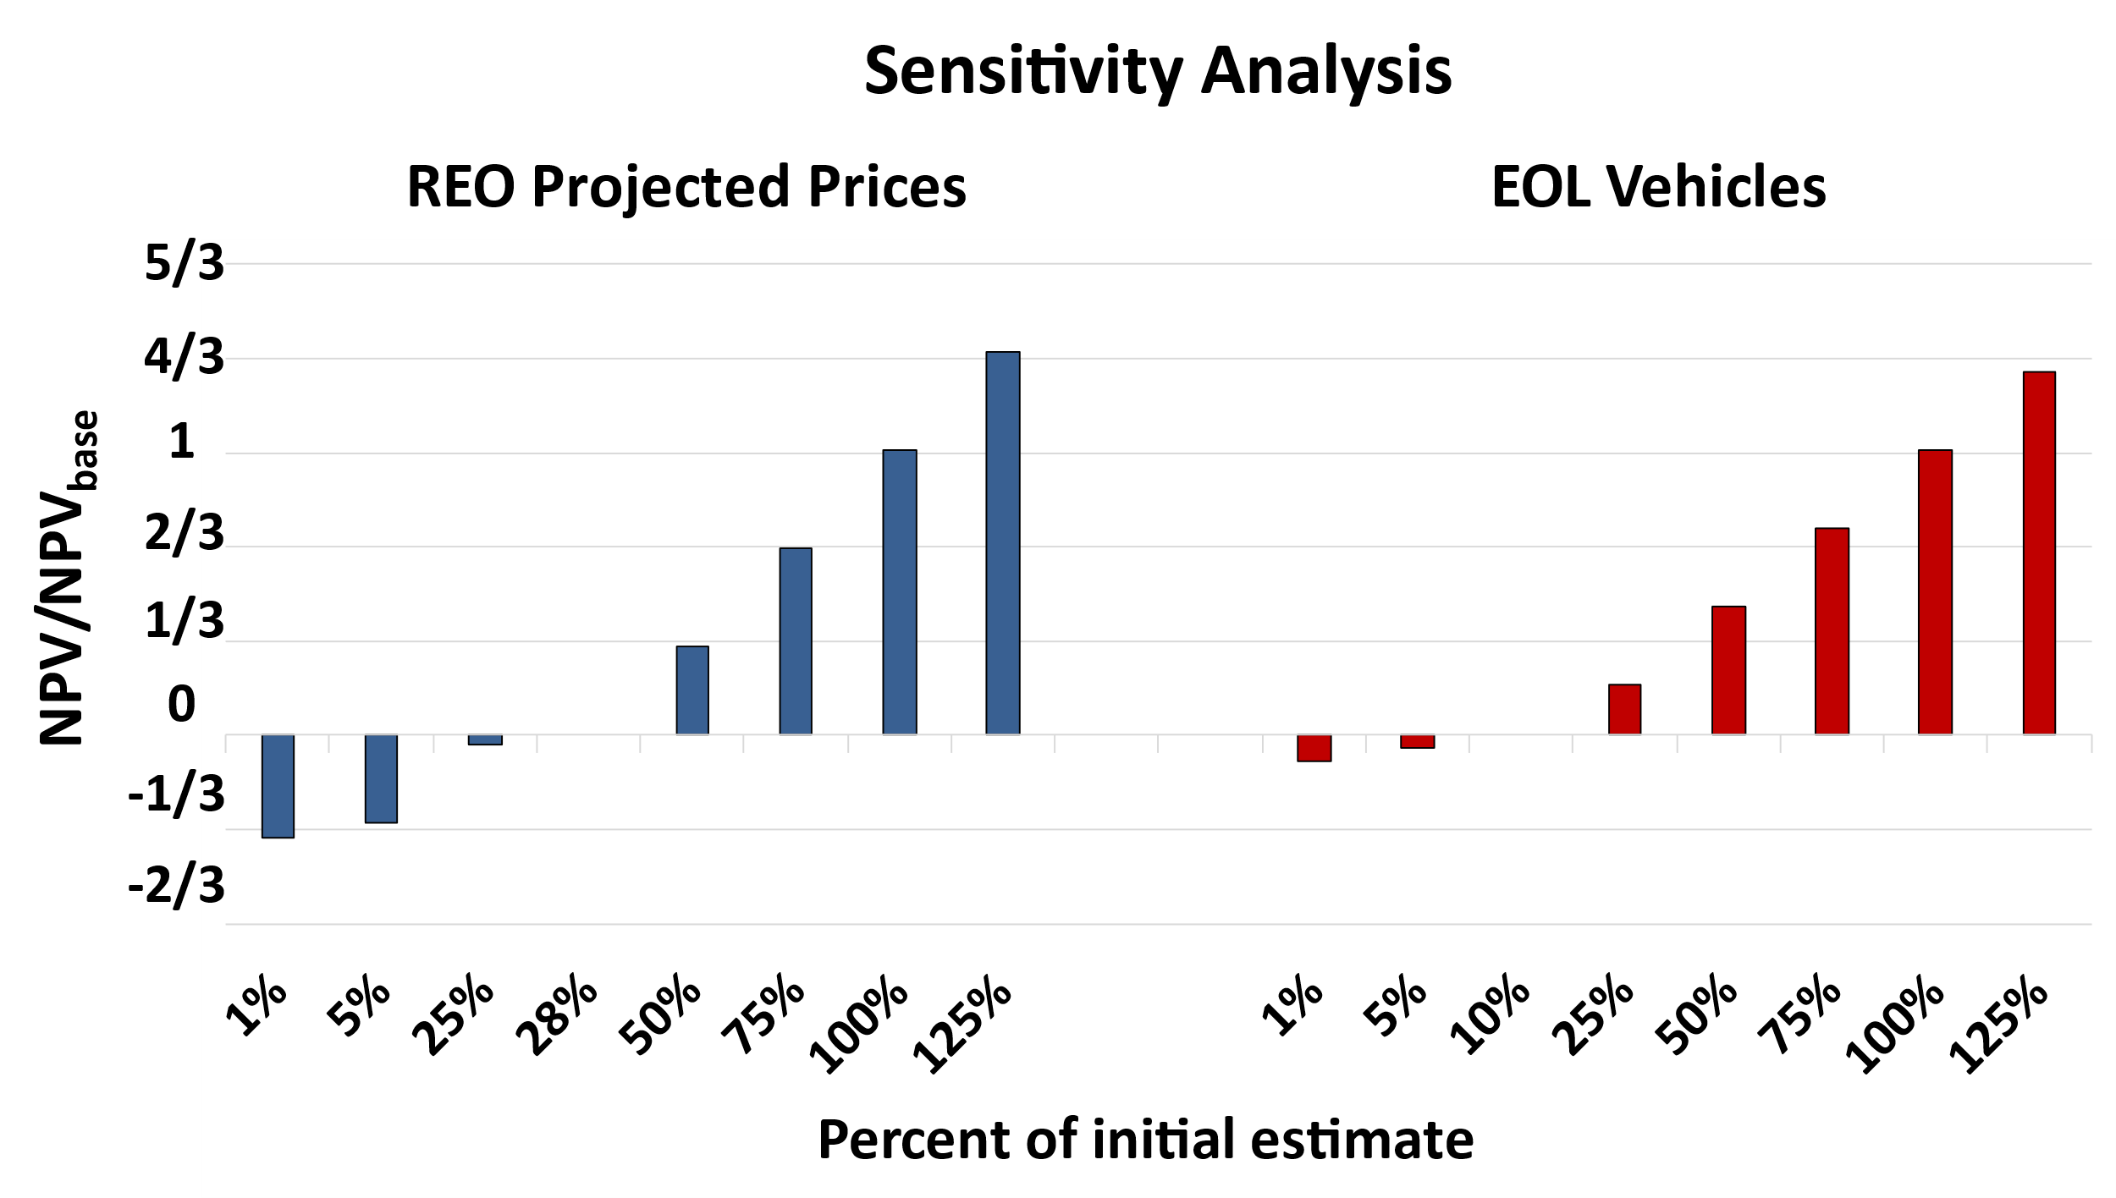

Figure 3. Sensitivity analysis for the product projected prices, and amount of EOL vehicles available for recycling. Values are reported normalized to the base case optimal solution to preserve confidentiality.

* 1. Conclusions

Superstructure optimization was utilized to define the optimal pathway for recycling REEs from EOL EV and HEV motors’ REPM, aiming to maximize the NPV. The study determined that the optimal process consists of automated disassembly, hydrogen decrepitation, and acid-free dissolution extraction. The process was also found to be profitable over a wide range of parameter estimates, suggesting that further investigation to optimize this pathway would be warranted. In particular, acid-free dissolution extraction is indicated as the largest contributor to the optimal pathway, hence supporting the need to further optimize this process.

**Acknowledgments**

This effort was funded by the US Department of Energy’s Process Optimization and Modeling for Minerals Sustainability (PrOMMiS) Initiative, supported by the Office of Fossil Energy and Carbon Management’s Office of Resource Sustainability. Neither the United States Government nor any agency thereof, nor any of its employees, nor the support contractor, nor any of their employees, makes any warranty, express or implied, or assumes any legal liability or responsibility for the accuracy, completeness, or usefulness of any information, apparatus, product, or process disclosed, or represents that its use would not infringe privately owned rights. Reference herein to any specific commercial product, process, or service by trade name, trademark, manufacturer, or otherwise does not necessarily constitute or imply its endorsement, recommendation, or favoring by the United States Government or any agency thereof. The views and opinions of authors expressed herein do not necessarily state or reflect those of the United States Government or any agency thereof.

References

Argonne National Lab, 2023, LDV Total Sales of PEV and HEV by Month (updated through May 2023), date accessed: 2023-07-29, URL: https://www.anl.gov/esia/reference/light-duty-electric-drive-vehicles-monthly-sales-updates-historical-data.

G. Azimi, M.E. Sauber, J. Zhang, 2023, Technoeconomic analysis of supercritical fluid extraction process for recycling rare earth elements from neodymium iron boron magnets and fluorescent lamp phosphors, Journal of Cleaner Production, 422, doi: 10.1016/j.jclepro.2023.138526.

U. Bast, R. Blank, M. Buchert, T. Elwert, F. Finsterwalder, G. Hörnig, T. Klier, S. Langkau, F. Marscheider-Weidemann, J.-O Müller, Ch. Thürigen, F. Treffer, T. Walter, 2015, Recycling von komponenten und strategischen metallen aus elektrischen fahrantrieben: kennwort: MORE (Motor Recycling), doi: 10.24406/publica-fhg-297259.

N.A. Chowdhury, S. Deng, H. Jin, D. Prodius, J.W. Sutherland, I.C. Nlebedim, 2021, Sustainable recycling of rare-earth elements from NdFeB magnet swarf: technoeconomic and environmental perspectives, ACS Sustainable Chemistry & Engineering, 9, 15915-15924, doi: 10.1021/acssuschemeng.1c05965.

J. Hykawy, T. Chudnovsky, 2021, Report: Rare Earths, date accessed: 2023-09-21, URL: https://www.stormcrow.ca/wp-content/uploads/2021/03/20210308-Stormcrow-UCore-Initiation-Final.pdf.

A. Klemettinen, A. Żak, I. Chojnacka, S. Matuska, A. Leśniewicz, M. Wełna, Z. Adamski, L. Klemettinen, L. Rycerz, 2021, Leaching of rare earth elements from NdFeB magnets without mechanical pretreatment by sulfuric (H2SO4) and hydrochloric (HCl) acids, Minerals, 11, 1374, doi: 10.3390/min11121374.

J.W. Lyman, G.R. Palmer, 1993, Recycling of rare earths and iron from NdFeB magnet scrap, High Temperature Materials and Processes, 11, 175-187, doi: 10.1515/HTMP.1993.11.1-4.175.

A. Nawab, X. Yang, R. Honaker, 2022, Parametric study and speciation analysis of rare earth precipitation using oxalic acid in a chloride solution system, Minerals Engineering, 176, 107352, doi: 10.1016/j.mineng.2021.107352.

W.D. Seider, D.R. Lewin, J.D. Seader, S. Widagdo, R. Gani, K.M. Ng, 2017, Product and Process Design Principles: Synthesis, Analysis and Evaluation – 4th Edition, John Wiley & Sons Inc., New York, USA.

B.J. Smith, M.E. Riddle, M.R. Earlam, C. Iloeje, D. Diamond, 2022, Rare Earth Permanent Magnets: Supply Chain Deep Dive Assessment, U.S. Department of Energy, Washington, D.C., USA.

D. Steinberg, M. Brown, R. Wiser, P. Donohoo-Vallet, P. Gagnon, A. Hamilton, M. Mowers, C. Murphy, A. Prasana, 2023, Evaluating impacts of the inflation reduction act and bipartisan infrastructure law on the U.S. power system, National Renewable Energy Laboratory, Colorado, USA, doi: NREL/TP-6A20-85242.

UNFCCC, 2021, Glasgow Climate Pact, Decision -/CP.26, Glasgow Climate Change Conference, date accessed: 2023-07-27, URL: https://unfccc.int/documents/310475.

T. Vander Hoogerstraete, B. Blanpain, T. Van Gerven, K. Binnemans, 2014, From NdFeB magnets towards the rare-earth oxides: a recycling process consuming only oxalic acid, RCS Advances, 4, 64099-64111, doi: 10.1039/c4ra13787f.

A. Walton, H. Yi, N.A. Rowson, J.D. Speight, V.S.J. Mann, R.S. Sheridan, A. Bradshaw, I.R. Harris, A.J. Williams, 2015, The use of hydrogen to separate and recycle neodymium-iron-boron-type magnets from electronic waste, Journal of Cleaner Production, 104, 236-241, doi: 10.1016/j.jclepro.2015.05.033.

H.-S. Yoon, C.-J. Kim, K.W. Chung, S.-D. Kim, J.R. Kumar, 2015, Process development for recovery of dysprosium from permanent magnet scraps leach liquor by hydrometallurgical techniques, Canadian Metallurgical Quarterly, 54, 318-327, doi: 10.1179/1879139515Y.0000000019.