Multi-objective Optimization of Forced Periodic Operation of Methanol Synthesis in a Fixed-Bed Reactor

Johannes Leipolda,*, Daliborka Nikolicb, Andreas Seidel-Morgensternc, Achim Kienlea,c

aOtto-von-Guericke-Universität, Universitätsplatz 2, D-39106 Magdeburg, Germany

bUniversity of Belgrade, Institute of Chemistry, Technology and Metallurgy, Njegoseva 12, Belgrade

cMax-Planck-Institut für Dynamik komplexer technischer Systeme, Sandtorstrasse 1, D-39106 Magdeburg, Germany

johannes.leipold@ovgu.de

Abstract

Methanol is usually produced in large amounts in fixed-bed reactors under steady-state conditions. Due to the nonlinearity of the process, the periodic stimulation of one or more inputs may improve the process behaviour compared to the traditional process realization. In this contribution, a rigorous optimization of a fixed-bed reactor is performed to investigate the potential of improvement by forced periodic operation of methanol synthesis. Axial temperature changes are included by solving simultaneously a dynamic energy balance. A multi-objective optimization with two objective functions is performed: (I) The flow rate of methanol at the reactor outlet and (II) the yield of methanol based on the amount of carbon in the feed. Following our previous work for an isothermal CSTR, simultaneous modulation of CO input concentration and overall feed rate with a phase shift - also to be optimized - is considered. This contribution considers different types of periodic input functions. The results show an improvement due to the forced periodic operation with harmonic forcing, triangle waves, and square waves. Square waves result in the best potential of improvement. Furthermore, it is shown that the optimal reactor temperature is lower in forced periodic operation compared to steady state operation, which leads to an additional advantage in terms of energy efficiency.

**Keywords**: Methanol synthesis, Fixed-bed reactor, Forced periodic operation, Multi-objective optimization, PDE-constrained optimization

* 1. Introduction

Methanol is an important raw material in chemical industry. It is produced in large amounts with Cu/ZnO/Al2O3-catalyst in fixed bed reactors. The following three reactions must be considered:

$CO_{2}+3H_{2}⇄CH_{3}OH+H_{2}O, ΔH_{R}^{0}=-50 kJ mol^{-1}$

$CO+2H_{2}⇄CH_{3}OH, ΔH_{R}^{0}=-91 kJ mol^{-1}$

$CO+H_{2}O⇄CO_{2}+H_{2}, ΔH_{R}^{0}=-41 kJmol^{-1}$

The first and the second reactions describe the hydrogenation of COand CO2. The third equation is the water-gas-shift reaction. Optimization of methanol synthesis is a very active field of research. One opportunity to improve the behavior of such chemical processes is forced periodic operation (FPO). First investigations on this topic were made by Horn (1967). A detailed overview is given in Silveston (2013). The idea is to periodically modulate one or more inputs to achieve improvements compared to the steady-state operation. Based on the kinetic model published in Seidel et al. (2018), the FPO of methanol synthesis was recently investigated theoretically in a CSTR (Seidel et al.,2022) and in an isothermal fixed-bed reactor (Leipold et al., 2023). It was shown that significant improvements are possible. However, temperature effects were not considered. This contribution deals with the FPO of a non-isothermal fixed bed reactor, which is much more realistic than the isothermal case. A multi-objective optimization is performed to quantify the potential for improvement. Two objective functions are considered. The average molar flow rate of methanol and the yield of methanol based on the amount of carbon in the feed. The best possible steady-state solution is then compared to the best possible FPO. One difficulty in the implementation is the choice of modulated inputs. The NFR Method predicts for isothermal operation of a CSTR the best potential of improvement by modulation of the CO feed together with the overall flow rate with an optimized phase shift (Nikolic et al., 2022). This is, therefore, also used as a starting point for non-isothermal operation in this paper. Another essential degree of freedom is the type of periodic modulation. This contribution examines which input function promises the highest benefit. The FPO is modulated with harmonic functions, square waves, triangular waves, upward-sawtooth waves, and downward-sawtooth waves.

* 1. Modelling
     1. Kinetics

The kinetic model from Seidel et al. (2018,2020) is used for the investigation in this contribution. It is based on the Langmuir Hinshelwood mechanism and also considers the catalyst dynamic. The model parameters are fitted to a set of 140 steady-state experiments and dynamic experiments (Seidel et al., 2021). Thus, this kinetic is very suitable for the FPO since it also represents the dynamic operation.

* + 1. Reactor model

|  |  |
| --- | --- |
| Table 1: Governing equations | |
| Component material balance: | $$n^{G}\frac{∂y_{i}}{∂t}+\dot{n}\frac{V^{G}}{A_{int}}\frac{∂y_{i}}{∂z}+m_{cat}q_{sat}P\left(\sum_{k=1}^{N_{k}}{\frac{∂Θ_{i}}{∂p_{k}}}\frac{∂y_{k}}{∂t}-y_{i}\sum_{i=1}^{N_{k}}{\sum_{k=1}^{N_{k}}{\frac{∂Θ_{i}}{∂p_{k}}}\frac{∂y_{k}}{∂t}}\right)=m_{\text{cat}}\left(\sum_{j=1}^{N_{r}}{ν_{i,j}r_{j}}-y_{i}\sum_{i=1}^{N_{k}}{\sum_{j=1}^{N_{r}}{ν_{i,j}r_{j}}}\right)$$ |
| Total material balance: | $$\frac{∂n^{G}}{∂t}+\frac{V^{G}}{A_{int}}\frac{∂\dot{n}}{∂z}+m_{cat}q_{sat}\sum_{i=1}^{N_{k}}{\sum_{k=1}^{N_{k}}{\frac{∂Θ_{i}}{∂p_{k}}}\frac{dp_{k}}{dt}}=m_{\text{cat}}\sum_{i=1}^{N_{k}}{\sum_{j=1}^{N_{r}}{ν_{i,j}r_{j}}}$$ |
| Energy balance: | $$\left(\underset{\text{gaseouse species}}{\underbrace{n^{G}c_{p}^{G}}}+\underset{\text{catalyst}}{\underbrace{m_{cat} c_{p}^{kat}}}\right)\frac{∂T}{∂t}+\underset{\text{convection}}{\underbrace{\frac{V^{G}}{A_{int}}\dot{n}c_{p}^{G}\frac{∂T}{∂z}}}+\underset{\text{heat of reaction}}{\underbrace{m_{\text{cat}}\sum_{i}{ΔH_{R,j}r_{j}}}}$$ $$+\underset{\text{heat of cooling}}{\underbrace{α_{c}A_{w}\left(T-T_{c}\right)}}+\underset{\text{heat of adsorption}}{\underbrace{P_{bar}m_{cat}q_{sat}ΔH_{ads}\sum_{i=1}^{N_{k}}{\sum_{k=1}^{N_{k}}{\frac{∂Θ_{i}}{∂p_{k}}}\frac{dy_{k}}{dt}}}}=0$$ |

The methanol synthesis usually takes place in non-isothermal fixed-bed reactors. Under the assumption of constant pressure ideal plug flow and no heat conduction in solid phase the system equations are given in Table 1 (Leipold et al., 2023). The governing equations can be summarized by matrix-vector notation into the following general  
system of partial differential equations (PDE).

|  |  |  |
| --- | --- | --- |
| Table 2: Reactor properties and process parameter | | |
| Paremeter | Value | Unit |
| $${\dot{n}}_{in}$$ | 1.326 | mol/min |
| l | 1.14 | m |
| d­int | 0.013 | m |
| mcat | 168.5 | g |
| εbulk | 0.395 | - |
| qsat | 0.98 | mol/kg |
| $$ΔH_{ads}$$ | 10 | kJ/mol |
| P | 80 | bar |

|  |  |
| --- | --- |
|  | (1) |

with $x=\left[y_{\text{C}{\text{H}}_{\text{4}}}, y_{\text{C}{\text{O}}_{\text{2}}},y_{\text{CO}}, y_{{\text{H}}_{\text{2}}}, y_{{\text{H}}_{\text{2}}\text{O}}, y_{{\text{N}}_{\text{2}}},ϕ,\dot{n},T\right]$. Heat capacities and heat of reaction are calculated with correlations in Reid et al. (1987). The heat transfer coefficient and all corresponding thermodynamical properties were taken from VDI e.V. (2013). For this investigation the lab scaled reactor from Nestler et al. (2021) is used. The process parameters are given in Table 2.

* 1. Methods

To validate the FPO a multi-objective optimization is performed. The objective functions are $Φ_{1}= {\overline{n}}_{CH_{3}OH}$, the average flow rate of methanol at the outlet and $Φ_{2 }={\overline{n}}_{CH_{3}OH,out}/({\overline{n}}_{CO_{2},in}+{\overline{n}}_{CO,in})$, the average yield of methanol based on the amount of carbon in the feed. To solve this problem, the $ϵ$-constraint method is used (Ehrgott, 2005). The second objective function is constrained by an $ϵ$, resulting in a single-optimization problem of the following form:

|  |  |
| --- | --- |
| $$\max_{u}{Φ_{1}\left(x\left(t,z,u\right)\right)}$$ | (2) |
| $$s.t. M\frac{∂x}{∂t}+W\frac{∂x}{∂z}=f$$ | (3) |
| $x\left(t,0,u\right)=BC$ | (4) |
| $x\left(0,z,u\right)=IC$ | (5) |
| $h\left(x,u\right)=0$ | (6) |
| $g\left(x,u\right)≤0$ | (7) |
| $lb≤u≤ub$ | (8) |
| $ϵ-Φ_{2}\left(x\left(t,z,u\right)\right)≤0$ | (9) |

|  |  |  |  |
| --- | --- | --- | --- |
|  | (10) | $$x\left(0,z,u\right)=x\left(0,τ,u\right)$$ with $τ=\frac{2π}{ω}$ | (11) |

The problem must be solved for a range of $ϵ$’s, where each $ϵ$ represents one point on the Pareto front. The PDE in equation 6 is discretized with orthogonal collocation and converted to equality constraints (Hedengren et al., 2014). The boundary conditions define the states at the reactor inlet over the time and are given in equation 13.

|  |  |
| --- | --- |
| Table 3 – Input Functions | |
| - harmonic wave: $P\left(t\right)=cos\left(t\right)$ |  |
| - square wave: $P\left(t\right)=square\left(t\right)$ $P\left(t\right)=2\left[\sum_{i=0}^{N}{{\left(-1\right)}^{i}sig}\left(n\left(π\frac{1-2i}{2}-t\right)\right)\right]-1$ |
| - triangular wave: $P\left(t\right)=triangle\left(t\right)$ $P\left(t\right)=\frac{2}{π}\int{square\left(t\right)dt}$ |
| - sawtooth wave up: $P\left(t\right)=saw_{up}\left(t\right)$ $P\left(t\right)=2\left[\frac{t}{2π}-\sum_{i=0}^{N}{sig\left(n\left(2πi-t\right)\right)}\right]-1$ |
| - sawtooth wave down: $P\left(t\right)=saw_{down}\left(t\right)$ $P\left(t\right)=-saw_{up}\left(t\right)$ |

It is assumed that the temperature at the inlet $T_{in}$ and the cooling temperature $T_{c}$ are equal. The CO feed flow rate is periodically stimulated together with the overall feed flow rate with the same frequency but with phase shift. The N2 feed is used to compensate the CO modulation, ensuring constant pressure in the reactor. P(t) is the periodic input function, which can be chosen between the five functions from Table 3. To avoid sharp fronts in the solution of the PDE’s the input functions are approximated with a combination of sigmoid function ($sig\left(t\right)=1/\left(1+exp\left(t\right)\right)$) and its integral. To ensure a periodic solution, the initial conditions are taken as in equation 14. Furthermore, the following equality and inequality constraints are considered:

|  |  |  |  |
| --- | --- | --- | --- |
| $$h\left(x,u\right)=\left[\begin{matrix}∑y_{i,in}-1 \\ A_{CO} y_{CO,in} - A_{N_{2}}y_{N_{2},in} \\ {\overline{n}}_{N_{2}}^{SS}- {\overline{n}}_{N_{2}}^{FOP}\end{matrix}\right]$$ | (12) | $$g\left(x,u\right)=\left[\begin{matrix}0.01- y_{CO_{2},in} - y_{CO,in} \\ -\dot{n}\left(t,z\right) \\ 453,15K-T_{in}\end{matrix}\right]$$ | (13) |

The constrainth1 and h2 fulfill the summation condition of the mole fractions. To guarantee the same amount of nitrogen in the reactor in steady state operation and in FPO, the nitrogen condition is introduced with h3 (Seidel et al., 2022). Due to the additional degree of freedom yin,N2 can be also used as decision variable in the FPO. The inequality constraints g1 and g2 make sure that there is at least 1 percent carbon in the reactor and that the flow rate does not become negative. g3 keeps the temperature always higher than 180°C since the gas mixture could start to condense below this temperature. With alle these adjustments, the vector of decision variables yields $u=\left[y_{\text{CO,in}}, y_{\text{C}{\text{O}}_{\text{2}}\text{,in}}, y_{{\text{H}}_{\text{2}}\text{,in}}, y_{{\text{N}}_{\text{2}}\text{,in}}, A_{\text{f}}, A_{\text{CO}}, A_{{\text{N}}_{\text{2}}}, τ, Δϕ,T_{in}\right]$. For optimizing the steady-state operation the amplitudes $A_{\text{j}}$ are set to zero and 15% nitrogen is assumed in the inlet. The upper and lower bounds of the decision variables are as follows:

|  |  |
| --- | --- |
| $$\left[\begin{matrix}0 \\ 0.35 \\ 18s \\ 0 \\ 453.15K\end{matrix}\right]≤\left[\begin{matrix}y_{CO_{2},in}, y_{CO,in}, y_{N_{2},in}, A_{f}, A_{CO,in}, A_{N_{2},in} \\ y_{H_{2},in} \\ τ \\ Δϕ \\ T_{in}\end{matrix}\right]≤\left[\begin{matrix}1 \\ 1 \\ 3600s \\ 2 π \\ 800K\end{matrix}\right]$$ | (14) |

The optimization problem is implemented in Julia and solved with the software package JuMP (Lubin et al., 2023) together with the solver Ipopt (Wächter and Biegler, 2004).

* 1. Results

Figure 1 shows the Pareto fronts for steady state operation compared to the Pareto fronts for FPO with different input functions. The FPO with harmonic, triangular, and square waves provides significant improvements compared to the steady state operation, where the amount of improvement increases from left to right. The two forms of sawtooth wave do not produce any improvement for most points. Only at very high yields, a minimal improvement of less than 1% is noticeable. The square waves deliver the highest benefits. Operating point 1 demonstrates this improvement. In steady state operation at a yield of 70%, a methanol flow rate of 333mmol/min/kgcat is achieved. At the same yield, the FPO with square waves can obtain a flow rate of 637mmol/min/kgcat, which corresponds to an improvement of 91%. On the other hand, at a same outlet flow rate of 333mmol/min/kgcat, the FPO with square waves can achieve a yield of 79%, which is an improvement of 13%. The right part of Figure 1 takes a closer look at the average inlet flow rates and the inlet temperature along the Pareto fronts. The optimal CO and CO2 flow rates increase from left to right, while the optimal H2 flow rate shows contrary behavior. It can be seen that the optimal average flow rates of H2 in the FPO cases are lower than in the steady state, with square waves requiring the least amount of H2. The optimal temperature starts in all cases at the lower bound and increases from left to right. The temperature with FPO is always lower than in steady state operation, with the lowest temperature also by using square waves.

* 1. Conclusions

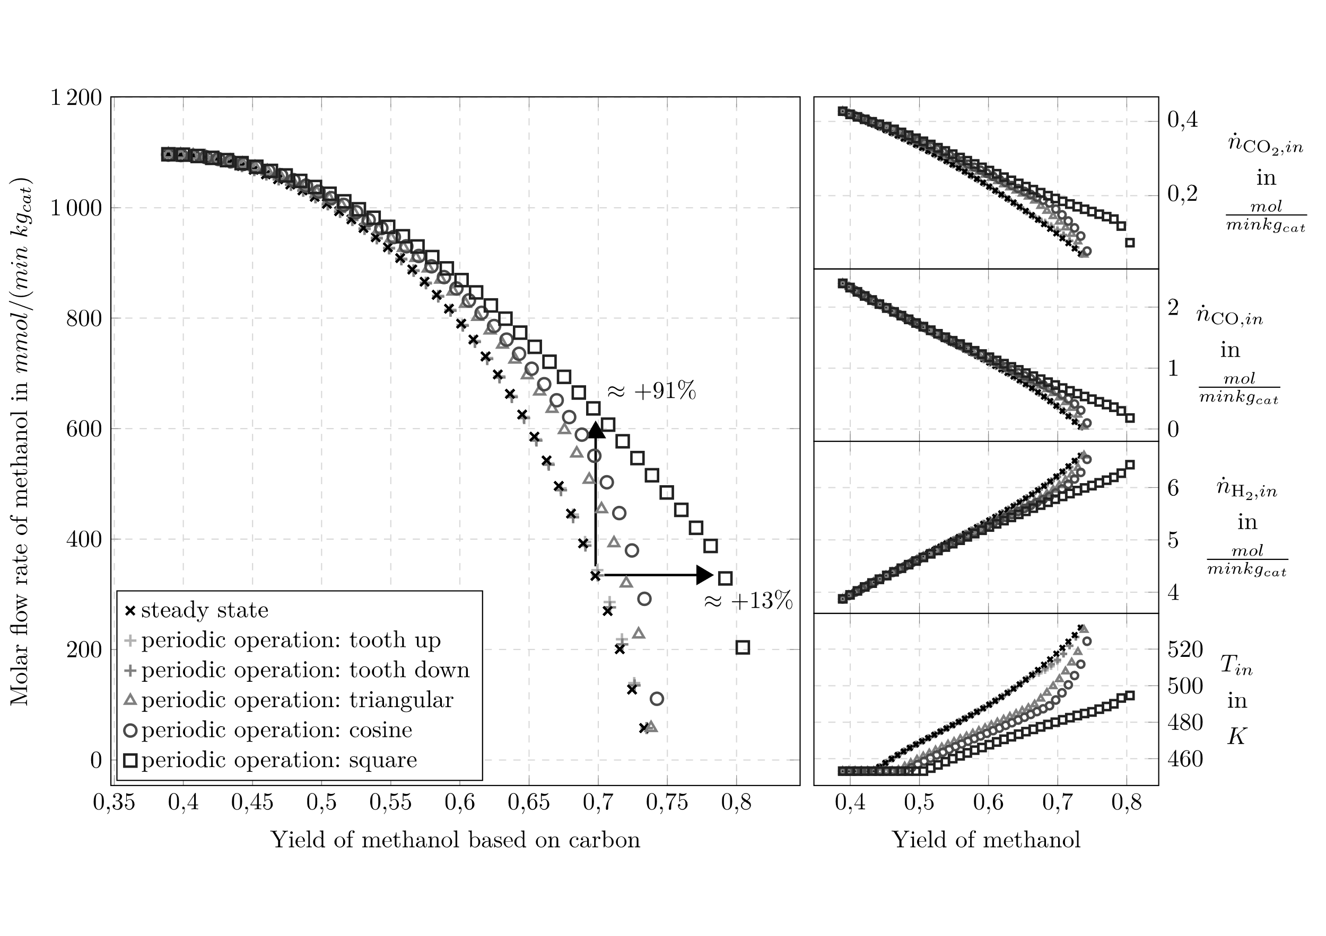This contribution investigates the impact of different input functions on the FPO in a non-isothermal fixed bed reactor for the methanol synthesis. The results show that the FPO with harmonic, triangular, and square waves show significant improvements compared to the steady state, especially for high yield. The FPO with sawtooth waves only shows a negligibly small benefit for high yields and is not worth the effort that a dynamic process realization involves. The best potential of improvement is achieved with square wave modulation. This can be implemented by switching between two constant operating points and is, therefore also, the easiest to realize in practice. In fact, the energy costs and the costs due to wear and tear caused by dynamic operation are considerably higher than in stationary operation. However, a large part of the production costs is accounted for the H2 supply. The FPO offers a further advantage here since less hydrogen is required in the feed. In addition, the optimal temperature in the FPO is lower than in the steady state, which is an advantage in terms of energy requirements. To identify these benefits more precisely, economic objective functions can be used in upcoming investigations. Further work will also focus on experimental validation of FPO.

Figure 1. Pareto fronts and corresponding inlet characteristics for the steady state operation and the FPO with different input functions

**Acknowledgments**

Financial support by the German Research Foundation (DFG) is gratefully acknowledged through the priority program SPP 2080 under grant KI 417/6-2, NI 2222/1-2, SE 586/24-2.

References

M. Ehrgott, 2005, Multicriteria Optimization. Springer Berlin Heidelberg

J.D. Hedengren, R.A. Shishavan, K.M. Powell, T.F. Edgar, 2014, Nonlinear modeling, estimation and predictive control in apmonitor, Comput. Chem. Eng., 70, 133–148.

F. Horn, 1967, Periodic countercurrent processes. Ind. Eng. Chem. Process Des. Dev., 6, 30–35.

J. Leipold, C. Seidel, D. Nikolic, A. Seidel-Morgenstern, A. Kienle, 2023, Optimization of methanol synthesis under forced periodic operation in isothermal fixed-bed reactors. Comput. Chem. Eng., 175, 108285.

M. Lubin, O. Dowson, J. Dias Garcia, J. Huchette, B. Legat, J.P. Vielma, 2023, JuMP 1.0: Recent improvements to a modeling language for mathematical optimization. Math. Program. Comput., 15, 581-589.

F. Nestler, V.P. Müller, M. Ouda, M.J. Hadrich, A. Schaadt, S. Bajohr, T. Kolb, 2021, A novel approach for kinetic measurements in exothermic fixed bed reactors: Advancements in non-isothermal bed conditions demonstrated for methanol synthesis, React. Chem. Eng., 6, 1092–1107.

D. Nikolic, C. Seidel, M. Felischak, T. Miličić, A. Kienle, A. Seidel-Morgenstern, M. Petkovska, 2022, Forced periodic operations of a chemical reactor for methanol synthesis – The search for the best scenario based on Nonlinear Frequency Response Method. Part II Simultaneous modulation of two inputs, Chem. Eng. Sci., 248, 117133.

R.C. Reid, J.M. Prausnitz, B.E. Poling, 1987, The Properties of Gases and Liquids, Mcgraw-Hill Professional, 4th edition.

C. Seidel, A. Jörke, B. Vollbrecht, A. Seidel-Morgenstern, A. Kienle, 2018, Kinetic modeling of methanol synthesis from renewable resources, Chem. Eng. Sci., 175, 130–138.

C. Seidel, A. Jörke, B. Vollbrecht, A. Seidel-Morgenstern, A. Kienle, 2020, Corrigendum to “kinetic modeling of methanol synthesis from renewable resources” (chem. eng. sci. 175 (2018) 130–138)

C. Seidel, D. Nikolić, M. Felischak, M. Petkovska, A. Seidel-Morgenstern, A., Kienle, 2022, Forced Periodic Operation of Methanol Synthesis in an Isothermal Gradientless Reactor. Chem. Eng. Technol., 45, 2261-2272.

P. Silveston, R. Hudgins, 2013, Periodic Operation of Chemical Reactors. Butterworth-Heinemann,

VDI e. V., VDI-Wärmeatlas, 2013, Springer Berlin Heidelberg.

A. Wächter, L.T. Biegler, 2004, On the implementation of an interior-point filter line-search algorithm for large-scale nonlinear programming, Math. Program. 106, 25–57