Novel process for eco-efficient production of formic acid by CO₂ hydrogenation
Maximiliano Taube,^{a#} Amsalia Barus,^{a#} Nikolaos Kalmoukidis,^{a#}
Savvas Staikos,^{a#} Farzad Mousazadeh,ª Anton A. Kiss ^{a*}
ª Department of Chemical Engineering, Delft University of Technology, Van der Maasweg 9, 2629 HZ, Delft, the Netherlands
# These authors have equal contribution
* Corresponding author e-mail: a.a.kiss@tudelft.nl
Abstract
Valorization of carbon dioxide towards value added chemicals can drastically mitigate the increased CO₂ levels in the atmosphere. In this context, formic acid is a versatile bulk chemical with promising market potential. The novel process design proposed in this work involves a sustainable thermochemical synthesis of formic acid from CO₂, which is rigorously simulated using Aspen Plus V12 as a CAPE tool. The process relies on the reverse water-gas shift reaction (RWGS) to synthesize CO from green H₂ and CO₂. The purified CO is used for the synthesis of methyl formate, which is then hydrolyzed to produce formic acid. To address downstream processing energy intensity, a distillation column with a dividing wall (DWC) is employed. The designed process achieves high molar yields of 95% for CO₂ and 96% for H₂ with a specific energy intensity of 21.8 MJ/kg of formic acid. The new process achieves a substantial reduction of 51% in the CO₂ emissions, 64% in electricity consumption and 20% in steam usage as compared to conventional fossil fuel-based FA production plants (reference case).

Keywords: carbon dioxide; formic acid; process design; process intensification

  - Introduction
To mitigate the ever-increasing CO₂ emissions, efforts have been directed toward the conversion of CO₂ into valuable chemicals and fuels. Formic acid is considered a versatile bulk chemical with various applications in food and tanning industry. Moreover, its potential as hydrogen carrier has been recently evaluated. However, direct thermochemical synthesis of formic acid from CO₂ encounters challenges due to the endergonic nature of the reaction (ΔG° = 32.9 kJ∙mol⁻¹). To overcome the key thermodynamic challenge of the direct reaction, intermediates have been introduced to the synthesis pathway. The most common commercial route to produce formic acid is from the hydrolysis of methyl formate derived from the reaction of fossil-fuel-based CO with methanol. This route is exergonic (ΔG° = -5.28 kJ∙mol⁻¹), rendering formic acid synthesis feasible. The CO needed for this design is provided from the reverse water-gas shift reaction (RWGS) of CO₂ and green hydrogen (Hietala et al 2016).
To the best of our knowledge, a detailed design of an energy efficient, sustainable and novel chemical process for formic acid production has not been extensively exploited in the open literature. The case study proposed combines readily available technologies, which enable the faster integration of this design into existing industries, with process intensification. The latter addresses the energy-intensive downstream processing of formic acid, involving the separation of a four-component solution with azeotrope.
  - Methodology
    - Properties database and thermodynamic models
The properties of the compounds employed in this design have been obtained from the Aspen Plus V12 database and additional literature (Novita et al., 2015), including the thermodynamic binary parameters necessary for describing the mixtures within the design. For the CO synthesis, given the low polarity of the compounds involved, the Peng-Robinson model has been selected as the most suitable. The NRTL model is used for the ethylene glycol/water mixture that serves as a thermal fluid with low freezing point. For the formic acid synthesis, the UNIQUAC with Hayden O’ Connell equation of state for vapor phase (UNIQUAC-HOC) best describes this system. Both vapour-liquid and liquid-liquid interactions are involved resulting in a non-ideal system with polar compounds. The HOC variance of the method accounts for the vapor phase dimerization of carboxylic acids, such as formic acid. Moreover, Henry’s law was used to consider the dissolved CO in liquid phase, which is the most appropriate model in temperatures well above the critical temperature.

    - Technology selection and operating conditions
The first step for the synthesis of formic acid involves the endothermic RWGS reaction:
CO₂ + H₂ ⇌ CO + H₂O ΔH_{300K} = 41.2 kJ/mol
For CO₂, a temperature of 25 ºC, and a pressure of 35 bar and two compositions (typical and limit for post-combustion capture quality) were considered, while pure green H₂ was used at 70 ºC and 30 bar. High temperature, high H/C ratio, and low-pressure favor selectivity (against methanation and methanol formation) and conversion towards CO formation. A solid transition metal carbide catalyst (1K-Cu/Mo₂C) is chosen due to its improved selectivity (100%), stability and capability of preventing sintering of the fine copper particles at the elevated temperatures required. Based on this catalyst, the reaction takes place at near atmospheric pressure (1-1.5 bar), at a temperature range of 573-600 ºC and H₂/CO₂ molar ratio of 2.5. At the chosen conditions, this catalyst achieves 48% single-pass conversion with WHSV of 84000 mL/g/h (Xu et al., 2021). The RWGS reactor would ideally operate isothermally to maximize conversion. However, the elevated temperatures needed are not easy to control, and in practice adiabatic stages with inter-heating (using a fired heater) are preferred. Five stages are used to limit the adiabatic temperature fall.
The produced CO is separated using the COPureTM technology, consisting in the selective chemisorption of CO with a CuAlCl₄ salt dissolved in toluene. This selection was based on the achieved purity (> 99%) and CO recovery (98%) and its ability to separate N₂ from CO where cryogenic distillation or membranes fail. Operating conditions in the absorption column were selected based on the pilot plant data (Go et al., 2019), adjusting the pressure to 27 bar to compensate for the slightly lower CO concentration in the feed. After CO is chemically bound to CuAlCl₄ at low temperature (12-52 ºC), other gases dissolved in the toluene are desorbed in a flash vessel at 90 ºC and atmospheric pressure. Finally, the CO-CuAlCl₄ complex is dissociated in a stripper operating at 2 bar and 135 ºC in the reboiler (Bierhals, 2001). Taking advantage of the relatively high pressure of the raw materials and recycle stream, and low pressure of the RWGS reaction, turbines are installed to generate power. Additionally, this pressure difference is also exploited to recover hydrogen from the inert purge by means of a polymeric membrane, suited to reject the main impurities such as CH₄ and N₂.
Methyl formate synthesis involves catalytic methanol carbonylation with CO to produce methyl formate, typically utilizing sodium methoxide as a homogeneous catalyst with a concentration of 2.5 wt. %. The reaction is the following:
CH₃OH + CO ⇌ HCOOCH₃ ΔH_{300K} = -29.3 kJ/mol
Anhydrous environment is essential to avoid fouling since the catalyst is sensitive to moisture. Increased pressure favours methyl formate synthesis, with optimal conditions at 80 ºC and 40 bar. Excess methanol (CH₃OH/CO molar ratio of 5) guarantees an almost complete carbon monoxide conversion. The reaction is conducted in a CSTR equipped with cooling coil to actively remove the heat generated. After the reaction, the unreacted CO is flashed and recycled back. Then distillation follows, where the excess of methanol is retrieved at the bottom and recycled back to the carbonylation reactor (BASF, 2006).
The last step is the hydrolysis of methyl formate towards formic acid:
HCOOCH₃ + H₂O ⇌ CH₃OH + HCOOH ΔH_{300K} = 16.3 kJ/mol
This reaction poses challenges due to formic acid decomposition being favoured. The equilibrium constant for hydrolysis depends on the water:ester ratio, with a molar ratio of 1.8 being recommended to diminish downstream processing energy requirements. Thermal decomposition of formic acid and azeotrope presence were considered for the selected conditions. The main reaction should ideally occur at 120°C at 18 bar. PFR reactor with L/D = 30 is employed to ensure turbulent flow. For both methyl formate and formic acid synthesis, kinetic reactor type in Aspen was utilized with kinetic equation obtained from Chua et al’s work (Chua et al., 2019).
The downstream processing involves decompression of the reactor outlet and cooling to prevent re-esterification. Methyl formate and methanol are separated from formic acid and water, and recycled back to the hydrolysis and carbonylation reactors, respectively. The final stage involves formic acid dehydration using distillation, carried out at 2.7 bar to yield a concentration of 85% wt. in formic acid while avoiding thermal decomposition in the bottom stream. Water distillate is recycled to the hydrolysis reactor (Chua et al., 2019).

    - Process Intensification
Process intensification has been introduced as a novelty to this design to reduce the energy needs of the process, namely reactive distillation (RD) and divided wall column (DWC) configurations have been considered. RD cannot be implemented to methyl formate synthesis, since the elevated pressure requirement (40 bar) of the reaction is incompatible with the operating pressure of the distillation (da Cunha et al, 2018). Several works have mentioned the utilization of RD and RDWC in formic acid synthesis. Despite the good results reported, narrow overlap between reaction and separation conditions and vapor recompression makes the process control challenging and hard to be retrofitted in existing plants (Ge et al, 2020).
On the contrary, the DWC configuration is deemed suitable for formic acid downstream processing. The separation of methyl formate, methanol, and the formic acid/water mixture can be achieved at the same pressure and is crucial to prevent the reverse decomposition of formic acid. In the Aspen Plus simulation, the DWC configuration is modeled using the Petlyuk configuration, which is its thermodynamic equivalent. The DWC design was initiated with constructing the V_{min} diagram which shows a graphical representation of the minimum vapor flow rate required at the column for proper separation (Figure 1). The minimum energy needed to separate a multicomponent mixture using a three-product Petlyuk arrangement is equivalent to the minimum energy required for the most challenging separation between the top/middle or middle/bottom products in a conventional single column (Halvorsen and Skogestad, 2003).
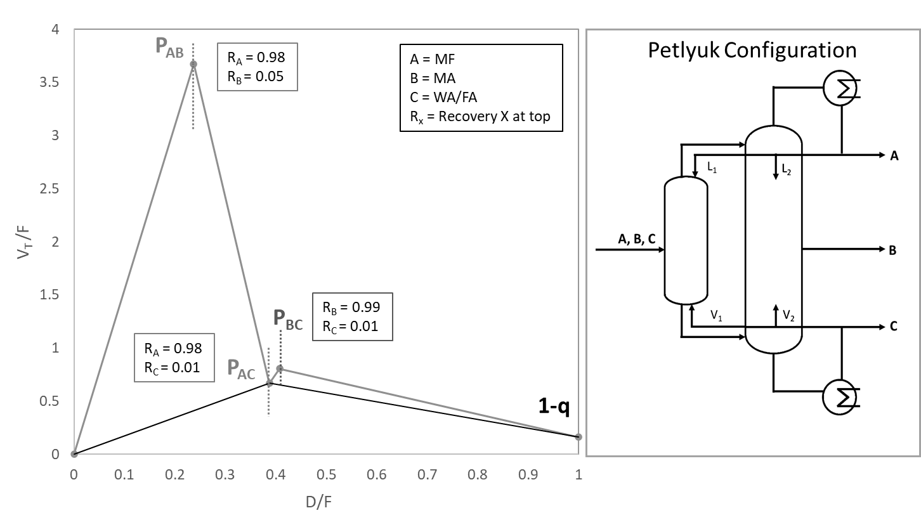
Figure 1. V_{min} diagram in FA separation
    - Heat Integration
Aligned with the energy-saving objective, heat integration was also performed. Firstly, the medium-pressure steam generation from the hot outlet stream of the CO synthesis reactor (573 °C) was valorized to fully cover the duty of the reboiler in the stripper. Moreover, the refrigerant generation through the turbines during the feedstock depressurization was also incorporated; thus, eliminating the need for chilled water.

  - Results and discussion
The simplified process diagram of the proposed concept is shown in Figure 2. This process renders 50.2 kta of formic acid with a process yield of 95% for CO₂ and 96% for H₂ (mass-based). Formic acid separation is the most energy intensive step in the whole process due to high energy demand for water and formic acid separation. Implementation of a DWC substantially contributes to achieving 20% energy saving compared to conventional distillation column arrangements. After applying heat integration, the overall heating duty is 31.8 MW, the cooling duty is 36.4 MW, and the power consumption equals 3.5 MW. This integrated approach not only enhances overall energy efficiency but also mitigates indirect CO₂ emissions within the proposed system.

Table 1. Comparison of this work with the reference case
Parameters | Unit | Reference Case* | This Work | Savings
Electricity | MWh/t FA | 1.55 | 0.56 | 64%
Steam usage | MJ/kg FA | 19.25 | 15.34 | 20%
Cooling water usage | t H₂O/t FA | 375.50 | 501.59 | -34%
Process water usage | t H₂O/t FA | 0.60 | 0.50 | 17%
Total CO₂ emissions | t CO₂/t FA | 2.18 | 1.07 | 51%
*Obtained from European Commission - JRC Science for Policy Report (Perez-Fortes, 2016)
Figure 2. Process flow diagram of the concept proposed in this work
To evaluate the performance of the proposed design, a comprehensive comparison was conducted with conventional formic acid production with CO produced from heavy-fuel oil partial oxidation, serving as the reference case for this work (Perez-Fores, 2016). Table 1 lists the main results which prove significant advantages across various key performance indicators (KPIs), such as 64% reduction in electricity consumption and a substantial 51% reduction in total CO₂ emissions. From a sustainability point of view, the waste generated from this process comes from the purge streams (rich in CO₂) and waste water. The waste water is almost pure and could be recycled again to the methyl formate hydrolysis which accounts for 73% process water savings.

  - Conclusions
This work successfully showcased a novel process design with a capacity of 50.2 kta of formic acid produced from captured CO₂. Significant energy savings were achieved through process intensification (namely a DWC configuration) and heat integration, CO₂(eq) emissions were effectively halved as compared to the conventional method. One suggested approach for additional energy efficiency involves employing a membrane reactor for a simultaneous reaction and selective separation of the CO. Continuous removal of the product shifts the equilibrium towards higher CO yield. The electrification of the fire heater could assist in to accomplishing net-zero emissions. Another area of improvement involves refining the modeling of the process. Specifically, the CO separation the system was analyzed with a combination of pilot plant data and physical absorption simulations. Using a custom model in Aspen Plus which incorporates the chemisorption reaction would render more accurate results. The same principle applies to the CO synthesis reactor, where it is essential to incorporate a kinetic-based reactor.
The success of this work lies on the utilization of readily available technologies in which innovative adaptations were incorporated to enable a swift integration of this design into a more sustainable and energy efficient formic acid production plant.

References
BASF SE, 2006, Method for producing metyl formate, 10/511088, 5
J. Biehals, 2001, Carbon Monoxide, Ullmann's Encyclopedia of Industrial Chemistry,
W. X. Chua, S. da Cunha, G. P.Rangaiah, K.Hidajat, 2019, Design and optimization of Kemira-Leonard process for formic acid production, Chemical Engineering Science: X, 2, 100021 Halvorsen, I.J. and S. Skogestad, 2003, Minimum Energy Consumption in Multicomponent Distillation. 2. Three-Product Petlyuk Arrangements. Industrial & Engineering Chemistry Research, 42(3): p. 605-615
Y.Go, Y.Yoon,Y. Lee, S.Y. Lee, 2019, Mathematical Modeling and Simulation of Carbon Monoxide Absorption Column for Blast Furnace Gas and Linz–Donawitz Gas Separation by COSORB Process, Journal of Chemical Engineering of Japan, 52, 439-446
J. Hietala, Jukka, V.Antti, J. Pekka, P. Ilkka, R. Werner, K.Heinz, 2016, Formic Acid, Ullmann's Encyclopedia of Industrial Chemistry,1-22
F. Novita, H. Lee, M. Lee, 2015, Self-heat recuperative dividing wall column for enhancing the energy efficiency of the reactive distillation process in the formic acid production process, Chemical Engineering and Processing: Process Intensification, 97, 144-152
J. Xu, X. Gong, R. Hu, Z. Liu, Z. Liu, 2021, Highly active K-promoted Cu/β-Mo2C catalysts for reverse water gas shift reaction: Effect of potassium, Molecular Catalysis, 516, 111954
Mar Perez-Fores, E.T., 2016, Techno-economic and environmental evaluation of CO₂ utilisation for fuel production: Publications Office of the European Union, JRC99380

