Flow regimes and reactivity assessment in arrow- and X-microreactors: a combined numerical and experimental approach
Sara Tomasi Masoni^{a*}, Alessandro Mariottiª, Maria Vittoria Salvettiª, Chiara Gallettiª, Elisabetta Brunazziª
ª Dip. di Ingegneria Civile e Industriale, Università di Pisa, Largo Lucio Lazzarino 2, Pisa, Italy
sara.tomasimasoni@phd.unipi.it
Abstract
In this study we use numerical simulations and experimental investigations to gain a comprehensive characterization of the flow dynamics inside microreactors. Two different simple geometries, namely the arrow- and the X-microreactors, are considered, both fed with reactive liquid streams. In both geometries, at low Reynolds number, Re, the streams stratify in the outlet channels due to the different densities of inlet solutions. At Re around 50, the X-microreactor exhibits a single central vortex in the mixing channels, leading to a highly mixed flow regime. By increasing the Reynolds number, the vortex elongates in the outlet channels and increases in size. Conversely, in the arrow-microreactor, three different flow regimes occur before transitioning to unsteady flow: the vortex, the engulfment, and the single-vortex regimes. Unlike the X-shaped geometry, the engulfment regime in the arrow geometry is characterized by the presence of two co-rotating vortices that extend in the outlet channel. The reaction yield is evaluated and compared in the two geometries, showing that higher performance is achieved when a single central vortex is present in the outlet channels.
Keywords: Microfluidics, microreactors, CFD simulations.
  - Introduction
Micromixers and microreactors consist of channels with a width $≤$ 1mm. They ensure continuous operation and precise control over the reaction progress due to the large surface-to-volume ratio (Rossetti et al. 2016). This feature can be exploited to achieve very high reaction yields and selectivity, allowing the reduction of reagents and wastes.
As the efficient mixing is fundamental for ensuring high reaction yields, different designs have been proposed to enhance mixing because the typical flow regime is laminar. Among these, the T-micromixer is the most studied configuration. Despite its simple design, it exhibits different complex flow regimes as the Reynolds number increases (Mariotti et al. 2020).
In this work, we focus on two additional simple geometries, namely the X- and the arrow-microreactors, fed with reactive streams. The X- and the arrow-micromixer were characterized by feeding water (see Zhang et al. 2019 and Mariotti et al. 2019).
At low Reynolds numbers, in both geometries, the two inlet streams flow side by side in the mixing channel. By further increasing the Reynolds number, the vortex regime occurs in the arrow-micromixer, characterized by the presence of two U-shaped vortical structures in the mixing channel. Subsequently, at higher Reynolds numbers in the engulfment regime, only the two strongest legs persist in the outlet channel. With a further increase in the Reynolds number in the arrow-micromixer, the two co-rotating vortices merge in the outlet channel, leading to a single-vortex regime.
Instead, the vortex regime does not occur in the X-micromixer, and the engulfment regime takes place at a lower Reynolds number compared to the arrow-geometry. In this case, the engulfment regime differs from that in the arrow-micromixer, in fact, it is characterized by a single vortical structure placed in the center of the outlet channels.
This work aims at characterizing the flow inside the X- and the arrow-microreactors, both fed with reactants, to ultimately investigate the impact on the reaction performance. More specifically, we analyze the reaction rate and the contact area between the two inlet reactive streams, to understand how flow regimes triggered by different geometries affect the reaction yield.
  - Geometries and reactive fluids
Figure (1) shows the geometries of the two microreactors. The arrow-microreactor has two identical inlet channels, each 40 mm long, with a square cross-section (W_{i}=H=1 mm), and an outlet channel, 60 mm long, with a rectangular cross-section (W_{o}= 2H= 2 mm). The angle between the x-axis and the inlet channels is 20°. The X-microreactor has four identical channels with a square cross-section (W_{i}=H=1 mm), each having a length of 60 mm. Such a X-microreactor is used in the impinging jet configuration, which means 2 inlets and 2 outlets.
The chemical reaction is the reduction of methylene blue (MB+), to the leucomethylene blue (LMB+), using ascorbic acid (AsA) with the hydrogen chloride (HCl) acting as the catalyst of the reaction. The dehydroascorbic acid (DA) is also a reaction product.
$${MB}^{+}+AsA \underset{→}{HCl}{LMB}^{+}+DA$$ | (1)
The progress of the reaction can be monitored by the decolorization of the fluid streams that progressively occurs as MB+ is consumed. The devices are made in transparent PMMA allowing us to experimentally follow the extent of the reaction.
The aqueous solution of methylene blue ([MB+] = 5.31$∙$10⁻⁵ mol/L) and hydrochloric acid ([HCl] = 2.19 mol/L) is fed to one inlet channel (indicated by the black arrow), while the aqueous solution of ascorbic acid ([AsA] = 1.7 mol/L) is fed into the other (indicated by the white arrow). The physical properties of the latter solution depend on the ascorbic acid content. The density is equal to ρ = 1.117 g/cm³, and the dynamic viscosity is μ = 1.7 mPa$∙$s for the above AsA concentration. The kinetic of the reaction follows a pseudo-first-order law in case of an excess of ascorbic acid (Mowry et al. 1999). At the concentrations of the present experiments the kinetic constant is equal to k_{r,0} = 21.43 s⁻¹.

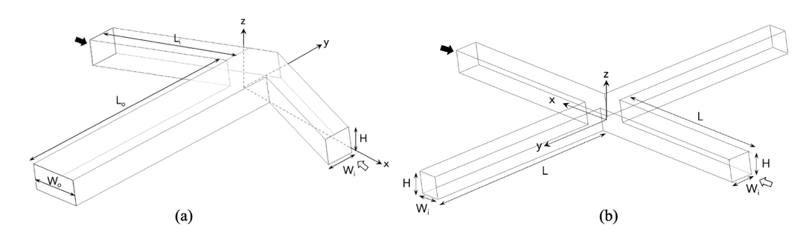
Figure 1: Geometries and reference system of the (a) arrow-microreactor and the (b) X-microreactor.
  - Numerical methodology
Steady Navier-Stokes equations and transport/reactions equations for all chemical species except water are solved with the finite volume code ANSYS Fluent v.20.
$$∇\left(\hat{ρ}u\right)=0$$ | (2)
$$\hat{ρ}u∇u=-∇p+\frac{1}{Re}∇⋅\left[\hat{μ}\left(∇u+∇u^{T}\right)\right]+Ri\left(\hat{ρ}-1\right)\hat{g}$$ | (3)
$$\hat{ρ}u⋅∇ϕ_{k}=\frac{1}{Pe}∇⋅\left(\hat{ρ}{\hat{D}}_{k}∇ϕ_{k}\right)+\frac{d{\dot{ω}}_{k}}{ρU}$$ | (4)
where lengths are normalized with the mixing channel hydraulic diameter $d$ and velocities with the inlet bulk velocity $U$. In the above equations, $u$ represents the non-dimensional velocity vector, $p$ is the modified non-dimensional pressure, i.e. $p$ = (P - ρ₀ g Z) / ρ₀ $U$², where P is the pressure, and g the gravity acceleration, while $\hat{g}$ is the non-dimensional gravity, i.e. $\hat{g} = g/g$. $\hat{ρ} = ρ/ρ_{0}$and $\hat{μ} = μ/μ_{0}$ are non-dimensional density and viscosity, respectively, referred to pure water at 25°C, i.e., $ρ_{0}$ and $μ_{0}$. $ϕ_{k}$ represents the mass fraction of the k-th chemical species while ${\dot{ω}}_{k}$ is its rate of production or consumption due to chemical reactions, which, for instance is ${\dot{ω}}_{MB+} =- k_{r} ρ ϕ_{MB+}$ for the methylene blue. ${\hat{D}}_{k}=\hat{D}/{\hat{D}}_{0}$ is the non-dimensional diffusivity referred to the water self-diffusivity ${\hat{D}}_{0}$. The characteristic non-dimensional numbers are: the Reynolds number $Re = ρ_{0} U d / μ_{0}$, the Richardson number, $Ri=gdΔρ/ρ_{0}U^{2}$, and the Peclet number $Pe=Ud/D_{0}$, where $Δρ$is the density difference between the two inlet fluids.
Since the fluid density and viscosity depend on the ascorbic acid content $ϕ_{AsA}$, their behaviour is implemented in the model.
Uniform velocity and concentration of the reactants are imposed at the entrance of the inlet channels, whereas no-slip velocity at the channel walls and pressure outlet conditions at ambient pressure are set at the outlet boundary.
A second-order upwind interpolation scheme is used for spatial discretization, and the SIMPLE algorithm is employed for the pressure and velocity coupling. Convergence is checked by monitoring normalized residuals for all equations (below 10⁻⁹).
  - Results
An overview of the flow topology in the X- and arrow-microreactors is presented in Figs. (2) and (3) that show the contours of the reaction rate at different cross-sections in the outlet channel. The reaction rate highlights the contact region, which is a fingerprint of the flow regime, between the two inlet streams where the reaction takes place. A quantitative comparison of the reaction performance between X- and arrow-shaped microreactors is also carried out by estimating the reaction yield. The comparison is conducted in terms of the Reynolds number evaluated at the inlet channel, i.e., Re_{i}=ρ Ud_{i}/μ, where d_{i} is the hydraulic diameter of the inlet channel. This approach enables a comparison of the two geometries with the same inlet flow rate. For the X-geometry Re = Re_{i}, as it has four identical channels. Instead, for the arrow-microreactors Re_{i} < Re due to the difference between the hydraulic diameter of the inlet channels and of the outlet channel.
Figure (2) summarizes the steady flow regimes in the arrow-microreactor. At low Reynolds numbers, the stratification effect leads to a tilting of the impinging plane between the two inlet streams, and the ascorbic acid solution occupies the bottom part of the channel due to its higher density. The lower the Re_{i}, the more upstream the stratification occurs (see Figs. (2a) and (2b)). The reaction takes place exclusively in the contact region between the inlet streams. For Re_{i}>37.5, the vortex regime occurs, which is characterized by two U-shaped counter-rotating vortical structures in the mixing channel. The stratification effect is still present but is visible further downstream in the outlet, leading to an asymmetry of the flow. Additionally, the reaction occurs at the interface between the two solutions.
The engulfment regime is observed in the range 75 < Re_{i} ≤ 142.5. In this regime, only the two strongest legs, which co-rotate, persist in the mixing channel. This results in a sudden enhancement of mixing between the reactive streams.
The intensity of the co-rotating vortical structures differs due to the distinct properties of the inlet streams, and this effect becomes more pronounced as the Reynolds number increases. Beyond Re_{i} = 142.5, in the single-vortex regime, only one vortical structure remains in the mixing channel. In the confluence region, four weaker vortical structures form due to the central vortex. The flow remains stable up to Re_{i} = 232.5.
In the engulfment and single-vortex regime, the reaction rate is low in the center of the vortex, instead is higher at the interface between the vortex and the bulk solution.
Figure (3) summarizes the steady flow regimes in the X-microreactor. At low Reynolds numbers, the stratified regime occurs in the device similarly to the arrow-geometry. The flow pattern at Re_{i} = 40 mirrors that of Re_{i} = 10. The impingement plane between the two streams tilts, and the ascorbic acid solution migrates toward the lower part of the channel. The contact regions between the two streams at Y = 1, 2, and 3 exhibit slight corrugations. Similar to the arrow-geometry, in the stratified regime, the reaction occurs at the interface between the two solutions. For Re_{i} > 50, a single vortical structure emerges in the confluence region and extends into the outlet channels. In the X-microreactor, the intermediate vortex regime does not occur; thus, the engulfment regime is triggered at a very low Reynolds number compared to the arrow-microreactor.
By further increasing Reynolds, the central vortex strengthens and elongates in the outlet channels. In addition to the central vortex, two secondary counter-rotating vortices form, further enhancing the mixing of the streams (see Fig. (3d) and (3e)).
The highest reaction rate in the engulfment regime is obtained along the external border of the central vortex. Conversely, in the vortex core, the reaction rate is lower due to the stagnation of the reactants. The flow remains stable up to Re_{i} = 375.

The reaction yield is computed as:
$$η=1-2 \frac{C_{MB+,Y}}{C_{MB+,in}}$$ | (5)
Where C_{MB+,Y} and C_{MB+,in} are the methylene blue concentrations evaluated at the Y cross-section and at the inlet channel, respectively.
Figure (4) presents a comparison of the reaction yield in the X- and arrow-microreactors, evaluated at the Y=-25 cross-section.
In the stratified regime, the reaction yield diminishes with increasing Reynolds for the two examined geometries. This behavior is attributed to the reduction in the residence time of fluid streams within the device. Specifically, as Re_{i} increases, the contact area between the streams remains unchanged, but the residence time decreases. Subsequently, η gradually increases in the vortex and engulfment regime in the arrow-geometry due to the increase in the contact area between the streams. In the X-microreactor, the yield starts to increase when the engulfment regime occurs, but after reaching a maximum at Re_{i}=80, the yield decreases. This is probably because, for Re_{i}>80, the contact area between the inlet streams does not significantly vary, but the residence time drastically diminishes.
By further increasing Re_{i}, the single-vortex regime occurs in the arrow-geometry, leading to a sudden increase in the reaction yield. Conversely, in the X-microreactor, the yield continues to diminish.

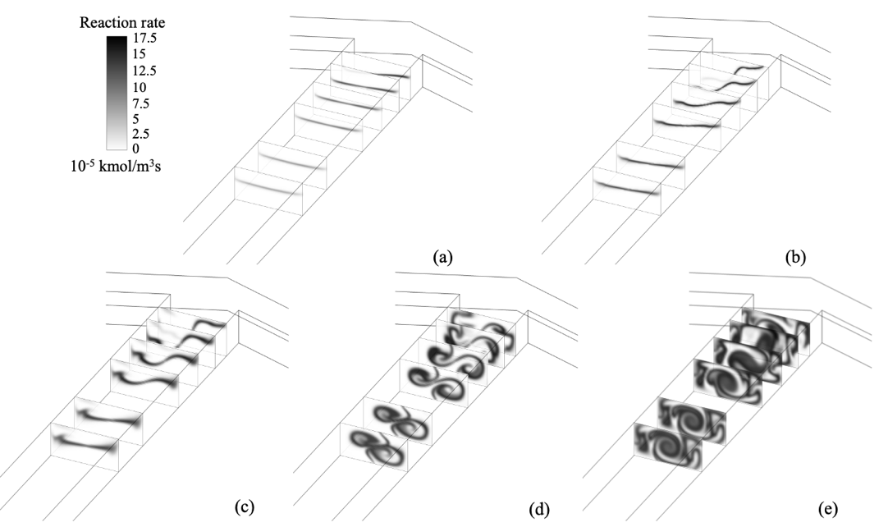
Figure 2: Contours of reaction rate in the arrow-microreactor at the Y = -1, -2, -3, -5, -8, -10 cross-sections along the outlet channel in numerical simulations at Re_{i}= (a) 7.5, (b) 37.5, (c) 60, (d) 112.5, and (e) 187.5.

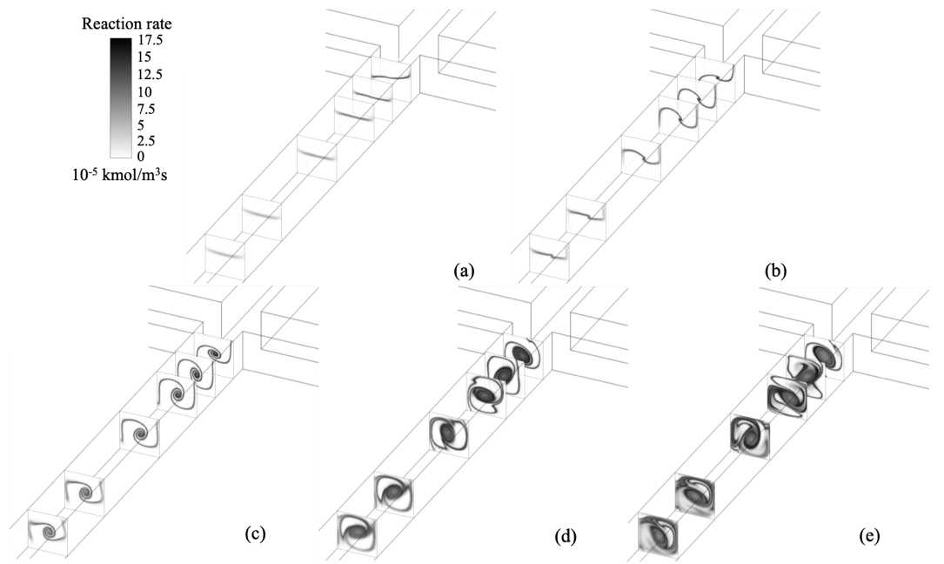
Figure 3: Contours of reaction rate in the X-microreactor at the Y = 1, 2, 3, 6, 8, 10 cross-sections along the outlet channel in numerical simulations at Re_{i}= (a) 10, (b) 40, (c) 50, (d) 100, and (e) 200.
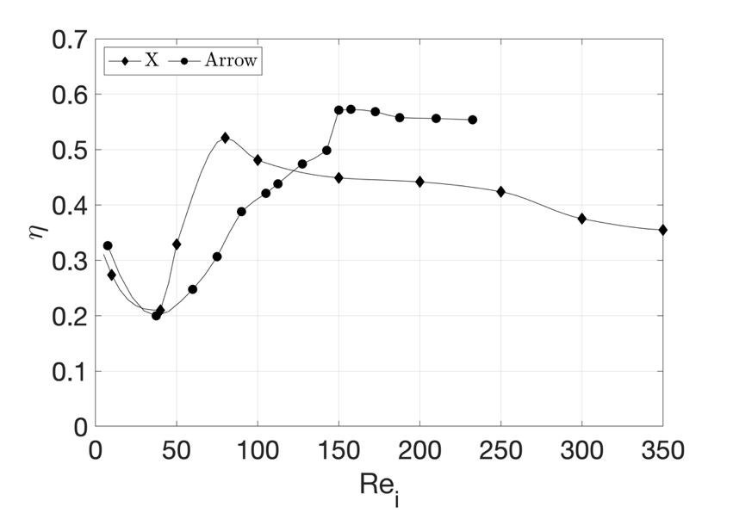
Figure 4: Reaction yield of the X- and arrow-microreactors at Y=-25 cross-section as a function of the Reynolds number evaluated at the inlet channel. Results are from numerical simulations.
  - Conclusions
The X- and the arrow-microreactors are compared in terms of reaction yield. At low Reynolds numbers, the two reactant streams stratify in the outlet channels, resulting in a low reaction yield that diminishes with increasing Re because of the reduction in residence time. At the vortex regime onset, the reaction yield increases in the arrow-microreactor, due to the expanded contact area between the inlet streams. By further increasing Reynolds, the engulfment regime promotes the progress of the reaction for both geometries. Indeed, the presence of vortical structures ensures effective mixing of the streams, leading to an increase in the yield. Above Re_{i}=80 in the X-microreactor, the contact area does not increase in size, but the residence time inside the device decreases, hence, the yield decreases.
The highest reaction yield in the steady regimes is achieved in the arrow-microreactor for Re_{i}>150, i.e., at the onset of the single-vortex regime. This regime provides the best compromise between the contact area of the inlet streams and the residence time inside the device.
References
A. Mariotti, C. Galletti, E. Brunazzi, M.V. Salvetti, Steady flow regimes and mixing performance in arrow-shaped micro-mixers, Physical Review Fluids, 4 (3) (2019) 1–20.
A. Mariotti, M. Antognoli, C. Galletti, R. Mauri, M.V. Salvetti, E. Brunazzi, The role of flow features and chemical kinetics on the reaction yield in a T-shaped micro-reactor, Chemical Engineering Journal, 396 (2020) 125223.
S. Mowry, P. Ogren, Kinetics of methylene blue reduction by ascorbic acid, Journal of Chemical Education, 76 (1999) 970-973.
I. Rossetti, M. Compagnoni, Chemical reaction engineering, process design and scale-up issues at the frontier of synthesis: Flow chemistry, Chemical Engineering Journal, 296 (2016) 56–70.
J.W. Zhang, W.F. Li, X.L. Xu, H.F. Liu, F.C. Wang, Experimental investigation of three-dimensional flow regimes in a cross-shaped reactor, Physics of Fluids, 31 (3) (2019) 034105.

