Life Cycle Assessment (LCA) of Dimethyl Ether (DME) Production: Fossil Fuels vs. Biogas
Matteo Fedeli^{a,b}, Alessandro di Pretoro^{b}, Ludovic Montastruc^{b}, Flavio Manenti^{a*}
ª Politecnico di Milano,Dipartimento di Chimica, Materiali ed Ingegneria Chimica
“Giulio Natta”, Piazza Leonardo da Vinci 32, Milano, 20133, Italy
^{b} Laboratoire de G´enie Chimique, Universit´e de Toulouse, CNRS/INP/UPS, 4 All. Emile Monso, 31030, Toulouse, 31030, France
*flavio.manenti@polimi.it
Abstract
This study conducts a comprehensive Life Cycle Assessment (LCA) to compare the environmental impacts of two alternative pathways for producing dimethyl ether (DME): one utilizing conventional fossil fuel-based processes and the other relying on biogas feedstocks. LCA is employed as a robust tool for evaluating the sustainability of these fuel production methods. The authors meticulously quantify resource inputs and outputs for both production routes in the inventory analysis phase. For conventional fossil fuel-based production, the value of the impact categories is retrieved from SimaPRO database. On the other hand, for biogas-based production, Aspen HYSYS is utilised to perform process simulations. The results of these are used as input for LCA analysis. Our findings reveal significant disparities between the two production pathways. Biogas-derived DME exhibit lower greenhouse gas emissions and reduced dependence on finite fossil resources. The biogas route also provides valuable co-benefits, such as organic waste valorization and potential improvements in soil quality through feedstock cultivation. However, it is essential to recognize that biogas-based production requires more land and water resources than fossil fuel-based. Therefore, trade-offs between reduced carbon emissions and increased resource use should be carefully considered, particularly in regions with limited land and water availability.

Keywords: Methanol, Di-methyl-ether, Biogas feedstock, LCA, Process sustainability
  - Introduction

The heightened global interest in renewable energy sources has been spurred by growing apprehensions regarding climate change and the conventional exploitation of fossil fuels. Among the prospective alternatives, biogas emerges as an auspicious solution owing to its sustainable attributes, capacity for waste management, and minimal ecological footprint. Presently, the European Commission is actively engaged in advancing the utilization of biogas employing an all-encompassing regulatory framework, investment incentives, and initiatives in research and development [1]. Biogas finds primary application in Combined Heat and Power (CHP) and Biomethane Injection Plants (BIP). CHP represents a conventional cogeneration cycle designed for the simultaneous generation of heat and electricity. BIP, on the other hand, involves the purification of biogas from CO₂ and other impurities to yield biomethane. Specifically, as outlined by the International Energy Agency (IEA), biomethane must possess a minimum methane content of 97%. Initially, the heightened attractiveness of CHP utilization was attributed to financial incentives extended by European governments during the 2007-2020 period. However, after the expiration of these economic advantages, the biogas market witnessed a notable decline in investor interest. The utilization of biogas to produce advanced fuels, including methanol and dimethyl ether (DME), holds paramount importance in the pursuit of sustainable energy solutions. This technological approach is referred to as Heat, Power, and Chemicals (HPC) [2]. In this work, a Life Cycle Assessment (LCA) analysis is performed to assess and compare two different production routes of the dimethyl ether. The difference between the two processes lies in the feedstock type. The first one is the conventional production of biofuel from natural gas, while the latter employs biogas as a raw material. The aim is to evaluate the environmental impact of the upcoming and more sustainable technology, compared to the conventional one. Process simulations are rigorously simulated in Aspen HYSYS v11 to retrieve LCA data input for biogas-to-bio-DME processes. LCA is computed through the software SimaPro.
  - Materials and methods
The biogas to biofuel process is rigorously simulated in Aspen HYSYS and Aspen PLUS to collect process data for the subsequent environmental assessment. Biogas properties are retrieved from the work of Fedeli and Manenti, which analysed a feedstock from energy crops. The average H₂S content in the gaseous mixture is 200 ppm [3].
Biogas is treated with caustic scrubbing first in order to remove H₂S impurities that could damage the downstream units by means of corrosion and catalyst poisoning [4]. Figure 1 illustrates the streamlined diagram of the scrubbing unit, meticulously simulated in Aspen Plus using the Electrolyte Non-Random Two Liquid (ELECNRTL) thermodynamic model. Gas phase behavior was characterized using the Soave-Redlich-Kwong (SRK) model. The choice of ASPEN Plus software was motivated by its enhanced suitability for managing electrolytic systems compared to Aspen HYSYS. Subsequently, the simulation outcomes were employed as input parameters in Aspen HYSYS.

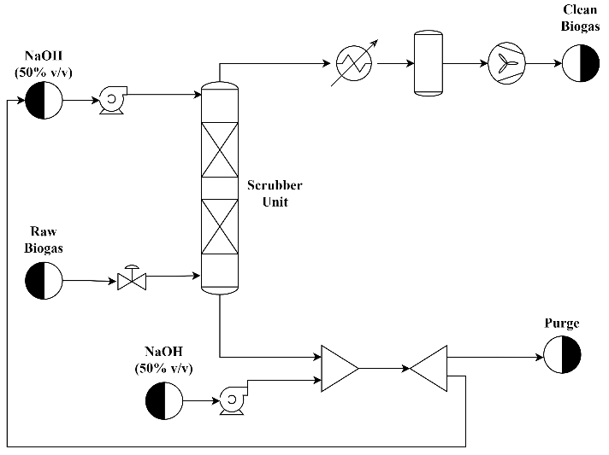
Figure 1 Flowsheet of biogas purification

DME production section is rigorously simulated in Aspen HYSYS v11. In the proposed layout three different sections can be distinguished: (i) biogas reforming, (ii) DME production, and (iii) purification section. The introduction of biogas into the system precedes its compression through a three-stage compressor, increasing the pressure to 1.5 MPa. Subsequently, the pressurized stream is amalgamated with medium-pressure steam from an internal loop. This composite stream undergoes pre-heating in a process-process heat exchanger before entering the steam reforming tubes. The modeling of this unit is achieved utilizing the Aspen HYSYS isothermal Plug Flow Reactor (PFR) module with Xu-Froment kinetics [5]. The operating conditions of the reformer unit are 950°C and 1.5 MPa. The syngas exiting the system imparts heat to the biogas-water mixture, followed by cooling through a heat exchanger. Within this unit, the thermal energy is harnessed to produce medium-pressure (MP) steam (at 1.5 MPa) from the pumped water. The cooled syngas undergo dewatering in a separator, and the resulting condensed water is returned to the water loop for steam generation. Additionally, the dehydrated reformate is directed to a dual-stage compressor (at 6 MPa) for subsequent synthesis stages. The initial portion of this stage remains consistent across both synthesis processes. The dehydrated syngas undergo pre-heating via two heat exchangers before being introduced into methanol reactor tubes at 235°C. This unit is modelled as catalytic PFR with the Graaf refitted kinetics model from the work of Bisotti et al. (2021) [6]. Pressure drops of 200 kPa are estimated with the Ergun equation. However, the produced methanol is rich in water and light gases such as CO, H₂, CH₄, and CO₂. The uncondensable gases are separated in a water-cooled vessel and recycled back to the reactor to enhance the overall conversion. Regarding DME synthesis, following the purification stage, methanol is pressurized to 1 MPa and heated to 230 °C before entering the DME reactor, where methanol dehydration occurs. Even in this instance, the elevated temperature of the resultant products proves beneficial for pre-heating the reacting mixture. From a simulation standpoint, this unit was modeled as an Aspen Gibbs reactor to predict the equilibrium behaviour of the system. The Aspen Gibbs reactor module is designed to establish equilibrium conditions while accounting for thermodynamic non-idealities. This selection is well-established in the literature, as evidenced by Merkouri et al. (2022), who evaluated DME production using an Aspen equilibrium reactor [7], and Moura et al. (2023), where DME production through sugarcane bagasse gasification was analyzed [8]. In the process simulation, the effluent from the DME converter primarily consists of DME, water, and unreacted methanol. The DME purification column, operating at 160°C and 1 MPa, separates DME, meeting ASTM D7901-14 standard specifications, from the other compounds. Specifically, DME is collected from the top of the unit, while the water-methanol mixture is recycled back to the methanol column. Figure 2 illustrates the process simulation flowsheet for methanol and DME production, respectively. Despite the utilization of two distinct software platforms for this section, consistency in the results, especially in the context of methanol/DME separation, is ensured by maintaining the same NRTL thermodynamic model and SRK equation for gas phase behavior.
The outputs of this process simulation are used as input for the LCA analysis concerning the DME production from biogas. Input values for the fossil-based process are directly retrieved from SimaPRO inventories. Based on the simulations, the LCA analysis of the three processes was then performed employing SimaPRO 9.3 software. A cradle-to-gate lifecycle model was selected as the method to analyse the systems. 1 kg of produced DME is selected as the functional unit of the assessment. The results of each impact category were normalised for each section to facilitate the comparison.

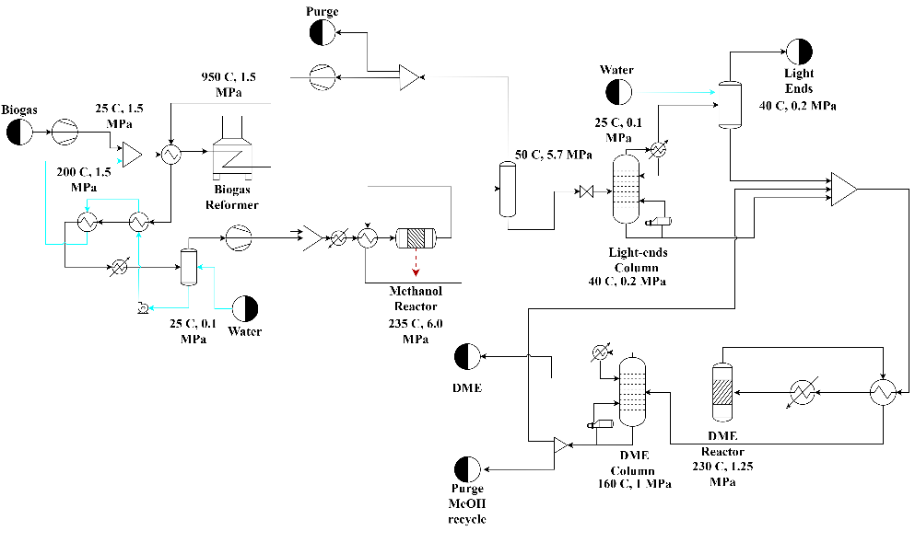
Figure 2 Flowsheet of biogas to bio-DME production

  - Results and discussions
The analysis of the chemical synthesis involves assessing the molar conversion of biogas, molar conversion of H₂, and chemical yield. Key performance indicators for DME production, including distillation column design, are presented in Table 4. Notably, these indicators are not provided for biogas cogeneration, as it lack relevant reactions and purification steps. The reforming unit yields a methane conversion of 93% in the process. This value aligns well with existing literature [9]. Furthermore, the hydrogen conversion is consistent between the two processes, as they share the same methanol reactor. In DME production, methanol is further converted in DME with a conversion of 89%. Although this value was obtained because of thermodynamic equilibrium instead of a proper kinetic model, it is still coherent with literature works assessing methanol conversion to DME on silica or zeolite catalysts.
Table 1 Main key performance indicators of bio-DME synthesis
Biogas reforming
χCH₄ | 92.8%
Chemical synthesis
χH₂ per pass | 20,7%
χCO_{x} per pass | 32,6%
χMethanol per pass | 88,6%
Purification section
DME column | 35 trays; RR 1.5

Figure 3 depicts the LCA comparison assessment. DME-biogas based shows less impact in most of the impact categories. The values of the bio-DME production are five times lower. 0.18 kgCO2eq is the climate change factor related to the bio-DME production. In their work, Barati et al. (2023) evaluated the environmental impact assessment of electrified CO2 to methanol process. The global warming value reported for this analysis is equal to 2 kgCO2eq, i.e. more than the LCA outcome of this research [10]. As concerns DME, Karittha Im-orb et al. (2023) showed a total GWP of about 1.2 kgCO2eq to produce bio-DME via biomass gasification [11]. The only indexes where fossil fuel-based DME performs better are related to water consumption, water eutrophication, and land usage. The second one describes the gradual increase in the concentration of phosphorus, nitrogen, and other plant nutrients and water ecosystems. Results of water use stand for 21 m³/h and 0.76 m³/h for bio and fossil-DME processes respectively. Thus, it is a greater deviation mainly because the biogas treating, purification, and reforming are water high-demanding steps. The CO₂ content in the biogas led to higher impurities in the downstream section, increasing the cooling water utilizations. The above-mentioned considerations are applied also for the eutrophication since this category is strictly related to the water consumption. Land use categories represents the environmental impacts of occupying, reshaping, and managing land for human purposes. In the context of bio-DME production, this value is larger than the fossil fuel-based production. This outcome is mainly related to the footprint are needed to build, manage, and process several steps such as: (i) biogas digestors, (ii) biogas purification, (iii) biogas reforming, (iv) bio-DME synthesis, and (vi) downstream section. The conventional way to produce DME requires only the latter three sections. However, potential solution could be developing the “biogas to bio-X” supply chain. The main limitation of the biogas context is the plant capacity since the average digestor production stands for 500 Nm³/h in the European scenario. The optimization of the space, with bigger plants for digestion and processing, for this technology is still not implemented, and it will be beneficial in terms of land use.

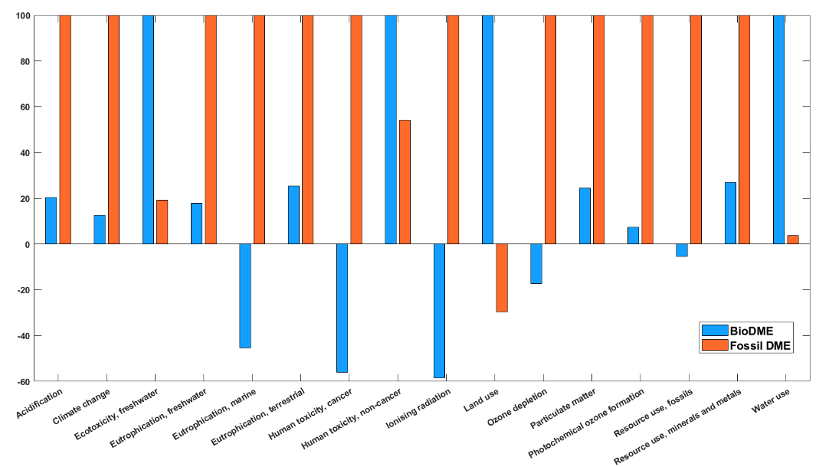
Figure 3 LCA comparison assessment
  - Conclusions
In conclusion, the conducted Life Cycle Assessment (LCA) has systematically compared the environmental ramifications associated with dimethyl ether (DME) production from divergent sources fossil fuel-based processes and biogas feedstocks. The analysis delineates huge disparities between these two processes, highlighting the commendable environmental attributes of biogas-based DME. Biogas-derived DME manifests as a superior alternative, characterized by diminished greenhouse gas emissions and a mitigated reliance on finite fossil resources. Furthermore, the biogas trajectory proffers auxiliary merits, encompassing organic waste valorization and conceivable enhancements in soil quality. However, it is imperative to underscore that biogas-driven production necessitates a more pronounced allocation of land and water resources in comparison to fossil fuel-based counterparts, thereby obligating a judicious calibration of trade-offs. The findings underscore the imperativeness of fine-tuning water management and land utilization to optimize the sustainability quotient of biogas-centric DME production.
  - References
[1] N. Scarlat, J.F. Dallemand, F. Fahl, Biogas: Developments and perspectives in Europe, Renew. Energy. 129 (2018) 457–472. https://doi.org/10.1016/J.RENENE.2018.03.006.
[2] M. Fedeli, A. di Pretoro, L. Montastruc, F. Manenti, Conventional vs. alternative biogas utilization: An LCA-AHP based comparative study, Clean. Environ. Syst. 11 (2023) 100150. https://doi.org/https://doi.org/10.1016/j.cesys.2023.100150.
[3] M. Fedeli, F. Manenti, Assessing process effectiveness with specific environmental and economic impact of heat, power & chemicals (HPC) option as future perspective in biogas, Clean. Chem. Eng. 2 (2022) 100016. https://doi.org/10.1016/J.CLCE.2022.100016.
[4] L. Chen, R. Case, L. Liu, S. Xiang, H. Castaneda, Assessment of sulfide corrosion cracking and hydrogen permeation behaviour of ultrafine grain high strength steel, Corros. Sci. 198 (2022) 110142. https://doi.org/10.1016/J.CORSCI.2022.110142.
[5] J. Xu, G.F. Froment, Methane steam reforming, methanation and water‐gas shift: I. Intrinsic kinetics, AIChE J. 35 (1989) 88–96. https://doi.org/10.1002/aic.690350109.
[6] F. Bisotti, M. Fedeli, K. Prifti, A. Galeazzi, A. Dell’Angelo, M. Barbieri, C. Pirola, G. Bozzano, F. Manenti, Century of Technology Trends in Methanol Synthesis: Any Need for Kinetics Refitting?, Ind. Eng. Chem. Res. 60 (2021) 16032–16053. https://doi.org/10.1021/acs.iecr.1c02877.
[7] L.P. Merkouri, H. Ahmet, T. Ramirez Reina, M.S. Duyar, The direct synthesis of dimethyl ether (DME) from landfill gas: A techno-economic investigation, Fuel. 319 (2022). https://doi.org/10.1016/j.fuel.2022.123741.
[8] C.P.C. Moura, M.A. De Araujo, H.G.D. Villardi, R.M. Cavalcante, F. Young, Process simulation and economic evaluation of an integrated production plant for methanol , acetic acid and DME synthesis via sugarcane bagasse gasification, 286 (2023). https://doi.org/10.1016/j.enconman.2023.117051.
[9] J. Chen, W. Song, D. Xu, Compact Steam-Methane Reforming for the Production of Hydrogen in Continuous Flow Microreactor Systems, (2019). https://doi.org/10.1021/acsomega.9b02063.
[10] K. Barati, Y. Khojasteh-Salkuyeh, O. Ashrafi, P. Navarri, Electrified combined reforming of methane process for more effective CO2 conversion to methanol: Process development and environmental impact assessment, Energy Convers. Manag. 287 (2023) 117096. https://doi.org/10.1016/J.ENCONMAN.2023.117096.
[11] K. Im-orb, P. Piroonlerkgul, Sustainability analysis of the bio-dimethyl ether (bio-DME) production via integrated biomass gasification and direct DME Synthesis Process, Renew. Energy. 208 (2023) 324–330. https://doi.org/10.1016/J.RENENE.2023.03.092.

