Analysis of the Catalytic Splitting of H₂S for H₂ Production
Anna Nova, Simone Caspani, Flavio Manenti*
Politecnico di Milano, CMIC Dept. “Giulio Natta”, Piazza Leonardo da Vinci 32, Milan 20133, Italy
flavio.manenti@polimi.it
Abstract
The splitting of hydrogen sulphide to produce value-added products, namely hydrogen and elemental sulphur, represents a promising route for the treatment of H₂S, a hazardous waste gas, and for a circular production of hydrogen. The decomposition reaction has been studied in a plug flow reactor on the catalyst MoS₂ for temperatures ranging between 640 and 929 °C and with a H₂S partial pressure of 1.27 kPa. Equilibrium conversions have been reached for residence times below 3 s and the apparent activation energy of 71.894 kJ/mol has been calculated. The catalytic decomposition on MoS₂ results therefore to be an interesting pathway for the production of H₂ from H₂s.
Keywords: hydrogen sulphide, H₂S splitting, H₂ production, kinetics, molybdenum disulphide
  - Introduction
Hydrogen sulphide (H₂S) is a poisonous and dangerous compound, the presence of which affects many fossil and renewable resources. It is also produced in industrial processes that involve desulphurization. H₂S is usually processed through the Claus process, which partially oxidizes it into sulphur and water. An interesting alternative is represented by the splitting of H₂S (Chan et al., 2023), which leads to the production of hydrogen and sulphur. The reaction involved is the following:
$$H_{2}S→H_{2}+\frac{1}{2}S_{2}$$ | (1)
The production of hydrogen is particularly interesting for the energy sector and the chemical industry. In a previous study, the simulation of a plant producing H₂ through the thermal decomposition of H₂S has been developed, proving the commercial interest of the process (Nova et al., 2023b). A variety of H₂S decomposition methods have been studied, including thermal, catalytic, non-thermal plasma-based, electrolytic, and biological processes (Zheng et al., 2023). However, the upscale production of hydrogen from H₂S has not been realized. The most substantial quantities of hydrogen sulphide are produced by large-scale plants. For a possible industrial application, carrying out the reaction with high flow rates and therefore reduced residence times is of fundamental importance. For this reason, this study focused on the analysis of the catalytic H₂S splitting.
The chosen catalyst is MoS₂; one of the early investigated catalysts which still appears to be among the most active ones for the reaction of interest (Aljama et al., 2023). Understanding the reaction and its kinetics in presence of MoS₂ is fundamental to improve its energy efficiency and conversion. Few studies investigated the reaction and its kinetic aspects. A Hougen-Watson adsorption model was chosen to represent the reaction mechanism (Kaloidas and Papayannakos, 1991). The rate-determining step resulted to be the cleavage of the hydrogen-sulphur bonds of the H₂S adsorbed on the catalyst active sites. Burra et al. (2018) compared catalysts of their production with MoS₂ in H₂S partial pressures between 10 and 50 kPa. The particle size of their catalysts was ~400 µm. Below 1000 K, the yield of H₂ obtained from MoS₂ was higher than the one obtained with every other tested oxide catalyst. They also calculated activation energies and orders of reactions with respect to H₂S.
The present work aims at presenting a new set of experimental data, obtained by performing the reaction between 640 and 929 °C, and at a lower H₂S partial pressure (1.27 kPa), compared to previous studies. This allows kinetic evaluations, like the apparent activation energy of the reaction. Starting from the same data, it will be possible to develop a kinetic model and regress the kinetic parameters.
  - Experimental setup
The core of the setup built for the experimental campaigns (Figure 1) is the quartz reactor, designed as a Plug Flow Reactor (PFR) and placed inside a tubular oven. The feed is represented by a gaseous H₂S/N₂ mixture with a concentration of H₂S equal to 1.5 wt%. The flow rate can be tuned ranging between 1 and 100 L/h. At the exit of the reactor, the scrubbing of sulphur from the outlet reaction gas is performed by passing it through distilled water. A stilling chamber reduces the risk of potentially entrained water droplets. Suitable filters ensure the total removal of any solid and liquid particle from the stream. The gases are analyzed with an Agilent 490 Micro GC (Micro Gas Chromatograph). The catalyst
is constituted of 0.5 g of Molybdenum(IV) sulfide powder (particle size below 44 µm, 99% pure, Thermo Fisher), sandwiched between two layers of quartz wool and placed in the isothermal zone of the reactor.
The reliability of the experimental setup has first been tested by performing the H₂S splitting reaction in thermodynamic regime (Nova et al., 2023a). During the campaign investigating the catalytic splitting, temperatures from 640 to 929 °C have been considered and the total inlet gas flow rate has been varied to determine the conversion at different residence times. The reaction pressure has been kept at 1 bar.
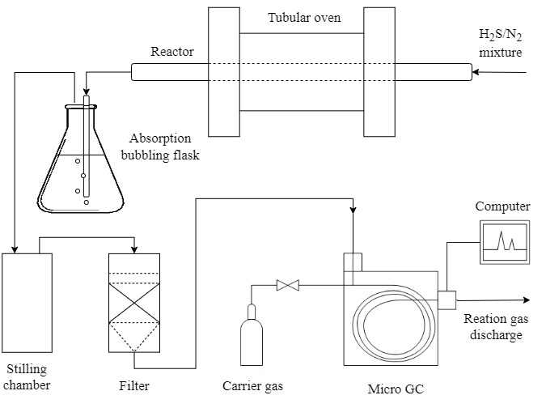
Figure 1 - Experimental setup.
  - Results and discussion
The reaction has been performed with a H₂S partial pressure of 1.27 kPa and at four different temperatures (640, 740, 831, and 929 °C). Five inlet flow rates have been considered (100, 80, 50, 30, and 10 L/h), corresponding to five different residence times inside the reactor. The experimentally obtained H₂ concentrations are reported in Table 1. The errors correspond to the standard deviation calculated from all the composition measurements.
Table 1 - Experimental H₂ concentrations obtained by performing the catalytic splitting of H₂S in the described conditions.
T [°C] | Inlet flow rate [L/h] | Residence time [s] | H₂ concentration [mol%]
640 | 100 | 0.8 | 0.029 ± 0.001
640 | 80 | 1.0 | 0.038 ± 0.001
640 | 50 | 1.6 | 0.055 ± 0.001
640 | 30 | 2.7 | 0.059 ± 0.001
640 | 10 | 8.0 | 0.089 ± 0.001
740 | 100 | 0.7 | 0.086 ± 0.001
740 | 80 | 0.9 | 0.099 ± 0.004
740 | 50 | 1.4 | 0.126 ± 0.053
740 | 30 | 2.4 | 0.152 ± 0.004
740 | 10 | 7.2 | 0.203 ± 0.004
831 | 100 | 0.7 | 0.195 ± 0.003
831 | 80 | 0.8 | 0.242 ± 0.012
831 | 50 | 1.3 | 0.270 ± 0.010
831 | 30 | 2.2 | 0.310 ± 0.006
831 | 10 | 6.7 | 0.333 ± 0.004
929 | 100 | 0.6 | 0.454 ± 0.001
929 | 80 | 0.8 | 0.483 ± 0.004
929 | 50 | 1.2 | 0.490 ± 0.005
929 | 30 | 2.0 | 0.498 ± 0.002
929 | 10 | 6.1 | 0.512 ± 0.005

Starting from the hydrogen concentrations, measured experimentally, the corresponding H₂S conversion has been calculated (see Figure 2).
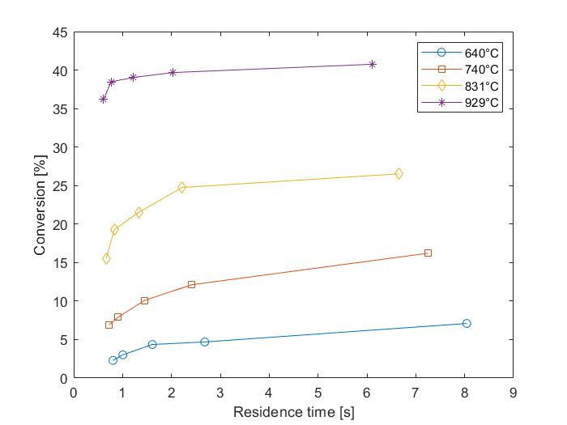
Figure 2 - H₂S conversion at different reaction temperatures and residence times.
The conversion increases with the residence time. In particular, values of conversions almost equal to those obtained at thermodynamic equilibrium start to be reached already at residence times comprised between 2 and 3 s. These residence times correspond to inlet gas flow rates of 30 L/h (see Table 1). These results can be compared with the conversions measured by performing the reaction with the same setup, working pressure, and inlet mixture, but in absence of a catalyst. In this case, the thermodynamic equilibrium is reached at residence times longer than 8 s (corresponding to a 2 L/h inlet flow rate). This shows that, in presence of the catalyst, the same value of conversion, the thermodynamic equilibrium value, is reached with shorter residence times. The experimental H₂ concentrations and corresponding conversions at equilibrium conditions are reported in Table 2.
Table 2 - H₂ concentrations and conversions at the thermodynamic equilibrium, measured by performing the reaction in absence of a catalyst and with a gas inlet flow rate of 2 L/h.
T [°C] | H₂ concentration [mol%] | Conversion [%]
640 | 0.063 ± 0.006 | 4.9 ± 0.6
740 | 0.173 ± 0.006 | 13.7 ± 0.6
831 | 0.34 ± 0.01 | 27 ± 1
929 | 0.533 ± 0.008 | 42.3 ± 0.8
To evaluate the reproducibility of the results, the deactivation trend of the catalyst, MoS₂, has been studied. A batch of fresh catalyst has been loaded into the reactor and a series of experiments have been carried out while monitoring the H₂ concentration as the catalyst working time progressed. In Figure 3 the results are presented for a reaction temperature of 740°C. As can be seen, no significant reduction of the catalyst efficiency can be observed. Therefore, in our operating conditions, in absence of impurities and within 10 h of activity, the MoS₂ powder is stable and does not show signs of deactivation or poisoning. This is in accordance with EDX analyses performed on MoS₂ after 2 h of activity, which highlighted no additional sulfur formation from the reaction (Burra et al., 2018)
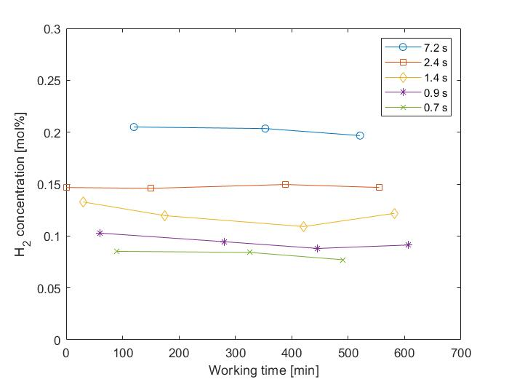
Figure 3 - H₂ concentration obtained by performing the splitting at 740°C, with different residence times, plotted against the time of activity of the catalyst.
For each inlet flow rate, the natural logarithm of the H₂S consumption rate has been plotted against the reciprocal of the reaction temperature . The slopes of the resulting lines represent the corresponding E/R values (where R denotes the universal gas constant and E the activation energy). In Figure 4 the Arrhenius plot for the 30 L/h case has been reported. The corresponding E is 67.470 kJ/mol. The activation energies obtained for each flow rate have been averaged to determine the apparent activation energy, equal to 71.894 kJ/mol. This value is in agreement with the literature data. For MoS₂, Burra et al. (2018) calculated an activation energy of around 50 kJ/mol. The difference is probably due to the lower H₂S inlet partial pressure employed in this study and to the smaller particle size of the catalyst. Also, the apparent activation energy is lower than that displayed by many catalysts, like metal oxides (γ-Al2O3, α-Fe2O3, V₂O₅) (Reshetenko et al., 2002) and sulphides (Meeyoo et al., 1996).

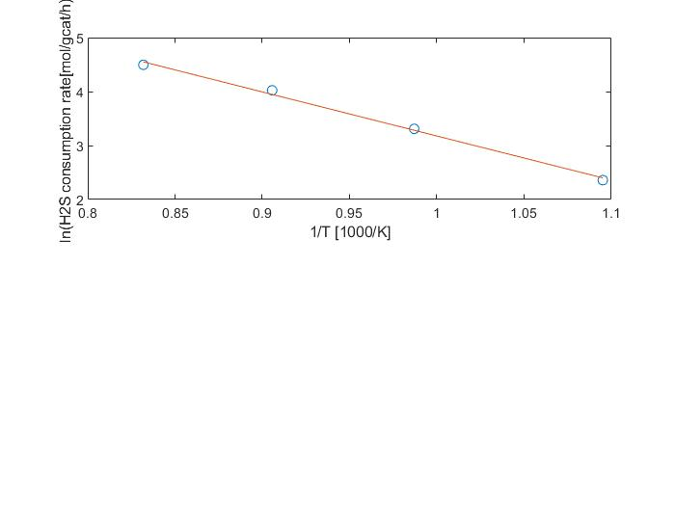
Figure 4 - Arrhenius plot, for the case of an inlet flow rate of 30 L/h.
  - Conclusions
The catalytic splitting of H₂S has been studied with an experimental campaign, in which the reaction has been performed at temperatures between 640 and 929 °C, with a partial pressure of H₂S of 1.27 kPa, and in the presence of MoS₂ as a catalyst. From the conversion values, it appears that thermodynamic equilibrium is reached with residence times lower than 3 s. The activity of the catalyst was monitored and up to 10 hours of activity no signs of reduction in the efficiency are shown. The apparent activation energy has been calculated and is equal to 71.894 kJ/mol. Starting from the set of data obtained, it will be possible to better understand the kinetics of the reaction, and eventually employ it in reactor and plant design. The splitting of H₂S could improve the performances of different plants and specifically of refineries, providing a source of hydrogen from a dangerous waste product.
References
H. Aljama, Z. Alaithan, A. Almofleh, 2023. Catalytic Conversion of H ₂ S to H ₂ : Challenges and Catalyst Limitations. J. Phys. Chem. C 127, 9022–9029.
K.R.G. Burra, G. Bassioni, A.K. Gupta, 2018. Catalytic transformation of H2S for H2 production. International Journal of Hydrogen Energy 43, 22852–22860.
Y.H. Chan, A.C.M. Loy, K.W. Cheah, S.Y.W. Chai, L.H. Ngu, B.S. How, C. Li, S.S.M. Lock, M.K. Wong, C.L. Yiin, B.L.F. Chin, Z.P. Chan, S.S. Lam, 2023. Hydrogen sulfide (H2S) conversion to hydrogen (H2) and value-added chemicals: Progress, challenges and outlook. Chemical Engineering Journal 458, 141398.
V.E. Kaloidas, N.G. Papayannakos, 1991. Kinetic studies on the catalytic decomposition of hydrogen sulfide in a tubular reactor. Ind. Eng. Chem. Res. 30, 345–351.
V. Meeyoo, A.A. Adesina, G. Foulds, 1996. The kinetics of H2S decomposition over precipitated cobalt sulphide catalyst. Chemical Engineering Communications 144, 1–17.
A. Nova, F. Negri, F. Manenti, 2023a. Multi-scale Modelling and Experimental Investigation of Hydrogen Sulphide Thermal Decomposition. Computer Aided Chemical Engineering 52, 2411–2416.
A. Nova, K. Prifti, F. Negri, F. Manenti, 2023b. Multiscale techno-economic analysis of orange hydrogen synthesis. Energy 282.
T.V. Reshetenko, S.R. Khairulin, Z.R. Ismagilov, V.V. Kuznetsov, 2002. Study of the reaction of high-temperature H2S decomposition on metal oxides (γ-Al2O3, α-Fe2O3, V2O5). International Journal of Hydrogen Energy 27, 387–394.
X. Zheng, G. Lei, S. Wang, L. Shen, Y. Zhan, L. Jiang, 2023. Advances in Resources Recovery of H₂S: A Review of Desulfurization Processes and Catalysts. ACS Catal. 13, 11723–11752.

