**Techno-Economic Analysis for Biogas Reforming using PSWA: Case Study on Methanol Synthesis**

Loretta Salanoa, Marcello M. Bozzinia, Flavio Manentia

Politecnico di Milano, Dipartimento di Chimica, Materiali ed Ingegneria Chimica “G.Natta”, Piazza Leonardo da Vinci 32,, 20133, Milano, Italy

flavio.manenti@polimi.it

Abstract

The production of biogas, a mixture of methane and carbon dioxide, from anaerobic digestion from different biowaste sources has been interesting for its application in chemical processes. Currently, it is invested in the production of thermal and electrical energy, but it has also been investigated for the production of syngas, which is usually derived from fossil fuels. A fundamental step for this application is the conditioning of biogas to produce valuable syngas, this can be achieved through a water absorption column among other technologies. This study aimed at the optimal configuration of a pressure swing water absorption (PSWA) tower for the optimal operation of a biogas reforming process. Results show how the placement of the water column has an impact on capital and operating costs, and how the level of conditioning can be useful for chemical synthesis.

* 1. Introduction

The demand for lower harmful emissions and a lower impact from the process industry on the total number of greenhouse gases (GHG) emissions has pushed the chemical sector towards innovative processes. The main molecule to mitigate is the CO2, this molecule can be mitigated by substituting thermal with electrical energy sources, with its capture and storage (CCS) and its capture and utilization (CCU) technologies. Biogas is a mixture of gases produced by anaerobic digestion of either agricultural, animal or municipal waste. This stream is usually composed of 55-60 % of methane and 38-40 % of CO2, with different amounts of impurities, depending on the feedstock. Biogas is considered a carbon-neutral renewable energy source, its capture of CH4 contributes to avoiding further emissions of GHG (Chen et al., 2015). In recent years some studies have emerged with the concept of Biogas-to-Fuel and its use as a direct substitute for natural gas for chemical processes (Bozzano et al., 2017). The typical route is to upgrade the biogas to biomethane and then undergo the well-known process of methanol production (Sheets & Shah, 2018). This approach requires the system to clean the biogas and then adjust the content of CO2 in the syngas to the desired quality. It has also been suggested by previous authors a partial upgrading (Previtali et al., 2018; Santos et al., 2023, Rinaldi et al., 2023) before sending it to the reformer. This study investigates an optimal layout for the biogas to syngas route with the partial upgrading of biogas through a water absorption column unit for quality syngas production for methanol synthesis.

* 1. Methodology

The process under study is built by two main blocks: the conditioning of the biogas and the reforming unit for the production of valuable syngas. The so-called conditioning of biogas is acted by the absorption of CO2 in a water scrubbing unit, in which the biogas passes through water inside a packed tower in a counter-current configuration. This method takes advantage of the high-water solubility of CO2 compared to CH4 (Yang & Ge, 2016). The amount of carbon dioxide removed strongly depends on the amount of water circulated inside the column. The top of Figure 1 reports such a relationship, the highest flow rate, the lowest CO2 residual in the biogas. The tenor of carbon dioxide in the biogas translates into a change in demand for fuel from the furnace and in the production of syngas. The top image in Figure 1 shows the impact on the quality of the syngas, this is evaluated from the stoichiometric ratio, Eq. (1). The optimal value for methanol synthesis is around 2.00 to ensure the best condition for the catalytic reactors.

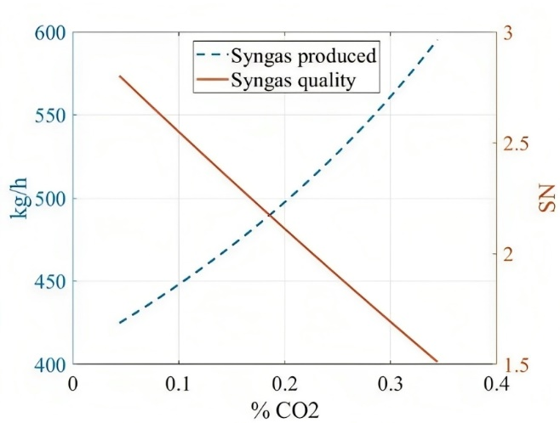The reforming section is composed of a fire-heated furnace and the catalytic tube reactors. Standard reforming technologies takes into consideration natural gas as a feedstock, and steam to ensure the steam methane reforming reaction, reported in Eq. (2). Along with this reaction there is the presence of the water gas shift reaction, Eq. (3). Having a high percentage of CO2 introduces the so-called bi-reforming: the methane will react in part with the CO2, Eq. (3), with higher production of the syngas mixture.

Two configurations of the two blocks were taken under study. The difference lies in the placement of the fuel feed. In configuration (a), Figure 2 top, the total amount of biogas is distributed in a reacting feed and a fuel one, which has a very high tenor of inert CO2 for combustion.

Figure 1 – top: carbon dioxide tenor depending on the water circulated in the column; bottom: syngas production versus quality of the syngas depending on the carbon dioxide tenor in biogas.

|  |  |
| --- | --- |
| $$SN=\frac{y_{H_{2}}-y_{CO_{2}}}{y_{CO_{2}}+y_{CO}}$$ | (1) |
| $$CH_{4}+H_{2}O→CO+3H_{2}$$ | (2) |
| $$CO+H_{2}O→CO_{2}+H_{2}$$ | (3) |
| $$CH_{4}+CO_{2}→2CO+2H_{2}$$ | (4) |

In the second layout, Figure 2 bottom, the biogas to be fed furnace-side is retrieved by the PSWA unit. In this way, the tenor of CO2 in the fuel is mitigated as well.

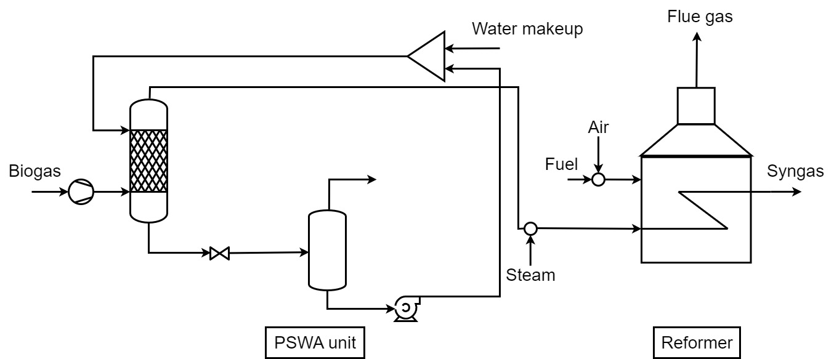

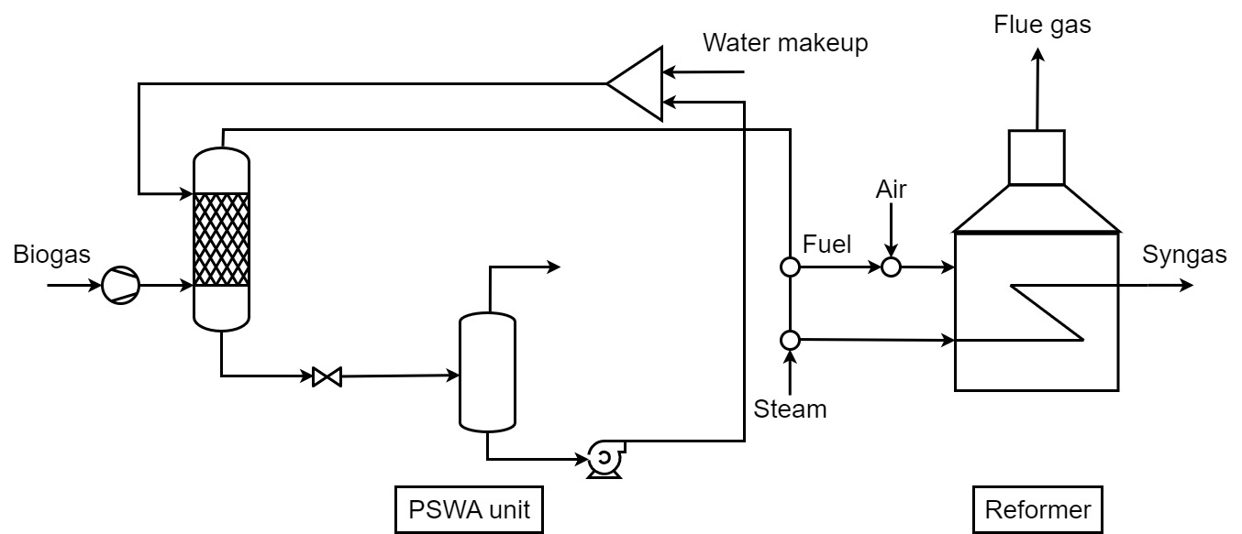

Figure 2 – top: configuration (a); bottom: configuration (b)

The first step taken was to optimize the system to minimize the costs of syngas production, according to the operating conditions, reported in Table 1. The physical constraints of the process refer to the steam-to-carbon ratio (S/C), Eq. (4), at the inlet of the reforming reactor, set equal to 3, the amount of biogas fed to both systems, fixed at 600 Nm3/h, equivalent to 1 MW power plants, and the excess of air to the furnace set to 105 % of the stoichiometric ratio. The S/C is relevant for avoiding coke formation inside the catalytic tubes and for optimal production while the amount of methane to feed is equal to the standard capacity of a biogas CHP plant in Italy (Previtali et al., 2018).

|  |  |
| --- | --- |
| $$S/C=\frac{F_{steam}}{F_{CH_{4}}}$$ | (5) |

For the evaluation of the economics, the capital costs (CAPEX) were estimated based on the bare module cost of each piece of equipment, according to the method proposed by Turton et al., (2018) and then actualized in recent years through the Chemical Engineering Plant Cost Index (CEPCI). As operational costs were only considered the utility consumptions, the reference prices are reported in Table 2. The total working hours per year considered were 8000, and the plant lifetime for the investment was assumed to be 5 years (Santos et al., 2023). The objective function of the problem is the cost of syngas production, Eq. (7), calculated from the total annual costs (TAC), Eq. (6), and the flow rate of syngas obtained.

|  |  |
| --- | --- |
| $$TAC=\frac{CAPEX}{Plant lifetime}+OPEX$$ | (6) |
| $$Syngas cost=\frac{TAC}{Syngas production}$$ | (7) |

Table 1 - Operating conditions of the main process units

|  |  |  |  |
| --- | --- | --- | --- |
|  | T [K] | P [bar] | Ref. |
| PSWA | 293.15 | 27 | (Santos et al., 2023) |
| Reformer | 1125.15 | 27 | (Hiller et al., 2011) |
| Furnace | 1373.15 | 1.013 | (Hiller et al., 2011) |

Table 2 - Utilities costs

|  |  |  |
| --- | --- | --- |
|  | Cost [$/kWh] | Ref. |
| Electricity | 0.1058 | (Santos et al., 2023) |
| Cooling Water | 0.001408 | (Turton et al., 2018) |
| Steam | 0.01801 | (Turton et al., n.d.) |

The overall goal of the optimization was to find the correct amount of water to circulate in the PSWA to obtain the minimum amount of energy requested from the system and its equivalent costs to compare the two setups. The simulation of the process was carried out in Aspen HYSY V11, using the Sour Peng-Robinson thermodynamic package.

* 1. Results and discussion

As already stated, the optimal conditions were found for each configuration, according to the constraints of the system. In the first configuration, as expected, the amount of water needed to remove around 50 % of carbon dioxide is lower than in the second configuration. This result is a direct consequence of the quality of the fuel that is sent to the furnace to sustain the reformer heat demand. Upon these conditions, the economic analysis was carried out. The capital costs differ due to higher demand from the compressor and pump, which in the second configuration face a higher intake in flow rate. The difference in production price is approximately 15 %. This value has a high impact on the overall costs, but considering the higher production of quality syngas, this value should be included in a wider economic study of the comprehensive methanol production chain.

Table 3 - Performance summary for configuration (a) with biogas as fuel and (b) with upgraded biogas as fuel

|  |  |  |  |
| --- | --- | --- | --- |
|  |  | (a) | (b) |
| Water circulating | m3/h | 14.89 | 21.9 |
| Syngas Production | kg/h | 505.6 | 509.1 |
| CAPEX | $ | 2,439,716.46 | 2,613,626.69 |
| OPEX | $/y | 145,028.88 | 211,381.69 |
| TAC | $/y | 625,463.41 | 734,183.10 |
| Syngas cost | $/kg | 0.1546 | 0.1803 |

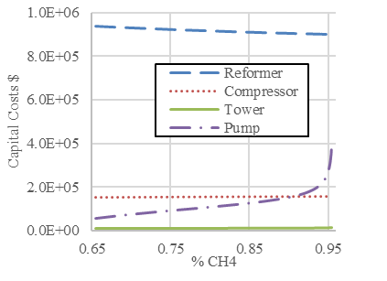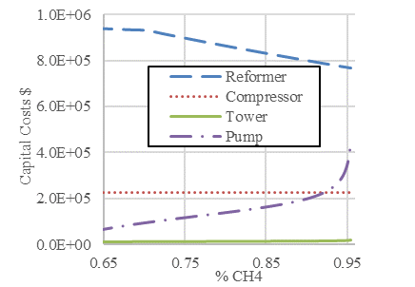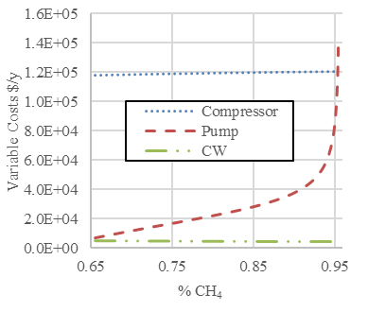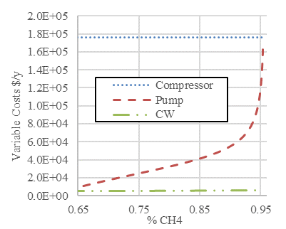

Figure 3 - top: capital costs for configuration (a), left, and (b), right; bottom: operating costs for (a), left, and (b), right

A sensitivity analysis was carried out on the tenor of methane in the biogas. In terms of capital costs, for both scenarios, the reformer takes up to around 75 % of total costs; the compressor and tower don’t show any fluctuations, while the pump sees a great increase for a high regime of CO2 separation. In scenario (b), the capital costs of the reformer have a significant decrease due to the lower tenor of CO2 on the fuel side. Operating costs are strongly affected by the compressor power, expectably, the more fluid to compress, the higher the demand. The same concept is applicable to explain the pump cost behaviour. The recovery in capital costs and higher syngas production isn’t enough to compensate for the very high operational costs of the system.

* 1. Conclusions

In this work, two process configurations were taken under study to maximise the production of quality syngas for methanol synthesis for the least expense. The goal of the study was to try and propose a new process layout that involves the least amount of biogas possible to be spent as fuel. The size of the plant considered corresponds to 1MW, a common CHP Italian plant size with biogas feed. The biogas available both as reactant and fuel was kept constant for both scenarios. The first one translated into a lower production of syngas, due to the energy to spend in the furnace for the heating of the endothermic reforming reactor, but an overall lower cost of production of only 0.1546 $/kg. The second configuration has a higher price, mostly due to the higher electricity demand from the compressor and pump, the operational costs show an increase of 45 % compared to the first configuration, while capital costs differ only by 7 %.

The study overall showed no definitive improvement from the alternative layout, the main upbringing was the possibility of producing higher amounts of quality syngas from equal feedstock, this aspect is to be further studied in an economic evaluation of the methanol comprehensive production chain.

References

Bozzano, G., Pirola, C., Italiano, C., Pelosato, R., Vita, A., & Manenti, F. (2017). Biogas: a Possible New Pathway to Methanol? In *Computer Aided Chemical Engineering* (Vol. 40, pp. 523–528). Elsevier B.V.

Chen, X. Y., Vinh-Thang, H., Ramirez, A. A., Rodrigue, D., & Kaliaguine, S. (2015). Membrane gas separation technologies for biogas upgrading. In *RSC Advances* (Vol. 5, Issue 31, pp. 24399–24448). Royal Society of Chemistry.

Hiller, H., Reimert, R., & Stönner, H. (2011). Gas Production, 1. Introduction. In *Ullmann’s Encyclopedia of Industrial Chemistry*. Wiley.

Previtali, D., Vita, A., Bassani, A., Italiano, C., Amaral, A. F., Pirola, C., Pino, L., Palella, A., & Manenti, F. (2018). Methanol synthesis: A distributed production concept based on biogas plants. *Chemical Engineering Transactions*, *65*, 409–414

Santos, R., Prifti, K., Prata, D., Secchi, A., & Manenti, F. (2023). Techno-economic Analysis of the Syngas Conditioning from Biogas Using PSA and Pswa: Case Study of Methanol Synthesis. *Chemical Engineering Transactions*, *2023*, 673–678.

Sheets, J. P., & Shah, A. (2018). Techno-economic comparison of biogas cleaning for grid injection, compressed natural gas, and biogas-to-methanol conversion technologies. *Biofuels, Bioproducts and Biorefining*, *12*(3), 412–425.

Turton, R., Bailie, R. C., Whiting, W. B., Shaeiwitz, J. A., & Bhattacharyya, D. (n.d.). *Analysis, Synthesis, and Design of Chemical Processes Fourth Edition*.

Yang, L., & Ge, X. (2016). Biogas and Syngas Upgrading. In *Advances in Bioenergy* (Vol. 1, pp. 125–188). Elsevier Inc.