Towards Environmentally Sustainable Production of Diphenyl Carbonate: Comparative Analysis of Alternative Pathways

Tsai-Wei Wu,a* Alexander Guzman-Urbina,a,b Hajime Ohno,a Yasuhiro Fukushima,a,c Hsin-Hao Liang,d Shiang-Tai Lind

aDepartment of Frontier Science for Advanced Environment, Graduate School of Environmental Studies, Tohoku University, 6-6-07 Aramaki-Aza Aoba, Sendai, Japan

bDepartment of Materials, Chemistry, and Life Sciences, Graduate School of Engineering, Osaka Metropolitan University, 3-3-138 Sugimoto Sumiyoshi-ku, Osaka, Japan

cDepartment of Chemical Engineering, Graduate School of Engineering, Tohoku University, 6-6-07 Aramaki-Aza Aoba, Sendai, Japan

dDepartment of Chemical Engineering, National Taiwan University, Taipei 10617, Taiwan

*tsai-wei.wu.b5@tohoku.ac.jp

Abstract

Diphenyl carbonate (DPC) plays a key role as a feedstock in the synthesis of polycarbonate (PC), a widely used plastic material. However, conventional DPC production routes are burdened by environmental concerns stemming from the use of toxic reagents, such as phosgene. Considering the urge to foster sustainability, this study undertakes a comprehensive evaluation of cradle-to-gate greenhouse gas (GHG) emissions associated with diverse industrial pathways for DPC synthesis, including:

1. Direct phosgenation of phenol (PhOH) as the base case.
2. Transesterification of CO2-based dimethyl carbonate (DMC) to yield DPC.
3. Transesterification of CO2-based diethyl carbonate (DEC) to yield DPC.
4. Transesterification of CO2-based dipropyl carbonate (DPrC) to yield DPC.

While the emission inventory data of the first two pathways were extracted from comprehensive commercial reports, the latter two were simulated in Aspen Plus according to patented approaches due to limited process data availability. The simulations serve as a foundation for comparative analysis among these routes. Notably, the alternative pathways leverage CO2-derived carbonates as feedstock, offering greener alternatives to the conventional approach. Through cradle-to-gate GHG emissions assessment, this research aids in identifying the potentially most environmentally benign alternative route for DPC production. An analysis of alternative feedstocks contributes to the assessment of current developments and potential pathways towards emission-free DPC production. The central aim of this study is to leverage industry insights to propose optimal pathways for future development, guiding towards a carbon-neutral paradigm in PC manufacturing.

**Keywords**: Diphenyl carbonate production, Cradle-to-gate emissions, CO2 conversion, Sustainable manufacturing

* 1. Introduction

Diphenyl carbonate (DPC) is a key precursor for the production of polycarbonate (PC), a widely used plastic. However, current manufacturing uses the highly toxic phosgene (Bell, 2017), which can be fatal even in small doses (Diller, 1985). Alternative feedstocks are crucial for more sustainable DPC production. Routes like phosgenation, oxidative carbonylation, and transesterification of phenol with dialkyl carbonates (DRCs) have been reported (Cao et al., 2005). Transesterification is promising since DRCs can be converted from CO2, potentially reducing greenhouse gases. Among DRCs, dimethyl carbonate (DMC) is widely studied, while diethyl carbonate (DEC) and dipropyl carbonate (DPrC) are promising candidates which can be produced from CO2 (Lee et al., 2021). Japanese government aims to cut emissions 46% by 2030, so understanding of the CO2 emission in chemical industry is necessary. This study employs a Cradle-to-gate life cycle CO2 assessment, which covers feedstock and process emissions (Kleinekorte et al., 2020). In this way, this study compares three CO2-to-DRC-to-DPC processes against conventional toxic phosgene route, analysing if they meet emission reduction targets. The scope in Figure 1 shows the DPC production routes compared in this study.

Figure 1 Cradle-to-gate research scope of DPC production

* 1. Method
     1. Process Information

Process information of the conventional phosgene process was extracted from PEP commercial report (Bell, 2007) to calculate CO2 emission amount and represent current manufacturing process.

The DMC-to-DPC process has two main licensors, Asahi Kasei and Versalis/Lummus. Detailed information of both processes can be extracted from PEP commercial report (Bell & Pavlechko, 2020) and used in comparison with other processes. The two main reactions included are as Eq. (1) and Eq. (2), representing (1) the transesterification of DMC and phenol to produce methyl phenyl carbonate (MPC) and methanol (MeOH), and (2) the disproportionation of MPC to DPC and DMC. Both licensors use reactive distillation to deal with the involved reactions.

|  |  |
| --- | --- |
| $$DMC +PhOH↔MPC+MeOH$$ | (1) |
| $$2MPC↔DPC+DMC$$ | (2) |

The DEC-to-DPC process lacks specifics but a patent (Yong Ryu, 2012) provides a basis to model it in Aspen Plus for accurate CO2 emission estimates. Like DMC process, main reactions are transesterification to ethyl phenyl carbonate (EPC) and EPC disproportionation in reactive distillation, shown in Eq. (3) and (4). A byproduct phenetole (EPE) also forms, shown in Eq. (5). Using patent data, a temperature conversion correlation was developed for Eq. (3), shown in Eq. (6). No data existed for other reactions, so average conversions were assumed according to the reported experimental data: 28.7% for Eq. (4) and 3% for Eq. (5).

|  |  |
| --- | --- |
| $$DEC+PhOH↔EPC+EtOH$$ | (3) |
| $$2EPC↔DPC+DEC$$ | (4) |
| $$DEC+PhOH↔EPE+EtOH+{CO}_{2}$$ | (5) |
| $$Conv.=-88966.8 +3274664.8/T+14564\ln\left(T\right)-16.2T$$ | (6) |

Flowsheet and the result of DEC-to-DPC process in the simulation can be seen in Figure 2, which includes 3 reactive distillation columns and 3 conventional distillation columns. The configuration was set corresponding to the process flowsheet in the patent (Yong Ryu, 2012), with Eq. (3) and Eq. (5) occurring in C1 and C2, Eq. (4) occurring in C5. C3 serves as the light components’ separator, while C4 serves as EPE purge column. C6 is the product separation column where DPC comes out from the bottom and EPC can be recovered from the top.

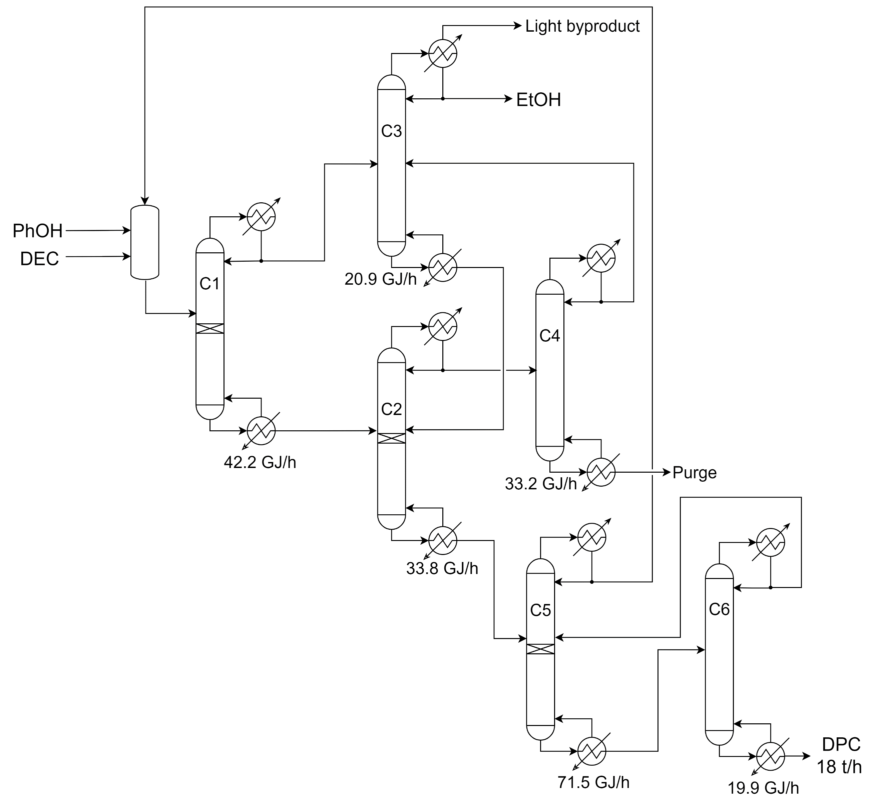

Figure 2 DEC-to-DPC Process Flowsheet

For DPrC-to-DPC process, the two main reactions are Eq. (7) and Eq. (8), representing the generation of the intermediate propyl phenyl carbonate (PrPC) and its disproportionation. No literature reported process can be found for DPrC-to-DPC process, but there’s reported equilibrium constant for the transesterification reaction of diisopropyl carbonate and phenol (Van Der Heide et al., 2010). The value was thus taken as the approximate value of Keq for Eq. (7) reaction in the Aspen Plus simulation. Given that there is no information available for Eq. (8) reaction, it was assumed to have a conversion the same (28.7 %) as the disproportionation reaction of DEC to DPC route tentatively.

|  |  |
| --- | --- |
| $$DPrC+PhOH↔PrPC+PrOH$$ | (7) |
| $$2PrPC↔DPC+DPrC$$ | (8) |

PrPC, the intermediate of DPrC-to-DPC process, plays a key role in the reaction, and it is necessary to review the thermodynamic parameters before further developing the process model. However, as an uncommon component, neither built-in PrPC-related thermodynamic parameters, nor thermodynamic experimental data can be found in the Aspen Plus databank and literature. For pure component parameters, group-contribution method was used for estimation; for binary interaction parameters, the conventional UNIFAC group-contribution method does not support estimation of PrPC-related parameters due to its special chemical structure. To fill this gap, an alternative estimation method using COSMO-SAC model was chosen. This estimation method has the advantage of being more flexible in dealing with a wider variety of chemical functionality (Lin & Sandler, 2002). After using COSMO-SAC model to provide a priori estimate of the thermodynamic properties for previously unmeasured components and phase equilibria for new mixtures, missing binary parameters were derived by using the estimated data.

The process configuration of DPrC to DPC was developed according to the process description in a patent regarding producing diaryl carbonate (Harada et al., 2021). Flowsheet and the result of DPrC-to-DPC process in the simulation can be seen in Figure 3, which includes 3 reactive distillation columns and 3 normal distillation columns. Eq. (7) occurs in C1, while Eq. (8) occurs in C2 and C3. A purge stream is designed here at the top of C2 distillate stream to prevent the accumulation of potential impurities. C4 serves as the product separator, whereas C5 serves as the recovery column of PrPC, with the bottom stream recycling back to C3 for disproportionation reaction. C6 is an assumptive catalyst recovery column, which simulates the separation of DPC and the homogeneous catalyst.

Figure 3 DPrC-to-DPC Process Flowsheet

* + 1. Calculation Basis for CO2 Emission

A cradle-to-gate scope was adopted for the life cycle analysis of CO2 emission. For phosgene route, it should include the CO2 emissions from raw materials production (Liao et al., 2020) (Ecoinvent v3.6 Database) and the phosgenation process (Bell, 2007). Analysis for CO2-to-DRC-to-DPC processes, on the other hand, should include the CO2 emissions from raw materials production (Ecoinvent v3.6 Database), CO2 capture process (Guandalini et al., 2019), CO2-to-DRC process (Lee et al., 2021), dehydrating agent (used in CO2-to-DRC process) regeneration process (Harada et al., 2023), and DRC-to-DPC processes (detailed process information as discussed in Section 2.1).

Figure 4 Cradle-to-gate CO2 emissions for different processes

* 1. Results and Discussion

Cradle-to-gate CO2 emissions of different processes can be seen in Figure 4. The hollow star points present total emission amount for each process, and apparently the process with the lowest emission is CO2 to DPrC to DPC. While CO2 consumption in the CO2-to-DRC process only helped little in CO2 emission reduction, emissions from phenol production, assumed to be conventional Hock process, account for a significant amount of percentage in every processes. Since phenol is the main carbon source in DPC production, alternative greener phenol production process is necessary to reduce the CO2 emissions in DPC manufacturing. Therefore, CO2 emission amount from biomass-based phenol production was alternatively used (Liao et al., 2020) and the corresponding values of CO2 emissions are presented in the figure by the hollow circle points. The values have a range since the non-renewable hydrogen used in the bio-phenol production process has a CO2 emission amount range of 1.354 – 0.736 kg CO2/kg H2, as reported in Liao et al. (2020). CO2 emission amount due to alcohols production can be barely seen because alcohols are almost recycled to be used in the CO2-to-DRC processes and thus leading to negligible results. It is worth noting that if we expand the research scope to PC production, as shown in Figure 5, in which can be seen that the byproduct of PC production is phenol, and it can be mostly recycled to the DPC production process as well. Under this circumstance, the burden of CO­2 emission reduction would lie in the DPC synthesis processes which require mostly steam as energy source.

Comparing the current, phosgene-based manufacturing process to the most optimistic scenario which uses bio-phenol in the CO2-to-DPrC-to-DPC process, around 42 % of CO2 emission can be saved, showing potential to meet the Japan’s emission reduction target (46%) by 2030.

Figure 5 Cradle-to-gate research scope of PC production

* 1. Conclusion

This research investigates cleaner and more diverse methods for diphenyl carbonate (DPC) production, seeking alternatives to the toxic phosgene-based process while assessing their feasibility and environmental impact, including newer and less-known options. The evaluation of cradle-to-gate CO₂ emission in this study highlighted both eco-friendly feedstock utilization and the importance of selecting route in guiding early-stage technology development in the chemical industry. CO2 emission because of DPC production can be reduced to at most 42 % if the CO2-to-DPrC-to-DPC route is chosen and bio-phenol is used as one of the feedstocks. Research scope will have huge influence on the assessment results, and it is recommended that the scope covers as wide as to the end-product. Also, it is essential to keep developing more efficient DPC synthesis processes and greener source for steam usage in the processes to deal with the real cause of CO2 emission in DPC production.

References

Bell, S., 2007, PEP Report 50E POLYCARBONATE, SRI Consulting.

Bell, S., 2017, Diphenyl Carbonate by Asahi Kasei Process, Process Economics Program Review, IHS Chemical.

Bell, S., & P. D. Pavlechko, 2020, PEP Report 50F Polycarbonate Update, IHS Markit.

Cao, M., Y. Meng, & Y. Lu, 2005, Synthesis of diphenyl carbonate from dimethyl carbonate and phenol using O2-promoted PbO/MgO catalysts, Catalysis Communications, *6*(12), 802–807.

Diller, W. F., 1985, Early Diagnosis of Phosgene Overexposure, Toxicology and Industrial Health, *1*(2), 73–80.

*ecoinvent v3.6 database (cutoff): direct impact contributions GWP 100a*.

Guandalini, G., M. C. Romano, M. Ho, D. Wiley, E. S. Rubin, & J. C. Abanades, 2019, A sequential approach for the economic evaluation of new CO2 capture technologies for power plants, International Journal of Greenhouse Gas Control, *84*, 219–231.

Harada, H., T. Isobe, H. Liu, Y. Shinkai, & R. Umezu, 2023, *Method for regenerating catalyst and method for producing carbonate ester* (Patent US 11,596,936 B2).

Harada, H., J. Taguchi, & Y. Isahaya, 2021, *DIARYL CARBONATE AND METHOD FOR PRODUCING THE SAME, AND METHOD FOR PRODUCING AN AROMATIC POLYCARBONATE RESIN* (Patent US 11,142,506 B2).

Kleinekorte, J., L. Fleitmann, M. Bachmann, A. Kätelhön, A. Barbosa-Póvoa, N. Von Der Assen, & A. Bardow, 2020, Life Cycle Assessment for the Design of Chemical Processes, Products, and Supply Chains, Annu. Rev. Chem. Biomol. Eng. 2020, *11*, 2020.

Lee, C. T., C. C. Tsai, P. J. Wu, B. Y. Yu, & S. T. Lin, 2021, Screening of CO2 utilization routes from process simulation: Design, optimization, environmental and techno-economic analysis, Journal of CO2 Utilization, *53*, 101722.

Liao, Y., S. F. Koelewijn, G. van den Bossche, J. van Aelst, S. van den Bosch, T. Renders, K. Navare, T. Nicolaï, K. van Aelst, M. Maesen, H. Matsushima, J. M. Thevelein, K. van Acker, B. Lagrain, D. Verboekend, & B. F. Sels, 2020, A sustainable wood biorefinery for low-carbon footprint chemicals production, Science, *367*(6484), 1385–1390.

Lin, S. T., & S. I. Sandler, 2002, A Priori Phase Equilibrium Prediction from a Segment Contribution Solvation Model, Industrial & Engineering Chemistry Research, *41*(5), 899-913.

Van Der Heide, E., T. M. Nisbet, C. G. Vaporciyan, & C. L. M. Vrouwenvelder, 2010, *PROCESS FOR THE PREPARATION OF DIARYL CARBONATE* (Patent US 7,732,629 B2).

Yong Ryu, J., 2012, *PROCESS FOR PRODUCING DIPHENYL CARBONATE* (Patent US 2012/0190878 A1).