Dynamic simulation and evaluation of integrated chromatography-ultrafiltration in mAb production
Wil Jones, Dimitrios I. Gerogiorgis*
Institute for Materials and Processes (IMP), School of Engineering, University of Edinburgh, EH9 3FB, UK
*D.Gerogiorgis@ed.ac.uk
Abstract
Dynamic simulation and optimisation offer the opportunity to identify process operating strategies for rapid-scale up of production platforms from benchtop to industrial scale. The challenge of process scalability is especially critical for downstream separation units, as the latter account for ca. 60% of total mAb manufacturing costs (DiLeo et al., 2017). Two key operations of interest are polishing chromatography and ultrafiltration which are typically operated sequentially in flowsheets. This paper addresses how robust simulation and optimisation of polishing-ultrafilter systems can elucidate key operating decisions (pH, elution and pressure drop manipulation strategies), as well as key design decisions (ultrafilter configuration) in pursuit of lower capital and operational expenditure for monoclonal antibody (mAb) separation. Moreover, mAb yield and titer specification constraints are simultaneously considered with the CapEx and OpEx reduction objective.
Keywords: Dynamic simulation; polishing chromatography; ultrafiltration; mAbs.
  - Introduction
Bioprocess systems engineering has capitalised on benefits from dynamic modelling, simulation, and optimisation: the latter facilitate rapid scale-up of mAb production, from laboratory and pilot scales all the way to industrial platforms (Badr and Sugiyama, 2020). Despite significant developments in upstream unit operations over the past few decades, leading to titers as high as 3–5 g L^{–1} (Chon and Zarbis-Papastoitsis, 2011), major downstream separation breakthroughs only emerged in the last one (DiLeo et al., 2017). Two key downstream separation pillars are polishing chromatography and ultrafiltration. Polishing chromatography is used to remove undesirable by-products, e.g. misfolded and charge variant proteins (Rathore et al., 2018), whilst ultrafiltration is routinely used with diafiltration post polishing, to purify the mAbrug excipient formulation (Baek et al., 2017). The operating strategies of polishing chromatography columns and ultrafilters must ensure industrial specifications of mAb quality and throughput are met. Achieving these set targets can be challenging, given the inherent variability of bioprocess platforms.
This paper employs dynamic simulation for a wide array of integrated polishing-ultrafilter flowsheet operating strategies, to visualise and comparatively assess their effectiveness at obtaining products meeting industrial specifications for mAb recovery yield and titer. Our comparative analysis relies on published studies: a pH-dependent steric mass action model is used for polishing chromatography (Saleh et al., 2020), and a Darcy’s law flow resistance (gel layer) model is employed for ultrafiltration (Thakur and Rathore, 2021). Dynamic simulation of 23 distinct polishing chromatography elution profiles enables a comparative analysis of each of the best six operating strategies combined with three ultrafilter configurations, to identify the elution-filter combination of max. performance.
  - Design of Integrated Polishing Chromatography-Ultrafiltration Systems
    - Polishing Chromatography Model and Operating Strategy
The complete system of partial differential (PDE) and algebraic equations employed for polishing chromatography dynamic simulations is given in Eqs. (1-8) below; detailed descriptions of all model states and parameters are already published (Saleh et al., 2020). All polishing steps are considered in the context of a Poros HS 50 resin in BPG 140 columns, 14 cm in diameter and 20.5 cm in length (GE Healthcare, Uppsala, Sweden). Model parameters are estimated via the Yamamoto correlation and the inverse method.
The inlet feed concentration has not been specified in the said model publication, in which the inlet has been assumed to consist of three species (main mAb variant, acidic charge variant, and basic charge variant; the aggregate mAb concentration is deemed negligible). Therefore, we hereby estimate an inlet feed concentration to the polishing column using data by Zhang et al. (2023), in which two acidic and two basic variants are considered. The given percentage contents for acidic and basic variants are summed separately, and the largest of the coefficients of variation of the variants is taken to be that of entire inlet.
The polishing chromatography elution strategies screened here are by Saleh et al. (2020). To ensure that the elution step is our exclusive focus here, we consider the operational template of loading, washing and re-equilibrium steps given in Müller-Späth et al. (2011): their cation exchange chromatography (CEX) cycle is followed here for every simulation. The pH is taken as constant throughout all steps, set to the value at which elution occurs.
$$\frac{∂c_{i}\left(x,t\right)}{∂t}=-\frac{u}{ε_{col}}\frac{∂c_{i}\left(x,t\right)}{∂x}+D_{ax}\frac{∂^{2}c_{i}\left(x,t\right)}{{∂x}^{2}}-\frac{(1-ε_{col})}{ε_{col}}\left(\frac{3}{r_{p}}k_{eff,i}(c_{i}\left(x,t\right)-c_{p,i}(x,t))\right)$$ | (1)
$$\frac{∂c_{p,i}\left(x,t\right)}{∂t}=\left.\frac{3}{r_{p}}\frac{k_{eff,i}}{ε_{p}}(c_{i}\left(x,t\right)-c_{p,i}(x,t))\right.-\frac{(1-ε_{p})}{ε_{p}}\frac{∂q_{i}\left(x,t\right)}{∂t}$$ | (2)
$$\frac{∂c_{i}\left(0,t\right)}{∂x}=\frac{u(t)}{D_{ax}}(c_{i}\left(0,t\right)-c_{in,i}(t))$$ | (3)
$$\frac{∂c_{i}\left(L,t\right)}{∂x}=0$$ | (4)
$$k_{kin,i}\frac{∂q_{i}\left(x,t\right)}{∂t}=k_{eq,i}\left(pH\right){\left(Λ-\sum_{j=1}^{k}{\left({v\left(pH\right)}_{j}+σ_{j}\right)}q_{j}\right)}^{{v\left(pH\right)}_{i}}c_{p,i}-q_{i}{c_{s}}^{v{(pH)}_{i}}$$ | (5)
$$q_{salt}=Λ-\sum_{j=1}^{k}{v_{j}}q_{j}$$ | (6)
$$k_{eq,i}\left(pH\right)=k_{eq0,i}e^{k_{eq1,i} pH+k_{eq2,i} {pH}^{2}}$$ | (7)
$$v_{i}\left(pH\right)=v_{0,i}+pH v_{1,i}$$ | (8)
    - Single-Pass Tangential Flow Filtration (TFF) Model and Operating Strategy
The semi-empirical dynamic model for the ultrafiltration system is given in Eqs. (9-16). Darcy’s law therein underpins the flow dynamics through membrane filters, whilst Graetz-Laveque correlations define the gel thickness growth (Thakur and Rathore, 2021). Therein and here, only negligible mAb amounts may permeate the membranes (losses). Combinations of membrane modules in parallel and in series yield tree configurations: this is essential in mAb scale-up, to handle la/rge inlets for industrial production capacity.
$$K=C2∙⁡log⁡\left({C_{o}}^{2}∙e^{\frac{∆P}{u^{C1}}}+C3\right)$$ | (9)
$$M_{d}^{*}=C4∙⁡log⁡\left({C_{o}}^{2}∙e^{\frac{∆P}{u^{C1}}}+C5\right)$$ | (10)
$$R_{b}=C8∙C7∙{\left(\frac{u}{\left(∆P∙C_{o}\right)}\right)}^{C6}$$ | (11)
$$R_{d}=α_{d}∙M_{d}$$ | (12)
$$J=\frac{∆P}{μ(R_{b}+R_{m}+R_{d})}$$ | (13)
$$F_{RET}=u-\left( J∙XSA \right)$$ | (14)
$$V_{CF}=\frac{u}{F_{RET}}$$ | (15)
$$\frac{dM_{d}}{dt}=K(M_{d}^{*}-M_{d})$$ | (16)
  - Results
    - Polishing Chromatography Column Outputs Evaluation
The detailed specifications of all 23 elution strategies simulated here are listed in Table 1 below: these distinct operational options include 16 gradient elutions and 7 step elutions. The total protein feed concentration to the column is taken as 2 g L^{–1} (the mAb variant content is 0.300, 1.442 and 0.258 g.L^{–1} for acidic, main and basic variants, respectively). A minimum recovery yield level (90%) is taken as required for industrial implementation: this specification is only achieved by 12 gradient elutions and 3 step elutions (Figure 1).

Table 1: Polishing chromatography elution strategies considered (Saleh et al., 2020).
Elution Number | Code | pH | Strategy | Elution Number | Code | pH | Strategy
1 | C3a | 5.5 | Gradient | 13 | C5a | 6.1 | Gradient
2 | C3b | 5.5 | Gradient | 14 | C5b | 6.1 | Gradient
3 | C3c | 5.5 | Gradient | 15 | C5c | 6.1 | Gradient
4 | V7 | 5.5 | Gradient | 16 | V10 | 6.1 | Gradient
5 | C1 | 5.8 | Gradient | 17 | V8 | 5.5 | Step
6 | C4a | 5.8 | Gradient | 18 | V9 | 5.5 | Step
7 | C4b | 5.8 | Gradient | 19 | C2 | 5.8 | Step
8 | C4c | 5.8 | Gradient | 20 | V3 | 5.8 | Step
9 | V1 | 5.8 | Gradient | 21 | V4 | 5.8 | Step
10 | V2 | 5.8 | Gradient | 22 | V11 | 6.1 | Step
11 | V5 | 5.8 | Gradient | 23 | V12 | 6.1 | Step
12 | V6 | 5.8 | Gradient
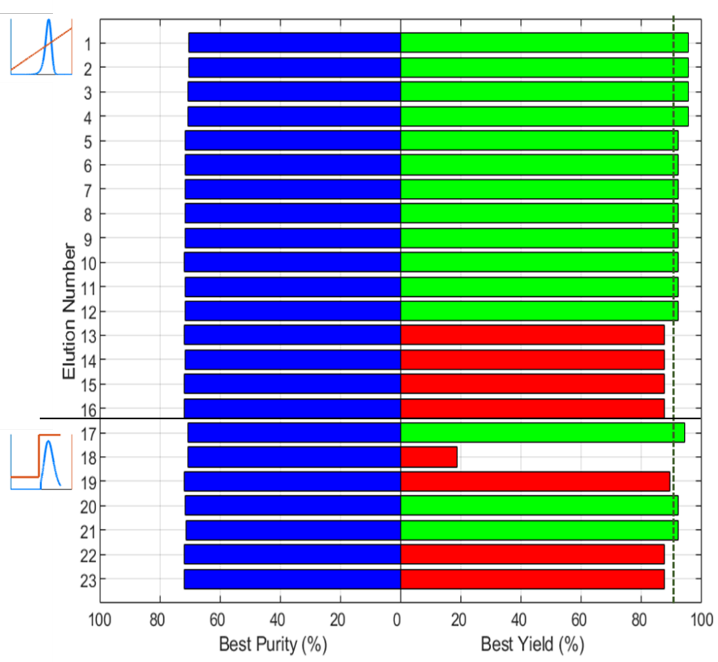
Figure 1: Purity and yield values for all polishing chromatography elution strategies.
    - Ultrafiltration Tangential Flow Filter (TFF) Cascade Outputs Evaluation
Each of the 23 polishing column outputs seen in Figure 1 are integrated with a reputable, commercial 7-stage Pall Corporation filter design. The Cadence Single-Pass TFF modular membrane units are 93 cm² in cross sectional area and configured as 3-3-2-2-1-1-1, where the ‘-‘ denotes a series connection and the number value of parallel modules at each stage.
The corresponding 23 outputs for the polishing-ultrafilter systems are shown in Figure 2. The outlet product flow from a polishing column is 1577.82 mLmin^{–1}: for the said 7-stage ultrafiltration, an inlet flow of 525.94 mLmin^{–1} must thus be fed to each of the three units. A target concentration of ultrafilter design of 100 g L^{–1} has been set (Kollár et al., 2020).
Figure 2 shows the few operational strategies which have achieved this effluent target, as only 6 of the 23 flowsheets succeed in achieving 100 g L^{–1} (namely 1, 2, 6, 11, 20, 21). All designs failing the 90% polishing recovery yield also fail the said ultrafiltration target. Key flowsheet success factors include a low pH, a short elution time domain and a salt concentration that is high enough to elute large quantities of the main mAb variant, fast.
Clearly, there is a correlation between purified stream concentration and pressure drop. In every ultrafiltration case simulated here, a fixed pressure drop operation is considered. Every ultrafiltration has an upper limit of pressure drop; if this value is exceeded it causes negative fluxes to arise within the final set of filters, thus clearly leading to system failure. The wide variation of pressure drops is because every flowsheet is operated just below the upper pressure drop limit, to elucidate the maximum outlet final mAb concentration.
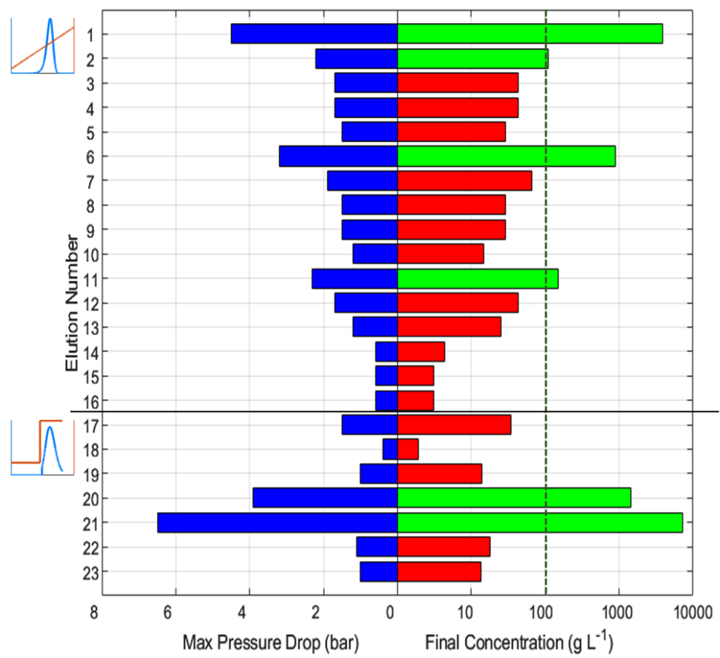
Figure 2: Maximum pressure drop and final concentration of the ultrafilter designs.
    - Ultrafiltration Configuration Performance Analysis
The ultrafilter configuration used in the foregoing flowsheets we consider is arbitrary, but the number of its stages and units per stage can be optimised (Thakur and Rathore, 2021). Figure 3 shows how two other configurations (5-5-3, 5-4-4), also with 13 filters in total, perform in purifying the polishing chromatography outlet stream: none of the two 3-stage cascades matches the high purity of the 7-stage one, indicating system design is critical.
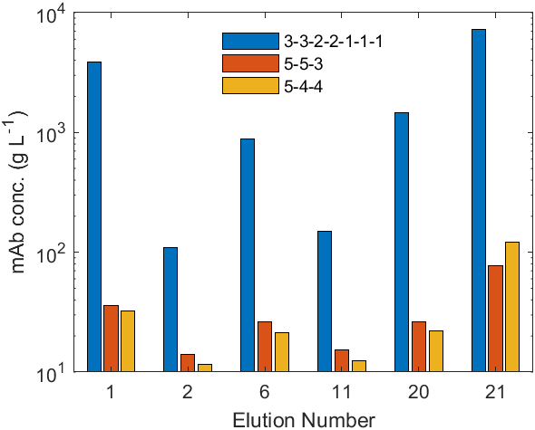
Figure 3: Final concentration of successful elution-ultrafilter configuration systems.
  - Conclusions
Dynamic simulation of polishing chromatography-ultrafilter systems for industrial mAb production has great value in comparative visualisation of design and operating strategies. A pH-dependent steric mass action model for polishing chromatography and a semi- empirical (Darcy and Graetz-Laveque) model for ultrafiltration have been combined here. A series of 23 (either gradient- or step-based) elution strategies (Saleh at el., 2020) have been analysed for performance vs. a target recovery yield of 90% in mAb manufacturing. A 7-stage (3-3-2-2-1-1-1) ultrafiltration system (Cadence Single Pass, Pall Corporation) has been subsequently considered to receive and purify the outlet of each of these elutions, and assessed vs. achieving a target (purified effluent) mAb concentration of 100 g L^{–1}. Only 6 of the 23 integrated polishing chromatography-ultrafiltration flowsheets proposed are shown as successful vs. both specifications. Finally, two new ultrafilter configurations are computationally implemented, to probe whether shorter series (fewer stages, but using the same number of total membrane units, 13) can achieve matching mAb performance. The original 7-stage (3-3-2-2-1-1-1) configuration outperforms by far both 3-stage ones, showing that structural optimisation can tremendously benefit mAb flowsheet efficiency.
Acknowledgements
The authors gratefully acknowledge UKRI and the Engineering and Physical Sciences Research Council (EPSRC) Doctoral Training Partnership (DTP) PhD Scholarship awarded to W.J., and a Royal Society Industrial Fellowship (2020-22) awarded to D.I.G.
Financial support via another UKRI-EPSRC grant (RAPID: ReAltime Process ModellIng & Diagnostics–Powering Digital Factories EP/V028618/1) is also hereby acknowledged.
References
S. Badr, & H. Sugiyama. (2020). A PSE perspective for the efficient production of monoclonal antibodies: integration of process, cell, and product design aspects. Curr. Opin. Chem. Eng., 27, 121-128.
Y. Baek, N. Singh, A. Arunkumar, M. Borys, Z. J. Li, & A. L. Zydney. (2017). Ultrafiltration behavior of monoclonal antibodies and Fc‐fusion proteins: Effects of physical properties. Biotechnol. Bioeng., 114, 2057-2065.
J. H. Chon, G. Zarbis-Papastoitsis. (2011). Advances in the production and downstream processing of antibodies. New Biotechnol., 28, 458-463.
M. DiLeo, A. Ley, A. E. Nixon, J. Chen. (2017). Choices of capture chromatography technology in antibody manufacturing processes. J. Chromatogr. B, 1068, 136-148.
É. Kollár, B. Balázs, T. Tari, I. Siró. (2020). Development challenges of high concentration monoclonal antibody formulations. Drug Discov. Today: Technologies, 37, 31-40.
T. Müller-Späth, G. Ströhlein, L. Aumann, H. Kornmann, P. Valax, L. Delegrange, E. Charbaut, G. Baer, A. Lamproye, & M. Jöhnck. (2011). Model simulation and experimental verification of a cation-exchange IgG capture step in batch and continuous chromatography. J. Chromatogr. A, 1218, 5195-5204.
A. S. Rathore, D. Kumar,, N. Kateja. (2018). Recent developments in chromatographic purification of biopharmaceuticals. Biotechnol. Lett., 40, 895-905.
D. Saleh, G. Wang, B. Müller, F. Rischawy, S. Kluters, J. Studts, & J. Hubbuch. (2020). Straightforward method for calibration of mechanistic cation exchange chromatography models for industrial applications. Biotechnol. Progr., 36, e2984.
G. Thakur, A.S. Rathore. (2021). Modelling and optimization of single-pass tangential flow ultrafiltration for continuous manufacturing of mAbs. Sep. Purif. Technol., 276, 119341.
X. Zhang, T. Chen, V. Li, T. Bo, M. Du, T. Huang. (2023). Cutting-edge mass spectrometry strategy based on imaged capillary isoelectric focusing (icIEF) technology for characterizing charge heterogeneity of monoclonal antibody. Anal. Biochem., 660, 114961.

