Assessment of low-carbon alternative fuels in maritime integrated with CCS on board
Nefeli Roufogali,ª Konstantinos A. Pyrgakis,ª Antonis C. Kokossisª
ªSchool of chemical engineering, National Technical University of Athens, Iroon Polytechneiou 9, GR-15780, Athens, Greece
akokossis@mail.ntua.gr
Abstract
This work uses PSE methods for screening, simulation, integration, and analysis of low-carbon fuels in maritime along with options for CCS on board. The efficiencies of conventional fuels (HFO, diesel) were addressed in front of alternative fuels (methanol, LNG, H2, biocrude) to investigate energy and fuels savings considering the potentials of process and energy integration and cogeneration that uses available heat from flue gases and the engine in new engine designs of ROPAX ships. The accounted energy demands include shaft work, electricity and heat respectively used for propulsion, the engine room, and the hotel. Alternative fuels could improve economic performance of shipping by 10% (LNG)-340% (Methanol). Energy integration of the ship’s hot/cold streams could reduce fuels costs by up to 10%, while CCS on board could yield CO2 emissions reduction in the range of 40% (cryogenic)-80% (MEA adsorption).
Keywords: marine engines; ROPAX; integration; CCS; LNG, methanol, H2, biocrude
  - The need for low-carbon fuels in maritime
Maritime produces ≈3% of GHG emissions, while shipping holds 80% of global trade (Faber et al., 2020). Most vessels currently use HFO or MDO bringing them in front of stringent emission regulations set by the International Marine Organization (IMO), which requires short- and long-term strategies to reduce GHG emissions. Key goals for 2030 include GHG emissions reduction by 20% and reduction of CO2 emissions per transport work by at least 40% (compared with 2008 levels). The goal of IMO is to achieve net-zero GHG emissions, as soon as possible within this century, which necessitates significant efficiency improvements to follow business-as-usual operations (Gibbs et al., 2014). These goals require drastic changes from conventional operations and the use of low-carbon fuels taking advantage of design (fuels and integration) and technology (engines and CCS) innovations on board. Still, sustainability of alternative fuels is also strongly affected by cost-effective upstream chemistries to valorize bio-based sources (Pyrgakis et al., 2016; Pateromichelakis et al., 2022). Fuel replacement is the promising long-term solution. Since novel fuels and engine systems are at lower TRLs and the bunkering systems for alternative fuels are underdeveloped, then energy integration and CCS on board can facilitate short- and mid-term scenarios. This work examines the performance of alternative low-carbon fuels, integration patterns and CCS on board.
  - Background of alternative fuels, designs, and technology options
Shipping needs to drastically reduce emissions of any kind requiring changes in fuels, equipment, and operation practices to reach IMO’s targets. This requires testing of various alternative options and degrees of freedom towards cost-effective shipping decarbonization. LNG is the most attractive and market competitive alternative to HFO and MDO by holding high energy density and meeting the needs for SOx and NOx limits; however, LNG is challenged by high cooling demands and volumes for storage (─163 ºC). Bio-based and synthetic LNG constitute an even more promising alternative for further emissions reduction. Other high trended bio-based and low-carbon fuels include methanol (MeOH); biocrude from pyrolysis or liquefaction of biomass; and hydrogen. MeOH holds adequate energy density, while green sourcing needs to be considered. Hydrogen is the most promising option for maritime decarbonization (zero-carbon emissions), but lacks cost-efficient production, sourcing, and requires high-cost infrastructures. Biocrude is attractive, but remains at low TRL featuring instability, equipment corrosion, and low mixture compositions. Overall, sourcing, seasonality, price volatility, and divergence from marine standards are vital challenges for new fuel entries.
Other options to drive emissions reduction involve direct intervention on existing operations in terms of process intensification by setting goals to optimally valorize available heat across ship and by appropriately integration with current energy demands, eventually reducing fuels consumption in the main engines and the boiler/heaters. Besides classical pinch analysis, there are several state-of-the-art process-to-process energy integration approaches to facilitate optimality in energy savings and applied utilities (Pyrgakis and Kokossis, 2019). Moreover, electricity cogeneration using steam turbines is another option to reduce loadings of auxiliary engines. The updated Turbine Hardware Model of Pyrgakis and Kokossis (2020) was used for estimation of the cogeneration potential. Such options are feasible for short-term strategies, but are challenged by re-engineering of existing mechanical, electronic and control systems.
Carbon capture and storage (CCS) on board is another option for CO2 emissions reduction. Different technologies and designs could be adapted to the specific needs and conditions of various industries including maritime. CO2 absorption with amine solutions (e.g., MEA) is the most mature and efficient technology for CO2 capture, though is challenged by utilities costs, and demands for compressing CO2 captured in vapor phase. Cryogenic distillation is another, also mature, option based on physical processing and is adaptable to various conditions. The high energy cost for CO2 condensation is the main challenge. Thus, a potential to use it in LNG ships can be justified, since cryogenic storage of LNG offers a viable source of cold energy enabling CO2 liquefaction and lower energy penalties for CCS and short-term storage on board. The captured CO2 could be deposit at port and be integrated with other energy carriers’ supply chains and industries.
The above fuel, design and technology options have been examined to investigate best combinations that achieve highest economic and environmental performance in ROPAX ships. The analysis takes for granted the known and fixed energy demands of a ROPAX reference ship (150 m length, 1200 passengers) including propulsion, electricity and heat for hotel and auxiliary operations. This work systematically screens the performance of each fuel, design and CCS option considering variations in the engine cylinder design and operating conditions. Marine engines using alternative fuel were simulated and their demands were integrated with the vessel’s streams to identify highest potentials for fuels savings considering, at the same time, process, and energy integration of CCS on board.
  - Screening, analysis, and design methodology
The approach involves 3 analysis steps to systematically assess the economic, technical, and environmental performance of alternative fuels, when used alone or combined with conventional fuels. The steps are:
(1) Quick and robust screening: 6 conventional (diesel, HFO) and alternative (MeOH, H2, biocrude, LNG) fuels were examined by means of mathematical modelling considering an equation system to describe combustion kinetics; fuels and flue gas properties; mass and energy balances; and cylinder operations. The model receives user-defined inputs for the cylinder operating conditions (fuel inlet pressure and temperature and Air Fuel Ratio-AFR) and design (compression ratio, bore and height) and fuel prices. The model returns as output the cylinder’s mass and energy balances, fuel conversion, energy efficiencies, power output, torque, fuel consumption, and CO2 emissions.
The analysis focused on the impact of the engine operations on the energy, economic and environmental performance. This approach was also considered for different compatible fuels mixtures (conventional with alternative) to assess trade-offs in economic and environmental performance. Overall, the aggregated results were used to map and rank the overall performance of single and mixed fuel alternatives.
(2) Engine simulation and process integration: Using the results of step (1), the analysis deepened in the engine design developing flowsheets and simulations based on the use of each fuel and type of engine in the basis of ROPAX ships energy demands. The simulations involved the engine cylinders, the turbochargers, the fuel feeding system (storage, pressurization, heating, vaporization), and flue gases production. The simulations were performed in ASPEN plus and the detailed mass and energy balances were calculated and used to estimate the reference energy savings from utilization of hot streams (engine, lubricating oil, and scavenge air) with cold streams of the ship, which include steam and calorifier energy production, fuel, and auxiliary heating processes across ship. The distribution of the reference fuel combustion energy among all above ship operations (including propulsion, shaft work for electricity production, the heater and energy losses) was mapped ringing the bell for process intensification across ship. A great potential of available energy was identified in energy losses in hot flue gases (>290 °C depending on the type of fuel) and the circulating cooling water (heat rejected to the sea heat sink) used for cooling the engine, the lubricating oil and the scavenge air. Both heat sources could be used to save fuel used for heat production (through integration) and fuel used for electricity production (through cogeneration). The composite curves of the reference scenarios were calculated revealing the integration, cogeneration and fuel savings potentials in the heater and ME/AE engines.
(3) Carbon Capture and Storage on board: The produced flue gases were further considered for Carbon Capture and Storage (CCS) on board through two alternative technologies: MEA absorption (MEA-CCS) and Cryogenic distillation (Cryo-CCS). In the case of MEA-CCS, both kinetic and equilibrium reactions among MEA-CO2-H2O as well as an absorber-stripper system were considered with appropriate integration of the energy intensive heating of absorbed CO2 and cooling of recycled MEA. The energy intensive Cryo-CCS requires delicate design adapted to the specific conditions and composition of flue gas to ensure sustainable CCS. Reference designs (Songolzadeh et al., 2014) regularly include (i) water condensation, (ii) high pressure compression (up to 80 bar) (iii) partial removal of air content and (iv) cryogenic distillation for sharp separation of CO2-air. High pressures enable lower dew points of CO2, which return lower electricity demands for chilling. However, high pressure compression of flue gas with low CO2 content (4-8% w/w) is not a sustainable option. This is outcome of using high AFRs in maritime to ensure full fuel consumption in the cylinder. The high compression power results in high electricity demands and fuel consumption in auxiliary engines producing extra CO2 emissions; almost equivalent to the CO2 that is captured by Cryo-CCS. This raises concerns about using lower AFR to favor CO2 capture, but lower LNG consumption results in either high CH4 emissions (25 times higher than CO2) or high energy costs to recover unconverted CH4. Under these conditions, CCS in LNG-ROPAX is re-engineered by bypassing compression and taking advantage of the viable cold energy from LNG storage to partially liquefy CO2 from flue gases. Short-term CO2 storage on board requires multistage compression and condensation of vapor CO2 in MEA-CCS, while liquefied CO2 (Cryo-CCS) can be pumped and stored at lower cost.
4) CCS design versus energy integration efficiencies: The analysis involves fixed streams of the ship and variable streams from CCS process that need to be appropriately designed to ensure the maximum feasible energy savings and CO2 capture efficiencies. Thus, the whole ship energy demands were continuously inspected through the integration graph of composite curves to ensure sustainable operation and CCS. The inspection of composite curves guided the flowsheeting and operating conditions of CCS, holding the target of CO2 emissions reduction by at least 40% (IMO goals for 2030).
  - Results
    - Screening alternative fuels
The kinetic models of Aronowitz et al. (1979), Konnov et al. (2019) and Frassoldati et al. (2009) were used, respectively, for the combustion of MeOH, H2 and CH4. The polynomial equation and parameters from ASPEN plus v.12 were used to model heat capacity of fuels, air and flue gases, while a 4-stroke diesel engine cycle was considered to model the temperatures, pressures, volumes and energy balances in the cylinder. The full cylinder model was implemented at various operations of real-life engines (Table 1).
The impact of alternative fuels and operating conditions (AFR, compression ratio, fuel inlet temperature and pressure) on energy and economic performance (torque-T [Nm] to fuel consumption-Price [€/hr]) were investigated. Indicatively, Figure 1 (left) presents trade-offs between various economic (T/Price) and energy efficiencies (n_{actual}) at different operating conditions and engine designs. Figure 2 also maps the economic performance vs CO2 emissions at best condition identified for each type of engine.
Table 1 Design specification of cylinders of addressed marine engines.
Fuel type | Diameter/Height | kW/RPM
MeOH | 0,32/0,4 | 470/700; 580/750
H2 and H2-Diesel | 0,128/0,157 | 740/1900; 750/2100
Biocrude and Biocrude-HFO | 0,225/0,3 | 130/750; 150/900
Diesel and MeOH -Diesel | 0,31/0,43 | 485/700; 600/750
LNG and H2-LNG | 0,31/0,43 | 420/650; 520/700
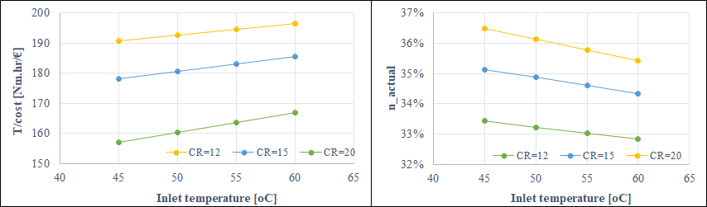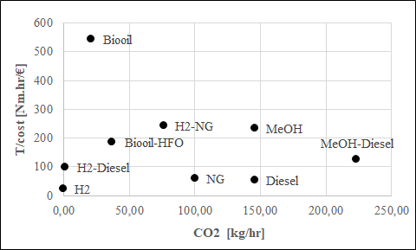
Figure 1 Energy efficiencies vs temperature and compression ratio in MeOH engines (left); map of economic-environmental performance of addressed marine fuels (right).

    - Engine simulation and process integration
The process flowsheets of engine operations and fuel management (vaporization, pressurization and/or heating) were developed and simulated in Aspen plus (Figure 2) resulting in the detailed mass and energy balances across engine. All thermal data were extracted and used for the energy analysis and detection of the maximum feasible energy savings, while electricity cogeneration was also considered.
Figure 3 presents the composite curves of a MeOH, LNG, and HFO engines revealing the potential for full integration of ship’s heating demands with available energy from the engine (producing hot water at 350 ºC) and hot flue gases (≥190 ºC).
In HFO-ROPAX, all steam production and Thermal Oil Heater demands can be covered by the engine’s available heat and the flue gases economizer reducing HFO consumption by ≈1.5%. Steam production using energy form the engine, scavenge air and flue gases can be used for 940 kW of cogeneration further reducing fuel consumption in auxiliary engines by 3%. Similar integration patterns in MeOH engines can reduce heating demands and fuel consumption from 3600 to 3200 kg/hr (10%), while the cogeneration of 585 kW could cover 30% of the hotel and engine room ventilation demands. In LNG-ROPAX, fuel savings from energy integration can reduce LNG consumption by 14%, while 44 kg/hr are further saved by cogeneration, resulting in total fuel savings at ≈17%.
    - Carbon Capture and Storage on board
CCS on board was investigated and appropriately integrated within ROPAX ships. Both MEA- and Cryo-CCS technologies were tested in HFO, MeOH and LNG ships. The process flowsheets of each CCS technology and storage stages have been developed in ASPEN Plus. Prior CCS, cooling of flue gases (at 40-50 ºC) and water condensation were considered reaching 4-8% w/w CO2 content. Such low CO2 contents raise the energy penalty in CCS and requires delicate design and adaptation of CCS conditions to appropriately match and/or cover chilling demands with waste cold energy of effluent air streams. The design of MEA-CCS followed a typical structure from literature (Songolzadeh et al., 2014). In contrast, Cryo-CCS needed to be appropriately tuned (temperatures, pressures and flowsheet) to ensure energy fitting with the ship’s streams.
MEA-CCS most fits to HFO and MeOH ships. MEA-CCS required 5060 kW to capture CO2 (7.4% w/w) from 166 tn/hr of HFO-based flue gases reaching 85% CO2 capture efficiency. In MeOH ships, MEA-CCS required 3591 Kw to capture CO2 (6.2% w/w) from 73.5 tn/hr flue gases reaching 81% CO2 capture. In Cryo-CCS, the use of flue gases compression (80 bar) resulted in additional fuel consumption equivalent to 70-80% of the fresh fuel consumption. Instead, the solution was to bypass compression and directly condense CO2 at atmospheric pressure and higher temperatures (─145 to ─155 ºC) matching with the cold energy for LNG vaporization and heating (─16340 °C). The condensed AIR-CO2 mixture is next pumped (80 bar) and driven to cryogenic distillation to recover pure CO2. This strategy resulting in the lowest feasible Cryo-CCS demands (4.23 MJ_{elec}/kg of captured CO2) and in the highest CO2 emissions reduction (40%).
  - Conclusions
A preliminary screening of alternative fuels performance highlighted biocrude, LNG and MeOH from economic and environmental perspectives. However, biocrude still lacks maturity and stability in use (asphaltenes precipitation and corrosion) and needs additives to enable use at concentrations. Instead, LNG and MeOH are best alternatives used alone or in mixtures. MeOH ships appear a higher integration and cogeneration potential than LNG and HFO, but methanol’s lower heating value requires larger fuel flows and CO2
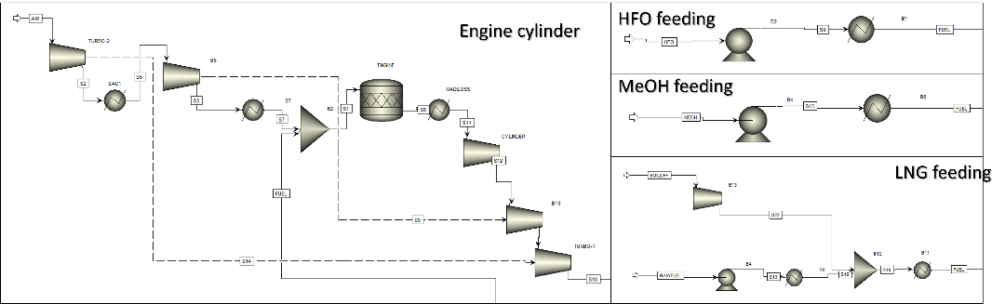
Figure 2 Process flowsheets of cylinder and fuel handling simulates in ASPEN Plus
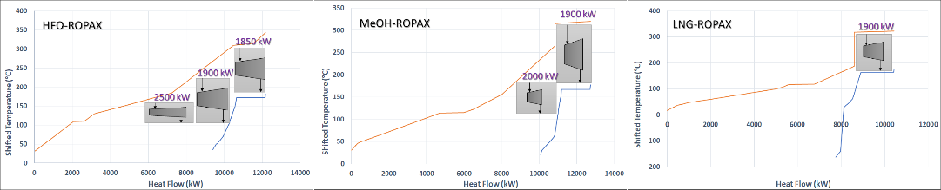
Figure 3 Composite curves of integrated ship’s demands.
emissions. CCS on board appears feasible reaching CO2 capture efficiencies of up to 80% using MEA-CCS and 40-50% Cryo-CSS, the latter better fits with energy profiles of LNG ships. Moreover, mixing of appropriate fuels, energy integration and cogeneration facilitated fuel savings by up to 10% compared with current practices in ROPAX.
Acknowledgments
The project is implemented within the framework of the National Recovery & Resilience Plan "Greece 2.0" and has been financed by the European Union (NextGeneration EU).
References
Aronowitz, D., Santoro, R.J., Dryer, F.L., Glassman, I., 1979. Kinetics Of The Oxidation Of Methanol: Experimental Results Semi-Global Modeling And Mechanistic Concepts. Symposium on Combustion, 17, 1, 633-644
Faber, J., et al., 2020. Fourth IMO GHG Study 2020. IMO, London SE1 7SR
Frassoldati, A., Cuoci, A., Faravelli, T., Ranzi, E., Candusso, C., Tolazzi, D., Simplified kinetic schemes for oxy-fuel combustion. S4FE 2009
Gibbs, D., Rigot-Muller, P., Mangan, J., Lalwani, C., 2014. The role of sea ports in end-to-end maritime transport chain emissions. Energy Policy, 64, 337–348
Konnov, A.A., 2019. Yet another kinetic mechanism for hydrogen combustion. Combustion and Flame, 203, 14–22
Pateromichelakis, A., Psycha, M., Pyrgakis, K., Maréchal, F., Kokossis, A., 2022. The use of GVL for holistic valorization of biomass. Computers & Chemical Engineering, 164, 107849
Pyrgakis, K.A., de Vrije, T., Budde, M.A.W., Kyriakou, K., López-Contreras, A.M., Kokossis, A.C., 2016. A process integration approach for the production of biological iso-propanol, butanol and ethanol using gas stripping and adsorption as recovery methods. BEJ, 116, 176-194.
Pyrgakis, A., Kokossis, A.C., 2019. A Total Site Synthesis approach for the selection, integration and planning of multiple-feedstock biorefineries. C&CE, 122, 326-355
Pyrgakis, K.A., Kokossis, A.C., 2020. Total Site Synthesis: Selection of Processes to Save Energy and Boost Cogeneration. Computer Aided Chemical Engineering, 48, 1345-1350
Songolzadeh, M., Soleimani, M., Ravanchi, M.T., Songolzadeh, R., 2014. Carbon Dioxide Separation from Flue Gases: A Technological Review Emphasizing Reduction in Greenhouse Gas Emissions. 2014, ID 828131

