**Variable structure simulation and optimization of start-up of batch distillation columns**

Nikhil Sharma,a* Kannan M. Moudgalya,a Sunil Shah,b

*a Dept. of Chemical Engg, Indian Institute of Technology Bombay, Powai 400076, India*

*bModelicon Infotech LLP, Bengaluru, 560066, India*

*nikhilsharma1207@gmail.com*

**Abstract**

A versatile hybrid simulator, capable of including only the active units, useful especially for start-up and shut-down simulations, has been developed using the scheduler developed by Paknikar et al. (2022). This simulator has been used to study the start-up operations of a methanol-water batch distillation column. The results of these simulations are validated with that of Elgue et al. (2004). After rigorously simulating the start-up, the reflux rate profile is optimized to achieve 99 % product purity in the shortest time. This exercise is repeated for the approximate modeling in which liquid in every tray is taken to be at feed composition, with vapor-liquid equilibrium established. Optimization with accurate initial conditions leads to 75 % reduction in batch time. This simulator is capable of start-up and shut-down also of continuous distillation columns, and extendable to that of entire flowsheets.

**Keywords**: Variable-structure modeling, start-up of batch distillation, optimal start-up

**1. Introduction**

Understanding of distillation column operation especially during start-up is an important step to enable “1st time right” policies for establishing optimal time and energy policies. Modeling of dynamic operations of start-up and shut-down operations is beneficial in the design, control, and operability of distillation columns. Fieg et al. (1993) tried to answer when and how proper valve switching should be done to achieve desired purity safely and in a short time. Scenna et al. (1998) demonstrated for reactive distillation systems how a given start-up policy may be better or worse. Modeling start-up operations is also of interest for optimizing a distillation system. Wang et al. (2003) suggested a trial and error method to obtain the pseudo-warm state for initializing optimization. Gonzalez-Velasco et al. (1987) suggested the improvement in batch distillation start-up without considering changes in the phases. Ruiz et al. (1988) developed a dynamic model for batch distillation start-up. Flender et al. (1998) also developed a start-up model for distillation but did not consider the transition from the empty column.

Modeling of start-up processes is an inherently difficult problem due to sequential on-streaming of unit operations and components. For example, cold start-up of distillation columns, will gradually bring on-stream trays till the whole column is filled, and vapor-liquid traffic is established. This requires a structurally changing set of equations that need to be modeled and solved.

Wang et al. (2003) simulated rigorously the start-up of a distillation column from a cold state using gPROMS Barton et al. (1994), handling the structurally changing set of equations indirectly: they solved one set of equations, with inactive units being modeled by trivial equations. They also validated their prediction with experimental results. Their model was improved by Elgue et al. (2004), who carried out a similar study. Hoffmann et al. (2020) suggested a pressure-driven dynamic model for the start-up of distillation columns through smooth reformulations of min/max operators and step functions.

In this work, the approach of Wang et al. (2003) and Elgue et al. (2004) is used without resorting to the use of trivial equations: a part of the column is simulated only if there is any liquid or vapor traffic in it. Feed is charged into the reboiler and heated. Tray models are used as and when the vapor reaches them, condenses, and VLE is established. Accordingly, the number of equations in the model keeps increasing, as and when a tray is brought into focus, using the scheduling engine developed by Paknikar et al. (2022). The results of this simulation are compared with a study in which all trays participate from the beginning, with the composition in every tray being equal to that of feed. Optimization studies confirm the benefits of using correct initial conditions.

**2. Simulator for variable structure modeling and simulation**

A scheduling engine developed by Paknikar et al. (2022) in OpenModelica has been leveraged to execute sequential operations during a distillation column start-up. This simulator facilitates the inclusion of only active units, which can be considered as *just-in-time* modeling. Inactive units are not included, and hence their model equations are

excluded from the simulation. Consequently, there is no need to provide trivial equations or guesses for inactive units. The scheduling engine of Paknikar et al. (2022) enables event monitoring for variable structure modeling and simulation.

The start-up procedure may vary based on the column geometries and modes of operation. For validation purposes, an experimental Oldershaw-type Methanol-Water column used by Elgue et al. (2004) is selected for modeling. A methanol-water feed with 18% methanol is charged to the reboiler in a 20-stage column operating at atmospheric pressure. The resulting temperature profiles of select trays during the start-up, as calculated by our simulator, are compared with that of Elgue et al. (2004) in Figure (1).

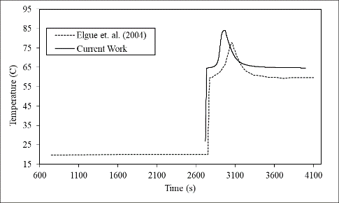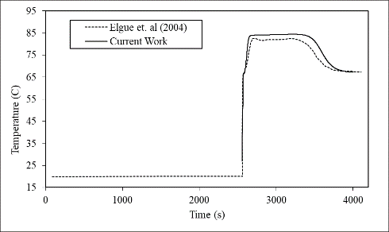There are slight differences between the two profiles, which can be attributed to the differences in hold-up values and in the modeling of the reboiler. As the current simulator solves a unit only when it is active, temperature profiles it predicts do not start from time

1. Bottom tray (b) Intermediate tray

zero: a tray becomes active only when vapor reaches the wall of the tray.

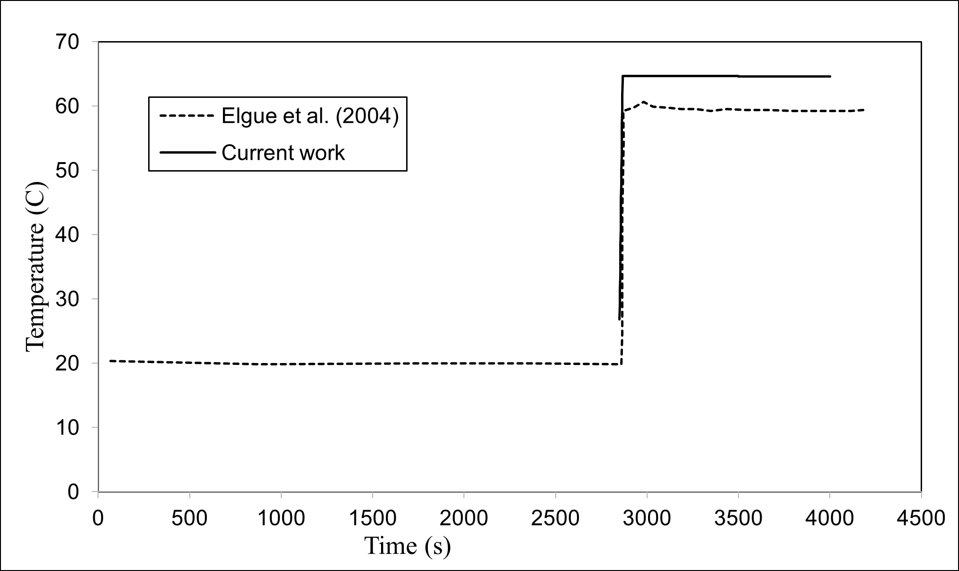

(c) Top tray

Figure 1: Comparison of temperature profiles of the current work with that of Elgue et al. (2004)

(a) Bottom tray (b) Intermediate tray (c) Top tray

**3. Start-up and optimization**

The importance of using correct initial conditions is brought out in this section. Just-in-time modeling, explained above, is used to carry out the start-up in an equimolar Methanol-Water system (see Table 1), using the realistic model equations of Elgue et al. (2004).

Table 1: Column Specification for the Methanol-Water system

|  |  |
| --- | --- |
| **Column Specifications** | |
| Components | Methanol- Water (Equimolar) |
| Initial charge | 800 Moles |
| Number of Trays | 20 (each with 10 Moles Hold-up) |
| Reflux Drum Hold-up | 200 Moles |
| Pressure | 101325 Pa |
| Heat Duty | 3 kW |
| K Values | NRTL |

Start-up is said to be complete when the vapor-liquid traffic is established and in equilibrium in the entire column. In this example, the start-up is considered complete when the bottom tray is completely filled with the incoming liquid from the tray just above it. Figures 2(a) and 2(b), respectively, show the temperature and composition profiles for a few select trays during the startup. As mentioned earlier, profiles of different trays begin at different times, depending on when they become active and hence get included in the simulation.

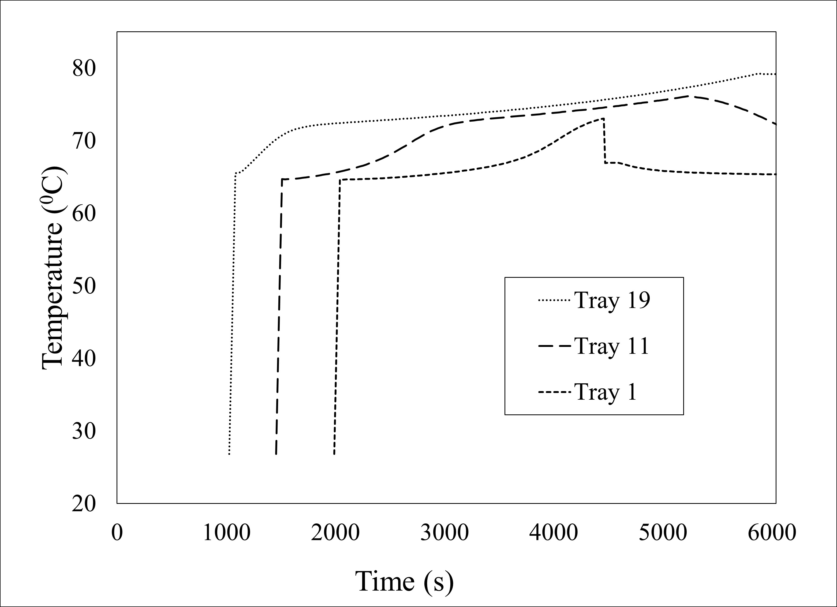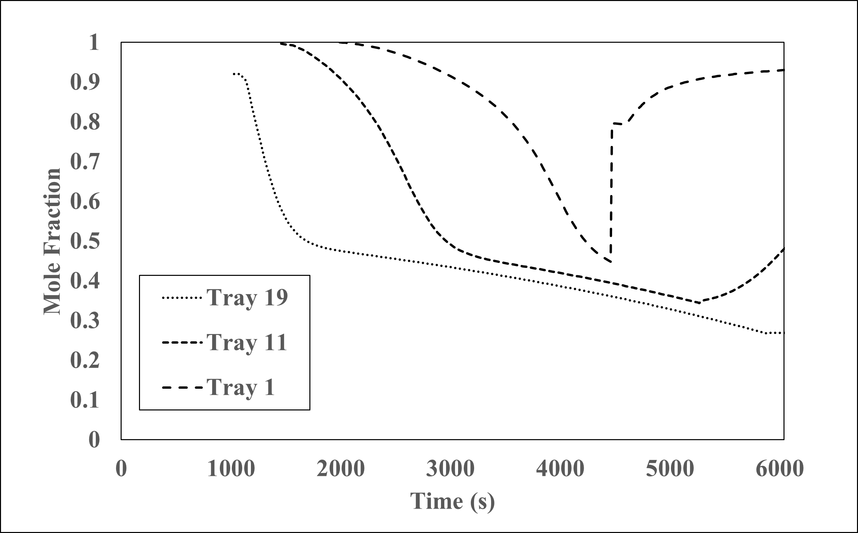

1. Temperature Profile (b) Mole Fraction of Methanol

Figure 2: Temperature and composition profiles of select trays, numbered from top to bottom during start-up

After the start-up, the reflux ratios are optimized so as to complete the separation in minimum time, with the constraint that 99% pure methanol is obtained at the top of the distillation column. As it is a batch operation, the product is taken to be the sum of the liquid collected at the reflux drum, and what is already withdrawn in the accumulator. The optimization problem is stated in Eq. (1).

|  |  |
| --- | --- |
| $\underset{rr}{\min{ }}{\frac{{ T}_{Batch}}{H_{a}}}$ | (1) |
| $Sub. to$ |  |
| $X_{p,1}≥0.99$ |  |

Where, rr is reflux ratio and is defined as an internal reflux i.e., the ratio of liquid returning to vapor flow rate and varies from 0 to 1. $T_{Batch}$ is the batch time, $H_{a}$ is the accumulator hold-up, and $X_{p,1}$ is the combined mole fraction of methanol in the accumulator and the reflux drum. The batch time is divided into five equal intervals with a constant reflux ratio in each. The approach of constrained optimization by linear approximations (Powell, 1994) is used. In this particular implementation, scipy.optimize.COBYLA is used in OpenModelica.

In the traditional method of start-up, however, it is assumed that every tray, the reboiler, and the reflux drum are filled with the liquid at feed conditions: equimolar composition at the bubble point, in this case. This assumption is at best approximate as vapor-liquid equilibrium is not possible even if every tray is charged with liquid at the feed composition with vapor-liquid traffic established. The reflux ratio for this initial condition is subsequently optimized to obtain 99% purity of methanol at the top.

Results of the traditional approach (left) and the just-in-time modeling approach (right) are now reported in Table 2. The optimal reflux ratio profiles for the two cases are compared in Figure 3. To handle different batch times, the model equations are integrated to unit time instant and multiplied by the actual batch time. Figure 4 compares the composition profiles in the reflux drum and the accumulator.

It is evident from Table 2 that initial conditions have a critical role in optimization. It takes less than 75 % time in separating components in the just-in-time modeling, as compared to the traditional method. Although the just-in-time modeling approach slightly overestimates startup as can be seen in Figure 1, it helps arrive at better optimal values (the improvement observed is around 75 %). Since 200 moles of holdup are present in the reflux drum, which is also 99% pure, implies that 370 moles out of 400 moles are obtained with 99% purity. Figure 3 and 4 shows for traditional approach column needs to be operated at total reflux for considerable amount of time to achieve the desired purity.

|  |  |  |
| --- | --- | --- |
| **Optimized**  **Variable** | **Results for different initial conditions** | |
|  | **Accurate (proposed**  **in this work)** | **Traditional (feed**  **composition in every tray)** |
| Batch Time | 11002 sec | 48713 sec |
| Accumulator Hold-up | 170 moles | 173 moles |
| Total top product | 370 moles | 373 moles |
| Accumulator purity | 98.8 % Methanol (moles) | 99.7 % Methanol (moles) |
| Reflux drum purity | 99.1 % Methanol (moles) | 97.7 % Methanol (moles) |
| Total Purity | 98.9 % Methanol (moles) | 98.6 % Methanol (moles) |

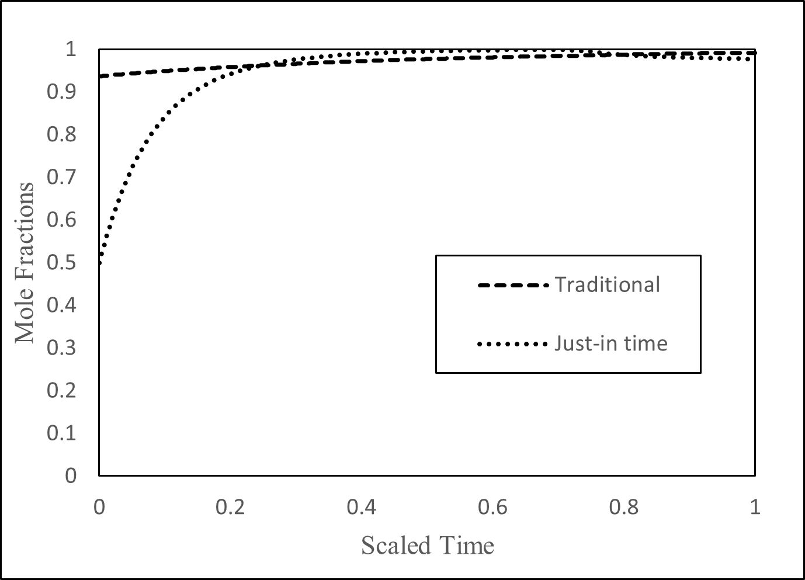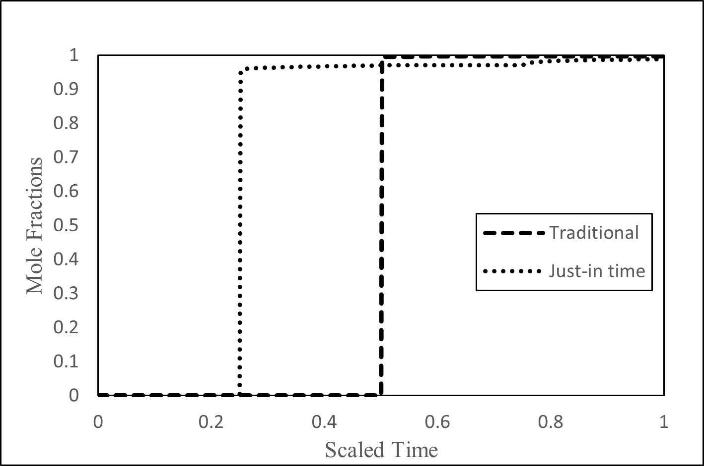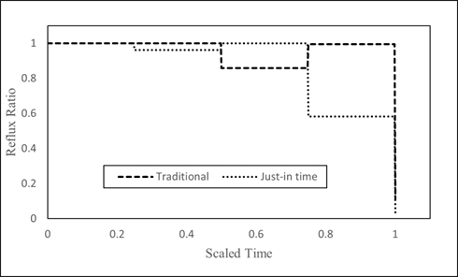Table 2: Comparison of optimization results

Figure 3: Comparison of Optimum reflux ratio profiles

(a) (b)

Figure 4: (a) reflux drum profiles and (b) accumulator profiles

**Conclusions**

A versatile hybrid simulator capable of doing just-in-time simulations, incorporating only the active units, has been developed in OpenModelica. Simulating only the active units obviates the need to come up with trivial models, to develop which, considerable effort may be required (Paknikar et al. (2022)). The simulator’s utility has been demonstrated through the start-up simulation of a batch distillation column. This simulator can be easily extended to the start-up and shut-down of continuous distillation columns and to the start-up and shut-down of entire flowsheet. Start-up and shut-down operations can be considered as batch processes.

The traditional method of taking the liquid composition in every tray to be equal to that of feed could be much less optimal than the rigorous start-up using just-in-time modeling. More importantly, this traditional method could give simulation results that are quite different from the actual situation, portrayed more correctly by the rigorous just-in-time simulation.

Future work includes optimizing these operations using variable structure optimization, implementing control strategies, and extending the scheduling framework for the startup and shutdown of process plants.

**References**

J. R. Gonzalez-Velasco, M. A. Gutierrez-Ortiz, J. M. Castresana-Pelayo, and J. A. Gonzalez-Marcos, “Improvements in batch distillation startup,” Industrial & engineering chemistry research, vol. 26, no. 4, pp. 745–750, 1987.

C. A. Ruiz, I. Cameron, and R Gani, “A generalized dynamic model for distillation columns—iii. study of startup operations,” Computers & chemical engineering, vol. 12, no. 1, pp. 1–14, 1988.

G Fieg, G Wozny, and C. Kruse, “Experimental and theoretical studies of the dynamics of startup and product switchover operations of distillation columns,” Chemical Engineering and Processing: Process Intensification, vol. 32, no. 5, pp. 283–290, 1993.

M Flender, G Wozny, and G Fieg, “Time-optimal startup of a packed distillation column,” IFAC Proceedings Volumes, vol. 31, no. 11, pp. 111–116, 1998.

N. Scenna, C. Ruiz, and S. Benz, “Dynamic simulation of start-up procedures of reactive distillation columns,” Computers & chemical engineering, vol. 22, S719–S722, 1998.

L. Wang, P. Li, G. Wozny, and S. Wang, “A startup model for simulation of batch distillation starting from a cold state,” Computers & Chemical Engineering, vol. 27, no. 10, pp. 1485–1497, 2003.

Barton, Paul I., and Constantinos C. Pantelides. "Modeling of combined discrete/continuous processes." AIChE journal 40.6 (1994): 966-979.

S. Elgue, L. Prat, M. Cabassud, J.-M. Le Lann, and J. Cezerac, “Dynamic models for start-up operations of batch distillation columns with experimental validation,” Computers & chemical engineering, vol. 28, no. 12, pp. 2735–2747, 2004.

N. Russell, W. M. Van Der Aalst, and A. H. Ter Hofstede, Workflow Patterns: The Definitive Guide. MIT Press, Feb. 2016, isbn: 9780262029827.

C. Hoffmann, J. Weigert, E. Esche, and J.-U. Repke, “A pressure-driven, dynamic model for distillation columns with smooth reformulations for flexible operation,” Computers & chemical Engineering, vol. 142, p. 107 062, 2020.

R. Paknikar, N. Sharma, P. Nayak, K. Moudgalya, and B. Raman, “Simulation scheduling of variable-structure systems in OpenModelica,” in Modelica Conferences, 2022, pp. 147–155.

Powell, Michael JD. A direct search optimization method that models the objective and constraint functions by linear interpolation. Springer Netherlands, 1994.