Improving Butanol and Acetone Production by Two-Stage Fermentation Coupled with Flash Distillation

Juan C. Barreiroa, Paula A. Tapiasa, Nicolas Muñoza, Karoll M. Rubianoa, Jose M. Bernalb, Carlos A.M. Riascosa,b*

aChemical and Environmental Engineering Dpt., Universidad Nacional de Colombia, Bogotá 111321, Colombia

bInstitute of Biotechnology, Universidad Nacional de Colombia, Bogotá 111321, Colombia.

camartinezri@unal.edu.co

Abstract

Bio-butanol and bio-acetone are alternatives to develop sustainable products and processes. The competitiveness of biotechnological processes depends on raw materials and operational costs, as well as on the productivity of the process. In the present work, butanol and acetone production by ABE fermentation coupled with an initial recovery stage by flash distillation is proposed. For the fermentation, a spontaneous mutant of *Clostridium acetobutylicum* DSM 1732, obtained at the Institute of Biotechnology of Universidad Nacional de Colombia, was employed. To increase productivity, a two-stage fermentation is proposed: the first stage, the acidogenesis phase, runs as a cyclic fed-batch, while the second one, the solventogenesis, runs as a batch; for this strain, ethanol production is practically negligible. This strategy allows to maintain high metabolic rates in both phases. On the other way, in the flash distillation, water-butanol azeotrope and the low boiling point of acetone allow to generate a solvent-concentrated vapor phase with high recovery (48 to 80 %). To generate a proposal for fermentation coupled with flash distillation, fed-batch fermentation and vapor-liquid equilibrium were studied, it allows to define operational conditions for each system unit. Results show that the operation in a cascade with two stages increases the combined productivity (acetone plus butanol) by 15 %, from 1.21 g L-1 h-1 in batch operation to 1.40 g L-1 h-1 in the proposed system, with no reduction in yield and reducing inoculum preparation, which is an advance for the development of a competitive process.

**Keywords**: ABE fermentation, cascade fermentation, flash distillation.

* 1. Introduction

Acetone-Butanol-Ethanol (ABE) fermentation has had a boom during the last 10 years due to the variability of production, price, the energy crisis and environmental problems of fossil fuels. It is one of the most ancient fermentation processes as it was important for obtaining the acetone necessary for the synthesis of cordite which was employed for gunpowder production in the First World War. With the rise of biofuels, interest in this fermentation has resumed, generating strains resistant to toxic metabolites and butanol hyperproducers (Patakova et al., 2013).

Butanol is mainly used in the surface coatings sector. 1-butyl esters of phthalic, adipic, sebacic, oleic, azelaic, stearic, and phosphoric acids are produced from butanol, serving as plasticizers and additives for surface coatings. In Addition, butanol is used as biofuel, proving to be even more effective than ethanol for gasoline replacement, due to its higher energy content and lower corrosiveness owing to its low miscibility with water (Bîldea et al., 2016). On the other hand, acetone is a key industrial solvent for cleaning purposes, given its complete miscibility with water and most organic solvents and oils. Furthermore, acetone serves as a precursor for large-scale products such as bisphenol A and methyl isobutyl ketone. Other uses of acetone as a solvent include dilution of fiberglass resin, paint formulations, ink, resin, and varnish (Morales-Rodriguez et al., 2014).

ABE fermentation has been developed by using strict-anaerobic bacteria from the *Clostridiae* family. Although there are different species capable of ABE production, *C. Acetobutylicum* and *C. Beijerinckii* are the most employed (Qureshi et al., 2001). The first fermentation stage ‒known as acidogenesis‒ occurs simultaneously with bacterial growth, this stage considers production of ethanol, and butyric and acetic acids, using glucose as substrate, which generates an important pH decrease. Acidogenesis ends when the concentration of acids reaches the maximum tolerance; at this point, a metabolic switch activates the set of reactions that allow acids to be transformed into solvents, the consumption of acid increases the pH and the final metabolic inhibition is generated by high concentration of solvents. The solventogenesis stage is a non-growth period.

Commercial butanol production through ABE fermentation considers challenges in solvent purification, as they are highly diluted in fermentation broth, due to the toxicity of the products. Recent research has generated new options for the separating of these solvents using techniques such as gas extraction, distillation, extractive distillation, pervaporation, and liquid-liquid extraction, among others. Moreover, it has been observed that combining fermentation and separation increases process productivity due to the reduction of butanol inhibition. However, these methods have disadvantages, such as the loss of micronutrients and intermediate products, as well as their lack of industrial implementation. Nevertheless, good performance and a high potential have been observed with the integration of fermentation plus separation (Zetty Arenas, 2019).

At the Institute of Biotechnology of Universidad National de Colombia (IBUN), spontaneous mutants of *Clostridium acetobutylicum* DSM 1732, resistant to high butanol concentrations, have been isolated (Sierra et al., 1996). For these mutants, the production of total solvents is between 6 and 18 g/L, with yields (*YP/S*) between 0.2 and 0.5 and productivities between 0.09 and 0.27 g of solvents/L·h. In the present work, alternatives to increase the productivity of butanol and acetone through ABE fermentation are evaluated.

* 1. Material and Methods
     1. Strain

ABE Fermentation studies started with vial fermentation for strain selection, and batch bioreactor experiments to develop a mathematical model, details of this previous research are presented in a complementary work (Tapias et al., 2024). IBUN IV, a spontaneous mutant of *Clostridium acetobutylicum* DSM 1732 strain, obtained at the Institute of Biotechnology of Universidad Nacional de Colombia, was selected due to its productivity and solvent tolerance. Tapias et al. confirmed the main characteristic of ABE fermentation: metabolism is carried out in two phases. The first phase employs sugars to generate acids (butyric and acetic) and biomass; whereas, in the second one sugars and acids are metabolized to generate solvents (butanol and acetone) without biomass generation. In that way, the switch between the metabolic phases generates changes in pH evolution. The best results were obtained with 40 g/L of glucose, which generates 36.3 g/L of solvents (*YP/S* = 0.908). Table 1 presents the key fermentation characteristics.

Table 1. Key batch fermentation characteristics with IBUN-IV strain.

|  |  |  |
| --- | --- | --- |
|  | Acidogenesis phase | Solventogenesis phase |
| Lag phase | 6 h | N.A. |
| Process time | 9 h | 15 h |
| Glucose Evolution | From 40.0 to 27.0 g/L | From 27.0 to 0.0 g/L |
| Biomass Evolution | From 1.0 to 3.2 g/L | Non-growing |
| Acids Evolution | From 4.5 to 10 g/L | From 10 to 4.5 g/L |
| pH Evolution | From 6.0 to 4.6 | From 4.6 to 5.2 |
| Average acids generation rate | 0.611 g/L h | N.A. |
| Solvents Evolution | No-generated | From 0.0 to 36.3 g/L |
| Average solvents generation rate | N.A. | 2.42 g/L·h |

* + 1. Analytics

Concentrations of glucose, butanol, acetone, butyric and acetic acids from fermentation were measured by HPLC, in a Shimadzu chromatograph, using a 300 x 4 mm Eurokat H column, 5 mM H2SO4, at 0.5 mL/min and 85 °C, using a refractive index detector RID 10A. Biomass was quantified by dry weight (Tapias et al., 2024).

* + 1. Fed-batch Fermentation

As other authors observed (Guo et al., 2018), metabolic differences between both phases and the non-growing production in the solventogenesis phase generate complexities for a single-stage process with feeding, whether continuous or fed-batch; considering that, two strategies for improving butanol and acetone production were considered. The first one includes two cyclic fed-batch bioreactors, the acidogenesis would begin with batch operation and, when it is at 2/3 of evolution, 2/3 of its volume is replaced with the original media to put on glucose and other spent nutrients, and to reduce the concentration of acids and other products. Meanwhile, the solventogenesis bioreactor would be fed with the volume harvested from acidogenesis, this feeding puts on spent acids, replaces biomass that is removed with the products, and reduces solvent concentration.

The second strategy considers a two-stage (cyclic fed-batch + batch) fermentation: the acidogenesis stage works like in the first strategy, meanwhile, the solventogenesis bioreactor would operate at batch regime.

To evaluate the viability of implementing a cyclic fed-batch solventogenesis process, a fed-batch fermentation was performed, this fermentation considers a 1:1 volumetric feeding of a synthetic acidogenesis broth at 36 h (approximately 2/3 of the solventogenesis phase). The concentration of the main components in the feeding was: glucose: 40.0 g/L, acetic acid: 7.5 g/L, butyric acid: 4.5 g/L, and other components: equal to the original media. This fermentation was performed in a 1 L BIOSTAT A with no pH control, details of equipment and procedures are presented in our previous work (Tapias et al., 2024).

* + 1. Vapor-Liquid Equilibrium

To assess VLLE, simulations in ASPEN PLUS® with NRTL model were performed. Due to the possibility of partial solubility, simulations were contrasted with experimental results from Lee et al. (2021). Results from Lee et al. confirmed that the NRTL model generates accurate predictions for this system. The simulations were employed to estimate butanol fraction and recovery in the vapor generated from a flash distillation of a mixture with the compositions of the broth after solventogenesis. Pressure between 260 and 560 mmHg was considered.

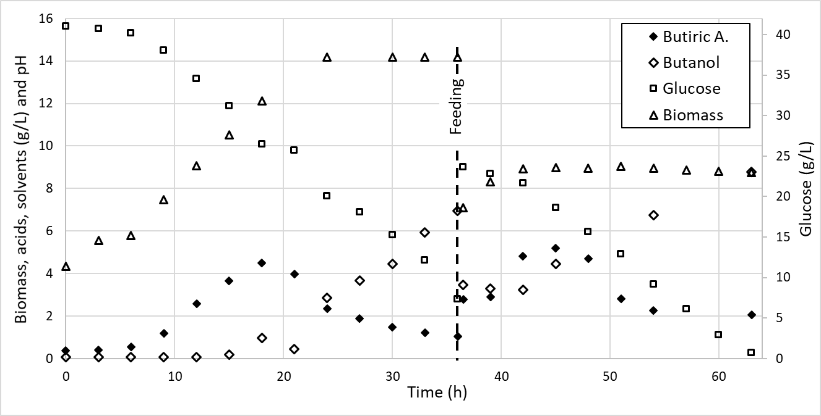

Figure 1. Concentration profiles for fed-batch fermentation.

* 1. Results and Analysis
     1. Fed-Batch Fermentation

Results from this fermentation suggest that it is very complex to maintain the fermentation in solventogenesis phase by cyclic feeding. That is supported by the evolution of the fermentation after the feeding: biomass grew again, acids were produced again, and solvent production stagnated, as observed in Figure 1; this suggests that feeding changed the metabolic state leading it to return to the acidogenesis phase.

* + 1. Vapor-Liquid Equilibrium

For the fermentation broth (butanol: 10 g/L and acetone: 26 g/L), VLE experiments did not show partial solubility (methodology presented in Chasoy et al., 2012), it agrees with the results from the simulations. On the other hand, mass fraction and recovery of butanol in distillate as functions of pressure and temperature (Figure 2), obtained from simulations, showed that 560 mmHg and 88 °C is a good set for the operation of the flash separation (dotted vertical line), at these conditions butanol mass titer in vapor is 8.35 % (an eight-fold increase compared to the fermentation broth) and the recovery is 47.8 %, which is a satisfactory separation. Another option for the flash condition is 560mmHg and 90 °C which generates vapor with 5.0 % butanol and recovery of 79.5 %. To rigorously define the flash operational conditions, an optimization analysis is suggested.

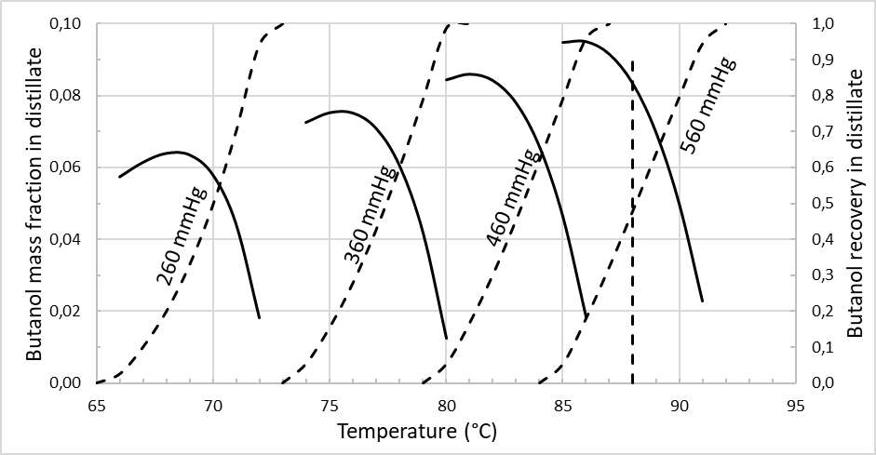

Figure 2. Mass fraction and recovery of butanol in flash distillation. Continuous lines are mass fraction, dotted lines are fractional recovery.

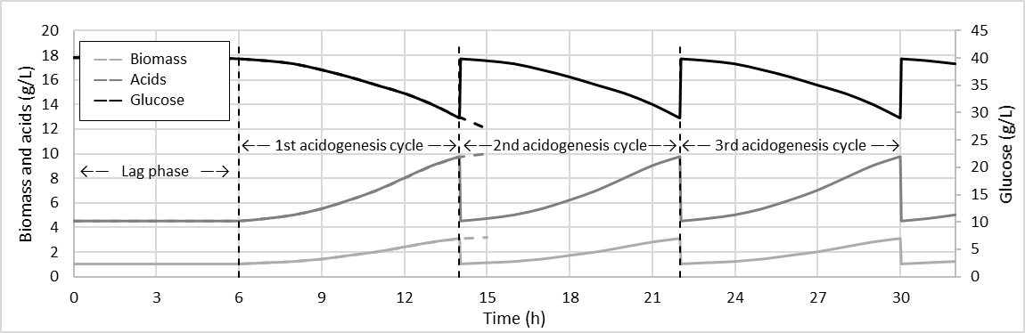

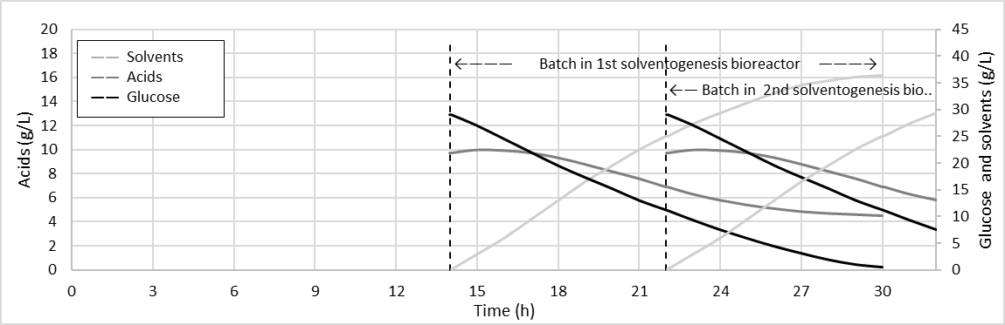

Figure 3. Profiles for the proposed two-stage (cyclic fed-batch + batch) fermentation. Top, acidogenesis cyclic reactor; down, solventogenesis batch reactors.

* + 1. Proposed Production System.

From the fermentation results, the proposed butanol + acetone production system considers a cyclic fed-batch bioreactor for acids production and two batch bioreactors for solvents production, estimated profiles for these reactors are presented in Figure 3.

Considering the time for each fermentation stage (9 and 15 h), the processing lasting in each bioreactor can be adjusted for highly efficient scheduling (8 and 16 h) with two solventogenesis bioreactors operating alternately: the first solventogenesis reactor receives the broth from the odd (first, third, etc.) cycles, while the second one receives from the even (second, fourth, etc.) cycles. The product from solventogenesis reactors takes turns to feed the separation system which begins with a flash distillation (Figure 4).

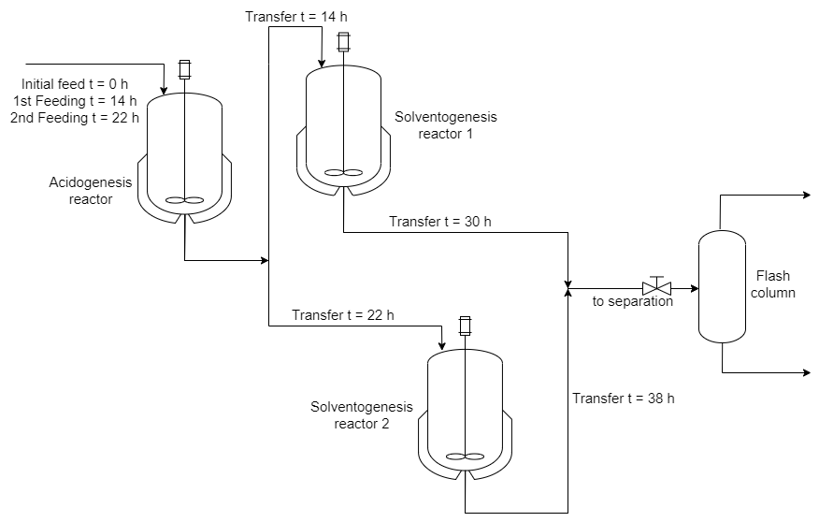

Figure 4. System configuration with cyclic fed-batch acidogenesis, batch solventogenesis and flash separation.

* 1. Conclusions

Due to the metabolic complexity of the ABE fermentation, a single-stage continuous or fed-batch fermentation is not viable. As an alternative, two-stage fermentation systems were evaluated. The best alternative includes a fed-batch cyclic bioreactor for acidogenesis and two batch bioreactors for solventogenesis, this configuration allows to eliminate idle time for all the bioreactors as well as the lag phase in the acidogenesis (lag phase reduces productivity in traditional batch operation).

The proposed configuration increases productivity from 1.21 g L-1 h-1 in batch operation to 1.40 g L-1 h-1 in the proposed system. Due to the solventogenesis phase being performed in batches, glucose is used until complete consumption, which allows to reach a high yield (0.91 g of solvents / g of glucose). Additionally, the cyclic operation in the first phase reduces the necessity of inoculum preparation, which is an advance for the development of a competitive process.

Analysis of flash distillation, as a first stage for the recovery of the products, shows that, due to the characteristics of the mixture obtained from the ABE fermentation, this operation allows to recover a high fraction of the solvents (between 48 and 80 %) with an important increase in concentration (from approximately 1 %, 10 g/L, to between 5 to 8 %).

References

C.S. Bîldea, I. Patraşcu, J.G. Segovia Hernandez, A.A. Kiss, 2016, Enhanced Down-Stream Processing of Biobutanol in the ABE Fermentation Process. Computer Aided Chemical Engineering, 38, 979-984. DOI: 10.1016/B978-0-444-63428-3.50168-5

W.A. Chasoy, 2012, Determinación experimental del equilibrio líquido-vapor del sistema etanol-agua-glicerina, M.Sc. Thesis, Universidad Nacional de Colombia, Colombia. https://repositorio.unal.edu.co/handle/unal/55058

D.D. Guo, X.J. Ji, L.J. Ren, F.W. Yin, X.M. Sun, H. Huang, G. Zhen, 2018, Development of a multi-stage continuous fermentation strategy for docosahexaenoic acid production by *Schizochytrium sp*. Bioresource Technology, 269, 32-39. DOI: 10.1016/j.biortech.2018.08.066

H.Y. Lee, T.S. You, C.L. Chen, 2021, Energy efficient design of bio-butanol purification process from acetone butanol etanol fermentation, J. Taiwan Institute of Chemical Engineers. DOI: 10.1016/j.jtice.2021.08.003

R. Morales-Rodriguez, D. Rodriguez-Gomez, M. Sales-Cruz, J.A. de los Reyes-Heredia, E.S. Pérez C., 2014, Model-Based Analysis for Acetone-Butanol-Ethanol Production Process through a Dynamic Simulation, Computer Aided Chemical Engineering, 33, 133-138. DOI: 10.1016/B978-0-444-63456-6.50023-5

P. Patakova, M. Linhova, M. Rychtera, L. Paulova, K. Melzoch, 2013, Novel and neglected issues of acetone–butanol–ethanol (ABE) fermentation by clostridia: *Clostridium* metabolic diversity, tools for process mapping and continuous fermentation systems, Biotechnology Advances, 31, 1, 58-67, DOI: 10.1016/j.biotechadv.2012.01.010.

N. Qureshi, H.P. Blaschek, 2000, Recent advances in ABE fermentation: hyper-butanol producing *Clostridium beijerinckii* BA101, Journal of Industrial Microbiology & Biotechnology, 27, 287-291.

P.A. Tapias, 2024, A Two Phases Model for ABE Fermentation with a Modified *Clostridium acetobutylicum* Strain, Computer Aided Chemical Engineering,

J. Sierra, R. Acosta, D. Montoya, G. Buitrago, E. Silva, Edelberto, 1996, Obtention of spontaneous mutant of *Clostridium acetobutylicum* of butanol resistant, Rev. Colomb. Ciencias Quim. Farm, 25, 26-35

A.M. Zetty Arenas, 2019, Towards enhanced second-generation n-butanol production from sugarcane, Ph.D. Thesis, TU Delft. DOI: 10.4233/uuid:7e5a2017-e3ef-4224-bdd2-e8a970c4fed9