Comparison of Domino Effect Analysis Tools using Graph Theory

Niki Moradmand-Niaa, Nelly Olivier-Mageta, Franck Pratsb

aLaboratoire de Génie Chimique INPT-ENSIACET, 4, allée Emile Monso - CS 44362, 31030 TOULOUSE Cedex 4, France

bINERIS; Parc Technologique Alata BP 2, 60550 Verneuil-en-Halatte

niki.moradmandnia@toulouse-inp.fr

Abstract

Domino effects refer to low-frequency accidents with critical consequences. During these accidents, one event triggers a more destructive event in a chain reaction. Modeling and assessing their safety are a considerable challenge due to their rarity, their complexity, and the limited data availability. This paper presents some graph-theory-based models used for domino effect assessment. The ultimate aim is to compare them, not in a mathematical way but from an industrial perspective. The framework of the comparison is defined: specifying the criteria of the analysis and the different case studies.

Instead of opposing the methods, it appears that a complementary use of the tools could be more beneficial.

**Keywords**: Domino effects, Risk analysis, Graph Theory, Bayesian Network, Petri Net.

* 1. Introduction

The definition of domino effects has evolved over the last decades, becoming increasingly precise over time. The current commonly accepted definition has the following key points: the propagation of a primary accident with an escalation or a worsening of the consequences (Alileche, 2015; Reniers and Cozzani, 2013). The escalation factor is what makes domino effects so devastating. The Feyzin disaster is a perfect illustration of a domino effect. On 4 January 1966, following an operating error, a propane leak generated a flammable cloud in an LPG storage area. The cloud is ignited on a nearby road, and quickly after, a torch fire is generated under one sphere. Emergency services tried to cool down the neighboring spheres for 1h30 and extinguish the giant flare, which expanded again after the safety valves at the top of the sphere opened. The sphere exploded (1st BLEVE) suddenly, killing 13 people. A neighboring propane sphere exploded 1 h later (2nd BLEVE) without causing any casualties. The human toll was high: 18 dead, including 11 firefighters, and 84 injured (BARPI, 2006).

Modeling the steps that make up domino effect accidents is therefore a challenge in order to avoid them or at least reduce their consequences. Dozens of methods have been developed to model domino effects with different approaches (Chen et al., 2020; Necci et al., 2015). Some of them aim to qualitatively find out the possible scenarios, others to precisely obtain the probability of a certain set of events occurring, and still others to help manage the accident during the crisis.

This diversity of methods is a proof of the interest into this topic and at the same time, the evidence that no consensus has yet emerged on how to correctly model domino effects (Alileche, 2015). Each method addresses a different aspect of the problem which makes their requirements and specificities unique: data input and output, precision, computation time. However, few, if any, articles test their method on identical case studies so comparing them is laborious.

Recently graph theory has been increasingly used as a way to represent domino effect. They are notably appealing as they are more visual and can include analytical or probabilistic aspects. Temporal aspect can also be included (Chen et al., 2020). This paper focuses on some of these methods, in particular, Bayesian network, Petri net and Markov chain. First, a brief description in the context of domino effect is given. Then the comparative study is detailed: the criteria of comparison and the case study used. In the last part, the first results are presented and improvement are suggested before concluding.

* 1. Graph Theory models

In graph theory applied to risk assessment, equipment or infrastructures are symbolized by nodes (or vertices). Nodes can be connected by links (or edges) if the equipment they represent can interact with each other.

* + 1. Bayesian Network

The Bayesian network (BN) is a probabilistic model that represents the dependency relationships between different random variables in a directed acyclic graph. Figure 1 (a) is a case of a really simple network. Each node can have several states that characterize plant *i*. It can, for example, be in a normal state Si1 or a damaged state Si2, and it is the states of the parent nodes that will determine the propagation probabilities. A conditional probability table is annexed to each node to compute the probabilities. One of the strengths of this tool, is that based on the observation of a situation (evidences), the probabilities can be updated. It allows for detecting the most likely causes and consequences (Weber et al., 2012).

Initially, BN aren’t able to deal with time-dependant probabilities, however, Dynamic Bayesian Networks are an improved version that can compute temporal escalation on top of spatial escalation (Khakzad, 2015).

* + 1. Petri Net

In Petri Nets (PN), transitions are a new type of element present on the graph. Pictured by a rectangle and placed between nodes, it embodies the conditions required for the evolution of the situation. Tokens, on a graph, dots in nodes, represent the state of the PN. In Figure 1 (b), the system is in state *p1* and would need to meet conditions defined by *t1* to get in state *p2*. Transition conditions can be probabilistic or deterministic. Also, for more realism, multiple conditions can be set and combined in a transition (Murata, 1989).

Stochastic PN are an extension of the traditional PN that incorporates randomness to represent uncertainty or variability in the modeling of systems.

For PN, estimation of scenarios and quantification of the most probable case is necessarily carried out with simulations, e.g. Monte-Carlo simulations (Weber et al., 2012).

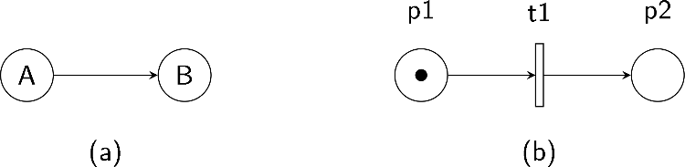

Figure 1 - (b) Basic Bayesian Network, (b) Basic Petri Net.

* + 1. Markov Chain

Markov Chains (MC) are Markov processes with discrete time or discrete state space. The essential property of those processes is that the probability of an event depends only on the state attained in the previous event (Cox, 2017). There is an independence between past and future states as future state are affected only by the present state.

Piecewise Deterministic Markov Processes (PDMPs) are a specific class of Markov processes that combine the deterministic and stochastic elements of the Markov model. These processes are characterized by the fact that they evolve deterministically for a certain period of time, after which they undergo a "jump" to a new state (Fearnhead et al., 2018). The deterministic part of the process can be used to model physical properties, while the stochastic part can be used to model uncertainties. This duality makes PDMPs suitable for risk assessment.

Stochastic finite state machines (SFSMs) represent another variant of Markov processes that has elements of both determinism and randomness. In SFSMs, the temporal transitions are probabilistic, not predetermined. Meaning that the future state cannot always be precisely predicted, adding a degree of uncertainty to the system.

* 1. Frame of comparison

Each method is compared on specific points using the same situation. From an initial situation, the aim is to obtain the sets of events produced by each method.

* + 1. Comparison criteria

To compare the methods, it is important to have reference points. These criteria can be divided into three big categories: those about the input data, those about the model itself and those about the output data.

The completeness and accuracy of the input data required to run the model may be limited. Depending on the actual situation modelled some information may be unknown. Some models expect all the data to run while others can handle this uncertainty factor.

The accessibility of the tool is another point to take into account. The time required for a new user to understand how the tool works is important for the spread of the model within companies. Even for an experienced user, a method that allows faster modelling is preferable. Other than the handiness for the user, the capacity for them to access the equations and to modify the method itself is to be studied, whether it is to update a step to make it more precise or to add new options.

A feature like sensitivity must be considered. This is the ability of the method to output least probable scenarios with high consequences. A model might find pointless to output some inconceivable sets of events. That would be a mistake as the essence of domino effect is to examine unlikely situations with terrible effects.

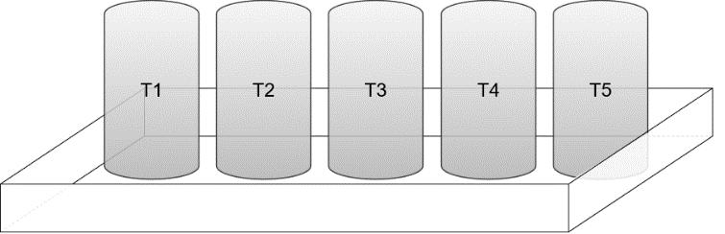

Figure 2 - Case study where five tanks are aligned and can interact with their closest neighbor.

Similarly, reachability analysis has to be performed. Particularly, state reachability which determine whether a particular state or set of states in a system can be reached from another state. It can be used to compare the consistency of simulations within a run and between methods.

Computation time is an obvious element to compare and is directly correlated to the power of calculation required to run the model. It is crucial for complex infrastructures but might not be relevant in the case studied as the situations considered are fairly simple and may sometimes be negligeable. Finally, the nature of the results, their precision and their accuracy have to be compared.

* + 1. Case study

The studied situation is the one depicted on Figure 2. Five identical tanks are aligned and equidistant from each other. They contain the same flammable compound. If one of them is on fire, the heat can ignite the adjacent tanks. Initially, each tank has only two states, either on fire or not. A schematic representation of the situation is shown on Figure 3. The situation is the one described by Khazad and Khan in chapter 3 of Cozzani and Reniers (2021)

The spread conditions are determined with a dose-response relationship. The probability of an escalation from tank *i* to tank *j* is given by equation (1).

|  |  |
| --- | --- |
|  | (1) |

With *QT* the heat radiation threshold of the tank *j* and *Qij* the intensity of heat radiation received by the tank *j* from tank *i*.

* 1. Results and discussion
     1. Results

The situation was modelled using BN on GeNIe 4.1 (BayesFusion, LLC, 2023). In order to get the most of the tool, the dynamic option was used instead of a classic BN that simulate the time step. Figure 4 is the dynamic BN created. Each link has a number representing the time order of the interaction.



Figure 3 – Network representation of the case study where five tanks are aligned and can interact with their closest neighbor.

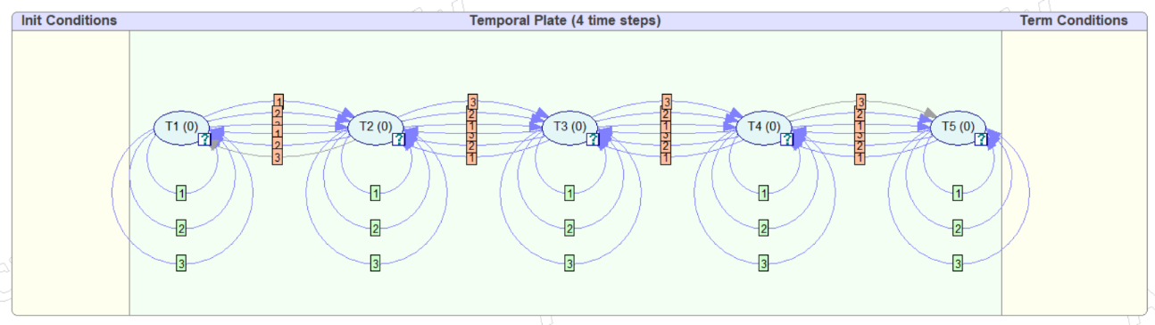

Figure 4 - Dynamic Bayesian Network of the first case study: five equidistant tanks which can spread fire to their closest neighbor.

The equivalence of the time step is not defined but is considered the order of magnitude of the minute. The initial conditions are an equal chance of spontaneous ignition for all tanks, set at 10 %; the spontaneous ignition is then zero for next time steps. This reflects the risk on long time span.

As the layout is symmetrical, the results are symmetrical too. Fire probabilities of an edge tank (T1 or T5) and the central tank (T3) are compared in Figure 5. As expected T3 is the most exposed tank and has a higher probability of catching fire. After 3 timesteps, the fire probability reaches 36 % for T3 versus 26 % for T1 or T5.

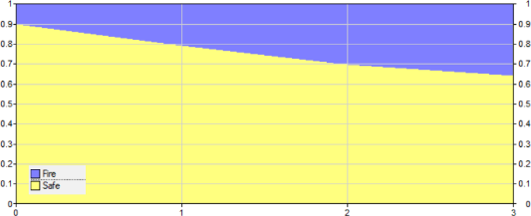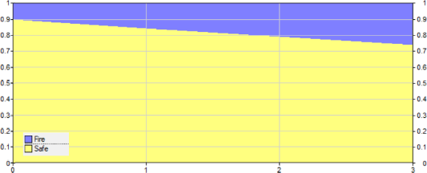

Figure 5 - Evolution of fire probabilities (dark gray) for the DBN for an edge tank (T1 or T5) on the left, and for the central tank (T3) on the right. Light gray represents the non-fire probability.

For PDMP, the same case was modelled using PyCATSHOO (Chraibi, 2018). The tool is less visual and produces raw data which is less appealing for the user.

* + 1. Discussion

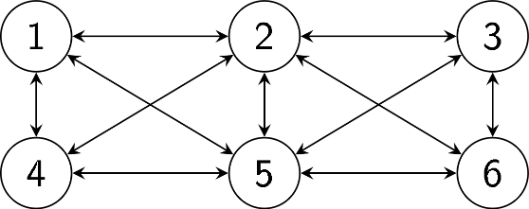

Figure 6 - Case study where six tanks are aligned and can interact with their closest neighbor.

The DBN fire probability of each tank matches the results previously obtained by Cozzani and Reniers (2021). However, the process for obtaining them was laborious as all previous states are treated for the calculation, unlike a Markovian process where just the last state impacts the probabilities of future states.

The case study can be gradually complexified to make it more realistic. First, mitigation measures can be added to the model. Mitigation measures are barriers that reduce the probability of escalation. The heat radiation received is decreased or the threshold is increased, causing an overall diminution of the probability. Also, the mitigation measures can delay the spread of the fire; completely protecting a tank for a certain amount of time. However, barriers can also be defective, and their success is subject to a certain probability.

The next step would be to change the layout of the tanks. Introducing distances between tanks in the equations allows for a more realistic model. It is no longer necessary for the tanks to be equidistant. More complex layouts can be studied. The layout shown in Figure 6 can, for example, be modelled with also more interactions between the tanks and possible cumulative effects.

In real chemical plants, tanks are placed inside spillage retention basins to limit the spillage if a leak occurs. An illustration of spillage retention is shown in Figure 2. However, in the case of a flammable liquid spill, a pool fire would affect not one but all the tanks. The propagation probabilities are updated accordingly. Another risk is that one of the tanks will explode due to the pressure increase caused by the heat.

Finally, equations can be updated again for greater realism, taking into consideration time aspects of a fire spread. Landucci et al. (2009) developed probit equations and determined their constant for various type of vessels. Their model includes the time for emergency response as a parameter that can influence escalation.

* 1. Conclusion and perspectives

Several tools using graph theory for risk analysis have been described. The aim of this study is to compare these different methods for domino effect assessment. The comparison is not made from a mathematical perspective but from an industrial one. The goal is to select the most suitable tool.

PDMPs provide a predictive aspect, whereas BN's main power resides in the update, thanks to evidence. Therefore, combining the tools might be the right decision to take advantage of their benefits. The assessment of scenarios being given by PDMP is then injected into BN. Thus, for domino effect management, from some observations, the most probable causes and consequences can be obtained. The Petri Net model still has to be created in order to complete the comparison. The discussed improvement to model more realistic case studies would upgrade the comparison.

References

N. Alileche, 2015. Étude des effets dominos sur une zone industrielle. INSA de Rouen, Rouen (France).

BARPI, 2006. BLEVE dans un dépôt de GPL en raffinerie, Le 4 janvier 1966 Feyzin (69) – France (No. 1), ARIA. Ministère chargé de l’environnement, France.

BayesFusion, LLC, 2023. GeNIe Modeler Programmer’s Manual (Software manual V4.1.R0).

C. Chen, G. Reniers and N. Khakzad, 2020. A thorough classification and discussion of approaches for modeling and managing domino effects in the process industries. Safety Science 125, 104618.

H. Chraibi, 2018. Getting started with PyCATSHOO V1.2.2.8 Document version V1. (Software manual No. V1.1). EDF R&D, Paris Saclay (France).

D. R. Cox, 2017. The Theory of Stochastic Processes, First edition. ed. CRC Press, Boca Raton, FL (United States of America).

V. Cozzani and G. L. L. Reniers (eds.), 2021. Dynamic risk assessment and management of domino effects and cascading events in the process industry. Elsevier, Amsterdam, Netherlands ; Cambridge, MA, USA.

P. Fearnhead, J. Bierkens, M. Pollock and G. O. Roberts, 2018. Piecewise Deterministic Markov Processes for Continuous-Time Monte Carlo. Statist. Sci. 33.

N. Khakzad, 2015. Application of dynamic Bayesian network to risk analysis of domino effects in chemical infrastructures. Reliability Engineering & System Safety 138, 263–272.

G. Landucci, G. Gubinelli, G. Antonioni and V. Cozzani, 2009. The assessment of the damage probability of storage tanks in domino events triggered by fire. Accident Analysis & Prevention 41, 1206–1215.

T. Murata, 1989. Petri Nets: Properties, Analysis and Applications. Proceedings of the IEEE 77.

A. Necci, V. Cozzani, G. Spadoni and F. Khan, 2015. Assessment of domino effect: State of the art and research Needs. Reliability Engineering & System Safety 143, 3–18.

G. Reniers and V. Cozzani (eds.), 2013. Domino effects in the process industries: Modeling, prevention and managing. Elsevier, Amsterdam; Boston (Mass.).

P. Weber, G. Medina-Oliva, C. Simon and B. Iung, 2012. Overview on Bayesian networks applications for dependability, risk analysis and maintenance areas. Engineering Applications of Artificial Intelligence 25, 671–682.