Monte Carlo-Free Radioactive Particle Tracking Technique
Ghazaleh Mirakhori,^{a,b} Jocelyn Doucet,^{c} Bruno Blais,ª Jamal Chaouki^{b*}
ªResearch Unit for Industrial Flows Processes (URPEI), Department of Chemical Engineering, Polytechnique Montreal, Stn Centre-Ville, Montreal, H3C 3A7, Canada
^{b}Process Engineering Advanced Research Lab (PEARL), Department of Chemical Engineering, Polytechique Montreal, Stn Centre-Ville, Montreal, H3C 3A7, Canada
^{c}Pyrowave Inc, Montreal, H2N 2B7, Canada
jamal.chaouki@polymtl.ca
Abstract
Radioactive particle tracking (RPT) is a non-intrusive method to measure the velocity profiles in single and multiphase systems. It tracks a radioactive particle by measuring the γ-rays it emits using NaI scintillation detectors positioned around the reactor (Alghamdi et al., 2022). Traditionally, this method relies on a mathematical model that incorporates Monte Carlo simulations to establish the relationship between radiation intensity and particle positions. The model requires three unknown inputs for every detector. These parameters are obtained through a calibration procedure which includes manually placing the particle at multiple known positions and solving an optimization problem to identify the model parameters (Zambonino and Santos, 2023). RPT has some limitations. It assumes a uniform attenuation coefficient for the system, which may not fully represent complex multiphase reactors. The model is also sensitive to detector and calibration point positioning, leading to a build-up of reconstruction error if these quantities are not known with great accuracy. In this work, we introduce a novel approach that bypasses the need for calibration prior to reconstructing the tracer particle’s position in RPT experiments. We implement a collaborative robot (cobot) to move the tracer particle inside the volume of interest, recording the exact position of the particle in time. The freedom to program a robotic arm enables strategic volume sampling, extensive data accumulation, and the creation of a dataset linking positions to detector counts. Instead of following the conventional calibration process to determine unknown parameters in the mathematical model, we utilize this dataset to train an Artificial Neural Network (ANN) model. The model predicts the particle position by analyzing the received photon counts from each detector surrounding it. Therefore, this ANN model can reconstruct the particle positions free from the limitations and artifacts typically associated with the mathematical model. Consequently, it yields lower prediction errors when compared to traditional methodologies. Due to these improvements, RPT will be able to accommodate larger-scales multiphase reactors, facilitating the design and scale up procedures.
Keywords: Radioactive Particle Tracking, Artificial Neural Networks, Robotics

  - Methodology
    - Database generation
We use a Doosan cobot (A0912) mounted on a fixed pedestal. The cobot carries a tracer particle attached to the tip of a metallic rod, held securely by a custom in-house-developed gripper. Its operation is managed through a controller, which itself is controlled by a computer executing a Python script.
We program the cobot in a way that moves the tracer within the specified volume, passing through hundreds of positions and mapping the entire volume. The cobot logs the position of the tracer along with the corresponding time throughout the entire experiment at determined time intervals. While the cobot is in movement and on an entirely distinct system, we capture the photon counts at each 10 ms interval using scintillation detectors strategically positioned around the volume.
The RPT hardware starts recording photon counts data slightly before the robot's movement. Both systems operate on different clocks and different temporal scales, necessitating an external synchronization. To effectively organize these positions and their associated photon counts into dataset for training the ANN model, a post-processing procedure is required.
    - Data post-processing for database generation
The post-processing of raw data comprises three steps:
- Time delay calculation: to find the time delay between the two systems, we establish a handshake protocol. We specify one detector to communicate with the cobot. The cobot places the particle in front of the detector at a distance of 20 cm. Subsequently, the cobot moves the particle toward the detector's face at a constant velocity. Following this approach, the cobot then returns the particle to its initial position. The reciprocating motion of the robot leads to the generation of two peaks in both the RPT signal and particle position. By aligning these two peaks, we can determine the lag between the two systems.
- Smooth out the noise: because of the quantized nature of γ-rays, the radiation emitted by the radioactive tracer particle exhibits continuous intensity fluctuations over time. We apply a 1st order Savitzky–Golay filter to smooth out the noise from the signal.
- Time step synchronization: the alignment of the position and photon counts datasets is essential due to their distinct time intervals. The goal is to calculate photon counts data at the instants which the cobot recorded the positions. To accomplish this, we utilize the time steps from the cobot dataset and employ a nearest interpolation technique to determine the photon counts at these specific time steps.
    - ANN for position reconstruction
ANN is comprised of interconnected neurons organized into layers: the input layer, hidden layers, and output layer. The input layer incorporates photon counts received by the array of detectors at each time step. The hidden layers consist of nodes designed to capture the non-linearity between the input and output (Bibeau et al., 2023) which is the spatial position of the tracer particle at each time step, including the coordinates x, y, and z. The details of the chosen architecture for the back calculation of the particle position from the photon counts data can be found in Table 1.
Table 1 Architecture summary of the ANN model
Parameter | Value
Number of hidden layers | 5
Number of neurons in each hidden layer | 256, 128, 64, 32, 16
Hidden layers activation function | tanh
Optimizer | Adam
Error function | MSE
Learning rate | 0.00001
Batch size | 50000
Number of epochs | 6000
  - Results and discussion
We sample a cube with dimensions measuring 6 × 6 × 6 cm, surrounded by a configuration of 8 detectors. In this experiment, we used a sealed Scandium source with an activity of 125 μCi. The cobot guides the particle through 300 sampling points within the cube. While transitioning from one point to another, we capture data on photon counts. Figure 1 shows the configuration of the cube in surrounded by scintillation detectors.
We evaluate the accuracy of the position reconstruction algorithm across various datasets using performance metrics, including Mean Absolute Error (MAE) and Standard Deviation (SD) for each directional component in the x, y, and z directions, as well as the Mean Euclidean Distance Error (MEDE). We train the ANN model with part of the experimental dataset (70%) and test it with the rest of the dataset (30%) until the point that it doesn't overfit the data.
Moreover, to demonstrate the model's performance, at the end of the sampling step, the robot moves the tracer particle in a spiral trajectory, and we subsequently reconstruct this path using the trained model. Table 2 shows the performance metrics corresponding to 8100 reconstructed positions inside a 3D spiral path within the sampled cube's volume. Figures 2 and 3 illustrate the spiral path from the actual movement of the robot alongside the reconstructed path via ANN implementation.

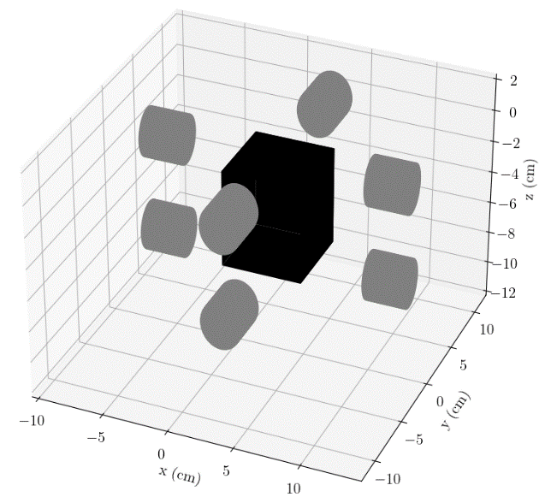
Figure 1 Detector configuration around the sampling volume
Table 2 Position reconstruction performance indices
 | MAE (mm) | SD (mm) | MEDE (mm)
x | 0.4 | 0.3 | 1.2
y | 0.4 | 0.3
z | 0.9 | 0.7

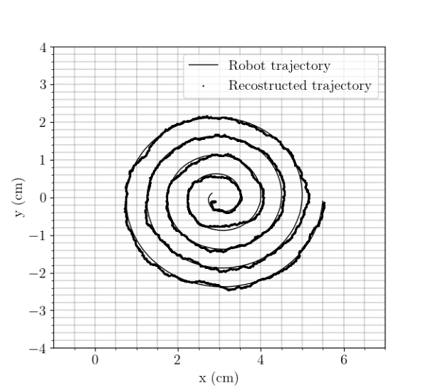  Figure 2 xy plane view of spiral reconstructed trajectory | 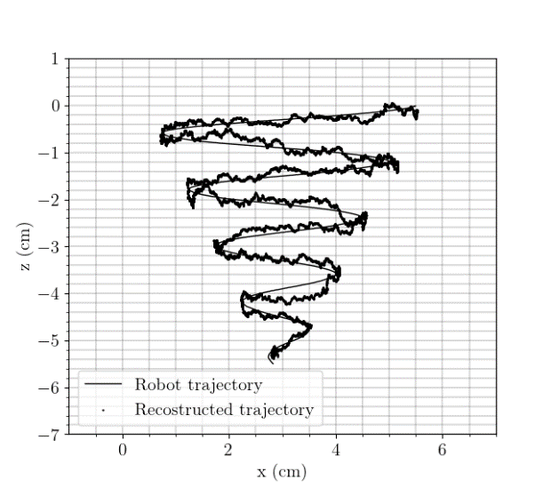  Figure 3 xz plane view of spiral reconstructed trajectory

  - Conclusion
This work introduces Monte Carlo-free RPT. We employ a cobot to establish a database, linking hundreds of thousands of positions within the volume of interest to the corresponding photon counts recorded by strategically positioned scintillation detectors surrounding the volume. Using this massive dataset, we train an ANN model to reconstruct the radioactive particle motion in an RPT experiment.
To validate this method, we reconstruct 8100 points along a 3D spiral. A thorough comparison with the actual cobot-recorded positions shows a significant improvement in reconstruction accuracy, MEDE of 1.2 mm, compared to recent experimental works in the literature, 3.84 mm, (Yadav et al., 2020).
Our dynamic data sampling, in contrast to static or time-averaged approaches, closely mimics real experimental conditions, contributing to a more realistic representation of photon count during the experiment. Furthermore, the validation procedure also uses the dynamically sampled data.
It's also worth mentioning that this innovative approach improves operator safety by eliminating the need for manual calibration and minimizing contact with radioactive particles.

References
A. A. Alghamdi, T. M. Aljuwaya, A. S. Alomari, M. H. Al-Dahhan, 2022, Geant4 simulation for radioactive particle tracking (rpt) technique, Sensors, 22, 1223.
S. S. Zambonino, R. Santos, 2023, Sas geant4 application and machine learning algorithms for radioactive particle tracking, Radiation Physics and Chemistry, 111056.
V. Bibeau, L. Barbeau, D. C. Boffito, B. Blais, 2023, Artificial neural network to predict the power number of agitated tanks fed by cfd simulations, The Canadian Journal of Chemical Engineering.
A.Yadav, T. K. Gaurav, H. J. Pant, S. Roy, 2020, Machine learning based position-rendering algorithms for radioactive particle tracking experimentation, AIChE Journal, 66, e16954

