**Decarbonization strategies by industrial ecology**

Marianne Boixa*, Henri de la Vaissière de Verduzana, Stéphane Négnya

aLaboratoire de Génie Chimique, UMR5503, Toulouse INP/CNRS/UPS, 4 Allée Emile Monso, 31432 TOULOUSE Cedex 4, FRANCE

marianne.boix@toulouse-inp.fr

Abstract

Eco-Industrial Parks (EIPs) are a way to enhance decarbonization of industrial activities by fostering collaboration among companies within an industrial park. Following this reorganization, a network can emerge in which companies exchange energy and raw materials. This work deals with the hypothetical implementation of a steam network among companies in an existing EIP. The objective is to demonstrate the benefits of multi-objective optimization in defining the most suitable network using a mixed-integer linear programming approach. Two criteria are considered to determine the optimal organization: cost and greenhouse gas emissions (GHG). This approach is implemented through a mathematical model that considers various utilities, production capacities, and industry demands seasonally. Subsequently, an epsilon constraint strategy is employed to select the best solution. The addition of a hybrid energy system and a CO2 capture unit to the model allows for assessing potential benefits. The result of this work shows a waste-free organization and reduced GHG emissions by approximately 2000 metric tons of carbon dioxide equivalents per year. The addition of a hybrid energy system and CO2 capture unit enables an additional reduction of 7000 tons of GHG emissions with a relatively modest increase in cost. This work could potentially be applied to another industrial park scenario in the future.

**Keywords**: Eco-Industrial Park, Multi-Objective Optimization, CO2 capture unit, decarbonization.

* 1. Introduction

For several years, the impact of human activities on the planet has been observed and acknowledged, leading to the emergence of various concepts. The term "Anthropocene" first appeared in 1990, initially referring to an era from which the geological impact of these activities significantly influences the planetary system (IPCC Report, 2021). This concept later expanded to encompass all global environmental changes caused by humans. In 2009, nine planetary boundaries were identified (Rockström et al., 2009). Each of them corresponds to a process in the Earth's system that is essential for the stability of living conditions and is impacted by human activities. This will significantly alter living conditions on Earth. The awareness of the importance of acting by certain states can, however, be perceived. Commitments are made, and investment plans are created to fulfill them. This is notably the case with the France Relance 2030 plan, which aims to finance major technical projects and, among other goals, reduce the impact of industry. Industrial ecology is one of the practices that can be relied upon to achieve this objective.

One of the most common strategies in industrial ecology is the establishment of eco-industrial parks (EIP). By definition, an EIP is an industrial park where stakeholders share infrastructure, services, and implement common development strategies to apply the principles of industrial ecology. The term was first referenced in 1992 during the United Nations Conference on Environment and Development, and since then, numerous projects have been launched. Most of industrial symbioses have originated from commercial agreements between industries and have evolved over time. Therefore, this approach does not guarantee optimal functioning of the industrial park (Boix et al., 2015). An optimization process will enable the creation of an EIP with most positive environmental, economic, and social impacts according to specific objectives. This approach can be applied to various cases such as spatial arrangement and design, energy efficiency, resource efficiency, waste management, mobility, or collaboration and knowledge sharing. One key aspect of establishing EIP is the presence of an exchange network among the constituent industries. This exchange network can take various forms and, for example, be utilized to optimize the use of raw materials and energy or to valorize waste.

In the current study, the focus is on determining an optimal steam exchange network to meet the needs of each participant. The aim of this paper is to propose an optimization-based approach to design an industrial symbiosis by integrating into the superstructure numerous ways of producing electricity as well as new carbon capture facilities. The objective is also to develop a generic superstructure as complete as possible, integrating several technology bricks with different degrees of maturity.

* 1. Superstructure improvement

The superstructure includes the detailed description of the different companies involved in the industrial park; a hybrid renewable energy sources (HRES) and several equipment: turbines, boilers, CO2 capture units. An illustration of the superstructure is represented in figure 1.

HRES

Industrial symbiosis

CO2 capture unit

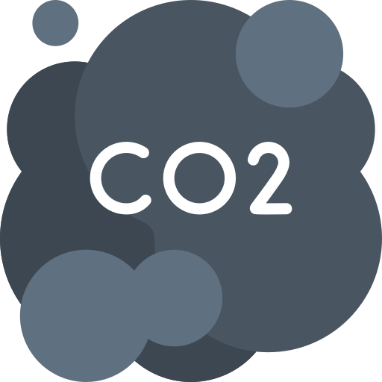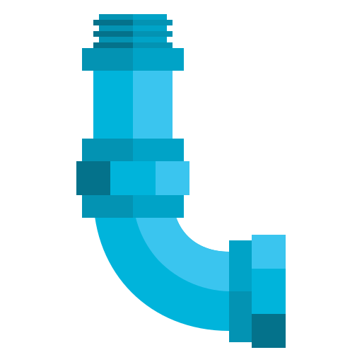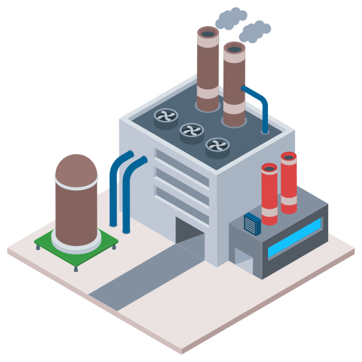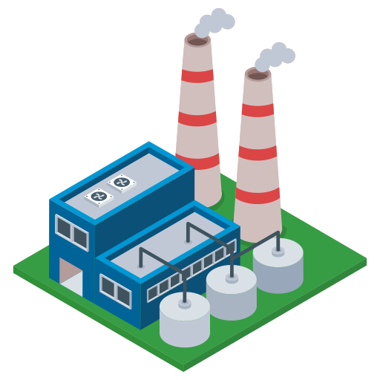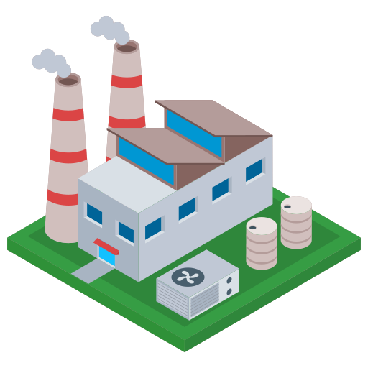

**Figure 1.** Schematic representation of superstructure

Three different cases of CO2 capture are distinguished: oxy-combustion capture, pre-combustion capture, and post-combustion capture (Akeeb et al. 2022). The focus is done in this paper on the latter case that allows the capture of CO2 emitted after combustion. Several technologies, more or less mature and suitable for industry, can be identified. For example, there is capture by cryogenic condensation, which is too energy-intensive, or capture by microalgae, which is too complex to implement. The three technologies mainly used in the industry are membranes, adsorption, and absorption. CO2 capture through membrane filtration is based on the use of a semi-permeable barrier to filter the flue gas stream. This technology has several advantages, such as its low cost (operational and investment), simplicity, reliability with good adaptation to production, and a low maintenance frequency. It is also very compact, and up to 88% of CO2 can be captured, but its performance is affected by the decrease in concentration. However, this technology is the least mature of the three and is the subject of numerous studies (Wu et al., 2023; Janakiram et al., 2023; Li et al., 2023).

Absorption involves bringing the gases to be treated into contact with a liquid solvent. The CO2 is then absorbed by this liquid, which can be recycled for further use. This process is generally implemented in absorption columns that can reach several tens of meters in height. This technology is very effective for CO2 capture. The solvents used are inexpensive while exhibiting high absorption capacities. However, most of them degrade over time and with temperature. In addition, these compounds generally have a high environmental impact. Nevertheless, this technology remains the most advanced.

Adsorption allows for CO2 capture by circulating the flue gas through porous materials. The CO2 is then physically or chemically fixed to these materials, which can be recycled afterward. Among the adsorbents used are activated carbon, zeolite, and polymers. In addition to its efficiency, this technology has a lower environmental impact and cost compared to absorption (Li et al., 2023). This process is thus the most promising for CO2 capture.

* 1. Problem statement

Given is a set of companies composed of processes involving vapour, electricity and water demands. The goal is to find the optimal configuration (exchanges between companies) that leads to the minimum of the cost and the minimum of carbon release in the atmosphere. The decision variables of the mathematical model are all the flows exchanged between companies (their existence and their physical characteristics) as well as the sizing of equipment. A multi-objective optimization approach is carried out on an EIP with new add-on facilities to show impact on its GHG emissions (Figure 2):

* Optimal steam network
* Hybrid Power System (HPS)
* CO2 capture unit

These facilities are integrated in the optimization model. The model is formulated as a multiperiod Mixed Integer Linear Programming (MILP) based on Mousqué et al. (2023) and solved using an epsilon-constraint approach to deal with two objective functions: minimum of total cost (investment, operational and raw materials cost) and minimum of Green House Gases (GHG) emissions. The constraints of the model consist in all the mass and energy balances and thermodynamic considerations. The presented results are issued by making a TOPSIS analysis among solutions on the Pareto fronts and a weight of 0.7 has been attributed to GHG emissions whereas 0.3 is affected to the total cost.

The model is formulated as an MILP (Mixed Integer Linear Programming) dealing with several thousands of variables (between 10234 and 12584 depending on the scenarios).

* 1. Case study

The work of Kim et al. (2010) on the Yeosu Industrial Park served as a case study. The aim of this work is also to demonstrate the applicability of an optimization approach for a steam exchange network within a real industrial complex. In this study, 15 industries were identified and classified into two types: producing and consuming companies. Their spatial distribution can be observed in the Figure 2.



Consuming companies:

Producing companies:

**Figure 2**. Map of industrial symbiosis of Yeosu

Producing industries have the ability to generate steam, unlike consuming industries, which are unable to produce it. Each of them has a different need, whether it be for the type or quantity of steam. Therefore, there is very high-pressure steam (THP), high-pressure steam (HP), medium-pressure steam (MP), and low-pressure steam (BP). As demand varies throughout the year, it has been divided into 4 periods based on seasons: t1 - Spring (April to June), t2 - Summer (July to September), t3 - Autumn (October to December), t4 - Winter (January to March).

In the first step, the flue gas to be treated must be defined. Assumptions will be made to simplify the system. Firstly, the flue gas stream to be treated will be assumed to be a binary mixture composed of 14% CO2 and 86% N2. In this case, the greenhouse gas (GHG) emissions from the boilers consist only of CO2. The reduction of its temperature to 25°C has also been assumed. We can then calculate the flue gas flow to be treated based on the GHG emissions from the boilers.

* 1. Results and discussion

This study was carried out considering climate and energy mix in South Korea and with weighting of criteria. A weight of 0.7 has been attributed to GHG emissions and 0.3 to the total cost for the multicriteria analysis. The choice of the energy source has a significant impact on GHG emissions. After optimizing this network, it can be discerned that the adsorption unit is much more environmentally advantageous than the membrane filtration unit. Additionally, the electricity demand of these CO2 capture units can be quite significant. The hybrid energy production system found after the previous optimization is therefore not suitable. The optimal solution to this problem involves using an adsorption unit. A new energy supply system has also been defined with a production capacity of 1140 kW and 6850 kW for solar and wind, respectively. The exchange network, on the other hand, has not changed. The optimal solution has also been determined in the case of CO2 capture through membrane filtration (Table 1).

|  |  |  |
| --- | --- | --- |
| Scenario explored | GHG emissions  (tons CO2eq / year) | Total cost  (106 USD) |
| EIP with steam network | **10 416** | **1.898** |
| add of **HPS** | **7 131** | **1.909** |
| add of **HPS** and **adsorption** unit | **3 304** | **1.906** |
| add of **HPS** and **membrane** unit | **5 142** | **1.964** |

Table 1. Comparison of results obtained

From table 2, it can be seen that this EIP organization emits approximately 2000 t eqCO2 more with additional expenses of about $60 million, despite a lower investment cost for the membranes. Compared to the base case, with a little increase of the total cost (0.4%), the total GHG emissions can be decreased of more than 65% by using absoption for CO2 capture. This is due to the fact that this technology is much more energy-intensive than adsorption. The hybrid power system must be more substantial than that needed for the other technology, increasing the total cost. However, emissions from electricity consumption still remain higher by a few hundred-ton eq. CO2.

|  |  |  |  |
| --- | --- | --- | --- |
|  | Base case (w/o CO2 capture) | CO2 capture by absorption | CO2 capture by membrane filtration |
| Total cost | 1.899x109 $/year | 1.906x109 $/year | 1.964x109 $/year |
| Investment cost for capture unit | - | 1.35x106 $/year | 2.6x105 $/year |
| Operating cost for capture unit | - | 154530 $/year | unknown |
| GHG total emissions | 10416 T eq. CO2/year | 3304 T eq. CO2/year | 5142 T eq. CO2/year |
| Amount of captured CO2 | - | 5735 T CO2/year | 4205 T CO2/year |
| GHG linked to electricity consumption | 3947 T eq. CO2/year | 2667 T eq. CO2/year | 3012 T eq. CO2/year |

Table 2. Comparison of scenarios: base case compared to two different CO2 capture technologies

Therefore, it can be seen that, despite a significantly higher investment cost, the implementation of an adsorption unit is markedly more advantageous than that of a membrane filtration unit, notably due to its capture capacity and lower energy demand. It is also worth noting that the capture of CO2 entails a substantial energy demand. The use of carbon-neutral electricity thus serves to minimize the impact of this high consumption. However, in the absence of clean energy, one might question the relevance of establishing a CO2 capture unit.

* 1. Conclusions and perspectives

Using the mathematical model and a multi-criteria optimization strategy, an optimal solution for a steam exchange network was determined. This led to a reduction in greenhouse gas emissions. Elements were then added to the model to assess their impact on the industrial eco-park. Initially, a hybrid electricity generation system and a post-combustion CO2 capture unit were tested. The use of a hybrid power system composed of carbon-neutral energy sources demonstrated a significant decrease in greenhouse gas emissions, approximately 30%. The additional integration of a CO2 capture unit resulted in a total reduction of 70% compared to the initial solution. The cost, on the other hand, was not greatly impacted by these additions. The result of this work shows an organization with zero waste and greenhouse gases emission reduced by around 2000 tons of carbon dioxide equivalent per year.

The main contribution of this work is the modelling and the implementation in the optimization model of several technologies including: the steam network (several level of pressure), the hybrid power system and a CO2 capture unit Two capture unit technologies are tested and adsorption unit is revealed to be more efficient in both CO2 capture and energy consumption. The implementation of both hybrid power system and CO2 capture unit leads to an additional decrease of 7000 tons CO2 eq. with a relatively modest increase in cost.

The perspective of the work is to extend the superstructure and the generic model to other kind of participants such as municipalities, neighbourhood and other kinds of material exchanges.

**Acknowledgements**

This work was supported by a government grant managed by the Agence Nationale de la Recherche under the France 2030 program, under the reference ANR-22-PESP-0004.

References

O., Akeeb, 2022, Post-combustion CO2 capture via a variety of temperature ranges and material adsorption process: A review. J. Environ. Manag. 313, 115026.

M. Boix, Montastruc, L., Azzaro-Pantel, C. & Domenech, S., 2015, Optimization methods applied to the design of eco-industrial parks: a literature review. J. Clean. Prod. 87, 303–317.

M. Boix, Négny, S., Montastruc, L., Mousqué, F., 2023, Flexible networks to promote the development of industrial symbioses: A new optimization procedure, Comp. Chem. Eng., 169, 108082.

IPCC report, 2021, Intergovernmental Panel on Climate Change. <https://www.ipcc.ch/>.

S. Janakiram, Lindbråthen, A., Ansaloni, L., Peters, T. & Deng, L., 2022, Two-stage membrane cascades for post-combustion CO2 capture using facilitated transport membranes: Importance on sequence of membrane types. Int. J. Greenhouse Gas Control 119, 103698.

S., Kim, Yoon, S.-G., Chae, S. H. & Park, S., 2010, Economic and environmental optimization of a multi-site utility network for an industrial complex. J. Env. Manag. 91, 690–705.

R. Li, Lian, S., Zhang, Z. & Song, C., 2023, Modeling of hollow fiber facilitated transport membrane modules for post combustion carbon capture process: Evaluation of non-ideal effect and module characteristic. Chem. Eng. Sc. 276, 11879.

J., Rockström et al. 2009, Planetary Boundaries: Exploring the Safe Operating Space for Humanity. Ecol. Societ.14.

H., Wu et al., 2023, Industrial-scale spiral-wound facilitated transport membrane modules for post-combustion CO2 capture: Development, investigation and optimization. J. Membr. Sc. 670, 121368.