Transfer Learning across Equipment Scales Can Accelerate Pharmaceutical Tablet Development
Luca Beccaro, ª Pierantonio Facco, ª Ranjitkumar M. Dhenge,^{b} Marv J. Khala, ^{b} Fabrizio Bezzo, ª Massimiliano Barolo ^{a,}*
ª CAPE-Lab – Computer-Aided Process Laboratory, Department of Industrial Engineering, University of Padova, Via Marzolo 9, 35131 Padova PD, Italy
^{b} GSK, Ware, SG12 0DP, United Kingdom
max.barolo@unipd.it
Abstract
Roll compaction is pivotal in pharmaceutical tablet manufacturing, but finding the best settings for the operation of a full-scale roller compactor (RC) involves resource-intensive experiments. This is especially challenging during product development, due to limited availability of active pharmaceutical ingredients. To address this issue, a small-scale compactor simulator (CS) is commonly used to save on materials and time. However, the operating conditions that allow one to manufacture a product with assigned specifications in a CS are different from those required to manufacture the same product in a full-scale RC. This study proposes a transfer learning approach enabling one to derive optimal RC settings from experiments carried out on a CS. The proposed methodology effectively captures equipment-scale differences and offers a reliable way to predict RC machine settings, thus allowing for significant time and resource savings.
Keywords: roller compaction, dry granulation, compactor simulator, pharmaceutical tablets
  - Materials, Methods, and Results
Roller compaction is a key unit operation in a dry granulation line, where pharmaceutical powder blends are densified producing a ribbon, by means of the pressure exerted by two counter rotating rolls. Johanson (1965) developed a powder mechanics model describing the compaction process phenomena. The model predicts roll pressure and ribbon solid fraction (SF) from powder physical properties, operating conditions, and roller compactor (RC) geometry. Calibration of the model requires parameter estimation from experimental results. Experimental campaigns on a full-scale RC are lengthy and expensive, also because the required materials may include active pharmaceutical ingredients (APIs), which may not be available in large amounts during product development. To save on time and materials, small-scale compactor simulators (CSs) are used that mimic the roll compaction process through uniaxial compaction using two counter-moving punches (Zinchuk et al., 2004). However, the Johanson model parameters derived from CS experiments are not suitable for modelling an RC, due to pressure differences at equivalent SF values (Reynolds et al., 2010). For this reason, a mass correction factor $f_{0}$ has been proposed as a correction to the Johanson model to account for the differences between the two pieces of equipment (Bi et al., 2014).
To understand the differences between the responses of a CS and an RC, and to achieve transfer learning between them, we prepared six formulations including both placebos and APIs. Experiments carried out on all formulations in both pieces of equipment allowed us to estimate the Johanson model parameters for each equipment on each formulation, which in turn allowed us to identify the relevant compression profiles. Figure 1 shows the experimental data obtained for one of the formulations in the CS (triangles) and RC (squares), and the relevant compression profiles fitted by means of the Johanson model (dashed line and dotted line, respectively).
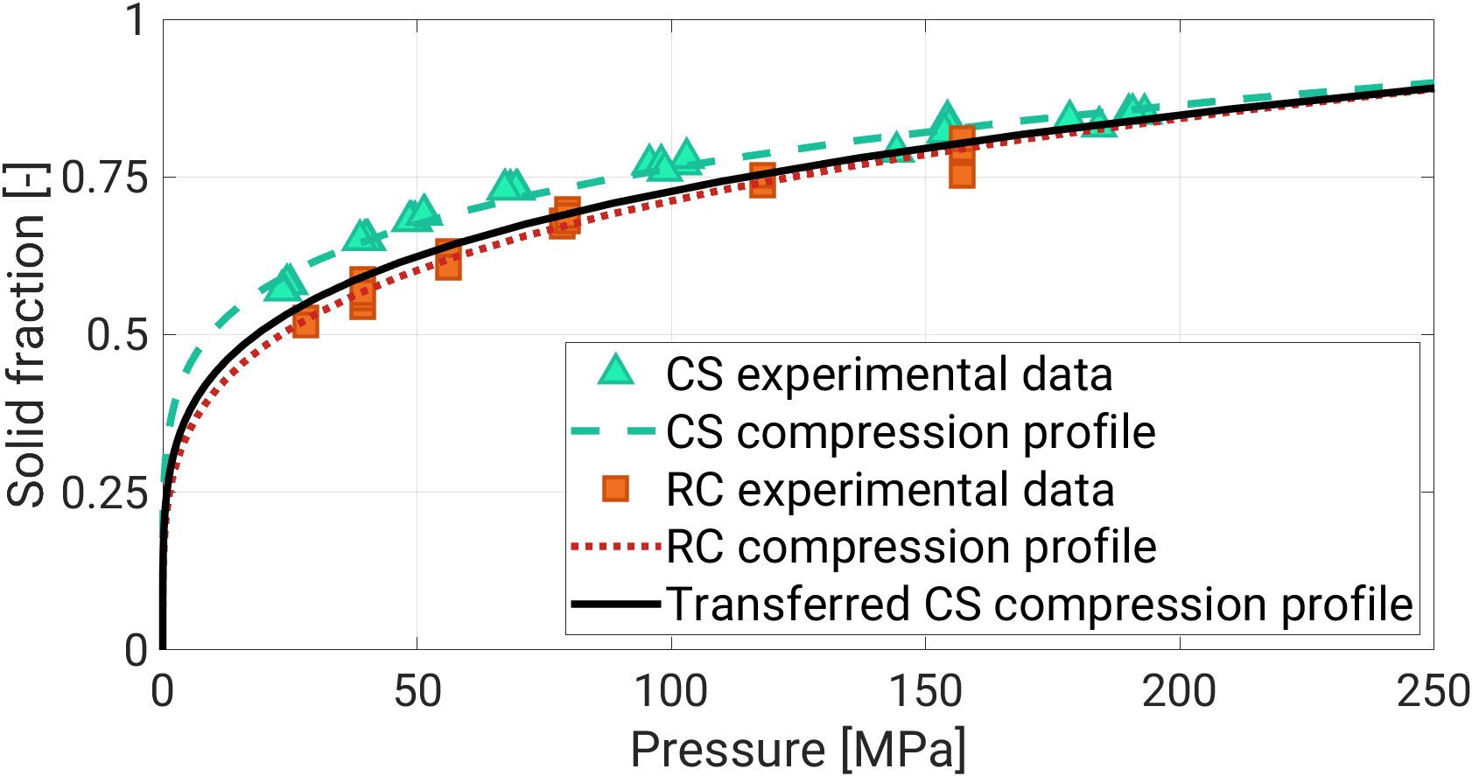
Figure 1. RC and CS compression profiles for one of the formulations investigated.
Clearly, the CS compression profile underestimates the pressure required to achieve the same SF using an RC. This finding holds true for all the formulations investigated. The $f_{0}$ parameter represents the link between the compression profiles obtained in different pieces of equipment, and can be used to transfer the operation from one equipment to the other. Whereas $f_{0}$ is typically assumed constant in the literature, we found that $f_{0}$ can be actually expressed as a generalized nonlinear function $F$ of the roller compaction pressure $P_{RC}$, namely $f_{0}=F(P_{RC})$. Four formulations were used to calibrate the parameters involved in $F$, and the remaining two formulations were used as validation datasets. Excellent transfer results were obtained in all cases. As an example, Figure 1 shows that the “virtual” RC compression profile (solid curve) obtained by transferring the CS experimental data (triangles) almost perfectly overlaps the compression profile that would be obtained by carrying out the experiments onto the RC directly (dotted line).
  - Conclusions
We presented a transfer methodology to relate the experimental results obtained from two compaction pieces of equipment at different scales and types. Results on six formulations demonstrated the effectiveness of the transfer methodology. The proposed approach enabling significant materials and time savings in pharmaceutical product development, requiring material in order of grams rather than kilograms for the experimental campaign.
References
Johanson, J.R. 1965. A Rolling Theory for Granular Solids. J. Appl. Mech. 32(4), pp.842–848.
Reynolds, G., Ingale, R., Roberts, R., Kothari, S. and Gururajan, B. 2010. Practical application of roller compaction process modeling. Comput. Chem. Eng. 34(7), pp.1049–1057.
Bi, M., Alvarez-Nunez, F. and Alvarez, F. 2014. Evaluating and modifying Johanson’s rolling
model to improve its predictability. J. Pharm. Sci. 103(7), pp.2062–2071.
Zinchuk, A. V, Mullarney, M.P. and Hancock, B.C. 2004. Simulation of roller compaction using a laboratory scale compaction simulator. Int. J. Pharm. 269(2), pp.403–415.

