Feasibility Analysis of Dimethyl Ether-based International Renewable Energy Supply Chain

Chong Wei Ong,a Sheng-Chi Lien,a Tsai-Wei Wu,b Cheng-Liang Chena*

aDepartment of Chemical Engineering, National Taiwan University, No. 1, Sec. 4, Roosevelt Rd., Taipei 106319, Taiwan (R.O.C.)

bDepartment of Frontier Science for Advanced Environment, Graduate School of Environmental Studies, Tohoku University, 468-1 Aramaki Aza Aoba, Aoba-ku Sendai, Miyagi, Japan, 980-8572

*CCL@ntu.edu.tw

Abstract

To tackle the urgent global challenge of climate change and the unequal distribution of renewable resources, a transition plan toward sustainable, low-carbon energy systems is imperative. This study introduces an international renewable energy supply chain leveraging dimethyl ether (DME) as an energy carrier. In pursuit of the 2050 net-zero carbon emissions target, this supply chain establishes a connection between two nations: one abundant in renewable energy resources as an energy-exporting country and the other lacking such resources as an energy-importing country. In the exporting country, renewable energy is harnessed for electrolysis to produce hydrogen (H2). Due to the high costs associated with H2 in terms of transportation and storage, using DME as an energy carrier for H2 enhance the feasibility of implementing this supply chain. Consequently, DME is synthesized from H2 and captured CO2 and transported to the importing country via shipping. Upon reaching the importing country, two viable methods for DME utilization emerge. The first option involves converting DME back into H2 via steam reforming process, which can then be employed in fuel cells for electricity generation. The second option entails introducing DME as fuel into oxy-combustion CO2 power plants, generating electricity. Simultaneously, the resultant CO2 is captured and transported to the exporting country for DME synthesis. This research assesses the feasibility of both application approaches, considering engineering, economic and environmental aspects. Furthermore, simulations and analyses of the chemical processes are carried out, along with the economic evaluations of these processes, electrolysis, fuel cells and transportation. Lastly, the costs of DME, H2 and green electricity in the importing country are evaluated to analyse the feasibility of this supply chain. The current result show that the cost of imported electricity is USD 135.42/MWhe with an electricity conversion rate between both regions is 30.8% (=4.358/14.145), and the carbon emission of this supply chain using solar and wind power are 0.190 and 0.069 t/MWhe respectively.

**Keywords**: Dimethyl ether, Energy carrier, Hydrogen fuel cells, Oxy-combustion, International renewable energy supply chain

* 1. Introduction

To address the urgent global challenge posed by climate change and the uneven distribution of renewable resources, it is crucial to implement a transition plan towards sustainable, low-carbon energy systems. Countries such as Australia and Saudi Arabia (Wang et al., 2023), which possess abundant natural resources, have the capacity to generate significant amounts of renewable energy. This surplus energy can be efficiently transformed into green hydrogen (H2) through electrolysis and stored for future use. However, the transportation of H2 is costly (Brändle et al., 2021). Therefore, to provide a cost-effective alternative, the international renewable energy supply chain relies on chemical energy carriers, which include H2, methanol (MeOH) (Dalena et al., 2018), ammonia (NH3) (Hasan et al., 2021), dimethyl ether (DME) (Catizzone et al., 2021) and methylcyclohexane (MCH) (Matsuoka et al., 2017). These carriers can be transported to energy-importing nations like Japan and Germany (Wijayanta et al., 2019), as depicted in Figure 1. Subsequently, these carriers can be used directly or converted into H2, facilitating the transfer of renewable energy between countries.

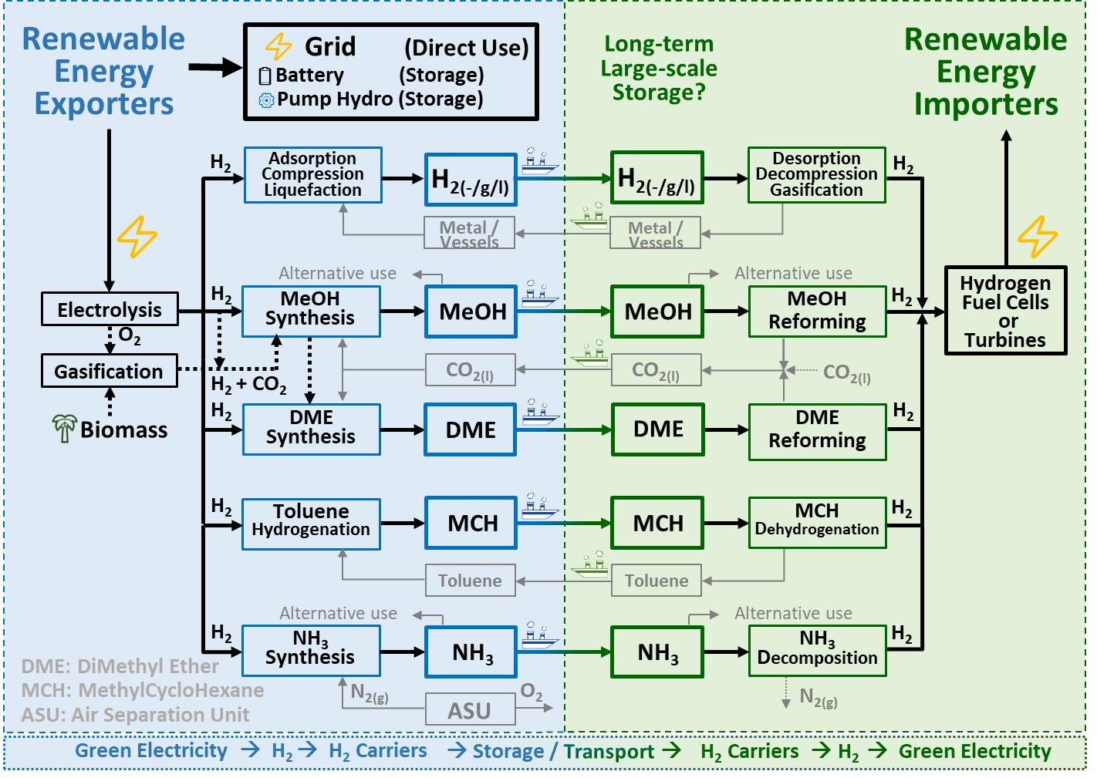

Figure 1 International renewable energy supply chains.

When considering MeOH, DME and MCH as energy carriers, it's crucial to address the by-products of MeOH or DME reforming (CO2) and MCH dehydrogenation (toluene). These by-products should be efficiently transported back to the exporting country for MeOH or DME synthesis or toluene hydrogenation, creating a closed-loop circulation system that minimizes waste. On the other hand, transporting the by-product of NH3 decomposition, nitrogen, is not cost-effective. Instead, utilizing an air separation unit (ASU) to produce nitrogen proves to be a more economically viable solution, eliminating the need for nitrogen transportation.

In comparison to gas-phase H2 (Moradi and Groth, 2019) and NH3 (Klerke et al., 2008), MeOH stands out due to its ability to be stored in a liquid state at room temperature and atmospheric pressure. This characteristic results in lower storage costs and improved safety. While DME requires liquefaction at -33oC for transportation, it boasts a significantly higher gravimetric and volumetric energy density when compared to MeOH, MCH, and NH3 (Table 1). Despite the need for careful handling due to its narrow explosive limit in air, the safety perspective suggests that DME is a suitable candidate as an energy carrier. While extensive research focuses on MeOH, MCH, and NH3 as energy carriers, there is a noticeable scarcity of comprehensive analyses on DME, particularly in the context of an international renewable energy supply chain. Therefore, an in-depth exploration of the DME-based international renewable energy supply chain is a worthwhile avenue for further study.

Table 1. Properties of chemical energy carriers.

|  |  |  |  |  |  |
| --- | --- | --- | --- | --- | --- |
| Properties | H2 | MeOH | DME | MCH | NH3 |
| Boiling point (oC) | -253 | 64.7 | -25 | 101 | -33 |
| Gravimetric energy density  (MJ/kg) | 120 | 15 | 28 | 7.4 | 21.2 |
| Volumetric energy density  (MJ/L) | 8.5 | 11.9 | 19 | 5.7 | 14.4 |
| Explosive limit in air (vol%) | 4-75 | 6.7-36 | 3.2-18.6 | 1.2-6.7 | 15-28 |

To aligns with the ambitious 2050 net-zero carbon emissions goal, this study presents a feasibility analysis of the international renewable electricity supply chain that utilizes DME as energy carrier which fosters a vital connection between two countries. One rich in renewable energy resources, serving as an energy-exporting country, and the other deficient in these resources, acting as an energy-importing country. In the exporting country, renewable energy is employed for electrolysis, generating H2 and DME is produced through the synthesis process of H2 and captured carbon dioxide (CO2) (Wu and Chien, 2022), then transported to the importing country via shipping.

Upon arrival in the importing country, two practical methods for utilizing DME come to the forefront. As illustrated in Figure 2(a), the first approach involves the conversion of DME back into H2 through a steam reforming process. This H2 can then be utilized in fuel cells to generate electricity. The second option, depicted in Figure 2(b), involves using DME as a fuel source in oxy-combustion CO2 power plants, known as the Allam cycle, for electricity generation. Simultaneously, the resulting CO2 is captured and transported back to the exporting country for DME synthesis. This research is therefore comparing the feasibility of the supply chain using both power generation approaches, considering engineering, economic and environmental aspects. Furthermore, simulations and analyses of the chemical processes are carried out, along with the economic evaluations of these processes, electrolysis, fuel cells and transportation. Lastly, the costs of DME, H2 and green electricity in the importing country are evaluated to analyze the feasibility of this supply chain.

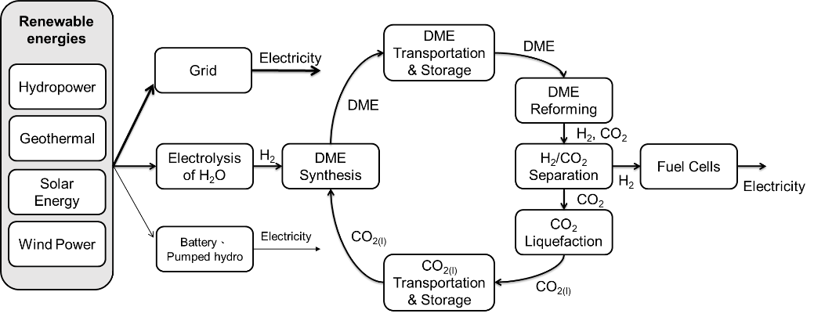

(a)

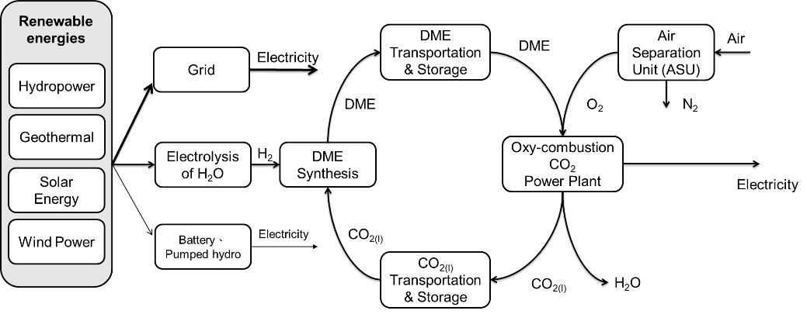

(b)

Figure 2 Conceptual design of DME-based international renewable electricity supply chain generating electricity with (a) fuel cells (b) oxy-combustion power plant.

Based on the simulation using Aspen Plus, the capital and operating costs of various chemical processes, including DME synthesis, H2 production through DME reforming, CO2 liquefaction and oxy-combustion CO2 power plant can be calculated. Additionally, economic assessments are also conducted for water electrolysis (Hodges et al., 2022), fuel cells (Jamil et al., 2022), and transportation (Placek, 2023). To account for advancing technology and ensure sustainability, the efficiency of electrolysis in sustainable future is assumed at 98%, based on the higher heating value (HHV) of H2 (39.39 MWhe/t). The cost of water electrolysis is estimated at 200 USD/kW. Solid oxide fuel cells (SOFC) are assumed to have an efficiency of 30% for thermal heat (LHV) and 55% for electricity (LHV), with a cost of 1,000 USD/kW.

The cost of green H2 production is significantly influenced by renewable energy electricity prices. The levelized cost of electricity (LCOE) for utility-scale solar photovoltaics (PV) is assumed to be USD 45/MWhe, with a projected decrease to USD 15/MWhe by 2050. Therefore, cost of renewable energy is assumed to be USD 30/MWhe in this study. Additionally, the carbon emissions associated with this process are estimated at 11 kg/MWhe from a life cycle perspective (Bruckner et al., 2014). On the other hand, the transportation of DME and CO2 between exporting and importing countries predominantly relies on shipping. Assume that a ship has a capacity of 312,500 cubic meters and travels at a speed of 12 knots. For the shipping route from Australia to Japan, which spans approximately 10,000 km, the ship is assumed to operate for 350 days each year, with a turnover time of one day. The capital cost associated with the DME/CO2 shipping vessel is estimated at 150.2 million USD (Al-Breiki and Bicer, 2020). In general, very low sulfur fuel oil (VLSFO) is chosen as the fuel source, and its approximate cost is 550 USD/t. It's worth noting that for every metric tonne of this fuel consumed, it generates 3.15t of CO2 emissions. The sensitivity analysis of each important variables will be carried for optimization.

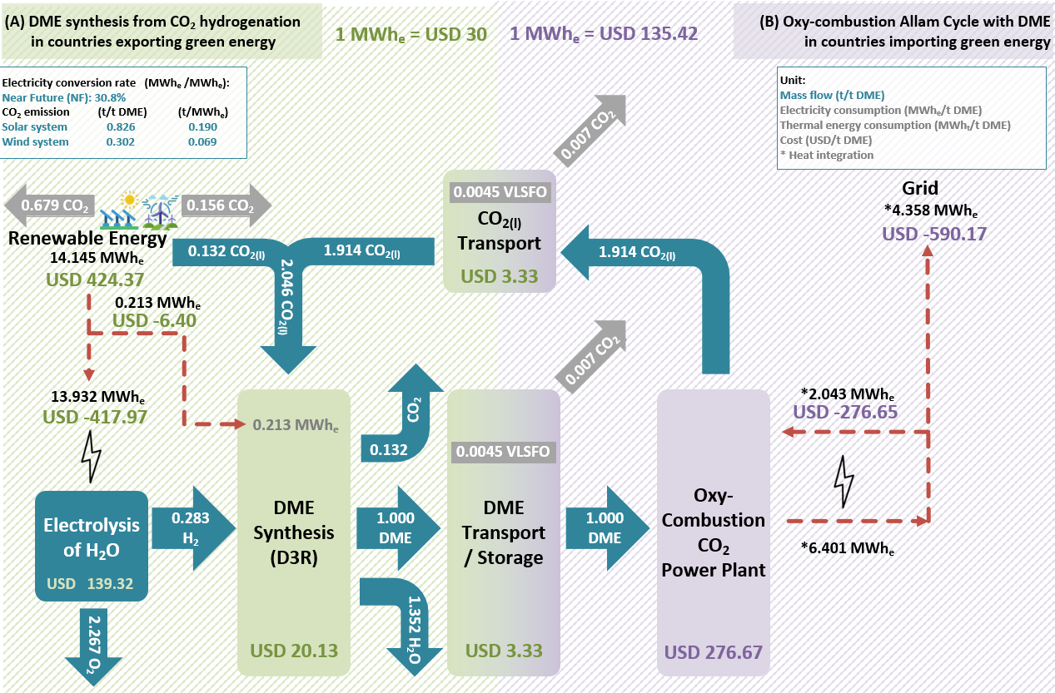

Figure 3 Techno-economic and carbon emission analyses result of DME-based international renewable electricity supply chain generating electricity with oxy-combustion power plant.

The process simulations of the chemical processes using Aspen Plus and techno-economic analysis of both DME-based international renewable electricity supply chains are carried out in this study. The techno-economic and carbon emission analyses result of DME-based international renewable electricity supply chain generating electricity with oxy-combustion power plant are depicted in Figure 3. The cost of imported electricity is USD 135.42/MWhe with an electricity conversion rate between both regions is 30.8% (=4.358/14.145), and the carbon emission of this supply chain using solar and wind power are 0.190 and 0.069 t/MWhe respectively. To compare the performance, the electricity conversion rate between the imported electricity and renewable electricity and the cost of imported electricity of the other pathway will be discussed in future.

* 1. Conclusions

In conclusion, the utilization of dimethyl ether (DME) as an energy carrier in an international renewable electricity supply chain is seen as a promising solution to address the global issues of climate change and the uneven distribution of renewable resources. The supply chain design offers two power generation options: hydrogen (H2) fuel cells and oxy-combustion power plants. To determine a more economical, environmentally friendly and efficient choice, the chemical processes simulations and techno-economic analysis of both supply chains are carried out.

References

M. Al-Breiki, and Y. Bicer. (2020). "Comparative cost assessment of sustainable energy carriers produced from natural gas accounting for boil-off gas and social cost of carbon." *Energy Reports*, 6, 1897-1909.

G. Brändle, M. Schönfisch, and S. Schulte. (2021). "Estimating long-term global supply costs for low-carbon hydrogen." *Applied Energy*, 302, 117481.

T. Bruckner, L. Fulton, E. Hertwich, A. McKinnon, D. Perczyk, J. Roy, R. Schaeffer, S. Schlömer, R. Sims, and P. Smith. (2014). "Technology-specific cost and performance parameters [annex III]", *Climate Change 2014: Mitigation of Climate Change*. Cambridge University Press, pp. 1329-1356.

E. Catizzone, C. Freda, G. Braccio, F. Frusteri, and G. Bonura. (2021). "Dimethyl ether as circular hydrogen carrier: Catalytic aspects of hydrogenation/dehydrogenation steps." *Journal of Energy Chemistry*, 58, 55-77.

F. Dalena, A. Senatore, A. Marino, A. Gordano, M. Basile, and A. Basile. (2018). "Methanol production and applications: an overview." *Methanol*, 3-28.

M.H. Hasan, T.M.I. Mahlia, M. Mofijur, I. Rizwanul Fattah, F. Handayani, H.C. Ong, and A. Silitonga. (2021). "A comprehensive review on the recent development of ammonia as a renewable energy carrier." *Energies*, 14(13), 3732.

A. Hodges, A.L. Hoang, G. Tsekouras, K. Wagner, C.-Y. Lee, G.F. Swiegers, and G.G. Wallace. (2022). "A high-performance capillary-fed electrolysis cell promises more cost-competitive renewable hydrogen." *Nature communications*, 13(1), 1304.

A. Jamil, S. Rafiq, T. Iqbal, H.A.A. Khan, H.M. Khan, B. Azeem, M.Z. Mustafa, and A.S. Hanbazazah. (2022). "Current status and future perspectives of proton exchange membranes for hydrogen fuel cells." *Chemosphere*, 303, 135204.

A. Klerke, C.H. Christensen, J.K. Nørskov, and T. Vegge. (2008). "Ammonia for hydrogen storage: challenges and opportunities." *Journal of Materials Chemistry*, 18(20), 2304-2310.

K. Matsuoka, K. Miyoshi, and Y. Sato. (2017). "Electrochemical reduction of toluene to methylcyclohexane for use as an energy carrier." *Journal of Power Sources*, 343, 156-160.

R. Moradi, and K.M. Groth. (2019). "Hydrogen storage and delivery: Review of the state of the art technologies and risk and reliability analysis." *International Journal of Hydrogen Energy*, 44(23), 12254-12269.

M. Placek. (2023). " Average monthly price of very low sulfur fuel oil (VLSFO) from November 2019 to May 2023 ". City: statista.

F. Wang, R. Swinbourn, and C.e. Li. (2023). "Shipping Australian sunshine: Liquid renewable green fuel export." *International Journal of Hydrogen Energy*, 48(39), 14763-14784.

A.T. Wijayanta, T. Oda, C.W. Purnomo, T. Kashiwagi, and M. Aziz. (2019). "Liquid hydrogen, methylcyclohexane, and ammonia as potential hydrogen storage: Comparison review." *International Journal of Hydrogen Energy*, 44(29), 15026-15044.

T.-W. Wu, and I.-L. Chien. (2022). "A novel energy-efficient process of converting CO2 to dimethyl ether with techno-economic and environmental evaluation." *Chemical Engineering Research and Design*, 177, 1-12.