Overcoming the challenges of dynamic systems in steady-state simulations: the use of meta-modeling as a surrogate for complex kinetic models

Andrew M. Elias,a,b,* Carina L. Gargalo,a Cristiane S. Farinas,b Krist V. Gernaeya

aPROSYS, Dept. of Chemical and Biochemical Engineering, Technical University of Denmark, Søltofts Plads, Building 228 A, 2800 Kgs. Lyngby, Denmark.

bEmbrapa Instrumentation, Rua XV de Novembro 1452, 13560-970, São Carlos, SP, Brazil.

andrewmilli@gmail.com

Abstract

Steady-state simulators are typically used for designing and optimizing industrial processes and techno-economic analysis. However, there are instances where dynamic phenomena play a crucial role in the process and cannot be overlooked. Certain unit operations, such as batch reactors, inherently exhibit dynamic behavior. To accurately capture the response of these systems under varying plant operating conditions, they must be modeled dynamically. Integrating a dynamic model into a full plant for steady-state simulation presents a significant challenge, regardless of whether the simulator concept is sequential or equation-oriented. A potential strategy to alleviate the computational load of integrating a dynamic model into a whole plant's steady-state simulation involves assuming a fixed and predetermined conversion for these reactors. However, such simplifications often result in a loss of accuracy and predictive capability, especially when assessing operational flexibility. Moreover, in some instances, the reaction time for batch operations could be a critical factor to consider in the overall plant design or optimization process. A potential solution for this challenge could be using surrogate models as substitutes for specific dynamic models, with time factoring in as an extra input for the meta-model. This work put this method into practice in an equation-oriented simulator (EMSO), applying a Kriging meta-modeling technique, where the meta-model replaced the kinetic model for fungi cultivation. In conclusion, this study explores the use of the metamodeling technique to replace complex kinetic models. It lays the groundwork for future research and potential scientific breakthroughs.

**Keywords**: Surrogate model, Kriging, submerged fermentation.

* 1. Introduction

Chemical plants have high production volumes and energy demands, which makes process modeling essential for enhancing their output. A small improvement in the process can have a significant impact on the overall performance. Despite the advances in computing science and the faster speed of computer processors that enable detailed dynamic simulations, steady-state modeling remains the most common method for full plant design and optimization (Seider et al., 2009).

Some unit operations, such as batch reactors, have dynamic behavior by nature. Dynamic modeling is necessary to capture how this kind of system reacts to different operating conditions of the plant. One way to reduce the numerical complexity of linking a dynamic model to a steady-state simulation of a whole plant is by assuming a fixed and predetermined conversion for these reactors. However, these simplifications usually result in loss of accuracy and prediction ability when the plant needs to operate under different conditions. Furthermore, in some cases, the reaction time for those batch operations could be a crucial factor to consider in the whole plant’s design or optimization (Bechara et al., 2016).

Equation-oriented process simulators tackle the system of equations concurrently. While they benefit processes with numerous recycle streams, this approach hinders the adoption of strategies to address local convergence issues. Specifically, it prevents the inclusion of ad hoc algorithms within the models of specific process units (referred to as “modules” in sequential modular simulators) (Smith, 2005). A sequential simulator could allow the integration of the original dynamic model into the whole simulation, but this would increase the solver's computational cost, simulation time, and convergence difficulty. For equation-oriented simulators, the direct integration of the dynamic model into the steady-state simulation is even more challenging. A potential solution to avoid this problem is to use a surrogate model that mimics the dynamic model to be integrated. This strategy was used to replace a CFD simulation (Partopour and Dixon, 2016), to mimic a kinetic model of enzymatic hydrolysis (Furlan et al., 2016), and to establish Surrogate Assisted Optimization (Carpio et al., 2017).

Meta-modeling simplifies complex dynamic kinetic models, reducing time, cost, and computational effort in steady-state simulation. It provides flexibility for exploring various scenarios, enhances decision-making processes, and improves predictive performance. It offers detailed solutions, captures high-level mechanisms with simpler rate expressions, and delivers robust, reproducible results. It presents an efficient, flexible, and understandable approach to dealing with complex dynamic kinetic models (Carpio et al., 2018).

This article proposes a Kriging meta-model to replace the dynamic model of a *Trichoderma reesei* fermentation reactor. The meta-model keeps the original dynamic response of the system by adding the processing time as an extra input to the Kriging meta-model. This simple strategy improves the accuracy of the meta-model, while still having low computational cost.

* 1. Methodology
     1. Simulator

The EMSO simulator (Environment for Modeling Simulation and Optimization), which was used in this work, is equation-oriented. This simulator has an internal object-oriented modeling language that enables to add new models into its internal library. Furthermore, it is possible to add plug-ins for running calculations that are not compatible with the equation-oriented approach; and new solvers can be linked as dynamic libraries as well.

* + 1. Kinect model

The dynamic model of the submerged fermentation reactor was simulated in EMSO using the kinetic model described by Velkovska et al. (1997). The model was based on four main points: (i) there are two types of mycelia: primary and secondary; (ii) only the secondary mycelia produce cellulase; (iii) the cellulase binds to the cellulose particles as a catalyst; and, (iv) the cellulose becomes less reactive as it is converted.

The kinetic model yields three output variables: biomass concentration (S), microorganism concentration (X), and biomass conversion into microorganisms. The fermentation reaction time was selected as the input variable for building the Kriging meta-model.

The fermentation reactor model can be broken down into the following steps:

1. **Medium Addition**: The reactor cultivation medium is gradually added until it fills 99 % of the reactor’s operating volume.
2. **Inoculation**: The inoculum is introduced, filling the entire operating volume of the reactor.
3. **Batch Stage**: During this stage, the substrate is consumed, leading to the formation of primary and secondary mycelia.
4. **Discharge**: The reactor volume is completely emptied.
5. **Cleaning**: The reactor undergoes a cleaning process.
6. The cycle then returns to step 1.

The reactor’s volume is determined through mass balances, considering the Height/Diameter ratio of the tank (which is set to 2). Additionally, the energy consumed during agitation is calculated by the diameter of the impeller, agitator rotationalspeed, and friction factor.

* + 1. Kriging meta-model

Kriging meta-models are popular for replacing complex non-linear models because they can accurately interpolate even with relatively small data sets. This work used Universal Kriging, Eq. (1), which is one of several types of Kriging meta-models.

$\hat{y}\left(x\right)= μ\left(x\right)+z(x)$ (1)

where the Kriging prediction at the point $x$ is $\hat{y}\left(x\right)$, which consists of a regression model $μ\left(x\right)$ (a kind of variable mean) and a stationary random function $z(x)$ (stochastic process) with zero mean.

A first-order polynomial was used for the regression model ($μ\left(x\right)$), and a Gaussian correlation for the random function ().

* + 1. Procedure for the surrogate model fitting and validation.

The detailed dynamic model was implemented in EMSO, the Python-EMSO communication interface was used to build the response surface, and MATLAB code was used to automate and validate the Kriging fitting process. The procedure is based on (Carpio et al., 2018).

(a) *Input data*: the number of input and output variables; the lower and upper bounds of input variables; the number of design points for validation and initial fitting; the incremental step for the number of design points for fitting at each iteration; and the accuracy criterion.

(b) *Design of Simulations (DoS)*: Latin Hypercube Sampling (LHS) was used to select the input data set for validating the meta-model with the dynamic model simulations.

(c) *Dynamic model simulations to obtain validation I/O data set*: The dynamic simulation with all the input variable combinations was performed from step b, to get the output variables for validation.

(d) *Design of Simulations for meta-model fitting*: Similar to step b, an LHS method is utilized to select the input data set that will be used to simulate the dynamic model, specifically to fit Kriging models.

(e) *Dynamic model simulations to obtain a fitting I/O data set.*: All the input variable combinations obtained during the DoS in step d are fed into the dynamic simulation. The simulation then produces the output variables that best fit the model.

(f) *Kriging meta-model fitting*: The fitting I/O dataset is provided to the DACE software (developed by (Lophaven et al., 2002)), which is a freeware MATLAB toolbox used for fitting the Kriging meta-model.

(g) *Calculate the Kriging prediction for the validation Input data*: All the input variable combinations intended for validation purposes are fed into the Kriging meta-model. The model then provides predictions for the output variables.

(h) *Compare the Kriging prediction to the validation Output data*: In this step, the accuracy criterion is calculated by comparing the Kriging prediction for the validation dataset with the dynamic model response. If the accuracy criterion is not met, the number of design points for meta-model fitting is increased (considering the incremental step specified in Step 1).

After estimating the final Kriging parameters in MATLAB, the meta-model was implemented in EMSO.

* 1. Results and discussion

The quantitative results of the evaluation of the Kriging meta-model, built with 30 design points, are shown in Table 1. To evaluate the metamodel’s ability to predict, 10 data points were used.

Table 1 - The quantitative results of the Kriging meta-model evaluation, derived from the detailed dynamic model, are juxtaposed with predictions made by the Kriging meta-model.

|  |  |  |  |
| --- | --- | --- | --- |
| Parameters | Values | | |
| Conversion | S* | X* |
| Correlation coeﬃcient (r) | 0.99998 | 0.99998 | 0.99997 |
| Mean absolute error | 0.00039 | 0.00750 | 0.00425 |
| Maximum absolute error | 0.00101 | 0.01928 | 0.01087 |

*Biomass concentration (S) and microorganism concentration (X)

It was observed that, with a small set of input data, low absolute deviations were obtained, as can be seen in Table 1. Worth noting is that the quantitative results demonstrate the Kriging meta-model’s successful substitution of the rigorous dynamic model within the validity region. However, for a deeper understanding, consider the qualitative results of the meta-model evaluation depicted in Fig. 1.

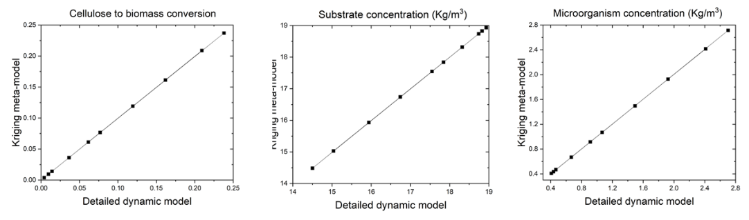Figure 1 - Qualitative results of the Kriging meta-model evaluation with 10 validating points.

Figure 1 illustrates the close to ideal alignment between the meta-model response and the detailed dynamic model outcomes across a comprehensive range of output models. It has been confirmed that, for the chosen variables in constructing the metamodel, a mere 30 data points were sufficient to yield curves with coefficients of determination exceeding 0.9999. Figure 2 presents the substrate (S) and biomass (X) process dynamics built from the metamodel added to the EMSO process simulator.

The behaviour of the variables over time can observed from Figure 2. The error bars are nearly invisible, given that the maximum absolute error for each output variable is extremely low. The computation time required by the meta-model in one simulation of the fermentation reactor was approximately 0.0001 s using a Ryzen 7 7745HX @ 3.60 GHz laptop machine, a very significant improvement over the computation time required for the original model.

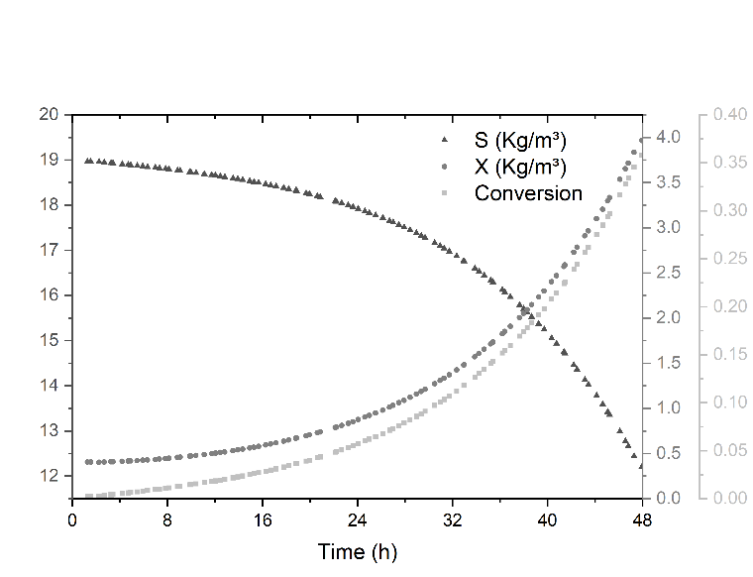

Figure 2 – Microorganism production kinetics of *Trichoderma reesei.* Biomass concentration (S), microorganism concentration (X), and biomass to microorganisms’ conversion as a function of time. The error bars are almost invisible due to the low maximum absolute error.

* 1. Conclusions

A methodology for integrating dynamic models into steady-state simulations was introduced in this work, primarily for optimization or design objectives. The approach entails replacing dynamic models with Kriging meta-models, incorporating time as an additional input variable to the meta-model. This methodology facilitates the creation of simplified models that closely approximate the outcomes of detailed dynamic models within the desired accuracy range for feasible operating conditions. The developed model will be employed in subsequent projects within a biorefinery framework. This approach will enable a more precise application of global sensitivity analysis, uncertainty assessment, and optimization techniques.

Acknowledgments

The authors are grateful for the financial support provided by: (i) Fundação de Amparo à Pesquisa do Estado de São Paulo (FAPESP, grants #2016/10636-8, #2020/15450-5, and #2022/10900-8; and, (ii) Novo Nordisk Foundation-funded Sustain4.0: Real-time sustainability analysis for Industry 4.0 (NNF0080136).

References

Bechara, R., Gomez, A., Saint-Antonin, V., Schweitzer, J.-M., Maréchal, F., 2016. Methodology for the optimal design of an integrated first and second generation ethanol production plant combined with power cogeneration. 214, pp. 441–449, Bioresour Technol.

Carpio, R.R., Furlan, F.F., Giordano, R.C., Secchi, A.R., 2018. A Kriging-based approach for conjugating specific dynamic models into whole plant stationary simulations. 119, pp. 190–194, Comput Chem Eng.

Carpio, R.R., Giordano, R.C., Secchi, A.R., 2017. Enhanced Surrogate Assisted Global Optimization Algorithm Based on Maximizing Probability of Improvement, in: Computer Aided Chemical Engineering. pp. 2065–2070, Elsevier.

Furlan, F.F., de Andrade Lino, A.R., Matugi, K., Cruz, A.J.G., Secchi, A.R., de Campos Giordano, R., 2016. A simple approach to improve the robustness of equation-oriented simulators: Multilinear look-up table interpolators. 86, pp. 1–4, Comput Chem Eng.

Lophaven, S.N., Nielsen, H.B., Søndergaard, J., 2002. DACE - A Matlab Kriging Toolbox, Version 2.0.

Partopour, B., Dixon, A.G., 2016. Computationally efficient incorporation of microkinetics into resolved-particle CFD simulations of fixed-bed reactors. 88, pp. 126–134, Comput Chem Eng.

Seider, W.D., Seader, J.D., Lewin, D.R., Widagdo, S., 2009. PRODUCT DESIGN PRINCIPLES AND PROCESS Synthesis, Analysis, and Evaluation, Third Edit. ed. John Wiley & Sons, Hoboken, NJ.

Smith, R., 2005. Chemical process design and integration. John Wiley & Sons, Chichester.

Velkovska, S., Marten, M.R., Ollis, D.F., 1997. Kinetic model for batch cellulase production by Trichoderma reesei RUT C30. 54, pp. 83–94, J Biotechnol.