Refining SOFC Performance: Parameter Estimation and Model Validation for Dynamic Energy System Optimization
Arthur Waeberª, Xinyi Wei^{a,b}, Shivom Sharmaª, Jan Van Herle^{b}, Francois Marechalª
ªIPESE, EPFL Valais Wallis, 1950 Sion, Switzerland
^{b}GEM, EPFL Valais Wallis, 1950 Sion, Switzerland
arthur.waeber@epfl.ch
Abstract
As environmental concerns intensify and energy demand rises, the global quest for sustainable energy sources becomes crucial. Given the intermittent nature of renewable electricity, the quest for transient solutions becomes imperative to ensure energy security. Solid oxide fuel cell (SOFC) stands out as a promising technology, characterized by its high electrical efficiency, fuel flexibility, and the capability for co-producing heat. Integrating SOFC into an energy system necessitates a dynamic model capable of handling fluctuations in electricity demand profiles. This underscores the significance of a reliable and reusable SOFC dynamic model. The present study focuses on constructing a detailed electrochemical SOFC stack model using gPROMS. Laboratory data is employed to perform model validation after mathematical pre-treatment. Furthermore, a sensitivity analysis was employed to select the most crucial parameters. Subsequently, parameter estimation was executed by minimizing the likelihood function. To assess the proximity between model predictions and experimental data and to evaluate the potential reuse of the model based on estimated parameter values, statistical analysis incorporated goodness of fit and t-test measures was performed.
Keywords: Solid Oxide Fuel Cell, Model Validation, Parameter Estimation.
  - Introduction
Escalating energy problems have led to a greater emphasis on the study of alternative energy sources. However, the viability of these renewable energy sources is heavily influenced by geographical location, and their intermittency poses limitations, particularly in areas requiring constant energy availability, such as hospitals. While green hydrogen offers promising alternatives to fossil fuels, a full switch to renewables requires modifications to existing pipelines, indicating a gradual process (Sharma et al., 2018). It is therefore necessary to identify interim solutions to provide stable electricity.

Solid oxide fuel cells (SOFCs) can convert chemical energy into electricity. Recent attention has focused on the remarkable efficiency of these systems, which exceeds 60%, and their high operating temperature of 800°C. This high temperature facilitates the production of heat as a valuable co-product (Xu et al., 2022). This high temperature facilitates the production of heat as a valuable co-product (Xu et al., 2022). This high temperature facilitates the production of heat as a valuable co-product (Xu et al., 2022). In addition, SOFC is flexible in the use of various fuel sources, including hydrocarbons, syngas, hydrogen and biofuels. The incorporation of biofuels indicates that it is possible to consider this electricity generation technology as carbon neutral. If combined with downstream carbon capture, it can even be considered carbon negative. When using a SOFC system to generate electricity, it is essential to take account of dynamic responses, particularly in residential areas. This behavior can be effectively managed with SOFC by simply adjusting the fuel input. However, it is essential to understand the performance of the system and refine the process conditions, which highlights the need for a validated dynamic model for the SOFC system. Previous validations of SOFC models can be found in the literature, but they are mainly based on steady-state performance or simplified mathematical models that significantly reduce the set of parameters. In this research, an elaborate electrochemical SOFC model was developed in the gPROMS library. The experimental data was provided by the Energy Materials Group (GEM) laboratory at EPFL, which is renowned for its expertise in the field of fuel cells. The subsequent critical step involved the validation of the model using the acquired experimental data, correctly accounting for the propagated error due to the intrinsic uncertainty of the measuring instruments.

This SOFC stack model encompasses more than 70 parameters. These parameters include pivotal factors such as exchange current density, stack area, and electrical conductivity, directly impacting the SOFC stack's performance. Additionally, parameters defining the microscopic structure of the electrodes (porosity, tortuosity or even equivalent pore radius) may exert a significant influence on the activation overpotentials or on the gas diffusion. Consequently, there arises a necessary task of discerning which sets of parameters are indispensable for estimation, particularly when confronted with a limited number of experiments to avoid overfitting. While parameter estimation is acknowledged as the initial step of a wider dynamical study, it is a fundamental and pivotal process. This paper introduces and executes the processing and pretreatment of experimental data, and its error propagation, alongside detailed parameter estimation. The results of this study highlight the robust and dependable nature of the SOFC stack model, rendering it well-suited for application in later stages of dynamic energy system development.
  - Methodology
    - SOFC stack model description
gPROMS Process Academic Research is among the most advanced modelling software available today. It features Global System analysis, together with design of experiments and model validation tools that can be carried out on highly sophisticated models. In this section, the electrochemical model of an SOFC is briefly described to enable a good overview of its structure.

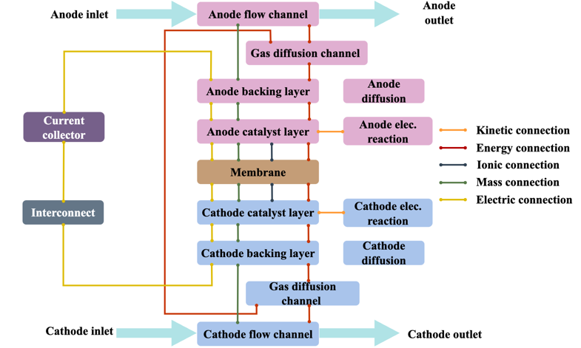
Figure 1. gPROMS SOFC model - modelling structure
In Figure 1 a process flow diagram illustrates the different layers for a precise SOFC modelling. The gases with a defined composition, temperature and pressure are injected through the flow channel in co-flow configuration. There, the molecules will diffuse through the backing layers (i.e. substrate layers) to reach the catalyst layer where the effective electrochemical reactions will take place. Each of these layers can be precisely characterized in terms of thickness, diffusion properties, thermal conductivity or even chemical reactivity. Between the 2 electrodes, the membrane should enable the propagation of O^{2—}ions, while limiting its electric conductivity to avoid any significant losses in the cell voltage. The electrons are then transferred to the current collector through interconnect, where, between others, the contact resistance and electrical conductivity can again be specified. This complex modelling enables very precise calculations even along the flow direction, requiring obviously a large set of parameters.
    - Methodology for the Model Validation mechanism
The model validation process is part of a more general scientific approach. As shown in Figure 2, it includes primarily the laboratory work like carrying out the experimental tests, processing the data and the extracting the interesting experiments. Secondly, the error propagation and sensitivity analysis for selecting the crucial parameters have to be performed. Once these first steps are accepted, one can finally turn to the model validation followed by a statistical analysis to assess the results. This procedure can then be repeated several times in order to gain accuracy on the final validated model. Indeed, after a first trial, one might want to diversify the experiments, or seek for new parameters to be estimated. Each of these steps is detailed in the results to stress out their importance and enable a clear overview of the procedure.

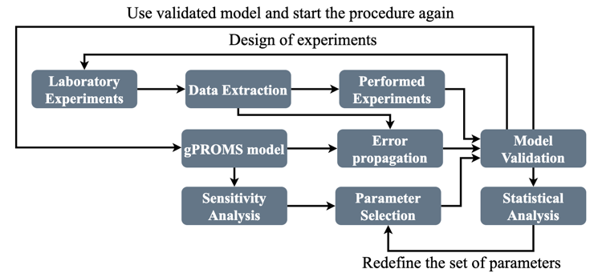
Figure 2. Working mechanism of model validation
  - Results and Discussions
    - Lab data analysis
The experimental data, sourced from GEM lab, is intended for the analysis of a SolydEra short stack performance. This stack comprises 6 cells in series, each possessing an active surface area of 80 cm². Over a duration of 6 months, measurements were conducted at the anode/cathode inlet and outlet, and on individual cell performance. The extensive set of measurements underwent processing, and 4 current ramps were isolated. Notably, the "dry ramps," involving a H₂/N₂ mixture at the anode inlet, are distinguished from "wet ramps," where steam, CO₂, and methane are additionally injected at the fuel electrode.
      - Error propagation
Given the complexity of the gPROMS model, a non-mathematical approach has been favored, opting for error calculation through the Sobol sampling method. Assuming normally distributed errors, the gPROMS model underwent 1000 calculations, selecting input conditions quasi-randomly based on their mean and standard deviation. Figure 3 shows the j-V curve with the 95%-interval for the dry and the wet experiments. It clearly emphasizes that the error on the voltage increases with increasing current densities and underscores that wet experiments are more susceptible to significant deviations from the actual value. It is important to clarify that a literature-based gPROMS model was employed at this stage, potentially introducing some relaxation in the computed errors. Additionally, for wet experiments, the system transitions to the concentration-limited regime at relatively low current density, resulting in a wider error range. This finding serves as a guideline for further experiment design.
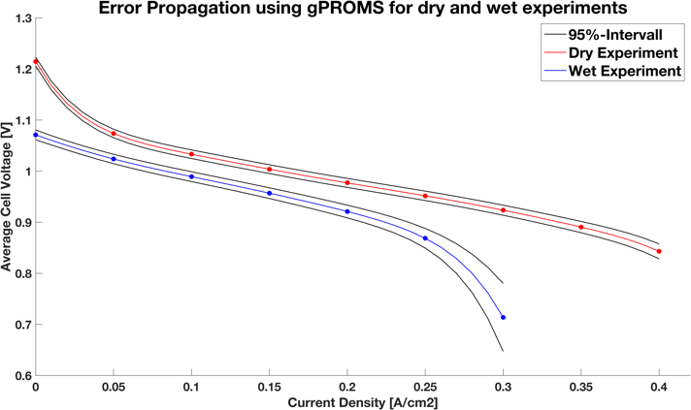
Figure 3. Error propagation of dry and wet experiments
    - Sensitivity Analysis for Parameter Selection
Employing a 2D-SOFC model offers advantages in comprehending the bidirectional behaviors of the stack. Nevertheless, constructing such a highly sophisticated mathematical model relies on numerous equations and variables. Given the limited quantity of data, discerning sensitive variables is crucial for enabling efficient validation. A sensitivity analysis was hence conducted on all relevant parameters across various current densities. Figure 4 depicts the methodology for four typical parameters. It appears that only the parameter defining the membrane's electrical conductivity has a discernible impact on the open circuit voltage. While the mass specific area of the anode catalyst has a major impact on voltage at medium current densities, the parameter describing the mass transfer at the anode has a considerable influence close to the limiting current density. On the contrary, a variation in the density of the anode backing layer produces a flat voltage response which indicates that the density is not crucial for this analysis. Employing this strategy allowed the reduction of parameters relevant for model validation from 70 to 8, which are detailed in Table 1.
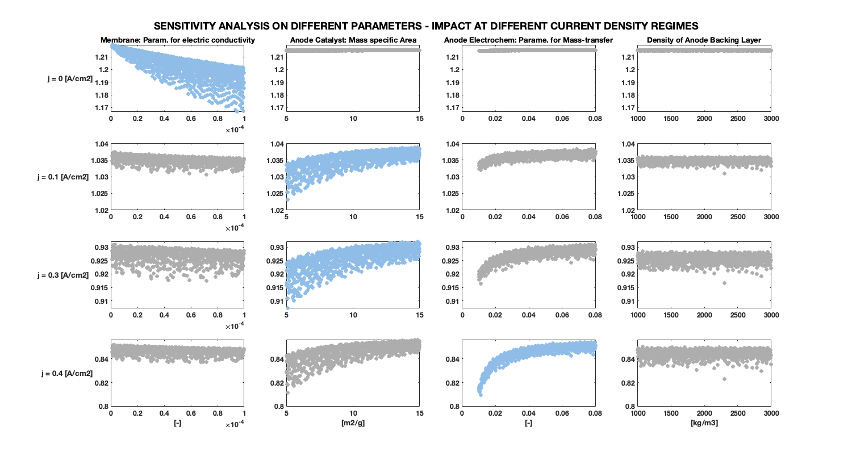
Figure 4. Sensitivity analysis on stack parameters

Table 1. List of potential variables for parameter estimation
Location | Variables | Default Value | Range | Unit
Anode Backing Layer | Tortuosity | 2 | [1 – 9] | -
Anode Catalyst Layer | Catalyst loading | 0.005 | [0.001 – 0.1] | kg/m²
Anode Catalyst Layer | Mass specific area of catalyst | 10 | [2 – 20] | m²/g
Anode Electrochemistry | Parameter for mass transfer | 0.05 | [0.005 – 0.1] | -
Anode Electrochemistry | Reference exchange current density | 18 | [10 – 1000] | A/m²
Membrane | Ionic conductivity | 5 | [1 – 50] | -
Membrane | Parameter for electrical conductivity | 1E-5 | [1E-6 – 1E-4] | -
Membrane | Thickness | 5 | [2 – 20] | µm
    - Parameter estimation
With limited experimental data, the selection of parameters becomes a critical aspect. Attempting to estimate too many parameters simultaneously would inevitably result in overfitting. Therefore, to prevent this, three parameters have been selected, as pre-analysis indicates that these parameters induce a strong impact on the stack average voltage. In this section, the outcomes of the parameter estimation are presented and discussed in statistical terms to thoroughly evaluate the fitting performance.
      - Overall system performance
In this section, a visual interpretation of the model validation performance is given and fitting performance are briefly discussed. From Figure 5, one can directly see that the validated model provides a better fit of the experimental data compared to the original non-validated model. The fitting performance appears to be slightly better for the first experiment, probably due to the higher number of points. For the same reason, the wet experiment is slightly disregarded, and the fitting performance is lower. This fact is also explained by the larger error in the wet experiment, due to the presence of water. Finally, the overall performance seems to be satisfying at least from a visual interpretation. Further investigations on the statistical analysis will decide and evaluate more deeply the validity of this fit.

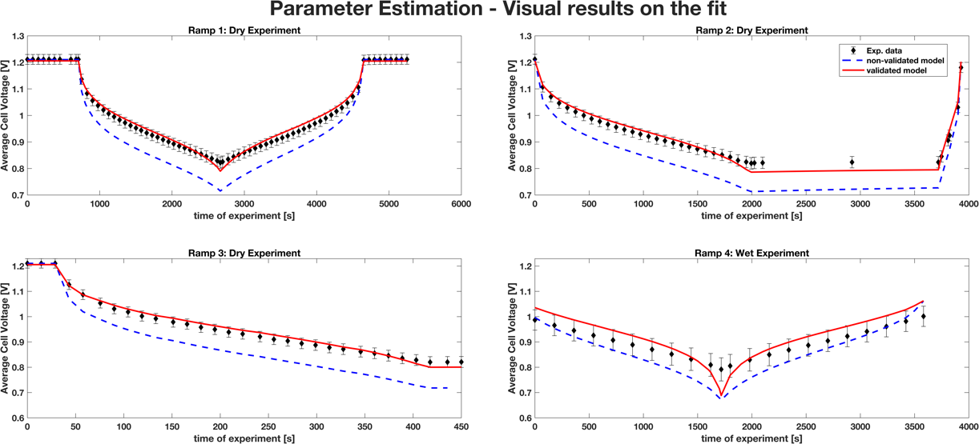
Figure 5. Visual interpretation - Original vs. validated model
      - Goodness of fit
The primary goal in parameter estimation is to minimize the likelihood function, which serves as a measure of the agreement between experimental and model data. Nevertheless, depending solely on the likelihood function for assessment poses difficulties in gauging the model's ability to faithfully depict reality. Goodness of fit encompasses a broader perspective by evaluating how well the model aligns with the observed data across various dimensions. A chi-squared test has been conducted, to compare the weighted residuals with the expected weighted residuals derived from the dataset. A chi-squared value below the critical threshold indicates that the experiment is suitably fitted by the model. Table 2 indicates that all experiments have successfully passed, affirming the model's capability to accurately represent the experimental data.
Table 2: Goodness of fit - χ² results for Exp 1, Exp 2, Exp 3: Dry ramps, Exp 4: Wet ramp
Exp 1 |  | Exp 2 |  | Exp 3 |  | Exp 4 |  | Overall results
χ² | χ²_{critical} | χ² | χ² _{critical} | χ² | χ² _{critical} | χ² | χ² _{critical} | χ² | χ² _{critical}
31.29 | 89.39 | 30.59 | 48.60 | 12.51 | 41.34 | 16.04 | 30.14 | 90.43 | 189.42
      - T-test
An additional consideration pertains to the reusability of the model, signifying the importance of ascertaining the confidence in the estimated parameters. To assess the confidence in estimated parameters, a pertinent statistical tool is the t-test. The application of the t-test enables a formal evaluation of the reliability of parameter estimates.
Table 3. t-value for the estimated parameters
Model Parameters | Initial Value | Final Value | CI 95% | 95% t-value
Exchange current density | 18 | 142.63 | 24.05 | 5.93
Param. for mass transfer | 0.05 | 0.0083 | 0.0021 | 3.91
Param. for elec. conductivity | 1E-5 | 5.4E-5 | 2.7E-5 | 1.99

Firstly, a ref. t-value is calculated for the set of experiments that was provided. In this study, it amounts to 1.654. Each parameter is then individually analyzed with a given final value and a 95% t-value. For the available data to be sufficient to estimate the set of parameters, the t-value of each parameter should be greater than the reference one. In Table 3, it is noteworthy that all parameters have successfully passed the t-test, signifying a high confidence in the estimated parameters and the potential reuse of this model.
  - Conclusions
In this study, the use of experimental data, sensitivity analysis and parameter estimation have been conducted and could provide a validated SOFC model. This work emphasizes further the need for other testing conditions, in presence of steam, thus allowing more parameters to be estimated and yielding more precise fitting results. The outlet temperatures and pressures could also be included. Moreover, linking this model with other programming languages could be an interesting dimension for further study in this field. Finally, this validated model should be tested in real case application, where the dynamics is crucial for system efficiency calculation or even meeting electricity demand profiles. It is hence to be integrated in dynamic energy system for further applications.
References
H. Alhumade, A. Fathy, A. Al-Zahrani, M.J Rawa, H. Rezk, 2021, Optimal Parameter Estimation Methodology of Solid Oxide Fuel Cell Using Modern Optimization. Mathematics, no. 9, p. 1066 A. Rahayu, Purhadi, Sutikno, DD. Prastyo, 2020, Multivariate Gamma Regression: Parameter Estimation, Hypothesis Testing, and Its Application. Symmetry, no. 12(5), p.813
S. Sharma, F. Maréchal, 2018, Robust Multi-Objective Optimization of Solid Oxide Fuel Cell–Gas Turbine Hybrid Cycle and Uncertainty Analysis, Electrochem. Energy Convers. Storage, vol. 15, no. 4, p. 041007
Q. Xu, Z. Guo, L. Xia, Q. He, Z. Li, I.T. Bello, M. Ni, 2022, A comprehensive review of solid oxide fuel cells operating on various promising alternative fuels, Energy Conversion and Management, no. 253, p. 115175.

