Surrogate Modeling for CFD Simulation in Coating Process Using Proper Orthogonal Decomposition and Deep Neural Networks

Sung Hyun Ju,a Kyeongmin Min, a Jong Min Lee a*, and Jaewook Nam a*

aSeoul National University, Department of Chemical and Biological Engineering, 1 Gwanak-ro, Gwanak-gu, Seoul, 08826, Korea

jongmin@snu.ac.kr

jaewooknam@snu.ac.kr

Abstract

Coating processes, integral in various industrial applications such as Li-ion battery electrode manufacturing, rely on accurate model of fluid dynamics for optimal outcomes. However, the dynamic nature of coating material conditions at the inlet of the coating apparatus poses challenges, leading to time and cost-intensive fluid dynamics calculations. To address this, there have been a growing demand for surrogate models capable of providing efficient and precise approximations of CFD results. Our approach leverages previously obtained CFD train data under diverse coating material conditions. Through a surrogate model integrating proper orthogonal decomposition and deep neural network, we efficiently derived CFD results for test conditions, reducing the need for resource-intensive CFD simulations. Our research applied this methodology to a practical coating apparatus, assuming the coating material properties align with those of Carreau fluid. This study holds promise for enhancing industrial efficiency in modeling and optimizing coating processes.

**Keywords**: Coating, Computational Fluid Dynamics, Surrogate model, Proper Orthogonal Decomposition

* 1. Introduction

Coating processes are employed in various industrial processes, including the manufacturing of lithium-ion battery electrodes (Li, et al. 2021). Typically positioned at the tail end of coating material production and transportation processes, coating processes involve the application of coating material slurry onto substrate as it passes through coating apparatus, such as slot die coater. For overall process modeling, the fluid dynamics inside the coating apparatus are important. This is because the pattern of coating material application on the substrate is determined by the slurry flow at the outlet of the coating apparatus.

It is worth noting that during transportation process or grade change, the rheological properties, such as viscosity, of the coating slurry can change due to factors such as deformations in the internal microstructure of the slurry (Sullivan, et al. 2022). When the rheological properties change, it affects the flow through the coating apparatus, resulting in variations of the velocity and pressure profile at the outlet of the coating apparatus and influencing the coated product significantly.

Simulating the outlet flow of the coating apparatus for each change in rheological properties of the inlet poses practical challenges, as it requires substantial time and resources for each computational fluid dynamics (CFD) simulations. Numerous efforts have been directed towards minimizing the time and cost from repetitive CFD simulations. Since first proposed by Raissi, et al. (2017), physics-informed neural networks (PINNs) have garnered a lot of attention from the field of fluid mechanics. While PINNs substantially reduce time and cost for CFD simulation inference, PINNs suffer from inherent inaccuracies due to the soft constraint formulation of loss function during its optimization process. This limitation particularly affects predictions related to fluid flow aspects, such as conservation principles, boundary conditions, and initial conditions (Krishnapriyan, et al. 2021, Wang, et al. 2021).

There also have been trials with model order reduction techniques based on existing CFD simulation data. Proper orthogonal decomposition (POD) (Berkooz, et al. 1993) is among the prominent techniques. The fundamental concept underlying this technique involves decomposing CFD data into reduced bases encapsulating distinctive flow behaviors inherent in the data and their corresponding projection coefficients. Surrogate model can be constructed with the reduced bases, which satisfy the fluid flow aspects aforementioned because they are extracted from existing simulation data already satisfying the conditions. Zhang and Zhao (2021) suggested matching the projection coefficients for each reduced base with CFD simulation parameters using deep neural network (DNN). This approach not only ensured a sufficiently short inference time, but also offered satisfaction of boundary conditions. This is particularly crucial for our coating system, as the outlet of the coating apparatus corresponds to such boundary conditions. In this work, we propose a surrogate model for CFD simulation of an actual coating process using POD and DNN. The prediction performance of the surrogate model is compared with the CFD simulation result of the same process.

* 1. Process and Data Description

The target process is a typical slot die coater apparatus widely used in practical coating applications, as shown in Figure 1 (a). The geometry of the shape through which fluid flows in the apparatus, as shown in Figure 1 (b), was designed in a mesh configuration using Pointwise 18.2R1. Numerical solutions were computed using Ansys Fluent 2021R1.

Carreau model was employed to describe the viscosity of the coating material slurry. This choice is based on a previous study by Lee, et al. (2022) where the Carreau model proved effective in simulating the viscosity properties of battery slurries. The Carreau model has the following mathematical form:

|  |  |
| --- | --- |
| $$η\left(\dot{γ}\right)=η_{∞}+\left(η_{0}-η_{∞}\right){\left[1+{\left(λ\dot{γ}\right)}^{2}\right]}^{\left(n-1\right)/2}$$ | (1) |

where $η$ and $\dot{γ}$ denote the shear viscosity and shear rate respectively. $η_{∞}$ (Pa∙s), $η_{0}$ (Pa∙s),

$λ$ (s), and $n$ (unitless) are the parameters of Carreau model. The flow was assumed to be isothermal and incompressible with a density of 2,230 kg/m3, following Lee, et al. (2022).

Coating apparatus inlet, wall, outlet boundary conditions were considered. To consider the transient pump inlet boundary condition in the actual coating process, the following mass flow inlet boundary condition equation was applied:

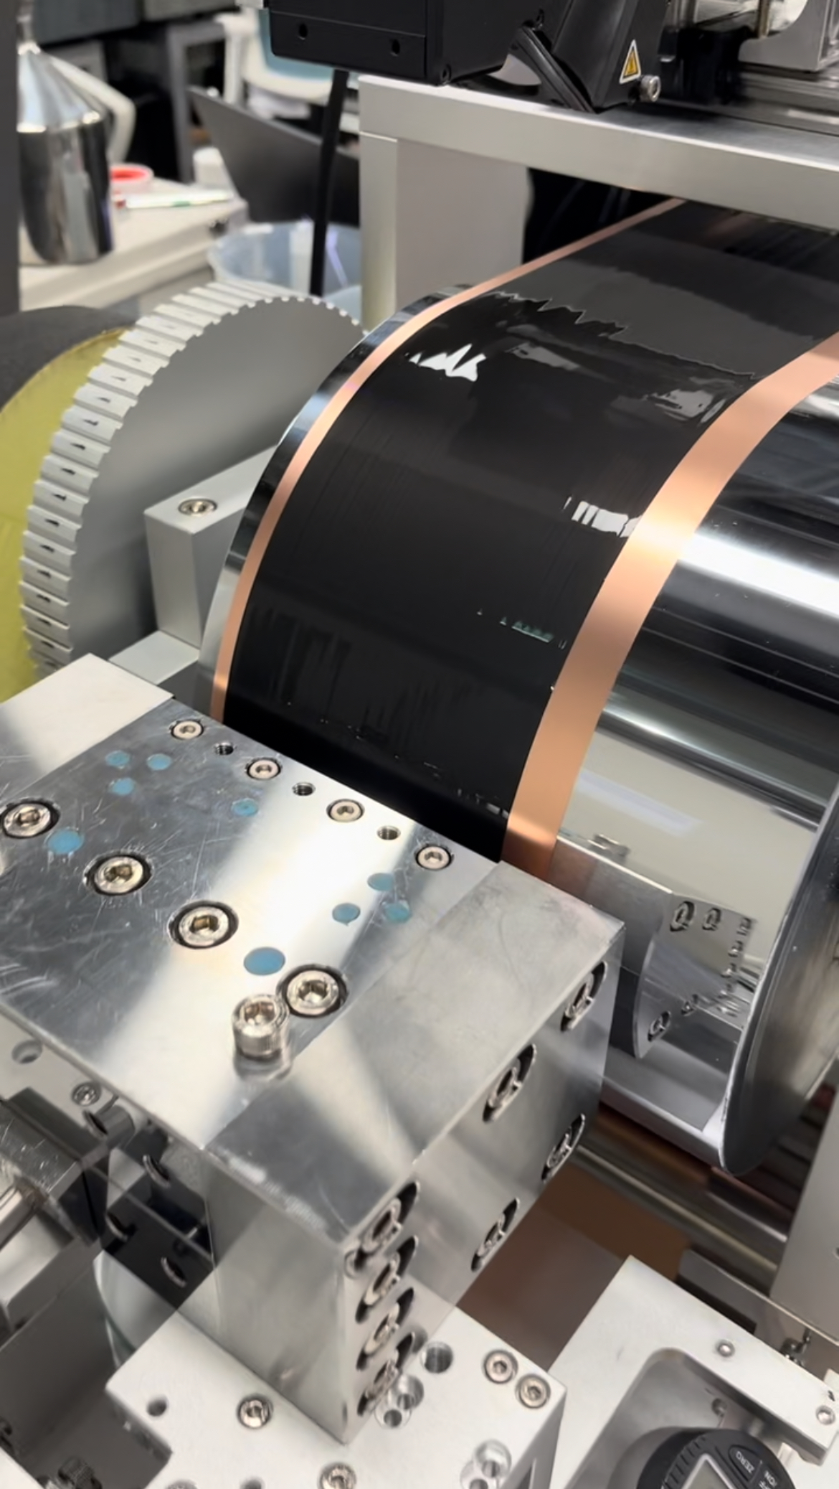 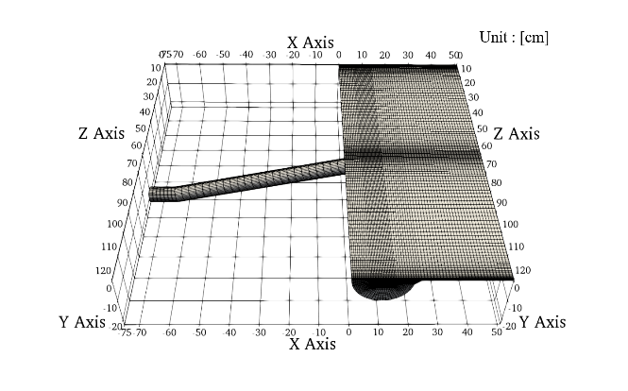

(a) (b)

Figure 1. (a) The slot die coater apparatus used in coating process, and (b) the mesh with 230k nodes designed for the region of fluid in the identical apparatus. The coating slurry is injected into the left pipe section, and exits through the right feed slot section.

|  |  |
| --- | --- |
| $$q=q_{average}\left(1+A\sin{2πtf}\right)$$ | (2) |

where $q_{average}$ is the average inlet mass flow rate of the steady-state flow, $A$ is the amplitude, and $f$ is the pump frequency. Here, $q_{average}$, $A$, and $f$ were fixed at 80 mL/min, 0.01, and 1 Hz respectively. Taking the mass flow rate into account, a laminar flow was assumed. A no-slip boundary condition was specified at the walls, and atmospheric pressure at the outlet was specified as the outlet boundary condition.

The parameters, $η_{0}$, $λ$ and $n$, of the Carreau model were varied to generate a total of 64 time-series CFD simulation data. All possible combinations of $\left(η_{0}, λ, n\right)$ for $η_{0}∈$ [25, 50, 100, 200], $λ∈$ [0.1, 1, 10, 100], and $n∈$ [0.4, 0.5, 0.6, 0.7] were explored with $η_{∞}$ fixed to 0.01. The time step size was set to 0.01second. Simulation results of 100 time steps after residence time, equivalent to one pump cycle, were prepared for our surrogate model.

* 1. Proposed Surrogate Modeling Approach

This section outlines a surrogate modeling procedure for the CFD simulation of a slot die coater detailed in Section 2. First, the overall model structure is introduced. Then, the procedures for data decomposition through POD and projection coefficient regression with DNN are discussed.

* + 1. Overall Model Structure

75% of the entire time-series CFD simulation data were randomly selected for training, with the remaining 25% reserved for testing. POD was applied to the train dataset, producing reduced bases and their corresponding projection coefficients. These reduced bases were assumed as the bases for the test dataset. The DNN regression model, trained on the coefficients of the train dataset, predicted the coefficients for the test dataset. Each predicted coefficient for the test dataset was then multiplied by the corresponding reduced base, and the resulting values were summed to obtain predictions for the CFD simulation data. The overall model structure is shown in Figure 2.

* + 1. Data Decomposition through POD

Mathematically, POD minimizes the following error:

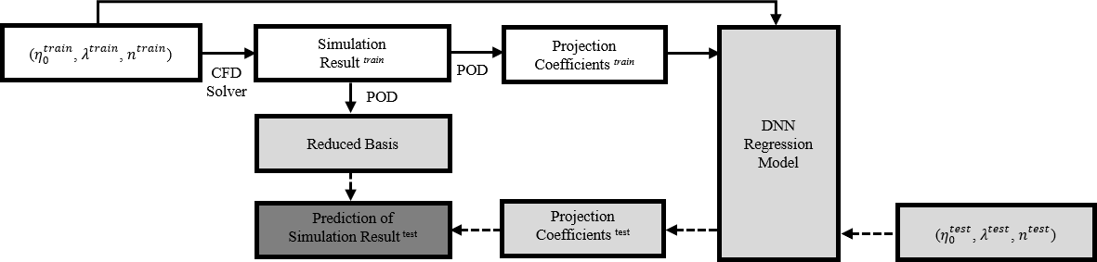

Figure 2. The Overall CFD Surrogate Model Structure

|  |  |
| --- | --- |
|  | (3) |

where $N^{train}$ is the number of train samples, $x_{i}$ is the $i$ th train sample on a vector space $V$, $P_{r}$ is the projection of rank $r$, and the operation $\left\|⋅\right\|$ is the induced norm from the inner product $〈⋅,⋅〉$ on $V$. The projection of $x_{i}$, $P_{r}x_{i}$, is expressed as follows:

|  |  |
| --- | --- |
| $$P_{r}x_{i}= \sum_{j=1}^{r}{〈φ_{j},x_{i}〉 φ_{j}}$$ | (4) |

where $φ_{j}∈V$ is the orthonormal basis of rank $r$. $φ_{j}$ and $〈φ_{j},x_{i}〉$ are the reduced base and projection coefficient previously mentioned. We set the inner product weighting matrix, $W$, to the identity matrix in the general inner product expression, $〈x_{i},x_{j}〉= x_{i}^{*}Wx_{j}$.

Minimizing the error in (3) leads to the following eigenvalue problem:

|  |  |
| --- | --- |
| $$XX^{*}Φ=ΦΣ$$ | (5) |

where $Σ$ is a diagonal matrix filled with eigenvalues, and $X$ and $Φ$ are as follows:

|  |  |
| --- | --- |
| $$X=\left[\begin{matrix}⋮ & ⋮ & & ⋮ \\ x_{1} & x_{2} & ⋯ & x_{N^{train}} \\ ⋮ & ⋮ & & ⋮\end{matrix}\right]$$ | (6) |

|  |  |
| --- | --- |
|  | (7) |

In this study, the columns of $X$ are flattened vectors of time-series CFD simulation train data from the coating apparatus outlet. Matrix X was scaled before implementing POD.

* 1. Projection Coefficient Regression with DNN

The DNN regression model predicts projection coefficients for the Carreau model parameter combinations $\left(η_{0}, λ, n\right)$. To prevent overfitting, batch normalization, dropout, L2 regularization, and early stopping were employed. The model used ReLU activation function, mean-squared error loss, and Adam optimizer. Grid search, based on 4-fold cross validation errors, determined the optimal hyperparameter combination from the parameter space $Ω_{h × N_{h} × Do ×Wd × Lr ×{SM}_{POD} × {SM}_{NN}}=$ {4, 8, 16, 32, 64} $×$ {1, 2, 3, 4, 5} $×$ {0.1, 0.2, 0.3, 0.4}{10-8, 10-7, 10-6, 10-5, 10-4, 10-3}{10-4, 10-3, 10-2}{MinMax, Standard} $×$ {MinMax ,Standard}, where $h, N_{h}, Do, Wd, Lr, {SM}_{POD}, {SM}_{NN}$ represents the hidden size, number of hidden layers, dropout rate, learning rate, scaling method before implementing POD, and scaling method of input and output of the neural network respectively. Using the optimal hyperparameter combination, the DNN model was trained with 25 % of the train dataset as a cross validation dataset.

* 1. Result and Discussions

The rank of $Φ$, $r$, and the optimal hyperparameter combination, $(h, N_{h}, Do, Wd, Lr, {SM}_{POD}, {SM}_{NN})$, were determined to be 48 and (8, 1, 0.3, 10-6, 10-2,

MinMax, MinMax), respectively. The CFD simulation result and surrogate model prediction for a randomly selected test sample, corresponding to $\left(η_{0}, λ, n\right)$ = (200, 0.1, 0.5), at a randomly selected simulation time, $t$ = 0.83 second, are illustrated in Figure 3. When comparing the velocities in the $x$, $y$, and $z$ directions predicted by the surrogate model with those predicted by the CFD simulation, a close alignment was observed, capturing key features such as the no-slip wall boundary condition, symmetry of $x$-velocity, $y$-velocity, and $z$-velocity profiles, and the parabolic flow profile in the $x$-velocity. To quantitatively evaluate the performance of the surrogate model, Figure 4 illustrates the mean absolute percentage errors in the surrogate model predictions at the coating apparatus outlet over time. This analysis specifically focuses on the $x$-velocity for the same test sample because, in the actual coating process, the $x$-velocity profile is the most influential factor affecting the application of the coating slurry onto the substrate. The remaining $y$ and $z$ velocity profiles have considerably lower orders of magnitudes,

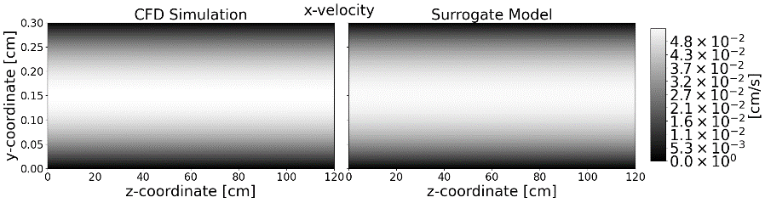

(a)

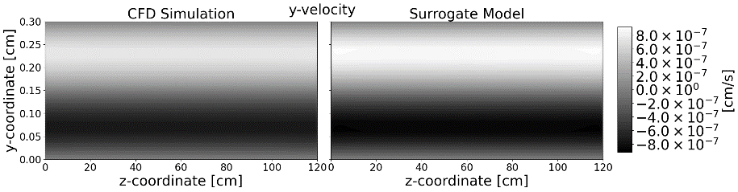

(b)

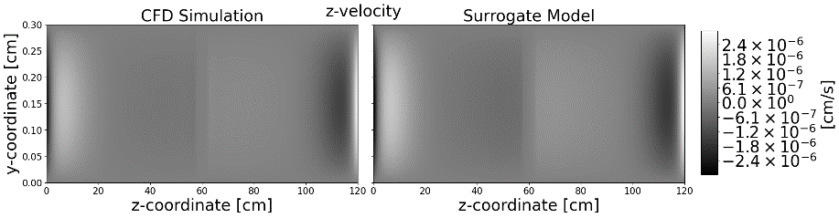

(c)

Figure 3. CFD Simulation Result and the Prediction Result of Surrogate Model for a Random Test Sample Data, $\left(η_{0}, λ, n\right)$ = (200, 0.1, 0.5) and $t$ = 0.83 second

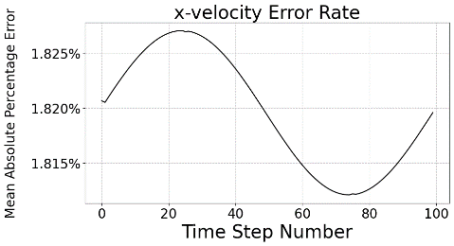

Figure 4. Mean Absolute Percentage Error of x-velocity

over Time for a Test Sample Data, $\left(η_{0}, λ, n\right)$ = (200, 0.1, 0.5)

resulting in negligible impact during the actual coating process. The mean absolute percentage errors of the surrogate model, when compared to the CFD simulation, did not exceed 1.830 % over time. The CFD simulation for the coating flow required over 9 CPU hours for a single case, while the proposed model achieved inference for 16 test cases in 0.36 second. The surrogate model, based on POD and DNN, exhibited strong agreement with the CFD simulation and showed significant improvement in inference speed.

* 1. Conclusion

This work introduced a surrogate modeling approach using POD and DNN for efficient CFD simulation of a slot die coater. Our model demonstrated strong agreement with CFD results, achieving accurate predictions while significantly reducing computation time. The novelty of our work lies in its applicability to real-world industrial processes where input properties may vary. This allows for the prediction of new CFD results based on existing data, eliminating the need to run CFD simulations for every change in input properties. In future work, integrating this research could lead to the development of a unified module encompassing post-coating processes, thereby expanding the scope of application.

References

Li, J., Fleetwood, J., Hawley, W. B., & Kays, W., 2021, From Materials to Cell: State-of-the-Art and Prospective Technologies for Lithium-Ion Battery Electrode Processing, Chemical Reviews, 122, 1, 903-956

Sullivan, J. P., & Bose, A., 2022, On the Connection between Slurry Rheology and Electrochemical Performance of Graphite Anodes in Lithium-ion Batteries, Electrochemistry Communications, 141, 107353

Raissi, M., Perdikaris, P., & Karniadakis, G. E., 2017, Physics Informed Deep Learning (Part I): Data-driven Solutions of Nonlinear Partial Differential Equations, arXiv preprint arXiv:1711.10561

Krishnapriyan, A., Gholami, A., Zhe, S., Kirby, R., & Mahoney, M. W., 2021, Characterizing Possible Failure Modes in Physics-informed Neural Networks, Advances in Neural Information Processing Systems, 34, 26548-26560

Wang, S., Teng, Y., & Perdikaris, P., 2021, Understanding and Mitigating Gradient Flow Pathologies in Physics-informed Neural Networks, SIAM Journal on Scientific Computing, 43, 5, A3055-A3081

Berkooz, G., Holmes, P., & Lumley, J. L., 1993, The Proper Orthogonal Decomposition in the Analysis of Turbulent Flows, Annual Review of Fluid Mechanics, 25, 1, 539-575

Zhang, J., & Zhao, X., 2021, Machine-learning-based Surrogate Modeling of Aerodynamic Flow Around Distributed Structures , AIAA Journal, 59, 3, 868-879

Lee, M., Jung H., Lee, M., Kwak, H., & Nam, J., 2022, Model Fluid for Coating Flows of Li-ion Battery Anode Slurry, Journal of Materials Science, 57, 38, 17935-17945