Efficient use of energy in distillation: Advancing towards the electrification of the chemical industry
Zinet Mekidiche-Martínez,^{a*} José A. Caballero,ª Juan A. Labartaª
ªInttitute of Chemical Process Engineering, University of Alicante. Carretera de S. Vicente s.n. 03690, Alicante, Spain
caballer@ua.es
Abstract
In the pursuit of sustainable development and reduced CO2 emissions, industries are transitioning from fuel-based to electrified processes. However, challenges in energy efficiency arise, particularly in sectors like chemicals and pharmaceuticals, which contribute significantly to energy consumption and emissions. The study focuses on improving the low thermodynamic efficiency of distillation processes, crucial for purification in these sectors.
Exploring advanced distillation configurations such as thermally coupled distillation, the study aims to enhance energy efficiency, decrease global energy demands in high-energy distillation processes, and advance electrification. It acknowledges the potential increase in operating costs when substituting combustion-generated heat with electrical sources. The analysis adopts a dual perspective, examining total annualized costs economically and considering environmental impacts through life cycle analysis, utilizing the ReCiPe metric at midpoint and endpoint levels.
  - Main Text
There has been considerable interest in Heat Pump Assisted Distillation (HPAD); however, there are limited contributions that simultaneously consider the synthesis of distillation sequences, heat pumping, heat integration, and thermal coupling. Noteworthy works in this area include the study by Kazemi et al. (2018), which explores configurations for a three-component separation. Kiss and Smith (2020) addressed the separation of a five-component alcohol mixture, considering common alternatives along with heat pumping. Miao et al. (2023) optimized the separation of light hydrocarbons with divided wall columns and heat pumping, although the column sequence was not explicitly optimized. Yuan et al. (2022) provided a comprehensive analysis, systematically considering all basic configurations, energy integration, mechanical recompression, and bottom flashing. According to Yuan et al. (2022), excluding HPAD from the synthesis of distillation sequences, traditional thermal energy is more cost-effective than electricity, and compressors rank among the most expensive equipment in the chemical industry. However, considering the imperative to reduce reliance on fossil fuels and transition to green electricity, it becomes crucial to incorporate heat pump-assisted distillation as a viable option during the synthesis of distillation sequences. Regardless of energy integration considerations, the initial step in designing a distillation-based separation sequence involves generating (explicitly or implicitly) the complete space of alternatives. Caballero and Grossmann (2006) and Giridar and Agrawal (2010) demonstrated that, for zeotropic mixtures with a single feed, the search space comprises 'regular configurations': configurations consisting of exactly N-1 columns (N being the number of components to be separated). This set of regular configurations can be systematically generated from structurally different sequences of separation tasks, or the equivalent Basic configurations, as per Agrawal's definition. While starting from a given configuration may yield several intensified alternatives, there is currently no definitive methodology, except for generating Divided Wall Columns (DWCs) and possibly some other intensification alternatives, that allows for the complete generation of the intensified configurations' search space. An excellent review on advances in distillation intensification can be found in Jiang and Agrawal (2019).
In this paper, we generate and evaluate, using the chemical process simulator Aspen-HYSYS, the complete search space for the separation of a three-component mixture. We simultaneously consider thermally coupled, heat integration, single compressor Vapor Recompression (VRC), Bottom Flashing, Heat-Integrated Columns with Internal Heat-Coupled Distillation (HICiD) following the suggestion of Harwardt and Marquardt (2012), and DWC. This approach allows us to identify relatively simple new arrangements that, to the best of our knowledge, have not been previously published. We can select a set of configurations that can be further improved using arrangements and ideas mentioned earlier (e.g., multi-staged compression, intermediate boilers/condensers integrated with VRC, etc.). The remainder of the paper is structured as follows. First, we describe the motivating example used as a case study. Then, we define the methodology used, demonstrating how to systematically generate all HPAD sequences for separating a three-component mixture, including intensified alternatives, and discuss how this strategy could be extended to mixtures with more components. In this section, we also introduce the total cost analysis and life cycle methodology used. Subsequently, we use the case study, involving a Benzene-Toluene-Xylene (BTX) mixture, to compare resulting arrangements considering full electrification, partial electrification, or no electrification at all, from both an economic and environmental perspective. Finally, we conclude with some remarks.
  - Example
To showcase the effectiveness of the algorithm, we will explore the separation of a Benzene, Toluene, and p-Xylene mixture. Our goal is to achieve a minimum purity level of 0.995 for each individual product. The specific data for this example can be found in Table 1. Data for the case study.
Table 1. Data for the case study.
Components | Composition (mol fraction)
Benzene | 0.3 | Feed Flow | 200 kmol/h (18430 kg/h)
Toluene  P-xylene | 0.4  0.3 | Pressure | 101.3 kPa
Cold Utilities | Cost ($/kW·y) | Hot Utilities | Cost ($/kW·y)
water (20-15 ºC) | 11.4 | LP Steam  (~2 bar 120 ºC) | 277.5
Thermodynamics Peng Robingson (default Aspen-HYSYS parameters)  Cost estimation based on correlations by (Turton et al, 2013)  Electricity 0.1 $/kWh  interest = 10% in 10 years |  | HP Steam  (~10 bar 180 ºC) | 292.18

Starting from the base case (direct sequence), simulations of two additional configurations were performed: indirect sequence, and divided wall distillation column,. All these three initial configurations were further modified using energy integration techniques. To do that, several energy integration strategies or techniques were implemented, including boiler-condenser integration (HI), thermal coupling (TC), vapor recompression (MVR), bottom flashing (MVR (Botton flashing)), and internal heat integration (HDiC). Additionally, these different techniques were also combined and customized to achieve the maximum energy savings and process efficiency. With the combination of all these options, a total of 77 configurations are obtained, which will be analyzed below.
  - Analysis
3.1 Total Cost Analysis
This study focuses on evaluating the economic aspects of different configurations, considering Annual Operating Costs (including labour, maintenance, energy, and supplies), Capital Costs (initial investments in equipment, infrastructure, licenses, etc.), and the Total Annualized Cost (TAC), which combines both operating and capital costs over a specific period. The TAC is calculated as the sum of capital and operational costs, with equations provided for each. The capital investment cost considers factors like equipment unit cost, adjusted to the relevant year based on the CEPCI index. The operational cost is a product of an annualization factor and electricity consumption. The annualization factor for capital investment is computed using an equation involving the annual interest rate and amortization period. Detailed formulas and correction factors are provided for estimating equipment unit cost. The study emphasizes the importance of this economic analysis for making informed decisions about different design alternatives. A figure in the paper breaks down the total costs, capital costs, and operating costs for each configuration, providing crucial data for a comprehensive economic assessment and comparative analysis.

3.2 Life Cycle Assessment Analysis

The Life Cycle Assessment (LCA) methodology, widely used for environmental impact evaluation, involves several key phases: Goal and Scope Definition, life Cycle Inventory (LCI), Life Cycle Impact, Assessment (LCIA) and Interpretation.
In this study, the ReCiPe 2008 method within the Ecoinvent Database was chosen for LCIA, assessing eighteen impact subcategories transformed into three endpoint categories: ecosystem quality, human health, and resource depletion. This structured LCA methodology provides comprehensive insights into the environmental impacts of analysed systems. The 18 midpoint categories evaluate impacts on various environmental aspects, including resource depletion, climate change, acidification, eutrophication, toxicity, ozone layer depletion, water warming, land use, and water consumption. The outcomes are measured through three endpoint categories: loss of biodiversity, loss of habitat quality, and impact on human health.
In conclusion, the employed LCA methodology, exemplified by the ReCiPe 2008 method, offers a robust framework for assessing and understanding the environmental impacts of complex systems, guiding the formulation of targeted objectives for sustainability enhancement.
  - Results
4.1 Cost Analysis Results
The graph now displays only the configurations that are within the 50% range of the total annual cost compared to the best obtained configuration.

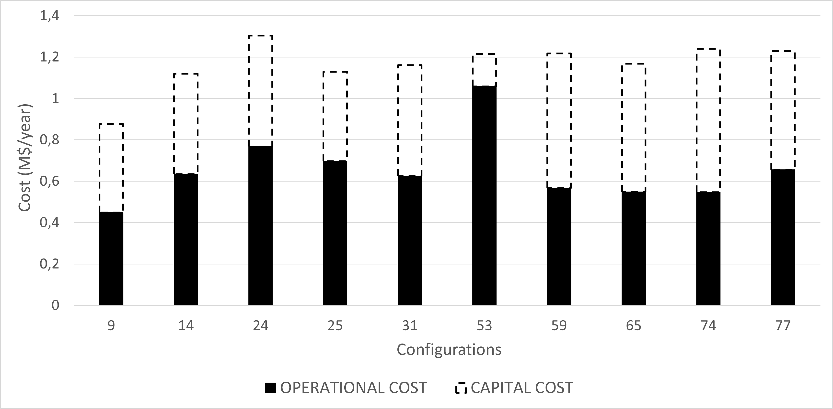
Figure 1. Analysis of Optimal Configurations: Economic Evaluation of Studied Setups.
Upon examining the figure 1, clear patterns and significant differences between various configurations can be identified. Some configurations stand out for having low operating costs, making them attractive options for long-term operations. On the other hand, certain configurations may require higher initial investments (capital costs) but could result in lower operating costs over time. In the base case, representing the direct separation sequence, the annual utility cost is 2.28 million dollars, with a manufacturing cost (COM) of 898,720 dollars per year, resulting in a Total Annualized Cost (TAC) of 2.370 million dollars per year.
Simulation results indicate that the analysed energy integration methods effectively reduce utility costs, enhancing the overall cost-effectiveness of distillation processes. After analysing energy, environmental impacts, and TAC, configuration 9 emerges as optimal, employing a direct sequence with bottom flashing in reboiler BC and condenser B, along with bottom flashing in reboiler C and condenser A. This configuration significantly reduces energy consumption and operational costs by substituting steam with electricity, resulting in a 63% reduction in TAC. The next favourable option is configuration 14, a direct sequence with vapor recompression in reboiler BC and condenser B, along with bottom flashing in reboiler C. It achieves a 53.7% decrease in TAC compared to the base case. Configuration 25, a direct sequence with thermal coupling and vapor recompression in condenser B and reboiler C, is also promising, with a 52.38% reduction in TAC. Another noteworthy alternative is configuration 31, incorporating a direct sequence with internal heat integration in the BC enriching section and vapor recompression in reboiler A and condenser BC. This results in a 51% reduction in TAC. Internal energy integration involves dividing the distillation column into enrichment and stripping sections, enhancing overall energy efficiency through internal heat transfer between process streams. In any case, by adopting these more efficient configurations, industries can gain a competitive advantage while advancing their commitment to sustainable practices. It is evident that investing in energy-efficient solutions is not only an economic necessity but also crucial for building a greener and more resilient industry for the future of our planet.

4.2 LCA Results

The Figure 2 represents the damage impact categories within the ReCiPe 2008 methodology at the endpoint level for all the studied configurations. Each impact category is labelled on the x-axis, while the magnitude of the impact is shown on the y-axis.
The interesting aspect of this graph is that it shows how different configurations or scenarios can have different environmental impacts. To provide a more detailed analysis, we present a refined version of the graph, exclusively showcasing the most cost-effective configurations.
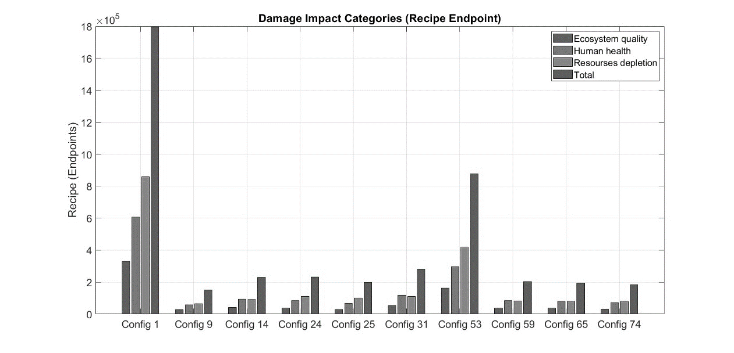
Figure 2. Measurement of Ultimate Environmental Impact Through Three Endpoint Categories in the Life Cycle Assessment (LCA) Process.
In the Figure 2 the first bar for each configuration corresponds to 'Ecosystem Quality,' the second to 'Human Health,' the third to 'Resources Depletion,' and the last bar represents the 'Total' assessment.
The analysis yields a crucial insight: while optimizing costs is essential, an equal emphasis must be placed on considering environmental impact when evaluating configurations. Fortunately, many cost-efficient configurations also demonstrate low environmental impact. This discovery underscores a promising synergy between profitability and sustainability, emphasizing the importance of prioritizing solutions that offer both financial and ecological benefits in industrial and production environments.
  - Conclusions
The study focused on enhancing distillation column efficiency for increased electrification and decarbonization, incorporating simultaneous heat integration alternatives. While individually not groundbreaking, these strategies significantly improved energy efficiency, reducing external energy needs, costs, fossil fuel dependence, and environmental impacts. Pressure swing distillation for benzene, toluene, and p-xylene separation proved effective, with Configuration 9 emerging as optimal. This configuration transitioned from steam to electricity, resulting in a 63% decrease in Total Annualized Cost (TAC). Other options with vapor recompression and thermal coupling demonstrated substantial cost reductions (53.7% to 52.38%) and environmental benefits. The positive correlation between lower energy requirements, costs, and environmental impacts suggests potential win-win scenarios. Life Cycle Assessment identified hotspots, emphasizing the need for eco-friendly solutions. Achieving emission reduction goals requires complementary approaches like hydrogen technologies and CCUS. Energy integration played a crucial role, with Configuration 9 standing out for sustained process improvement. The findings underscore the urgency of addressing challenges in alignment with the Paris Agreement goals.
  - Acknowledgements
The authors acknowledge financial support to the Spanish «Ministerio de Ciencia e Innovación», Spain under project PID2021-124139NB-C21 and to the «Generalitat Valenciana» under project PROMETEO/2020/064.

  - References
Caballero, J.A., Grossmann, I.E., 2006. Structural Considerations and Modeling in the Synthesis of Heat-Integrated−Thermally Coupled Distillation Sequences. Ind. Eng. Chem. Res. 45, 8454–8474. https://doi.org/10.1021/ie060030w
Harwardt, A., Marquardt, W. (2012). Heat-integrated distillation columns: Vapor recompression or internal heat integration? AIChE J. 58, 3740–3750. https://doi.org/10.1002/aic.13775.
Jiang, Z., & Agrawal, R. (2019). Process intensification in multicomponent distillation: A review of recent advancements. Chem Eng Res and Des. 147, 122-145. https://doi.org/10.1016/j.cherd.2019.04.023
Kazemi, A., Mehrabani-Zeinabad, A., Beheshti, M. (2018). Evaluation of various heat pump assisted direct, indirect, Petlyuk and side stripper sequences for three-product separations. Chem. Eng. Sci. 181, 19–35. https://doi.org/10.1016/j.ces.2018.02.007. Kiss, A.A., Smith, R. (2020). Rethinking energy use in distillation processes for a more sustainable chemical industry. Energy. 203, 117788. https://doi.org/10.1016/j.energy.2020.117788.
Miao, G., Ma, Y., Yang, C., Tong, B., Li, G., Xiao, J. (2023). The effective synthesis of heat-pump assisted distillation process with multiple columns for light hydrocarbon separation.Chem. Eng. Sci. 269, 118449. https://doi.org/10.1016/j.ces.2023.118449
Shah, V.H., Agrawal, R., 2010. A matrix method for multicomponent distillation sequences. AIChE J. 56, 1759–1775. https://doi.org/10.1002/aic.12118
Yuan, H., Luo, Y., Yuan, X., 2022. Synthesis of heat-integrated distillation sequences with mechanical vapor recompression by stochastic optimization. Comput. Chem. Eng. 165, 107922. https://doi.org/10.1016/j.compchemeng.2022.107922

