Case study on quality assurance of third-party models for co-simulation using FMI

Isabell Viedta*, René Lorenzb, Leon Urbasa

aTU Dresden, Chair of Process Control System and Process Systems Engineering Group, Helmholtzstr. 14, 01069 Dresden, Germany

bGerman Aerospace Center (DLR), Institute of Engineering Thermodynamics, Energy System Integration, Pfaffenwaldring 38-40, 70569 Stuttgart, Germany

*isabell.viedt@tu-dresden.de

Abstract

In this paper, the workflow for the quality assessment and assurance of modularized simulation models (Viedt et al., 2023) is utilized for the quality assessment of independent third-party simulation models in form of Functional Mock-up Units (FMUs). Besides the process of testing of third-party models, the paper discusses the required information exchange between the manufacturer and the end-user of the simulation models to allow quality assessment and execution in a co-simulation. The case study is based on the use case of a modular Solid Oxide Electrolysis (SOEL) plant. The co-simulation integrates third-party FMUs, such as a SOEL model, with in-house developed FMUs, including the water supply unit and the steam supply unit. A best practice for the quality assessment and exchange of simulation models is derived. This comprises the testing of the third-party models, their subsequent integration into the co-simulation as well as the definition of the information, that is required for the integration of an FMU into the co-simulation.

**Keywords**: Quality assurance, Quality assessment, Co-simulation, Model exchange, Solid Oxide Electrolysis, Modular plants.

* 1. Introduction

Co-simulation is a very powerful tool for the process of plant design, especially of modular plants, as it allows a detailed analysis of the system and the individual components’ behavior in various steady-state and transient operating conditions. A co-simulation of modular process plants must combine, potentially confidential, partial models for each process unit from different manufacturers. As most manufacturers are assumed to be reluctant to share their internal model structure (Mädler et al., 2022), the co-simulation of the partial models can be realized via a standardized interface using Functional Mock-up Units (FMUs). This approach in return also requires a more flexible and modular approach to model quality assessment as, without knowledge of the internal structure, different quality factors like interoperability, usability and flexibility must also be considered.

In this paper, the workflow outlined in Viedt et al. (2023) to conduct quality assurance of modularized simulation models is applied specifically to the evaluation independent third-party simulation models represented as Functional Mock-up Units (FMUs). The paper not only delves into the testing process for third-party models but also explores the essential information exchange between the simulation model manufacturer and end-user. The presented case study focuses on FMUs related to modular solid oxide electrolysis (SOEL) plants. The co-simulation integrates third-party FMUs, such as the SOEL reactor, with internally developed FMUs like the water supply unit and steam supply unit.

The case study results in the identification of a best practice for quality assessment and for the exchange of simulation models. This encompasses the comprehensive testing of third-party models, their seamless integration into the co-simulation framework, and the specification of essential information needed for the integration of a FMU into the co-simulation. This information must be transferred alongside the FMU to ensure a smooth and effective integration process.

* 1. Co-simulation and the Functional Mock-up Interface (FMI)

There are typically three approaches for integrating partial models into a full-system simulation (FMI, 2023):

* **Monolithic Approach:** Construct the entire full-system model within a single tool dedicated to simulation.
* **Model Exchange:** Transfer models between tools to conduct simulations in one of them, allowing for interoperability.
* **Co-simulation:** Loosely couple two or more simulators, enabling a modular, flexible full-system simulation composed of independent sub-simulators.

Co-simulation presents numerous advantages compared to the other two approaches (Hatledal et al., 2019. Its modular design and high flexibility allow the construction of a full-system simulation from distinct stand-alone sub-simulators. Co-simulation enables the utilization of specialized tool chains and domain-specific knowledge already employed by participants and partners, while safeguarding their intellectual property rights through the optional black box approach. Therefore, it is well-suited for addressing the complexity arising from the integration of diverse elements within the system, especially when dealing with numerous partial models originating from different fields and disciplines (Hatledal et al., 2019).

The Functional Mock-Up Interface (FMI) serves as a tool-independent standard, enabling binary compatibility among partial models. FMI is an open and freely usable standard, gaining support from a diverse array of tools such as Dymola, Python, SimulationX, and Simulink. A model adhering to FMI is referred to as a Functional Mock-Up Unit (FMU).

* 1. Quality assurance for simulation models for the exchange of models

The literature identifies various strategies for evaluating simulation model quality, with Balci and Sargent's verification and validation (V&V) methods being prominent (Murray-Smith, 2015; Sargent & Balci, 2017). Despite their comprehensive assessment techniques focusing on model accuracy, a meta-analysis reveals inconsistent use of V&V methods in simulation studies (Sargent & Balci, 2017).

An alternative perspective is presented by Mädler et al. (2021) and Viedt et al. (2023), who explore the applicability of quality assurance methods from software development to simulation models. In this approach, quality assessment strategies adopted from software development, such as test-driven development, and quality models defining features through FCM (factor–criteria–metrics) models, are employed to ensure test-driven modeling. This cross-disciplinary approach aims to enhance the reliability of simulation models by leveraging established practices from software development.

Since the partial models are compiled into a co-simulation framework, quality features outside of the models’ behavior must also be considered to assure successful model interaction. In the realm of co-simulation, the distinction between the person overseeing quality assurance and the model builder introduces a significant challenge. Information exchange is essential for aligning expectations and ensuring that the co-simulation process is not only compliant with standards but also harmonized in terms of modeling methodologies and objectives. For more detail the reader is kindly referred to Mädler et al. (2022) and Viedt et al. (2023).

* 1. Case study

Scaling water electrolysis to the gigawatt level involves modularization following standards such as VDI 2776 and VDI/VDE/NAMUR 2658. This manufacturer-independent integration holds potential for efficient and flexible hydrogen production (Lange et al., 2023). However, implementing modular plants faces challenges from distributed knowledge and diverse simulation models by different manufacturers, hindering the simulation of connected cyber-physical systems (Hamzah et al., 2023).

Among the power-to-hydrogen converters the high-temperature Solid Oxide Electrolysis (SOEL) can operate at the highest efficiency. Its capabilities for heat integration and parallel reduction of CO2 and H2O unlocks further efficiency increase on the system level. Due to these unique features the SOEL is considered as a key technology for Power-to-X processes. In this case study the use case of modular SOEL is utilized to derive a best practice for the quality assessment and exchange of simulation models. The SOEL model (see 4.1) was developed and exported as a black-box FMU by DLR, and handed over to TU Dresden. Hence, the modelling details remained unveiled for TU Dresden and created a realistic test case for the quality-driven model assurance framework. This comprises of the testing of the third-party FMU and its subsequent integration into the co-simulation.

* + 1. HTEL model

The SOEL model is developed using the modelling framework TEMPEST (Santhanam et al., 2018; Tomberg et al., 2022) and exported as an FMU from the commercial editor Dymola. The model represents a single reactor module, comprising the stacks and the power electronics. The stacks are modelled zero dimensionally (0D) with lumped mass, energy and species balances. This simplified model was compared to a more detailed and validated model (Tomberg et al., 2022). The simplified model gives a good estimate of the reactors operating conditions and transient behaviour, while solving very quickly.

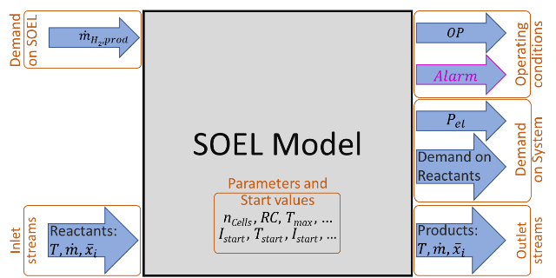

Figure 1: FMU of the SOEL model. The parameters being exchanged with other system components are indicated by arrows pointing into or out of the SOEL model.

For the integration into the co-simulation, certain information on conditions and demands have to be communicated between the component models. The exchanged parameters are represented by the arrows pointing into or out of the SOEL model in Fig.1. The time independent parameters and their start values can be set before starting the simulation run. These comprise parameters defining the reactors size, like number of cells, heat capacitance and area of insulation, operating parameters like nominal operating point, reactant conversion rate (RC) and forming gas flow in standby and operating limitations such as temperatures and voltage limits. The arrow in the top left sets the desired hydrogen production rate, which internally is converted into a current, based on Faraday’s law and the RC. This leads to a demand on electrical power and reactant flow, which is transferred back to the system with the respective arrows on the right. The inlet streams pass the actual properties of the supply streams to the SOEL. Potential mismatches between supply and demand, which may lead to unbeneficial operation or malfunction and throwing of an alarm, can be identified.

Depending on the target of the analysis, the given level of modelling depth in the component models as well as the distribution of control intelligence between component and system level additional information might need to be exchanged. Exemplary, this can be details on supply and product stream qualities, state of health of the component or operation dependent degradation rate. However, the herein presented methodology itself, is generic and therefore independent of the components and exchanged parameters.

* + 1. Model quality assessment

The quality assurance of the individual partial models defines if the FMU can be used in the context of the system simulation at all. If the model does not reach the desired quality as an individual model, the co-simulation will not be successful. In Table 1 an excerpt of the corresponding FCM model for the SOEL unit is shown. As the case study focuses on the applicability of the partial model in a system-wide co-simulation, the focus lays on the quality factors Functional Suitability and Compatibility. The quality assessment of the SOEL partial model shows that the models fulfill the necessary requirements and is therefore qualified to be utilized in the specified plant simulation. The interface specifications for the quality factor compatibility fulfills the required metrics. Furthermore, the FMU’s behavior matches the defined criteria of functional correctness and therefore reaches the quality for the intended purpose.

Table 1: Excerpt of the tested FCM model for the SOEL partial model

|  |  |  |  |  |
| --- | --- | --- | --- | --- |
| Factor | Criteria | Metric | Target | Model value |
| Functional Suitability | Functional Correctness | Min. outlet mass flow SOEL | 0.18 g*s-1 | 0.184 g*s-1 |
| Max. outlet stack temperature | 850 °C | 860°C |
| Compatibility | Interoperability | Interface standard adherence | FMI standard | FMI standard |
| Unit outlet mass flow water/hydrogen | kg*s-1 | kg*s-1 |

* + 1. SOEL system co-simulation

To assess whether the partial model can be used effectively in a plant simulation, the SOEL-FMU is co-simulated below in a simplified plant configuration with the balance of plant components Water Supply, Steam Supply and Air Supply. These balance of plant components are realized as simple, dynamic 0D models in MATLAB/Simulink and also exported as FMUs. The co-simulation of the system is then implemented in Simulink. The system structure is shown in Fig. 2. The balance of plants components can in this context be considered quality assured. The defining factor for the success of the case study is the integration of the SOEL FMU into the plant co-simulation and its subsequent execution. Therefore, we define a simple test case which evaluates the SOEL behavior in the plant context. For that, a steady state scenario 1 at nominal operating point at 60 A is compared to scenario 2, which is a transition from hot-standby to an operating point above nominal. This is achieved by ramping-up the current from 0 to 70 A at a rate of 5 A/min.

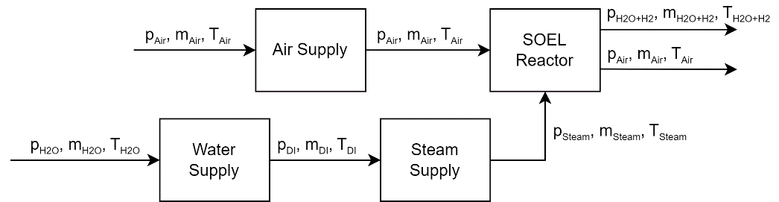

Figure 2: Simplified HTEL system configuration

Fig. 3 shows the product gas mass flow at the outlet of the Steam Supply Unit. The test scenario shows that the dynamic model behavior from the SOEL FMU is propagated in the balance of plant components and therefore correctly reflects the expected plant behavior. The higher mass flow at the beginning of both scenarios reflects the forming gas mass flow that is applied during hot standby.

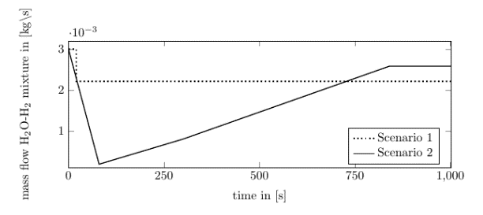

Figure 3: Selected results of the co-simulation, outlet mass flow H2O-H2 mixture

* + 1. Best practice for quality assessment and exchange of simulation models

From the successful integration of the SOEL FMU into a co-simulation the critical information exchange for the simulation execution is derived. Without this meta information the behavior of the FMU cannot be assessed effectively. One valuable information about exchanged FMUs is the model’s purpose. This must include a general understanding of the modeled process, which encompasses the implemented basic process functions and the employed modeling approach and goal. This allows an evaluation if a FMU is generally suitable for the covered process. Besides, detailed specifications about interfaces, including units, purpose and connections with other partial models are fundamental for connecting the partial models. Depending on the co-simulation platform, these interface specifications can either be defined as a formalized system configuration or lay the groundwork for manual model connection through a GUI. Lastly, the boundary conditions and model performance indicators, which allow the individual quality assessment, must also be exchanged along with the FMU. They function as a guideline as to how the FMU shall be utilized in the context of the system simulation by defining clear limits and operating ranges. The specification of key model performance indicators allows for quality assessment of the model's performance. One example for necessary exchanged information in the case study is the modeling approach of the SOEL model. Only because the dynamic modeling approach is known, the end-user expects this dynamic behavior to propagate into the plant simulation as well.

* 1. Conclusions and outlook

The case study shows that the quality-driven model assurance framework is employed to facilitate the successful exchange of partial models, in form of FMUs, and the subsequent co-simulation of a modular electrolysis plant configuration. An early quality assessment of the exchanged FMUs allows for easy suitability assessment and following integration of the partial model into an existing, simplified plant co-simulation.

In a next step, partial models are integrated into the co-simulation from various manufacturers. This process necessitates a more precise definition of interfaces, as iterative adjustments to the models may not be preferable or feasible in many instances. The FCM model in the quality assurance framework can be utilized to pre-define meta information like interface specifications that are necessary for the exchange of FMUs. With this information modeling and standardized interface descriptions come into focus for the exchange of models but also the quality assurance, bringing together standards such as FMI, ISO/IEC 25010, MTP, DEXPI and OntoCAPE.

Acknowledgements

We thank the German Federal Ministry of Education and Research for their financial support within the eModule research project (FKZ 03HY116A-B).

References

FMI. Functional Mock-up Interface Literature. Available online: https://fmi-standard.org/literature/ (accessed on 04 December 2023).

M. Hamzah, M.M. Islam, S. Hassan,M.N. Akhtar, M.J. Ferdous, M.B. Jasser, and A.W. Mohamed, 2023. Distributed Control of Cyber Physical System on Various Domains: A Critical Review. Systems, 11, 4. https://doi.org/10.3390/systems11040208

L.I. Hatledal, A. Styve, G. Hovland, and H. Zhang, 2019. A language and platform independent co-simulation framework based on the functional mock-up interface. IEEE Access, 7.

H. Lange, A. Klose, W. Lippmann, and L. Urbas, 2023. Technical evaluation of the flexibility of water electrolysis systems to increase energy flexibility: A review. International Journal of Hydrogen Energy, 48, 42, 15771–15783. https://doi.org/10.1016/j.ijhydene.2023.01.044

J. Mädler, I. Viedt, J. Lorenz, L. Urbas, 2022. Requirements to a digital twin-centered concept for smart manufacturing in modular plants considering distributed knowledge.In Computer Aided Chemical Engineering, 49, 1507-1512. https://doi.org/10.1016/B978-0-323-85159-6.50251-7

J. Mädler, I. Viedt, L. Urbas, 2021. Applying quality assurance concepts from software development to simulation model assessment in smart equipment, in: Türkay, M., Gani, R. (Eds.), Computer Aided Chemical Engineering. Elsevier, 50, 813–818. https://doi.org/10.1016/B978-0-323-88506-5.50127-3

D.J. Murray-Smith, 2015. Testing and Validation of Computer Simulation Models, Simulation Foundations, Methods and Applications. Springer International Publishing, Cham. https://doi.org/10.1007/978-3-319-15099-4

R.G. Sargent, O. Balci, 2017. History of verification and validation of simulation models. In 2017 winter simulation conference (WSC), 292-307. IEEE.

S. Srikanth, M. P. Heddrich, S. Gupta and K. A. Friedrich, 2018. Transient reversible solid oxide cell reactor operation – Experimentally validated modeling and analysis. Applied Energies. Elsevier, 232, 473–488. https://doi.org/10.1016/j.apenergy.2018.09.186

M. Tomberg, M. P. Heddrich, F. Sedeqi, D. Ullmer, S. A. Ansar and K. A. Friedrich, 2022. A New Approach to Modeling Solid Oxide Cell Reactors with Multiple Stacks for Process System Simulation. J. Electrochem. Soc. 169. https://iopscience.iop.org/article/10.1149/1945-7111/ac7009

I. Viedt, K. R. Gopa, J. Mädler, and L. Urbas, 2023. Quality assessment of partial models for co-simulation of modular electrolysis plants. In Computer Aided Chemical Engineering, 52, 217-1222. https://doi.org/10.1016/B978-0-443-15274-0.50194-3