Combining Energy System Planning with Carbon Emissions Trading Optimisation for Decarbonisation of Emerging Economies

Gul Hameed,a Purusothmn Nair S. Bhasker Nair,b Raymond R. Tan,c Dominic C. Y. Foo,b Michael Short a*

aSchool of Chemistry and Chemical Engineering, University of Surrey, Guildford GU2 7XH, UK

bDepartment Chemical and Environmental Engineering, University of Nottingham Malaysia, Broga Road, Semenyih 43500, Selangor, Malaysia

cDepartment of Chemical Engineering, De La Salle University, 2401 Taft Avenue, Manila 0922, Philippines

*Corresponding Author: [m.short@surrey.ac.uk](mailto:m.short@surrey.ac.uk)

Abstract

This study integrates scalable carbon trading models into an energy planning framework to address carbon emissions challenge associated with increasing energy consumption in emerging economies. The models utilise mixed-integer nonlinear programming (MINLP) formulations to optimise power generation, emissions, and costs. A case study is demonstrated on an ASEAN (Association of Southeast Asian Nations) country, Malaysia. Results reveal that carbon trading enhances both financial gains and environmental sustainability, with direct optimisation (where emission rights or carbon prices are variables) approach proving more effective in maximising carbon markets’ efficacy, leading to better cost to emission ratios when compared to indirect optimisation (with emission rights prices as parameters, estimated via demand-supply curve). For emissions minimisation, direct optimisation resulted in cost to emissions ratios about 1.3 to 2.1 times more than those for indirect optimisation for three out of four studied periods. The study highlights the potential of coordinated emissions trading and optimal investment decision-making, providing valuable insights for energy planning in Malaysia which is aiming for net-zero target by year 2050.

**Keywords**: Emissions trading; energy planning; decarbonisation

* 1. Introduction

Energy planning is pivotal in achieving climate targets, such as net-zero emissions and limiting global temperature rise to 1.5°C above pre-industrial levels. While developed nations are transitioning towards sustainability, the rapid growth of emerging economies, particularly in Southeast Asia, has led to escalating emissions and resource depletion. This has created a web of issues, such as deforestation, global warming, inflation, and energy crisis, inextricably linked to the energy market crisis (specifically the emissions stemming from energy sector), impacting ASEAN and other countries (Kabanov et al., 2022). These challenges can jeopardise ASEAN economies if not managed (“Open Access Government,” 2021). ASEAN region is on track to become the fourth-largest global economy by 2030, with electricity as a key player in meeting energy demands (Permatasari, 2020). However, predominant use of fossil fuels for electricity generation raises concerns about achieving emission targets while sustaining economic growth.

Among ASEAN, Malaysia’s GDP (Gross Domestic Product) growth stands out; however, its significant greenhouse gas (GHG) emissions, exceeding 400 Mt in 2016, position it among top 25 emitters globally (Ertugrul et al., 2016). Malaysia's emissions will persist until at least 2030 due to current coal agreements (Mohd Salleh, 2022). Its commitment to maintain 50% of forest cover to curtail atmospheric CO2 level, highlights its climate action goals (Tan, 2021). Reliance on forests alone is insufficient, necessitating diversification in climate change mitigation strategies to achieve carbon neutrality (Bhasker Nair et al., 2022b). National Renewable Energy Policy set targets (Sustainable Energy Development Authority, 2011), but deeper emissions cuts are required by Malaysia Renewable Energy Roadmap (MRER) (Sustainable Energy Development Authority, 2021), targeting 31% renewable by 2025, further increasing to 40% by 2035. This aligns with Malaysia's goal of a 45% reduction in GHG emissions intensity per unit GDP by 2030, projected to rise to 60% by 2035.

Malaysia’s aim to achieve net-zero by year 2050 requires immediate implementation of feasible climate policies. Energy optimisation tools that may predict decarbonisation pathways are efficient in guiding decision-making towards sustainable energy, appropriate decarbonisation technologies and implementing economic instruments (e.g., carbon trading and taxation). A multi-criteria method for Malaysian energy planning outperformed alternative tools like MARKAL, ENPEP (Energy and Power Evaluation Program), and LEAP (Low Emissions Analysis Platform) in handling diverse objectives (Hussain, 2011). A similar multi-criteria approach proposed solar to be potentially the best renewable energy for Malaysia (Ahmad & Tahar, 2014). An MILP (mixed-integer linear programming) model was developed focusing on CO2 reduction strategies in Iskandar Malaysia via fuel switching, renewable energy, and CCS (Carbon Capture and Storage) deployment (Lee & Hashim, 2014), adoption of these technologies by 2025 was predicted. Results showed a transition from coal to natural gas in existing plants and greater biomass utilisation in new facilities to meet emission targets. An MILP model was developed (Bhasker Nair et al., 2022a), which optimised the deployment of energy resources, alternative fuels (AFs), CCS and NETs (negative emission technologies) for Malaysian power sector to forecast the CO2 neutrality by 2050 scenarios (Bhasker Nair et al., 2022b). This formulation was published as DECarbonisation Options Optimisation (DECO2) software, a tool for multiperiod energy planning and long-term decarbonisation strategy assessment (Bhasker Nair et al., 2023).

A carbon trading policy is inevitable for Malaysia to meet its environmental and economic targets (Izlawanie, 2021). However, uncertainty surrounds the strategies Malaysian government should adopt to navigate carbon trading policies effectively. Combined carbon trading and energy planning optimisation are shown to be promising for both environmental and economic sustainability (Hameed et al., 2023). While previous studies have focused on CCS, the potential of CCUS (Carbon Capture Utilisation and Storage), which not only captures and stores CO2 but also leverages it for economic benefits, remains unexplored for Malaysia. This study bridges these gaps by pioneering Malaysian case study using modified DECO2 framework (Hameed et al., 2023) to include emissions trading, fuel balancing, electricity pricing, and decarbonisation technologies’ (CCUS, NETs, AFs, Renewable Energy) deployment, to determine long-term planning scenarios, and predict carbon and electricity prices.

* 1. Mathematical Model

The original DECO2 framework encompassed a range of power plant types, technologies, and factors like energy prices, budget targets, and emission goals to meet energy demands (Bhasker Nair et al., 2023). The modified DECO2 (Hameed et al., 2023) is an MINLP formulation that introduces a carbon banking financial concept, which encourages the rapid adoption of costly emission reduction technologies and renewable energy solutions to achieve net-zero emissions within electricity sector. This model provides indirect incentives, allowing power plants to obtain profit from emissions trading apart from their core energy operations. When carbon prices are high, plants may opt to install emission reduction technologies to consume fewer emission rights than they have purchased and sell surplus/unused rights to generate revenue and to offset the costs of emission reduction technologies. The enhanced framework also considers electricity prices as variables and incorporates CCUS for additional revenue. Various taxes may also be applied to promote cleaner fuels, ultimately striving for both financial and environmental sustainability. Overall, various interconnected components within the model such as financial factors, energy prices, carbon prices, energy demands, CO2 gas prices, technologies, plants, emissions, etc., will assist the analysis of long-term energy system. Emerging economies have dynamic energy systems, and hence the model can help to assess policies, uncover potential challenges and opportunities for their power sectors.

Two approaches are used for establishing emission prices and caps: a direct optimisation method that simultaneously optimises both prices and caps for each plant in each period, and an indirect optimisation approach where emission prices for each plant are treated as parameters while emission caps are optimised (Hameed et al., 2023). Four-stage carbon trading model as in Eq. (1) is implemented via the above-mentioned approaches.

|  |  |
| --- | --- |
| $$Total Carbon Trading Income=Per Unit Emissions Price ×(\left(Emissions Bought from the Previous Period or Stage 1\right)+\left(Emissions Bought from the Government or Stage 2\right)-\left(Emissions Traded within the Plants or Stage 3\right)-\left(Emissions Left to Trade in the next Period or Stage 4\right))$$ | (1) |

The net income from carbon trading can either be positive (cost) or negative (revenue) depending on the carbon trading prices and the volume of emission rights traded in the final two stages of carbon trading. In the initial two stages, purchasing emission rights from the government adds to plant costs, contributing to government profits. In the third stage, a plant incurs cost when it acquires emission rights from another plant, while it generates revenue if it sells emission rights. It's worth noting that in the same period, one plant may earn revenue while another incurs costs. In the last stage, if a plant consumes more emission rights than it purchases, it pays a cost to the government. Conversely, if the plant has unused emission rights, the government will pay the plant to buy back the unused rights, resulting in revenue for the plant. These rights bought by the government will be available for trading in the next period. Consequently, some plants may generate revenue, while others may incur costs in the fourth stage.

The mathematical formulations handle two objectives (Hameed et al., 2023). In adapted combined energy planning and carbon trading framework, one objective function minimises costs to achieve emission targets, while the other aims to minimise emissions while adhering to a predetermined budget. The complete mathematical model is available on GitHub (<https://github.com/gulhameed361/DECO2-2023v.git>).

* 1. Case Study

This study's primary focus is to create a practical energy planning strategy for advancing decarbonisation initiatives utilising carbon trading in Malaysia. Data used in this study accurately represents Malaysia's existing energy landscape. The planning covers four periods, each spanning five years, encompassing 20 years from 2023 to 2043. Values are predicted for the fifth year of each period, listed as 2028, 2033, 2038 and 2043. Aligning with MRER (Sustainable Energy Development Authority, 2021), the goal is to propose a forward-looking approach to expedite Malaysia's journey towards achieving net-zero by year 2050. A total of 35 existing (15 renewables, 14 natural gas and 6 coal) and 41 planned (19 renewables and 22 natural gas) power plants are considered to meet energy demand between 133 and 166 TWh/y for the duration between years 2023 and 2043 (Bhasker Nair et al., 2022b). It is expected that 19% CO2 emission reduction will be achieved by 2043 from current emission levels, i.e., from 116 Mt/y to 94 Mt/y (Bhasker Nair et al., 2022b).

* + 1. Minimisation of Budget

Direct optimisation (with variable carbon prices) for budget minimisation anticipates an initial focus on installing renewable plants. With time, there's a shift towards natural gas, attributed to CCUS retrofit and the utilisation of AFs in plants. At the same time, rapid decommissioning of coal plants is observed. By year 2043, the optimised model projects the Malaysian power sector to emit 56.3 Mt/y of CO2, much lower than the targeted CO2 emissions of 94 Mt/y (Figure 1). Higher projected carbon prices lead to reasonable electricity prices for years 2028, 2033, 2038, and 2043 (70, 140, 176, and 225 million USD/TWh, respectively), resulting in positive net incomes (profits). On the other hand, budget minimisation via indirect optimisation (with carbon prices as parameters) predicts 30 Mt/y emissions by 2043. Note that, via indirect optimisation, negative net income is foreseen for the first three periods, while the last period predicts positive net income (i.e., profit) possibly because of a comparatively higher carbon and electricity prices.

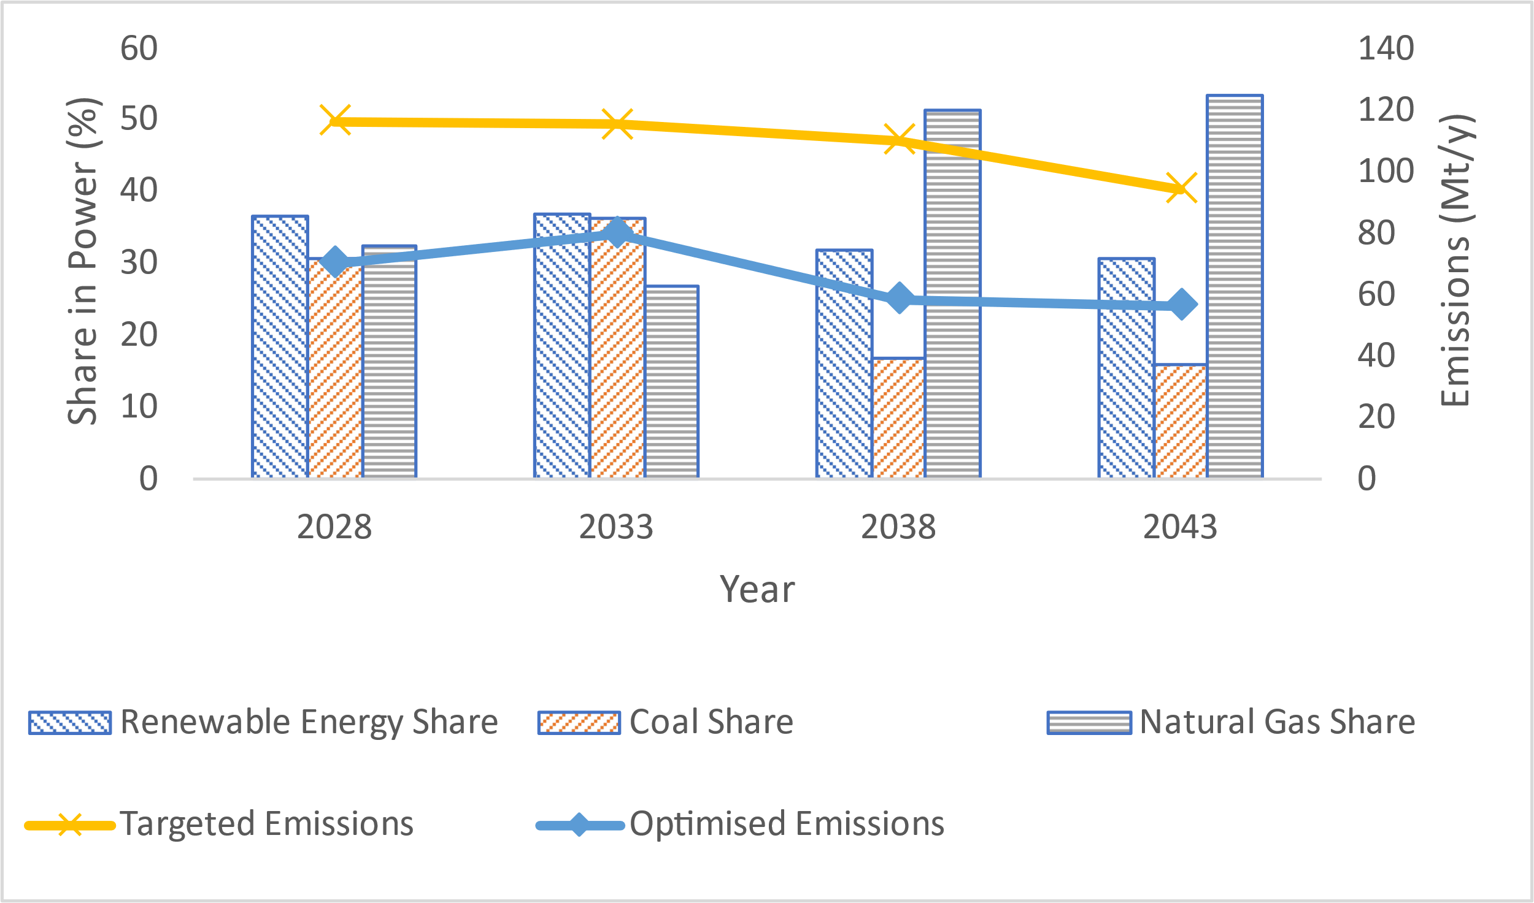

Figure 1. Minimisation of budget with direct optimisation approach

* + 1. Minimisation of Emissions

Minimisation of emissions using direct optimisation (variable carbon prices) envisions an initial emphasis on renewable plants. Natural gas share remains prominent, facilitated by CCUS retrofit and AFs’ usage. The coal share, though minimal, persists due to the use of AFs. In year 2043, the Malaysian power system is projected to achieve zero emissions target via direct optimisation (Figure 2). Higher predicted carbon prices lead to overall positive profits and low electricity prices (70, 125, 173, and 231 million USD/TWh, for 2028, 2033, 2038 and 2043, respectively). Through indirect optimisation model, the Malaysian power system again achieves zero Mt/y of CO2 emissions by year 2043. However, negative net income is projected for the initial three periods, while last period anticipates positive net income due to a relatively higher electricity and carbon prices.

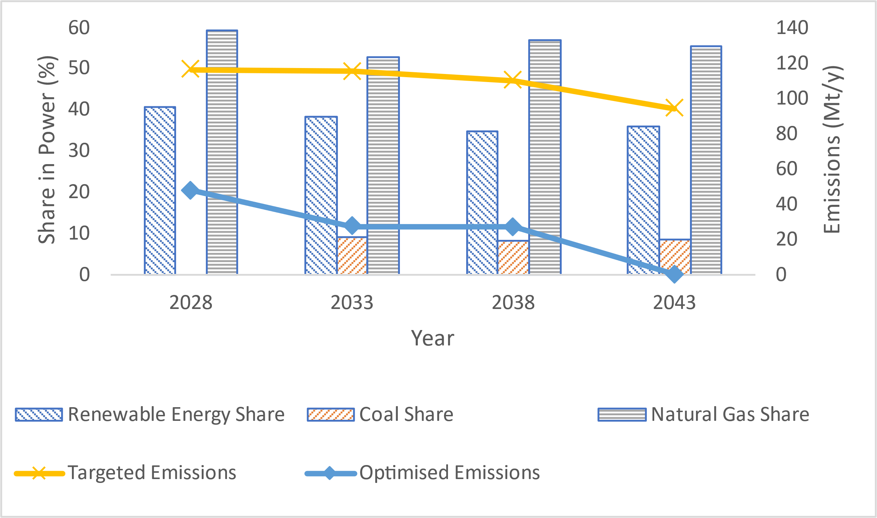

Figure 2. Minimisation of emissions with direct optimisation approach

* + 1. Policy Recommendations for Malaysia

There is a crucial need for high carbon prices to ensure both environmental sustainability and economic viability. The old carbon prices forecasted by British Petroleum (British Petroleum, 2020) are deemed inadequate for the post-COVID energy dynamics. Carbon trading is essential to maintain low electricity prices in Malaysia. Immediate sizeable investments in renewables are recommended, prioritising their deployment in the initial phases of the planning horizon. Given the environmental goals, it is advisable to refrain from signing further coal agreements. Relying solely on renewables for meeting targets may not be economically viable, emphasising the importance of a diversified approach (e.g., adoption of emission mitigation technologies within existing fossil-based plants) for long-term sustainability, therefore, a revision of renewable energy targets is proposed.

* 1. Conclusions

This study underscores the significance of combining energy system planning with carbon emissions trading optimisation for the decarbonisation of emerging economies, with a specific focus on Malaysia. Through meticulous case studies and strategic optimisation approaches, research recommends the involvement of carbon trading policy within energy planning to meet financial and environmental goals. Direct optimisation model achieved 1.67 times lower emissions than the targets for budget minimisation and achieved zero emissions for emissions minimisation. This advocates Malaysia toward achieving its ambitious net-zero targets by year 2050. Case tests should be extended to encompass other ASEAN countries, delving into carbon trading for regional emission rights allocation and industrial emissions management.

Acknowledgement

This project is funded by the Foreign, Commonwealth & Development Office (FCDO), UK through its call for proposals “Research and Innovation for Development in ASEAN (RIDA)”

References

Ahmad, S., & Tahar, R. M. (2014). Selection of renewable energy sources for sustainable development of electricity generation system using analytic hierarchy process: A case of Malaysia. *Renewable Energy*, *63*, 458–466. https://doi.org/https://doi.org/10.1016/j.renene.2013.10.001

Bhasker Nair, P. N. S., Foo, D. C. Y., Tan, R. R., & Short, M. (2022). A Software Framework for Optimal Multiperiod Carbon-Constrained Energy Planning. In Y. Yamashita & M. Kano (Eds.), *Computer Aided Chemical Engineering* (Vol. 49, pp. 1177–1182). Elsevier. https://doi.org/https://doi.org/10.1016/B978-0-323-85159-6.50196-2

Bhasker Nair, P. N. S., Short, M., Foo, D. C. Y., & Tan, R. R. (2022). A Process Integration-Based Optimal Decarbonisation Policymaking Software Framework. In L. Montastruc & S. B. T.-C. A. C. E. Negny (Eds.), *32 European Symposium on Computer Aided Process Engineering* (Vol. 51, pp. 1603–1608). Elsevier. https://doi.org/https://doi.org/10.1016/B978-0-323-95879-0.50268-X

Bhasker Nair, P. N. S., Tan, R. R., Foo, D. C. Y., Gamaralalage, D., & Short, M. (2023). DECO2 - An Open-Source Energy System Decarbonisation Planning Software including Negative Emissions Technologies. In *Energies* (Vol. 16, Issue 4). https://doi.org/10.3390/en16041708

British Petroleum. (2020). Energy outlook 2020 edition. *London: BP*.

Ertugrul, H. M., Cetin, M., Seker, F., & Dogan, E. (2016). The impact of trade openness on global carbon dioxide emissions: Evidence from the top ten emitters among developing countries. *Ecological Indicators*, *67*, 543–555. https://doi.org/https://doi.org/10.1016/j.ecolind.2016.03.027

Hameed, G., Nair, P. N. S. B., Tan, R. R., Foo, D. C. Y., & Short, M. (2023). A novel mathematical model to incorporate carbon trading and other emission reduction techniques within energy planning models. *Sustainable Production and Consumption*, *40*, 571–589. https://doi.org/https://doi.org/10.1016/j.spc.2023.07.022

Hussain, N. (2011). Long Term Sustainable Energy Planning for Malaysia: A Modelling and Decision Aid Framework. *Journal of Energy and Environment*, *3*(1). https://journal.uniten.edu.my/index.php/jee/article/view/118

Izlawanie, M. (2021, November 3). *Challenges in implementing carbon pricing policy in Malaysia*. THE BARTLETT. https://www.ucl.ac.uk/bartlett/news/2021/nov/challenges-implementing-carbon-pricing-policy-malaysia

Kabanov, O. V., LyubovPudeyan, V. M., Sadunova, A. G., & Avlasevich, A. I. (2022). ASEAN ENERGY MARKET CRISIS. *Procedia Environmental Science, Engineering and Management*, *9*, 751–757.

Lee, M. Y., & Hashim, H. (2014). Modelling and optimization of CO2 abatement strategies. *Journal of Cleaner Production*, *71*, 40–47. https://doi.org/https://doi.org/10.1016/j.jclepro.2014.01.005

Mohd Salleh, N. H. (2022). *Malaysia Now*. https://www.malaysianow.com/news/2022/04/13/is-malaysia-ready-to-leave-coal-behind-in-renewable-energy-push

Open Access Government. (2021). *Environment News*. https://www.openaccessgovernment.org/asean-climate-change/123591/

Permatasari, Y. (2020). Building Indonesia through ASEAN economic community. *Journal of ASEAN Studies*, *8*(1), 81–93.

Sustainable Energy Development Authority. (2011). *NATIONAL RENEWABLE ENERGY POLICY*. https://www.seda.gov.my/policies/national-renewable-energy-policy-and-action-plan-2009/

Sustainable Energy Development Authority. (2021). *MALAYSIA RENEWABLE ENERGY ROADMAP (MYRER)*. https://www.seda.gov.my/reportal/myrer/

Tan, Y. (2021). *Climate Tracker Asia*. https://climatetracker.asia/fact-sheets/what-is-happening-to-malaysias-rainforests/