An Application of a New Nonlinearity Measure to a Rotary Dryer Model
Jan M. Schaßbergerª, Anton Ponomarevª, Veit Hagenmeyerª, Lutz Gröllª
ªKarlsruhe Institute of Technology, Hermann-von-Helmholtz-Platz 1, 76344 Eggenstein-Leopoldshafen, Germany
jan.schassberger@kit.edu
Abstract
Nonlinearity measures can be a helpful tool when selecting a control concept, especially if flexible plant operation over a large operating range is of importance. In this paper, the application of a new nonlinearity measure to a distributed-parameter rotary dryer model is presented. Besides assessing the model’s nonlinearity, special emphasis is put on the measure’s application and its interpretation based on the model. The analysis shows that the nonlinear model can be represented by a linear approximation in a large operating range, if operating conditions that lead to complete drying of the particles are avoided.
Keywords: Nonlinearity analysis, Rotary dryer, Partial differential-algebraic equation
  - Introduction
Demand-side flexibility is seen as a key factor in the transition of the energy grid towards renewable energy sources (Heffron et al., 2020). The provision of flexibility goes hand in hand with changes in process variables, for instance due to the variation of the material throughput. In order to continuously meet the product requirements despite flexible operation, a precise process control is required. An important factor in the design of a control concept is the nonlinearity of the system, e.g. whether sufficient performance can be expected from a linear control concept when applied to nonlinear system dynamics. While a linear controller is often sufficient for the current predominantly stationary operation, this question is more difficult to answer when considering controller design for demand-side flexibility. One approach that can be helpful in assessing this question is the use of nonlinearity measures. As one application, these measures allow the systematic investigation of the nonlinearity of a model by comparing it with its linear approximation. In the following, we describe the application of a new dynamic nonlinearity measure to a distributed-parameter rotary dryer model. On the one hand, the contribution focuses on the interpretation of the measure based on the model and the assessment of its nonlinearity. On the other hand, the article addresses challenges that arise in the measure’s application to models of industrial processes instead of the usually considered rather academic concentrated-parameter examples. We first describe the considered dryer model in Section 2, before analysing the model's nonlinearity in Section 3.
  - Rotary Dryer Model
As a detailed description of the considered rotary dryer model would go beyond the scope of this article, we will limit ourselves to the core ideas and the presentation of the model structure. For a more detailed description, the reader is referred to Schaßberger et al. (2023). The dryer model is based on the idea of two interacting plug flows exchanging energy and material while traveling through the dryer. Each phase is modeled by one equation for the mass density of dry matter, for water/vapor and the temperature. Furthermore, the model covers the dryer shell and heat losses to the environment. Different from most existing models, time- and location-dependent gas and particle velocities are regarded. For modeling heat and mass transfer, common approaches are used that assume nonlinear transfer coefficients. The obtained model is given by a system of quasilinear partial differential-algebraic equations (PDAEs) in conservative form
$$E∂_{t}x\left(z,t\right)+∂_{z}F_{1}\left(x\left(z,t\right)\right)=F_{0}\left(x\left(z,t\right),d\left(t\right)\right), \\ x\left(z,0\right)=x_{0}\left(z\right), \\ x\left(0,t\right)=G\left(u\left(t\right)\right), \\ y\left(t\right)=H\left(x\left(l,t\right)\right),$$ | (1)
where $t∈R^{+}$ and $z∈\left[0, l\right]⊂R$. The state vector $x\left(z,t\right)∈\{x∈R^{8}:x_{i}≥0, i=1,2,...,8\}$ consists of the mass densities of the phases, their temperatures, the temperature of the shell and the gas velocity. From the input streams $u\left(t\right)∈\{R^{6}:u_{i}≥0,i=1,2,...,6\}$, the boundary conditions of the PDEs are calculated using the function $G\left(⋅\right)$. In addition to all elements of the state vector belonging to the particle and gas phase, also the mass shares of vapor and water at $z=l$are considered as output variables $y\left(t\right)∈\{y∈R^{9}:y_{i}≥0,i=1,2,...,9\}$ determined by means of $H\left(⋅\right)$. The variable $d\left(t\right)∈R$ represents the disturbances corresponding to the ambient temperature. The remaining system parts are the singular diagonal matrix $E$ as well as the nonlinear functions $F_{1}\left(⋅\right)$ and $F_{0}\left(⋅\right)$. Linearization of (1) using the Gateaux derivative w.r.t. an equilibrium leads to a system of linear PDAEs
$$E∂_{t}\tilde{x}\left(z,t\right)+A_{1}\left(z\right)∂_{z}\tilde{x}\left(z,t\right)=A_{0}\left(z\right)\tilde{x}\left(z,t\right)+b_{d}\left(z\right)\tilde{d}\left(t\right), \\ \tilde{x}\left(z,0\right)={\tilde{x}}_{0}\left(z\right), \\ \tilde{x}\left(0,t\right)=B\tilde{u}\left(t\right), \\ \tilde{y}\left(t\right)=C\tilde{x}\left(l,t\right),$$ | (2)
where $A_{1}\left(z\right), A_{0}\left(z\right)$ are matrices and $b_{d}\left(z\right)$a vector with spatially varying coefficients. The matrices $B$ and $C$ have constant entries. The variables $\tilde{u}\left(t\right), \tilde{x}\left(z,t\right), \tilde{y}\left(t\right)$ and $\tilde{d}\left(t\right)$ refer to that of the nonlinear PDEs, but now to be understood as deviations from their values at the considered equilibrium.
  - Nonlinearity Analysis
Many approaches for assessing the nonlinearity of models exist in literature (Reyero-Santiago et al., 2020). Most approaches are based on the comparison of the nonlinear $N\left(⋅\right):U→Y$ and the linear $L\left(⋅\right):U→Y$ input-output map of a system, where $U$ is the set of admissible input signals and $Y$ the set of admissible output signals. Hence, the explicit realisations of the respective systems are disregarded in these approaches. However, all existing approaches of this type have certain disadvantages. First, in general also the initial values of the nonlinear and the linear system need to be taken into account. This not only increases the calculation effort but poses difficulties when different system classes like an infinite- and a finite-dimensional system are to be compared. Second, the existing measures typically consider arbitrary input signals, which has little relevance for many practical applications. For this reason, we propose a new measure based on the classical idea (Kelemen, 1986) that the output $y$ of a (nonlinear) system
$$y=N\left(u;x_{0}\right),$$ | (3)
moves close to a sequence of points in the equilibrium set $Y_{eq}$ during the transition between two operating points $y_{0}, y_{1}∈$ $Y_{eq}$ for a sufficiently long transition time $T$. The variable $x_{0}$denotes the initial values of the system corresponding to $y_{0}$. This motivates the consideration of $N\left(⋅\right)$as a sum of a static input-output map $y_{\text{eq}}\left(u\right)$ and a dynamic part quantifying the deviation from equilibrium corresponding to the current input $u$. Thus, the approach makes full use of the typically approximately known static input-output map $y_{\text{eq}}\left(u\right)$. The linear dynamical approximation $y_{\text{lin}}$of $y$ can be defined as
$y_{\text{lin}}=y_{\text{eq}}\left(u\right)+L\left(u-u_{0}\right),$ where $L\left(0\right)=0, \lim_{t→∞ }{L\left(u\right)(t)}=0,$ | (4)
where $u_{0}$ is the input corresponding to $y_{0}$. Due to the additional requirements, the linear map $L\left(⋅\right)$ is a system with a static gain equal to zero. This approach has the advantage that, due to the latter property, zero initial values of the linear system can be considered in case of transitions between equilibria. With these system descriptions, the difference between the nonlinear output and its approximation denoted by$ρ\left(⋅\right)$ can be written as
$$ρ\left(N,L;u,y_{0},y_{1}\right)=N\left(u;x_{0}\right)-y_{\text{eq}}\left(u\right)-L\left(u-u_{0}\right),$$ | (5)
with which the following nonlinearity measure $ν\left(N\right)$ can be defined
$$ν\left(N\right)=\inf_{L∈L}{\sup_{\begin{aligned}y_{0},y_{1}∈Y_{eq} \\ u∈U_{fwd} (y_{0},y_{1})\end{aligned}}{||ρ\left(N,L;u,y_{0},y_{1}\right)||}.}⁡$$ | (6)
This means that $ν\left(⋅\right)$is the lowest maximal value of $ρ\left(⋅\right)$for all linear maps $L\left(⋅\right)$ within a permissible set $L$, outputs $y_{0}$ and $y_{1}$ in the set of permissible equilibria $Y_{eq}$ and permissible inputs $U_{fwd}$ steering the system from $y_{0}$ to $y_{1}$. In order to make this measure applicable to the purpose of the paper, the sets considered in (6) must be narrowed down. While the set $L$ can possibly cover all linearizations of the nonlinear system about $y∈Y_{eq}$, we limit ourselves in the present contribution to the linearization with respect to the nominal operating point. Thus, the infimum in (6) can be omitted. On the one hand, this is a natural choice from a control engineering point of view, but on the other hand, it in general leads to an overestimation of the model's nonlinearity. In addition, for a system with a large number of inputs and disturbances, as in the case under consideration, it is necessary to severely restrict the sets $Y_{eq}$and $U_{fwd}$ in order to limit the number of simulations to be carried out. Instead of considering all changes between operating point $y_{0}, y_{1}∈Y_{eq}$, in the following we examine ramp-shaped changes starting from $y_{0}$, so that the starting point is fixed to the nominal operating point. Of course, the output of a nonlinear system being steered from an operating point $y_{1}$ back to $y_{0}$ generally behaves differently than the application of a similar change of the input starting from $y_{0}$. However, for a reasonable choice of the operating range that is not in close proximity to a critical point, this should not be too much of a simplification for most technical systems. Nevertheless, in order to exclude the existence of such points, like e.g. hysteresis, we also consider the case of steering the system from all possible $y_{1}$ back to $y_{0}$ for one particular input. By fixing the starting point $y_{0}$, the input signal is parameterized by $y_{1}$ and a transition time $T∈T$. The input signal ranges examined in the following comprise a symmetrical interval of at least 20 % around the nominal operating point as standard. The intervals are shortened if large deviations between the linear and the nonlinear model already occur for lower variations of the respective input or if the input loses its physical relevance, e.g. humidity below zero. Within the present contribution, (6) is evaluated separately for each output, where $L^{∞}\left(R,R\right)$ is considered. Thus, the nonlinearity measure simplifies to
$$ν\left(N\right)=\sup_{\begin{aligned}y_{1}∈Y_{eq} \\ u∈U_{fwd} (y_{1},T;y_{0})\end{aligned}}{{||ρ\left(N,L;y_{1},T\right)||}_{L^{∞}}}.⁡$$ | (7)
Whereas the nonlinear system model (1) can be directly used to represent $N\left(⋅\right)$, the linear system model (2) cannot be applied directly for $L\left(⋅\right)$ because the requirement of zero static gains is not met. However, by using the static characteristic curve $y_{\text{lin}}-y_{0} =K⋅\left(u-u_{0}\right)$ of (2), a linear map in the sense of the norm can be defined by
$$L\left(u-u_{0}\right)=\tilde{L}\left(u-u_{0}\right)-K⋅\left(u-u_{0}\right),$$ | (8)
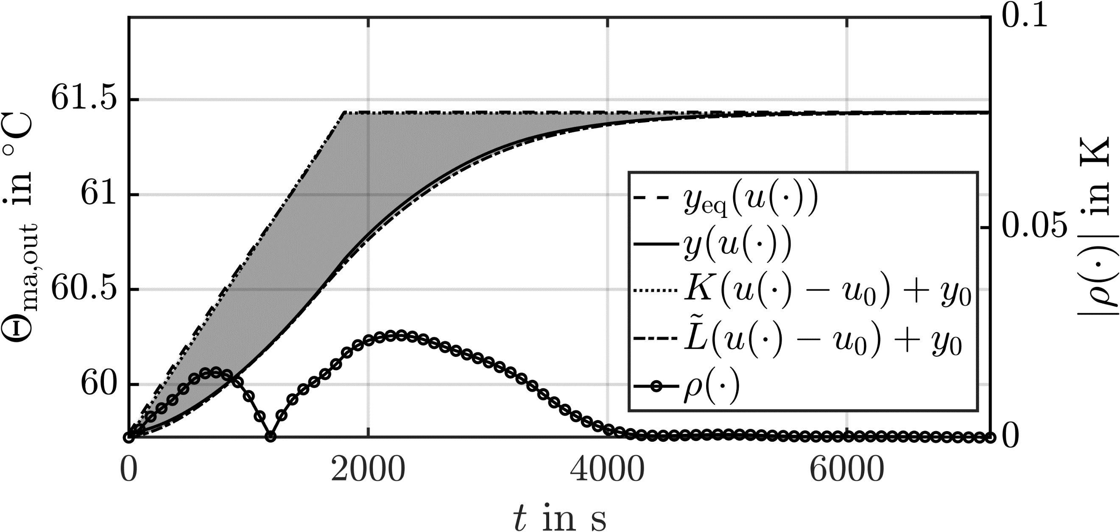 | 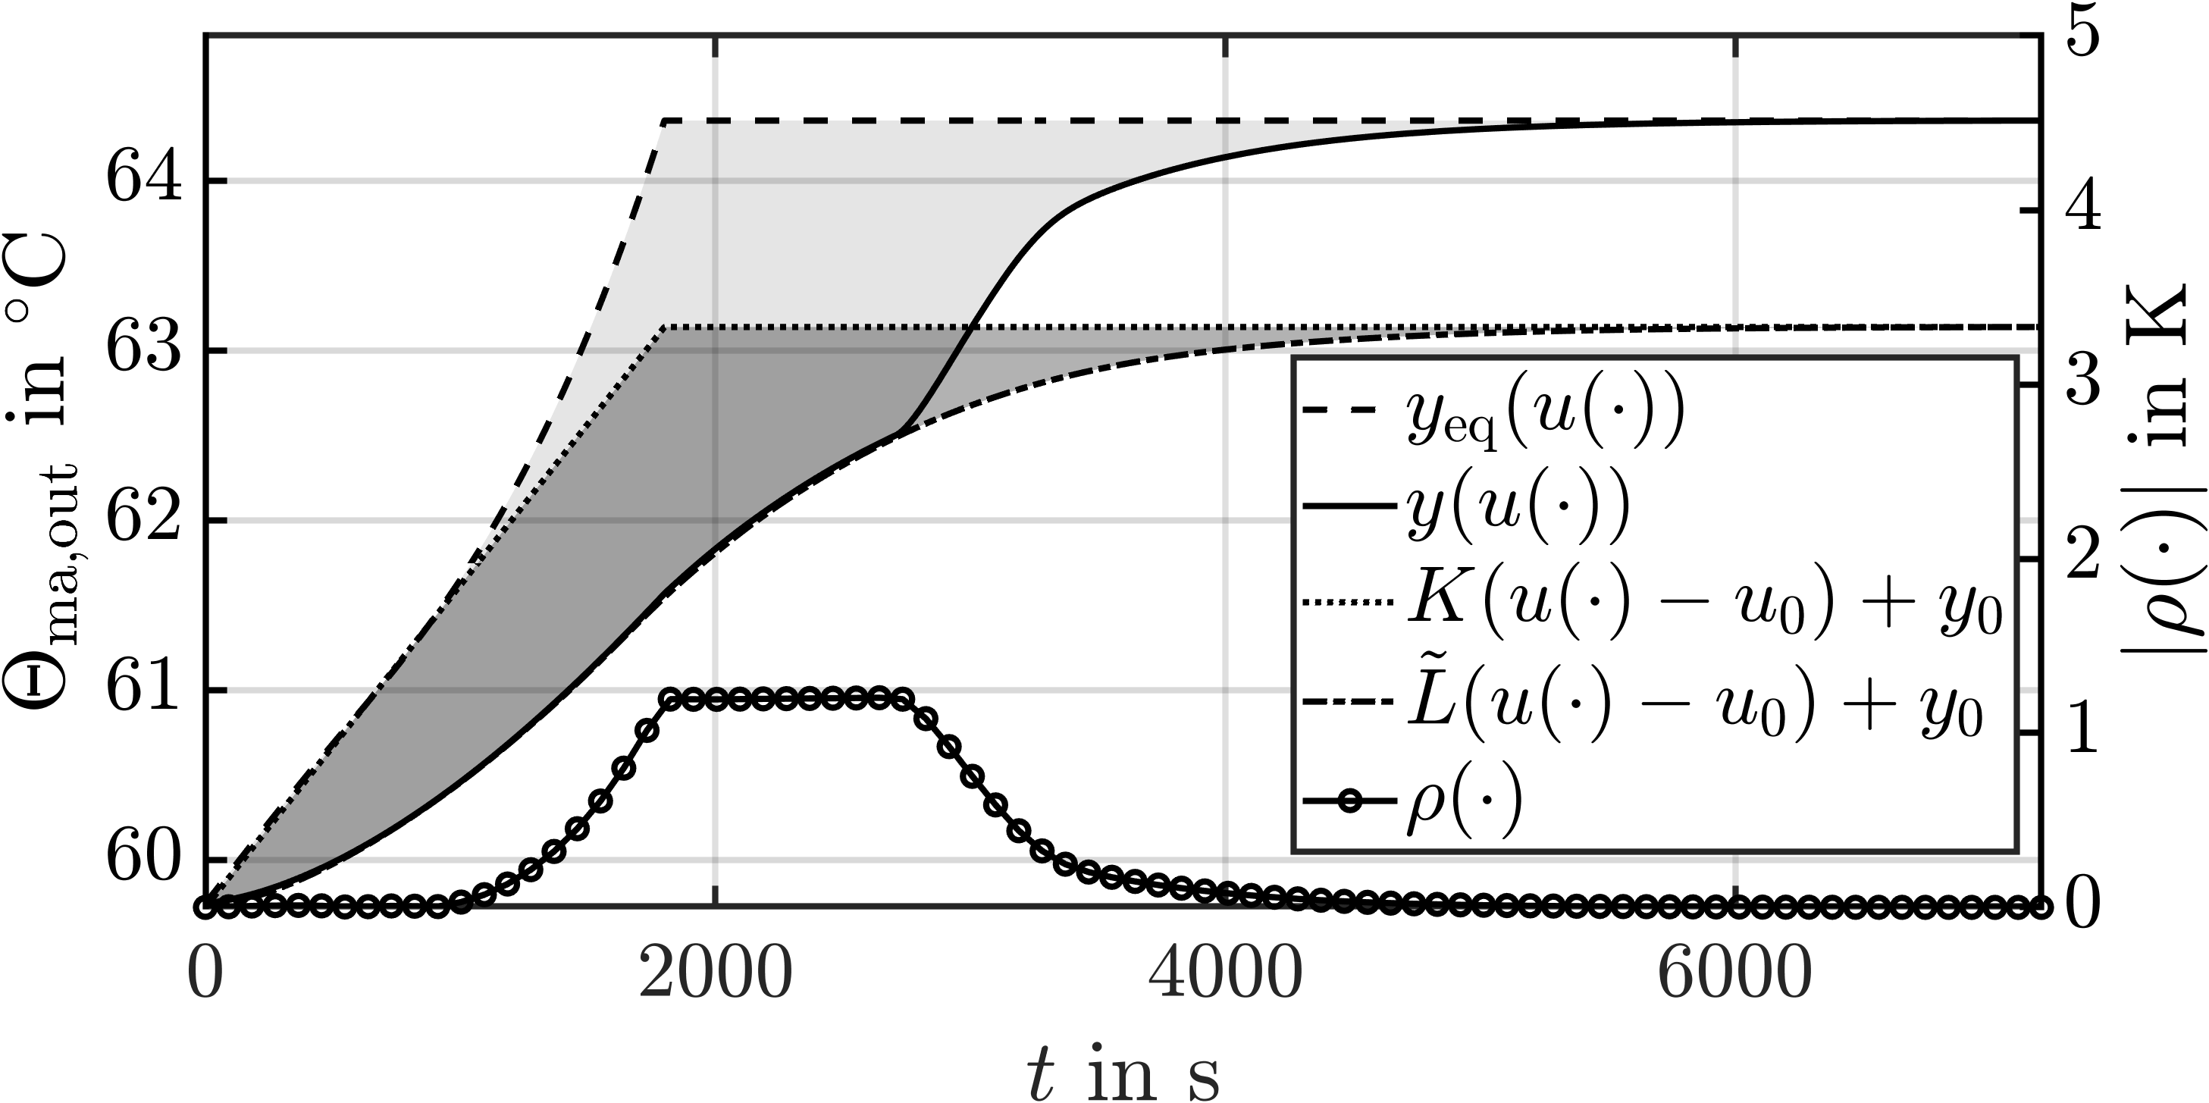
(a) ${\dot{m}}_{\text{ma,in}}={\dot{m}}_{\text{ma,in,0}}+0.1$kg$⋅$s⁻¹. | (b) ${\dot{m}}_{\text{ma,in}}={\dot{m}}_{\text{ma,in,0}}+0.2$kg$⋅$s⁻¹.
Figure 1: $ρ\left(⋅\right)$and its components evaluated for $Θ_{\text{ma,out}}$ and $T=1800$ s.
where $\tilde{L}\left(⋅\right)$is realised by (2). As the expression for $ρ\left(⋅\right)$ is rather abstract, it is shown in Figure 1 together with all the components used in its calculation. The variables of the linear system are shown shifted to the nominal operating point $y_{0}$ for display reasons. The ramp-shaped curves in Figure 1 correspond to the static input-output maps applied to the input signal. Whereas the static input-output map of the linear system is obviously only a scaling of the input signal, a distortion due to the nonlinearity of $y_{\text{eq}}\left(u\right)$can be observed in Figure 1b. The remaining components of $ρ\left(⋅\right)$ are the gas temperatures calculated by means of $N\left(⋅\right)$ and $\tilde{L}\left(⋅\right)$. After inserting (8) in (5), $ρ\left(⋅\right)$ can be interpreted as the difference between the areas spanned by the static input-output map and the transient system response of the linear and nonlinear system, respectively. This results in specific properties of the $ρ\left(⋅\right)$ and $ν\left(⋅\right)$. First, $ρ\left(⋅\right)$ becomes zero for $t→∞$ so that integral norms can be applied. Second, $ν\left(⋅\right)$ decreases for increasing $T.$ Third, the deviation in the static input-output relation $y_{\text{eq}}\left(u\right)$ and $K⋅\left(u-u_{0}\right),$become visible in the measure $ν\left(⋅\right)$ for small $T$. The latter two properties are particularly interesting with regard to linear control, as they directly account for the static differences between the original nonlinear model and the linear approximation as a function $T$. These differences can be typically well compensated by an integrator component in the controller for large values of $T$, whereas they can be problematic for small ones. Since the steady-state deviation between the models takes an important role in the measure and to simplify its interpretation, we will first look at the static deviations in Section 3.1 and consider afterwards the dynamic nonlinearity measure $ν\left(⋅\right)$ in Section 3.2. Due to the large number of possible input-output combinations, only a very small number of results can be presented within the paper. The results are shown exemplarily using the gas outlet temperature $Θ_{\text{ma,out}}$for a varying mass flow of gas ${\dot{m}}_{\text{ma,in}}$ to the dryer and its vapor share $w_{\text{v,in}}.$
    - Steady-State Nonlinearity
The deviations between $y_{\text{eq}}\left(u\right)$ and $K⋅\left(u-u_{0}\right)$ are predominantly caused by the nonlinearity of $y_{\text{eq}}\left(u\right)$ visualized in Figure 2. The Figures show the transient response of $Θ_{\text{ma,out}}$ for several values of ${\dot{m}}_{\text{ma,in}}$, where their stationary values correspond to $y_{\text{eq}}\left(u\right).$ From Figure 2, the existence of discontinuous nonlinearities, like hysteresis, can be
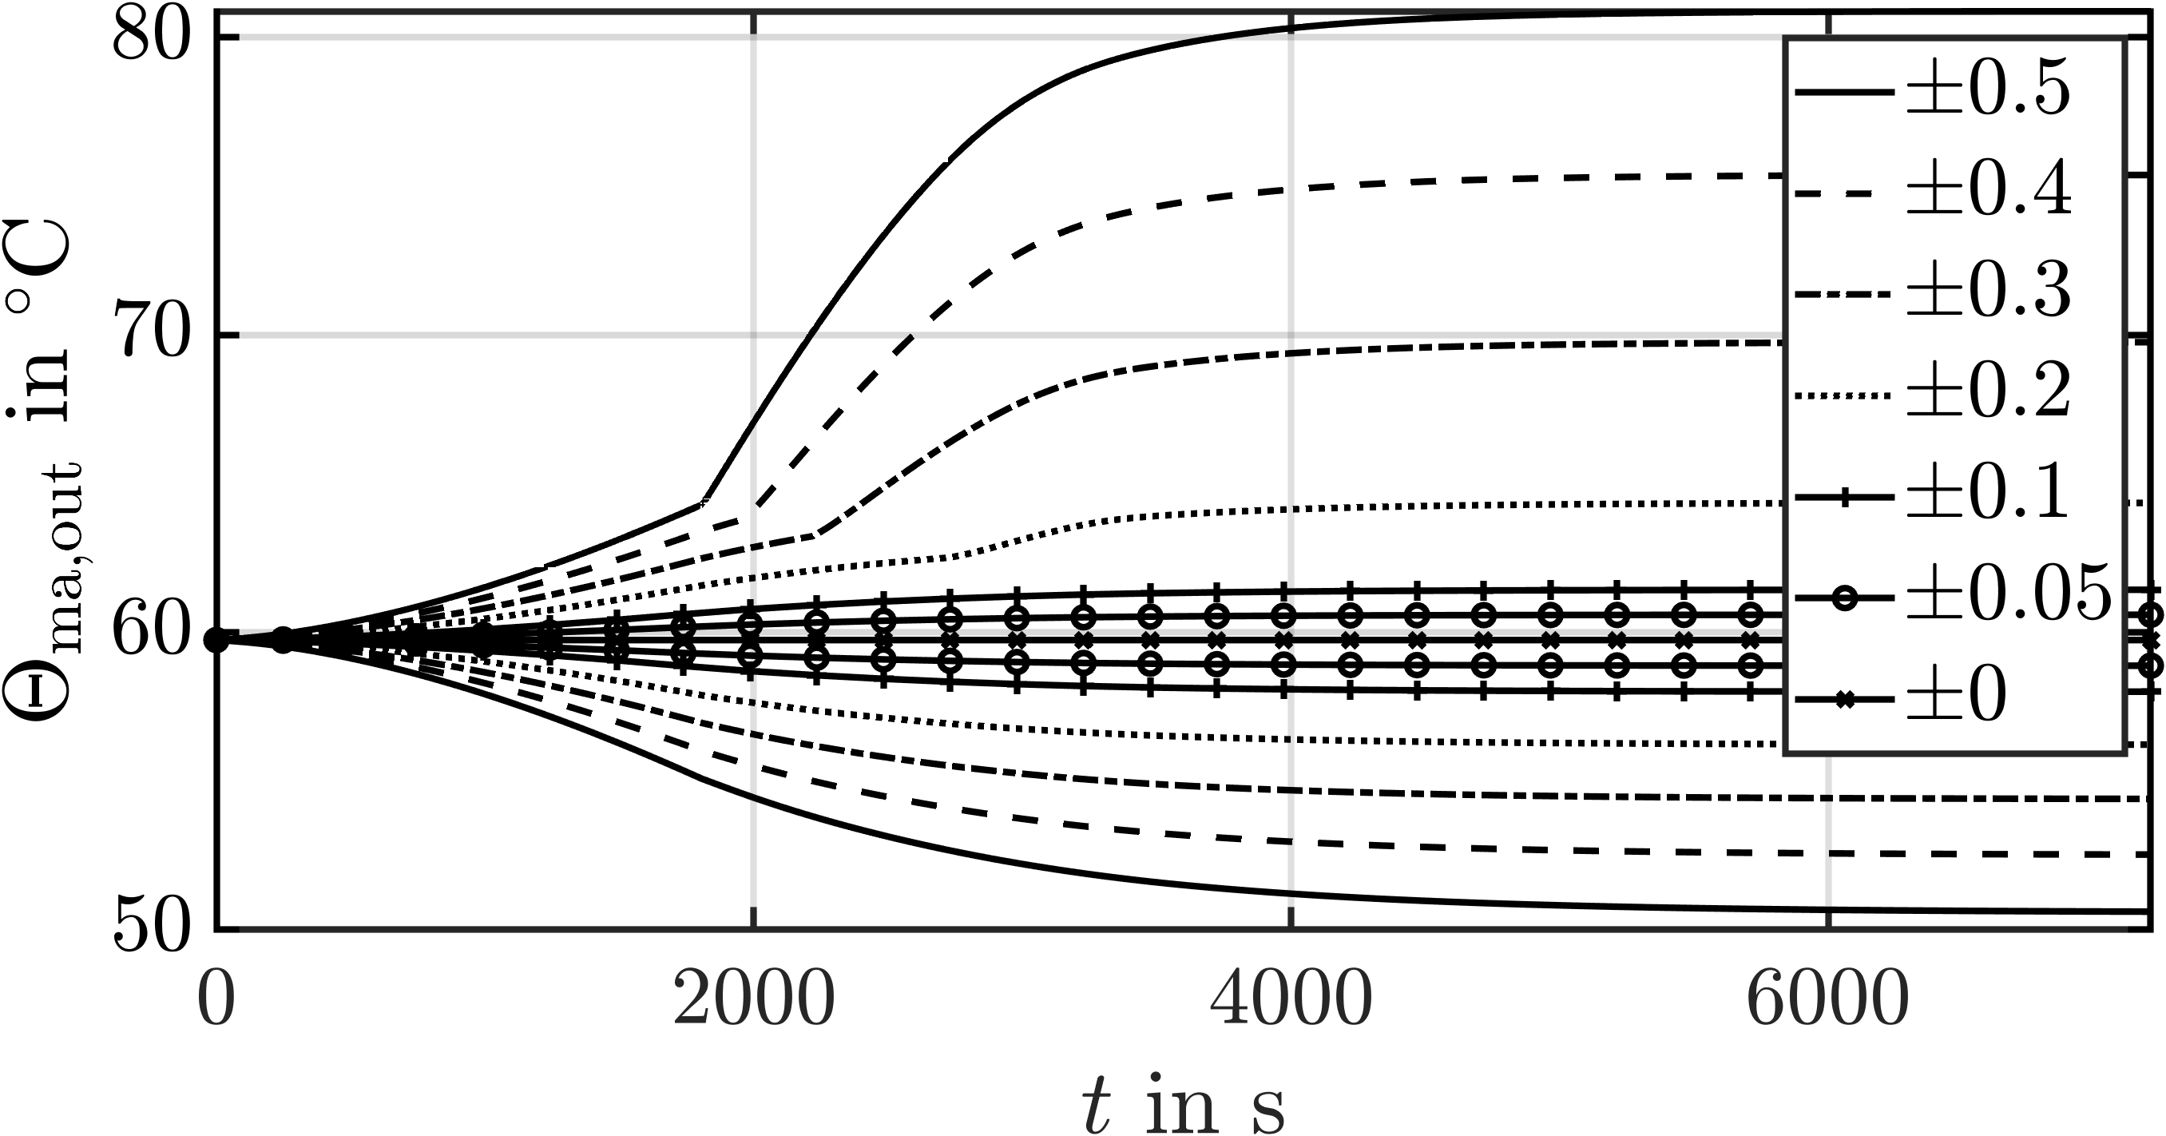 | 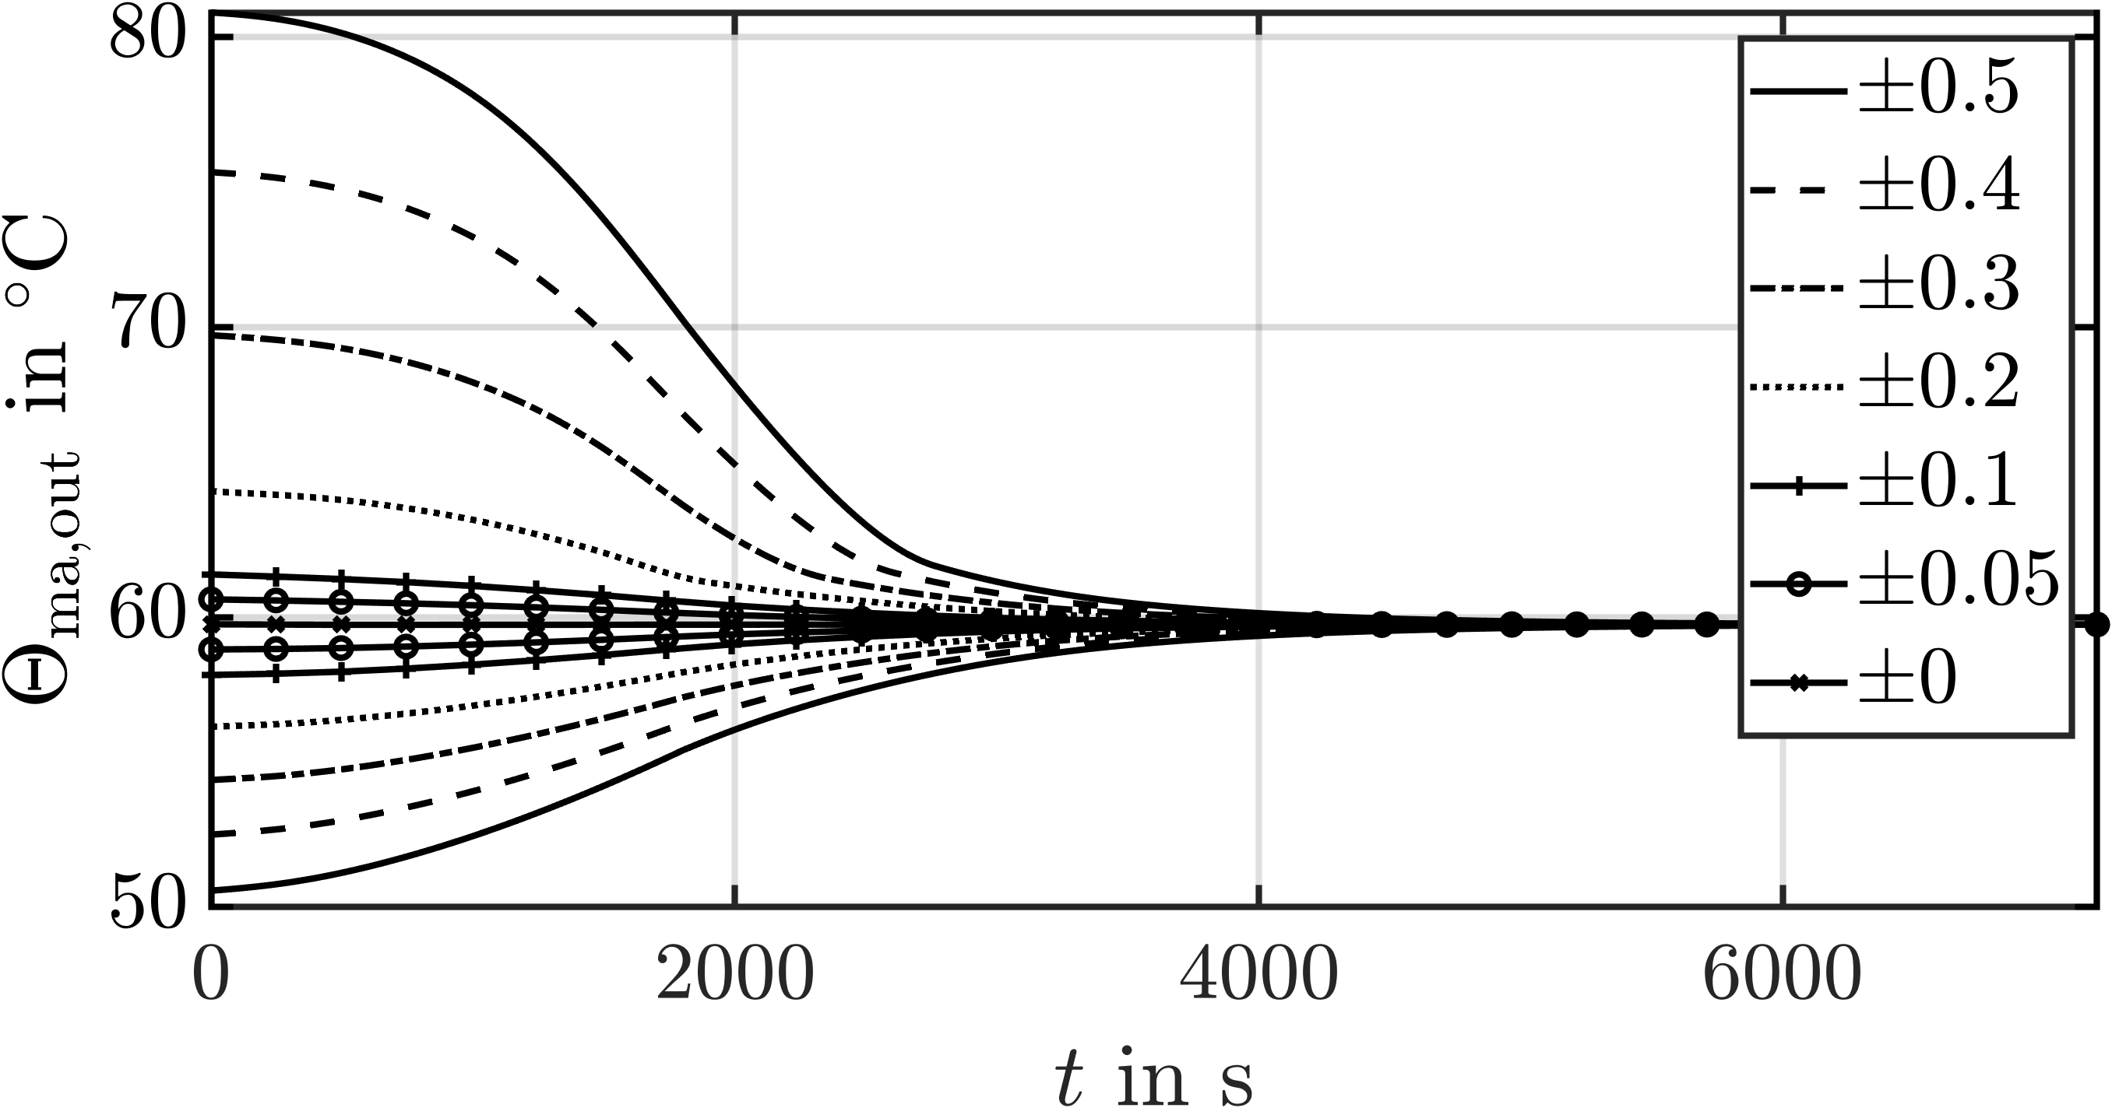
(a) From $y_{0}$ to several $y_{1}$. | (b) From several $y_{1 }$to $y_{0}$.
Figure 2: $Θ_{\text{ma,out}}$ for several ${\dot{m}}_{\text{ma,in}}$ specified in kg$⋅$s⁻¹ w.r.t. ${\dot{m}}_{\text{ma,in,0}}$ for $T$ =1800 s.
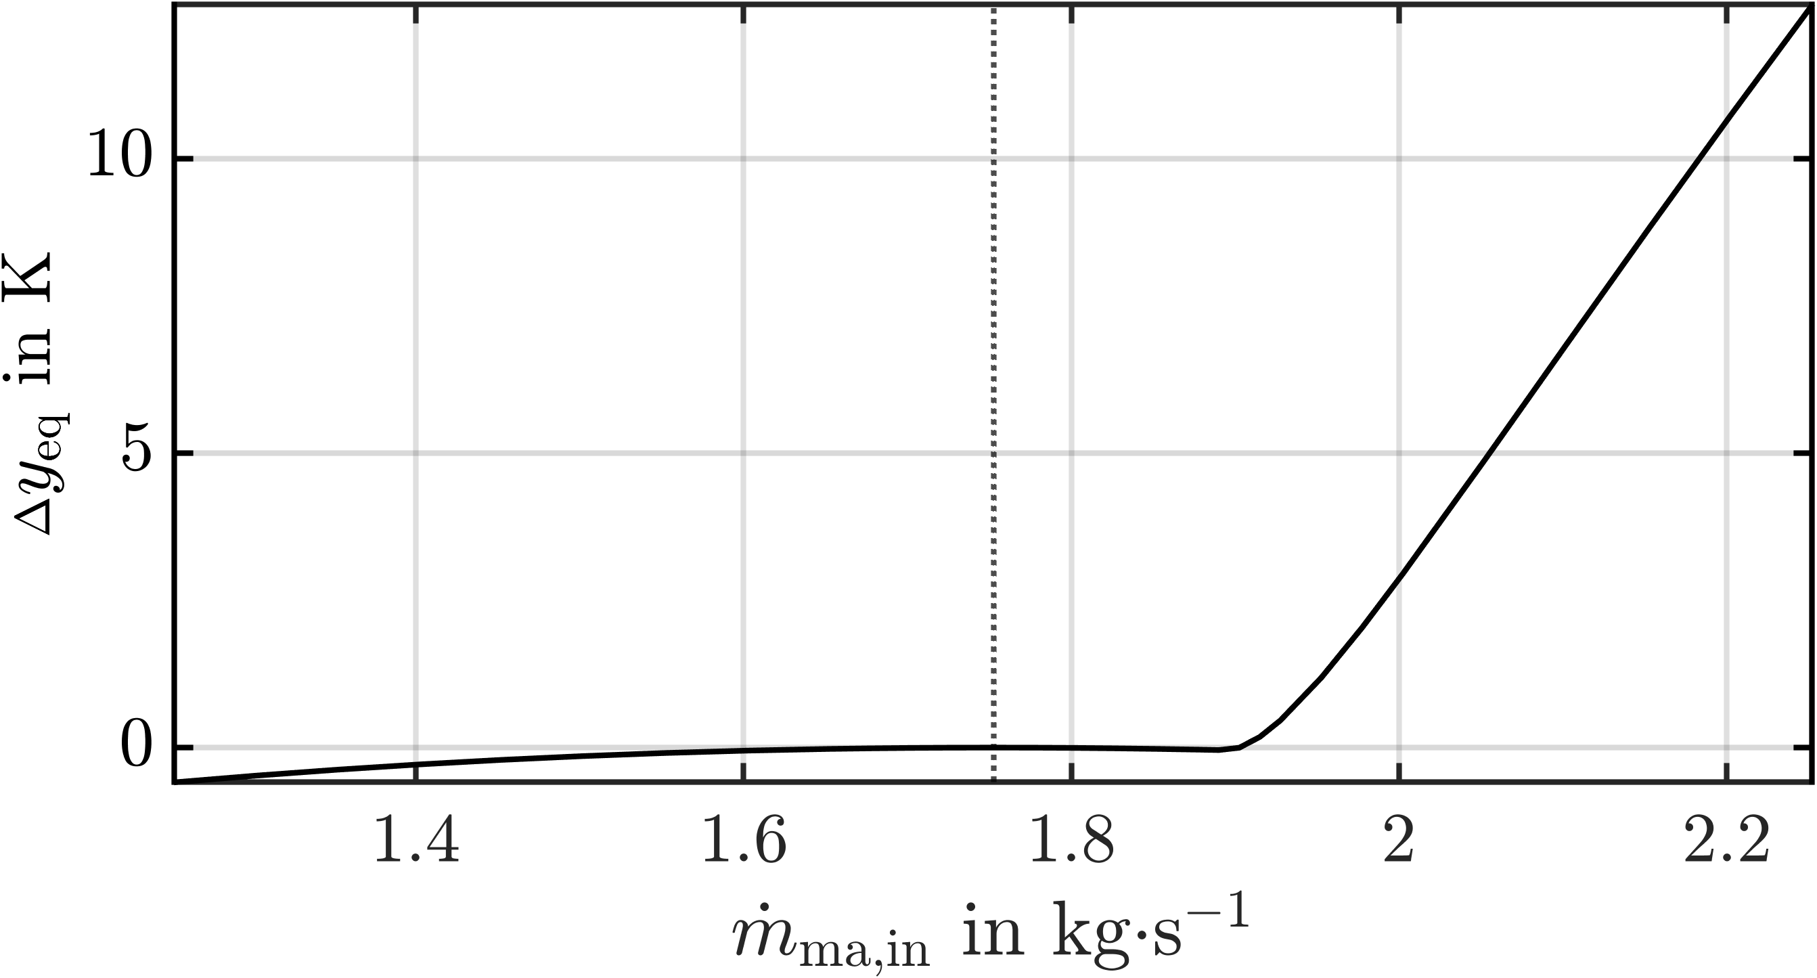 | 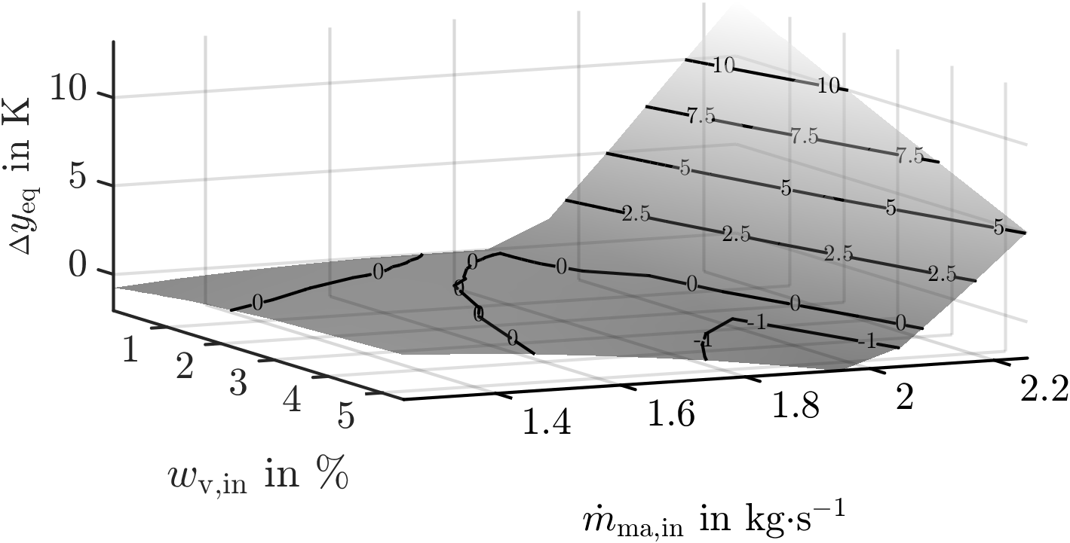
(a) Variation of ${\dot{m}}_{\text{ma,in}}$. | (b) Variation of ${\dot{m}}_{\text{ma,in}}$ and $w_{\text{v,in}}$.
Figure 3: Steady-state nonlinearities $Δy_{\text{eq}}= y_{\text{eq}}\left(u\left(⋅\right)\right)-\left(y_{0}+K⋅\left(u\left(⋅\right)-u_{0}\right)\right)$ for $Θ_{\text{ma,out}}$.
excluded as all curves starting from $y_{0}$ in Figure 2a return from $y_{1}$ to $y_{0}$ in Figure 2b. Moreover, an asymmetry above a certain deviation of ${\dot{m}}_{\text{ma,in}}$ from its nominal value ${\dot{m}}_{\text{ma,in,0}}$ can be observed. This becomes particularly apparent, when looking at the difference between the static input-output maps depicted in Figure 3a. From this picture, it can be seen that the linear map is in good approximation a tangent to the nonlinear one at the nominal operating point, indicated by the dashed line. Moreover, one can observe that there are in principle two types of nonlinearities. The first one slowly increases away from the operating point as can be seen for ${\dot{m}}_{\text{ma,in}}<1.7$ kg$⋅$s⁻¹ in Figure 3a. This type may be caused by nonlinear heat and mass transfer coefficients, which can only be represented in the linear model approximately. The second type are strongly increasing nonlinearities that are active above ${\dot{m}}_{\text{ma,in}}=1.9$kg$⋅$s⁻¹. This abrupt change in the nonlinear system's behaviour is caused by the almost complete drying of the particles due to the increased energy input. As a result, the energy supplied to the particle phase by convection is no longer consumed by the evaporation of moisture, causing the particles to heat up. This qualitative change cannot be represented by the linear system. In addition to the linearity of the outputs with respect to individual inputs, it is also of particular interest whether the superposition principle is approximately fulfilled. This can be investigated by looking at the simultaneous change in several input variables, such as the ${\dot{m}}_{\text{ma,in}}$ and $w_{\text{v,in}}$ in Figure 3b. From the Figure, two observations can be made. First, as long as no saturation in the nonlinear model occurs the superposition principle is fulfilled in good approximation. Second, the range of linearity of different inputs influence each other. In Figure 3b one can see that the maximal nonlinearity decreased with increased vapor share in the gas stream, as the latter reduces the evaporation rate and thus delays the appearance of completely dried particles. The observations made can be transferred to all outputs for all pairwise combinations of the input variables and disturbances.
    - Dynamic Nonlinearity
The dependence of the measure on the transition time in presence of static deviations can be investigated from Figure 4. It shows $ρ\left(⋅\right)$ for the same inputs as in Figure 1 for three different transition times. One can conclude from Figure 4a that as long as the saturation
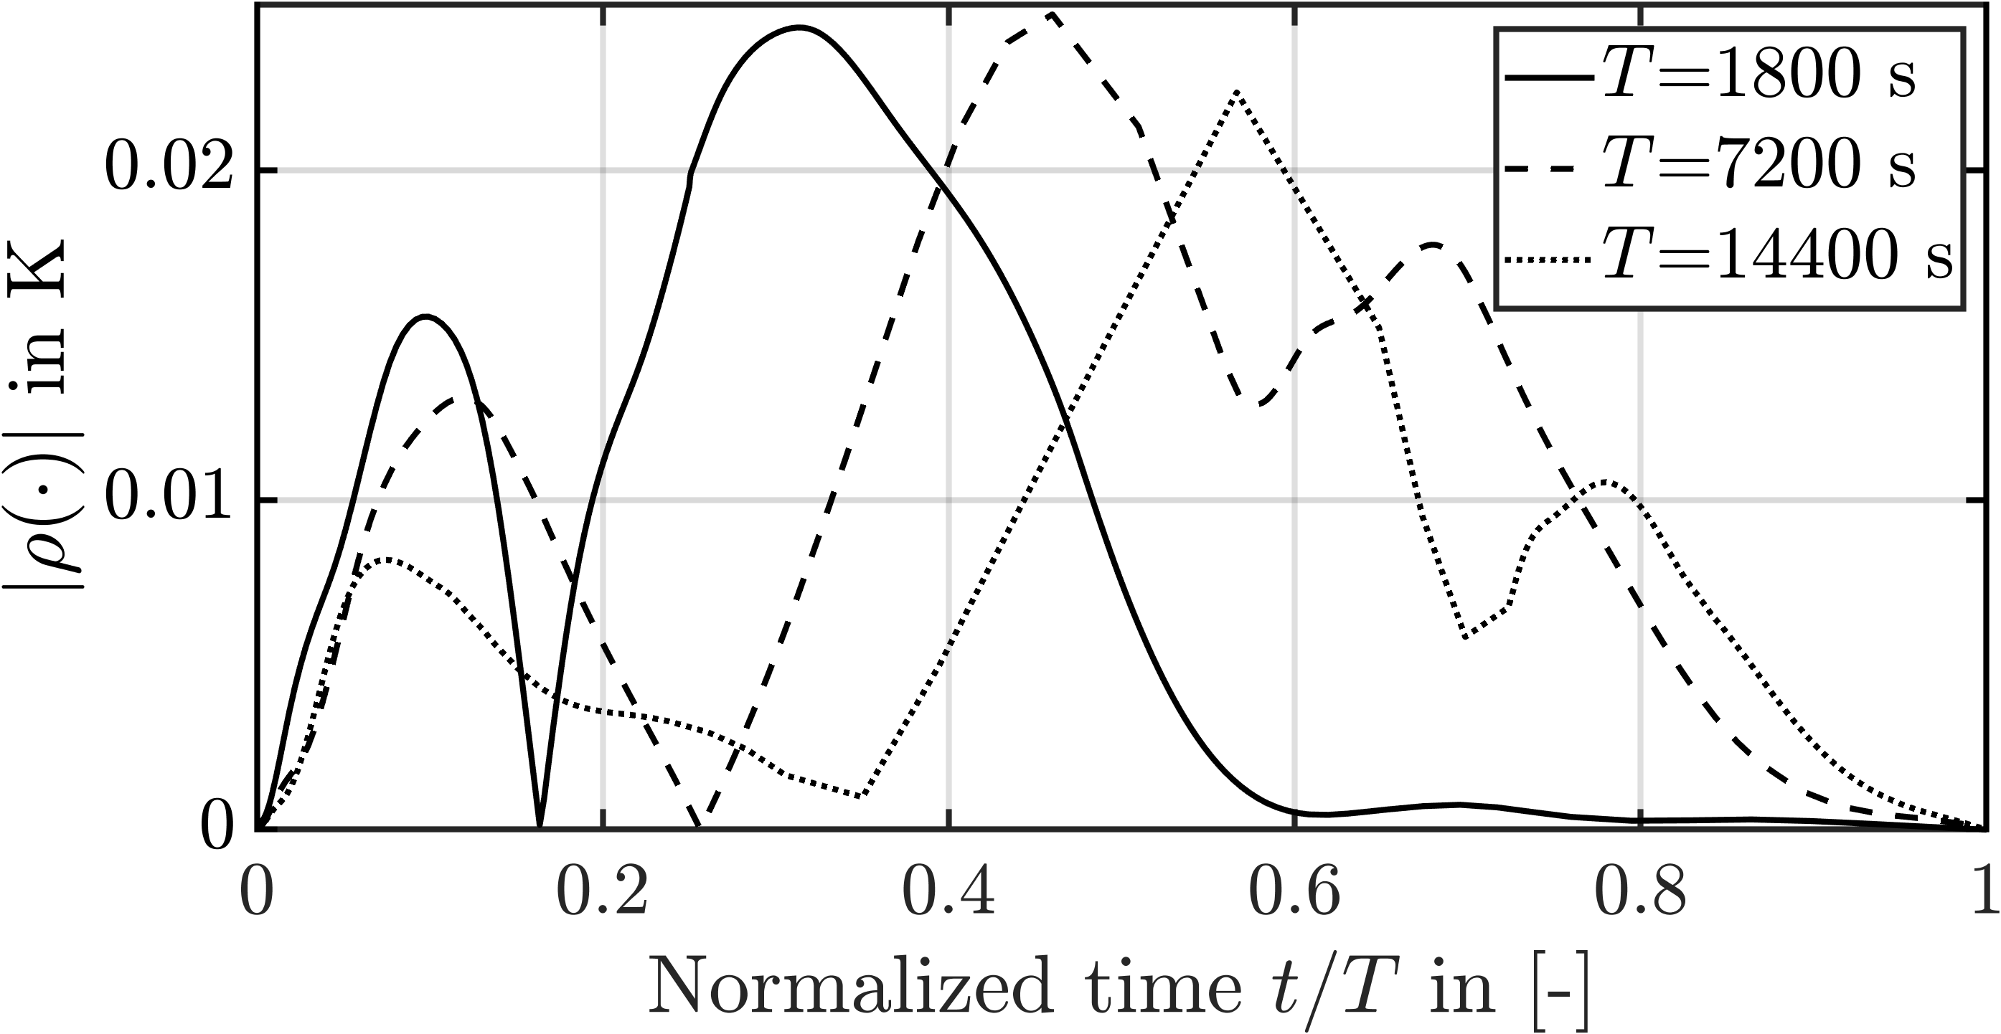 | 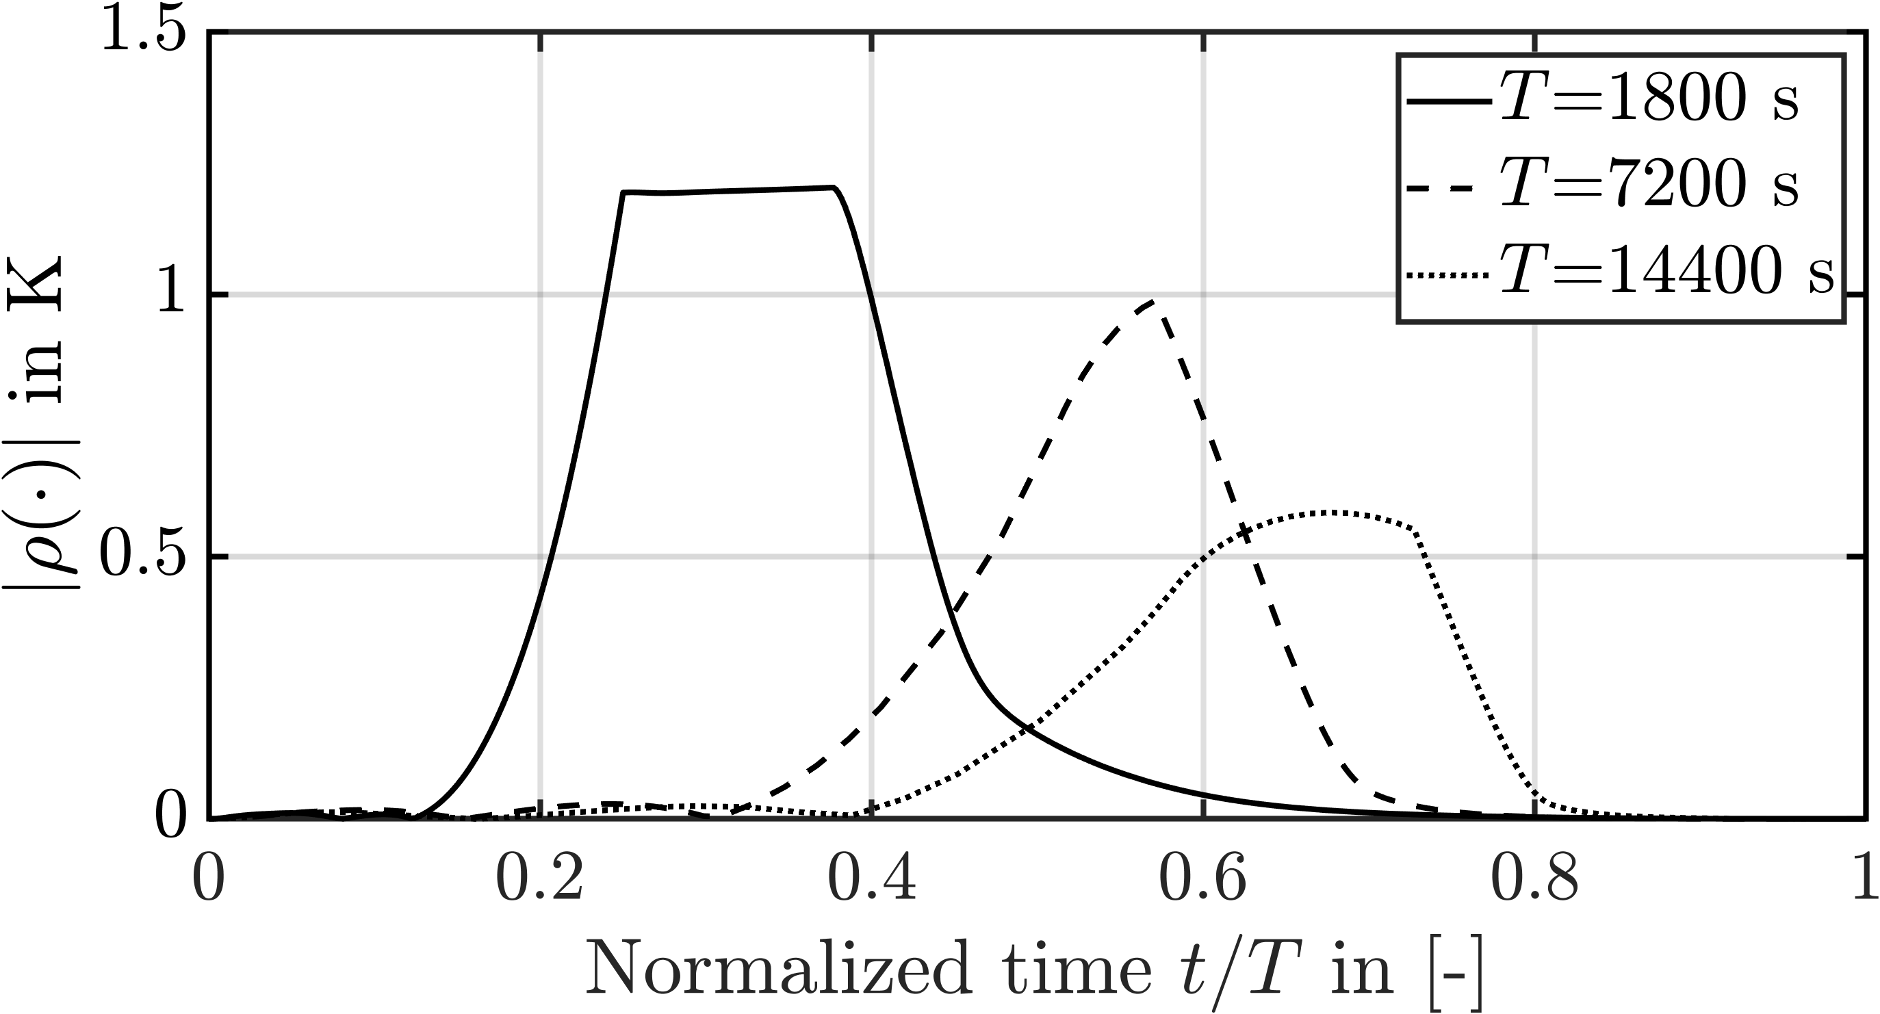
(a) ${\dot{m}}_{\text{ma,in}}={\dot{m}}_{\text{ma,in,0}}+0.1$kg$⋅$s⁻¹. | (b) ${\dot{m}}_{\text{ma,in}}={\dot{m}}_{\text{ma,in,0}}+0.2$kg$⋅$s⁻¹.
Figure 4: $\left|ρ\left(⋅\right)\right|$ evaluated for $Θ_{\text{ma,out}}$ and three different transitions times$.$
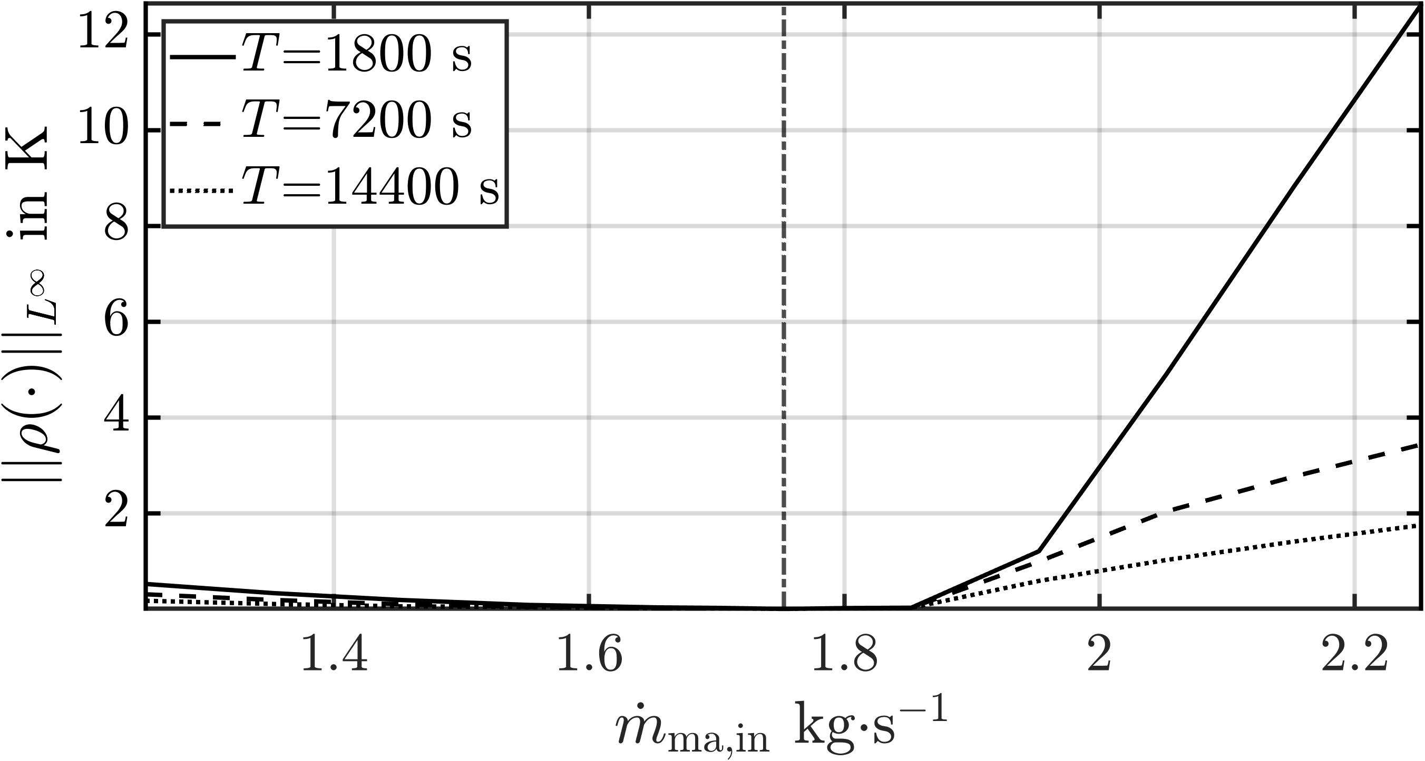 | 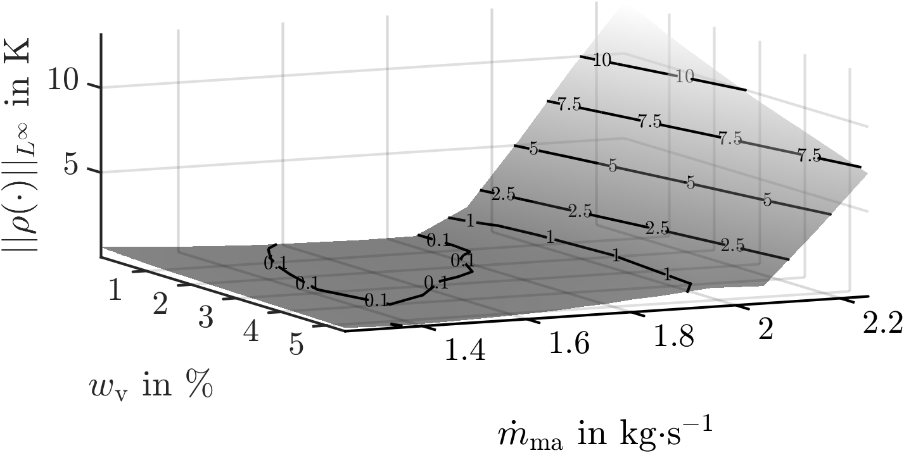
(a) Variation of ${\dot{m}}_{\text{ma,in}}$. | (b) Variation of ${\dot{m}}_{\text{ma,in}}$ and $w_{\text{v,in}}$.
Figure 5: ${\left\|ρ\left(⋅\right)\right\|}_{L^{∞}}$ evaluated for $Θ_{\text{ma,out}}$, 5b shown for $T=1800$s.
is avoided, $T$has hardly any effect on $ρ\left(⋅\right)$. Otherwise,$ρ\left(⋅\right)$ strongly depends on $T$as shown in Figure 4b. The observed decrease of $ρ\left(⋅\right)$ for increasing $T$ can be attributed to the fact that, due to the longer transition time, the system states approach the sequence of equilibrium points between $y_{0}$ and $y_{1}$. In that case, the steady-state deviation is largely compensated by the static input-output maps. It can also be seen that the maximum value of the curve for $T=1800$s in Figure 4b has approximately the same value as the corresponding static deviation shown in Figure 3a. By applying the supremum norm to the signals in Figure 4 as well as to all other analysed changes of ${\dot{m}}_{\text{ma,in}}$, one obtains Figure 5a. When evaluating the measure for a certain fixed $T,$ $ν\left(⋅\right)$ can be readily determined by taking the maximal value of the individual curve. If a range of $T$ is examined, $ν\left(⋅\right)$ is approximately the maximal value of all curves corresponding to the investigated samples $T∈T$. Of course, it is not sufficient to consider only the variation of individual inputs because, as in the case of static nonlinearities, interactions can occur between the individual inputs, as shown in Figure 5b for $T=1800$s. The results presented on the basis of the gas temperature can be transferred to the other output variables for all pairwise combinations of inputs and disturbances.
  - Conclusion
The contribution presents the application of a new dynamic nonlinearity measure to a rotary dryer model. The usage of the measure is shown in detail and the physical relevance of the measure's components is explained using the underlying process. The analysis shows comparatively small differences between the nonlinear and the linear model both w.r.t. static as well as the dynamic nonlinearities, as long as operating conditions that lead to complete drying of the particles are avoided. Furthermore, it is illustrated that for such operating points the superposition principle is approximately fulfilled. Otherwise, strong static nonlinearities can occur causing high values of control-relevant nonlinearity for fast operating point changes. It is also found that interactions between the inputs can influence the permissible ranges of the individual inputs needed to avoid the highly nonlinear operating conditions.
References
R. Heffron, M.-F. Körner, J. Wagner, M. Weibelzahl, and G. Fridgen, 2020, Industrial Demand Side Flexibility: A Key Element of a Just Energy Transition and Industrial Development, Applied Energy, 269,115026.
J. M. Schaßberger, V. Hagenmeyer, L. Gröll, 2023, From Stationary to Flexible Plant Operation: Extension of a Co-Current Rotary Dryer Model for Energy Demand Flexibility, 2023 24th International Conference on Process Control (PC), Strbske Pleso, Slovakia, 2023, 233-239.
P. Reyero-Santiago, C. Ocampo-Martinez, R. Findeisen, R.D. Braatz, 2020, Nonlinearity Measures for Distributed Parameter and Descriptor Systems, IFAC PapersOnLine, 53,2,7545-7550.
M. Kelemen, 1986, A Stability Property, IEEE Trans. Automat. Contr., 31, 766-768.

