Multiscale Modeling of Solid Oxide Fuel Cells Using Various Microscale Domains Across the Length of the Cell
Hamid Reza Abbasi,ª Masoud Babaei,ª Constantinos Theodoropoulos,^{a*}
ªDepartment of Chemical Engineering, The University of Manchester, Manchester,
M13 9PL, United Kingdom
Abstract
This study presents a multiscale modelling approach for solid oxide fuel cells (SOFCs), focusing on the interplay between macroscopic and microscopic features. Our investigation delves into the electrochemical performance of SOFCs, using a microscale solver that models electrochemical reactions and mass/charge transport within porous anode microstructure and a macroscale model that only solves mass/charge transport equations. The multiscale model is responsible for communicating information between a single macroscale model representing the entire cell and multiple microscale models of the anode microstructure. This multiscale model offers valuable insights into how both the macro and micro aspects of cell design collectively influence overall electrochemical performance. Applicability of the current multiscale framework lies in its capacity to eliminate the necessity for model calibration with experimental measurements. This is achieved by employing lineal exchange current density that remains independent of porous microstructure topology. Consequently, novel configurations incorporating distinctive attributes at both macro and microscales may be explored without preliminary calibration with experimental measurements. Results of multiscale model indicate that it can predict the polarization curve with higher accuracy, compared to an exclusively macroscale model that has undergone calibration with experimental measurements.

Keywords: Solid Oxide Fuel Cell, Multiscale model, Microstructure, Porous media
  - Introduction
Solid oxide fuel cell (SOFC) offers promising technology for clean and efficient power generation. SOFCs provide high energy efficiency, low emissions, and versatility in fuel sources, making them an attractive option for a wide range of applications, from portable power generation to large-scale industrial processes.
Various numerical models, characterized by varying degrees of precision, have been formulated to predict the operational characteristics of SOFCs. Frequently employed in capturing cell performance, macroscopic scale models (Tseronis, Kookos, and Theodoropoulos 2008; Tseronis et al. 2012; 2016; Fu et al. 2021) are subject to versatility limitations. Specifically, alterations in the microstructure of porous electrodes are inadequately represented within the confines of such macroscopic models. Conversely, microscale models have been employed to address the phenomena of transport and electrochemical reactions within an individual porous microstructure (Hsu et al. 2022; 2020; T. A. Prokop et al. 2020; T. Prokop 2020). However, microscale models are limited in their ability to represent the entire cell with the refined numerical resolution required, which leads to enormous computational costs.
This work aims to build a computationally efficient multiscale numerical framework that facilitates the efficient information exchange between macro and microscale models. This framework addresses transport equations in both macro and microscale domains, with electrochemical reactions solely being modelled within the microscale domain, at spatially resolved triple phase boundaries. The newly developed multiscale model can be used in predicting the characteristics of new SOFC configurations without necessitating experimental calibration. This framework is built based on previous SOFC work performed by the same group of authors (Abbasi et al. 2023). Nevertheless, the previous method disregards the spatial variation of the porous microstructure across the length of the cell. The recently developed method may be considered an extension of its predecessor considering spatial microstructure variation across the length of the cell, through a multiple microstructure representation, which allows the multiscale solver to be more accurate particularly in scenarios characterized by substantial variations in field variables along the length of the SOFC.
  - Methodology
Macroscopic and microscopic scale computational domains are schematically depicted in Figure 1. The macroscale domain consists of fuel/air channel, porous electrode, and electrolyte, whereas the microscale domain only consists of an electrochemically active thin layer of porous anode microstructure in the vicinity of the electrolyte. This is where electrochemical reactions involving hydrogen oxidation take place; therefore, the microscale model can facilitate the use of a microlevel description of kinetics of electrochemical reactions. In the macroscale model, kinetics of electrochemical reactions is described using area-specific exchange current density, $J_{0,M}$:
$$J_{M}\left[\frac{A}{m^{2}}\right]=J_{0,M}\left[\frac{A}{m^{2}}\right]×f_{BV}\left( η_{act,M}\right)$$ | (1)
Where $J_{M}$ is the current density, $η_{act}$ is the activation overpotential, and $f_{BV}$ the Butler-Volmer operator that describes the rate of electrochemical reaction with respect to bulk voltage difference between the electrode and the electrolyte. $J_{0,M}$ has units of $(A/{m^{2}})$, which is inconsistent with the true nature of the electrochemical reactions that take place on triple phase boundary (TPB) sites that are lines in space. It provides an area-averaged way of reporting the kinetics of electrochemical reactions in each microstructure and, hence, it depends on the topological properties of the microstructure. A more precise way of reporting the exchange current density would be to express it per length $\left(A/m\right)$. This approach eliminates the reliance on the topological characteristics of microstructure when describing the kinetics of electrochemical reactions and consequently is more versatile. The lengthwise exchange current density, $J_{0,m} [A/m]$, should be used in a microscale domain where TPB sites have been resolved. In microscale model, the current density is defined as:
$J_{m}\left[\frac{A}{m}\right]=J_{0,m}\left[\frac{A}{m}\right]×f_{BV}\left( η_{act,M}\right)$ | (2)
Lengthwise exchange current density, $J_{0,m}$, does not depend on the intricacies of the microstructure; it only depends on the macroscale descriptors such as material, temperature, and pressure. Therefore, experimentally measured lengthwise exchange current densities can be used to solve the rate of electrochemical reactions in any microstructure with any set of topological properties.
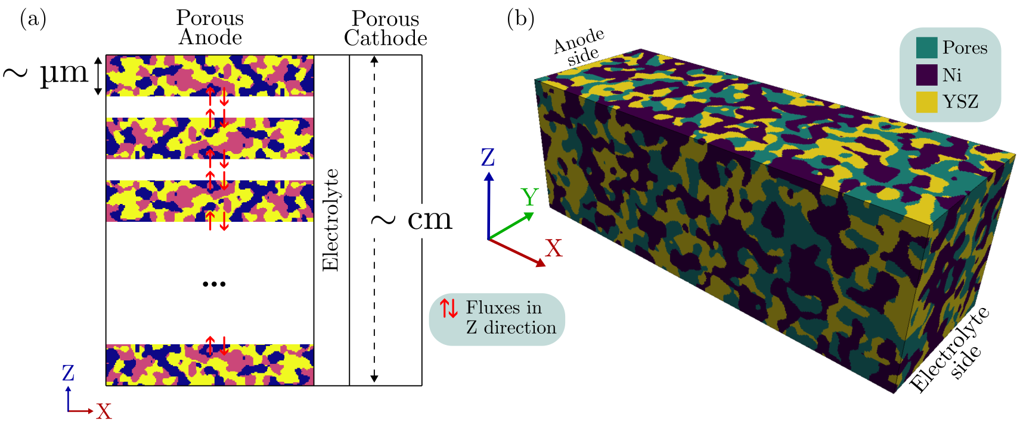
Figure 1 – Computational domain for macro and microscale simulations
Our multiscale method uses a microscopic description of the electrochemical reactions that take place on triple phase boundaries in vicinity of anode/electrolyte interface. It also solves the mass/charge transport at a larger scale within the entire cell, consisting of fuel/air channels, porous electrodes, and electrolyte.
The flowchart of our multiscale methodology is schematically described in Figure 2. It starts with a macroscale description of the kinetics of electrochemical reactions (exchange current density, $J_{0,M}$) as an initial guess to conduct macroscale simulations. The distribution of field variables across the length of the cell in Z direction at the anode/electrolyte interface is then used to run different microscale simulations with different boundary conditions. Boundary conditions of microscale patches are linked to the results obtained from the macroscale simulation:
$$BC_{m,1}, BC_{m,2},…,BC_{m,N}∝Φ_{M}\left(z\right)$$ | (3)
Here, $BC_{m,i}$ denotes the boundary conditions used in i_{th} patch at microscale, and $Φ_{M}\left(z\right)$ represents the distribution of field variables at macroscale. Separate values of current density at different microscale patches are then used to calculate the interpolated current density at the macroscale:
$$J_{m→M}(z)=f_{int}\left(J_{m,1}\left(z_{1}\right), J_{m,2}(z_{2}),…,J_{m,N}(z_{N})\right)$$ | (4)
Here, the function $f_{int}$ denotes a simple spatial interpolation operator. The interpolated current density at the microscale is then compared to that of the macroscale ($J_{m→M}$ and $J_{M}$, respectively) to measure the error of the iteration. In the first iterations of the described algorithm, these two values differ greatly; therefore, a correction step is needed to improve the macroscale description of electrochemical reactions ($J_{0,M}$) with respect to the difference in current densities obtained from micro and macroscale simulations. The correction formula shown in Figure 2 is the simplest approach to correct $J_{0,M}$ that assumes a first-order convergence. This iterative approach continues until the current density obtained from micro and macroscale simulations agrees within an acceptable tolerance.
Both macro and microscale models use finite volume method to discretize equations in space. Tolerance of the microscale, macroscale, and multiscale models are set to 1E-5, 1E-6, and 1E-4, respectively. It was observed that convergence beyond 1E-4 is especially difficult for the multiscale model.
  - Results and discussion
Results of the multiscale model are presented in this section, focusing on the distribution of mole fractions and current density across different length scales within the fuel cell.
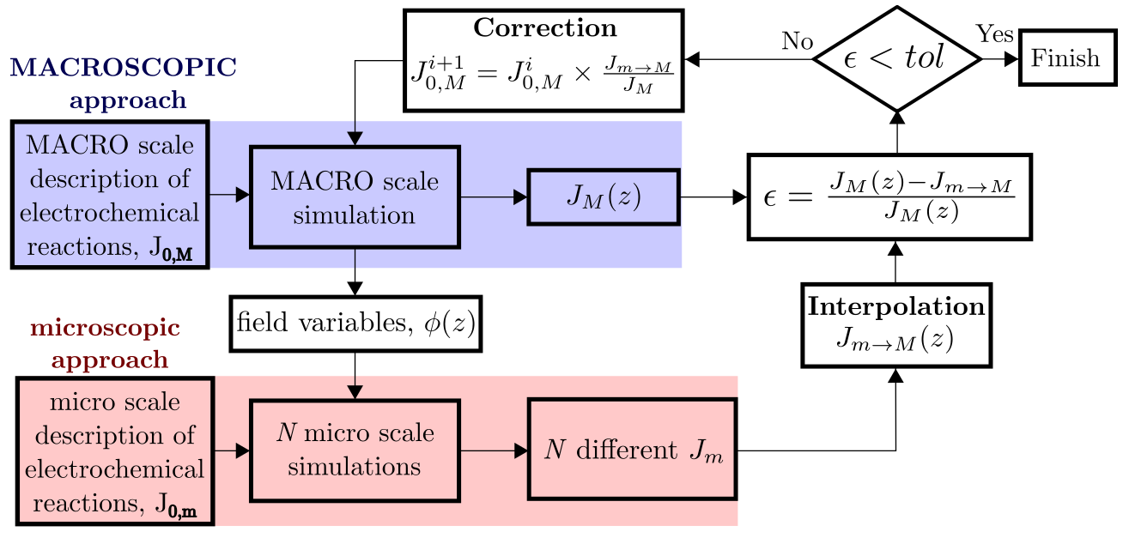
Figure 2 – Flowchart of the multiscale method used in this study
Mole fractions of hydrogen and oxygen in fuel and air channels, as well as in porous electrodes, are shown in Figure 3. The studied SOFC is anode-supported; therefore, the thickness of the electrolyte and porous cathode is too small to be visualized properly when the entire cell is shown.
As hydrogen and oxygen diffuse through the porous electrodes from the fuel/air channel inlets to the outlets, their concentration reduces due to electrochemical reactions that consume these components at both sides of the electrolyte. The mole fraction of hydrogen drops from 0.95 at the inlet to approximately 0.86 at the anode/electrolyte interface close to the outlet. For oxygen, it reduces from 0.21 at the inlet to 0.16 in the vicinity of the cathode/electrolyte interface, which is close to the outlet.
Figure 4 shows the polarization curve of the SOFC predicted with two different numerical frameworks, namely a fully macroscopic and the multiscale one. Both models are compared with experimental data points of (Rogers et al. 2003). As seen, the multiscale model can make more accurate predictions, especially at higher current densities, where the interplay between different physical phenomena becomes more pronounced. It should be noted that SOFCs are normally designed to operate at higher ranges of current density to provide maximum efficiency. It should be highlighted that the macroscopic model in Figure 4 has been initially calibrated with experimental measurements (Rogers et al. 2003). In contrast, multiscale model does not necessitate any calibration with experimental setups.
The variation of current density across different patches in the Z-direction is shown in Figure 5. Ten different microstructure patches are evenly distributed in the Z-direction from the fuel channel inlet (Z=0) to the outlet (Z=16 mm).
Each patch is an anode microstructure with length 50x10x10 microns in X, Y, and Z directions, respectively. The X=0 line is aligned with the anode/electrolyte interface. Current density across the length of each patch varies from zero to a maximum value at the interface. The maximum current density predicted in each patch corresponds to the current density that is calculated by the macroscale model at that exact location in Z direction. As mentioned before, the error of the multiscale model is defined as the difference between current density calculated by the multiscale model and the macroscale model at specific locations throughout the cell length. Electrochemical reactions only take place at a noticeable rate at the electrochemical active layer in vicinity of the anode/electrolyte interface. As seen from the microscale results presented in Figure 5 (a), the length of the electrochemical active layer is approximately 25 microns, and it does not change significantly throughout the length of the cell from the inlet to the outlet.
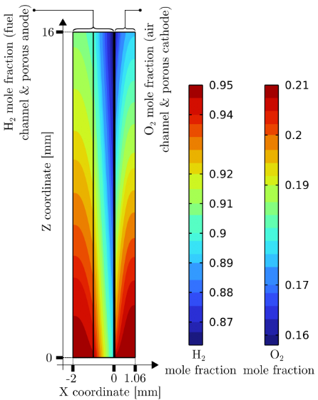 | 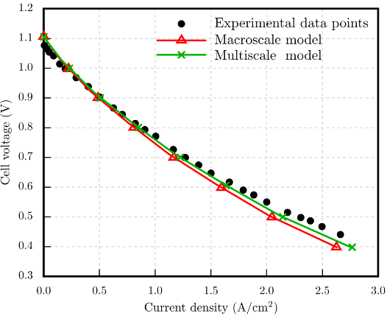
Figure 3 – Mole fraction of hydrogen and oxygen in the entire cell consisting of fuel/air channels, and porous electrodes. Operating voltage V_{op}=0.4 V. |  | Figure 4 – SOFC Polarization curve. Comparison of multiscale and macroscale models with experimental data (Rogers et al. 2003)
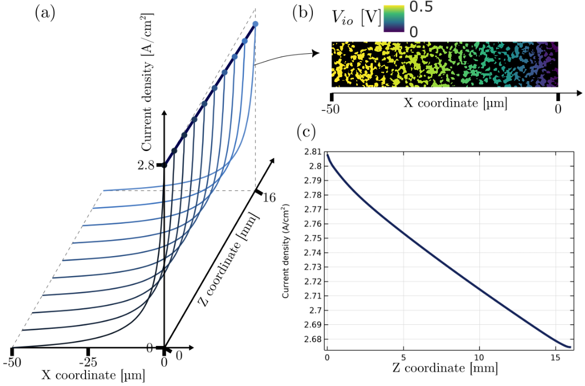
Figure 5 – Distribution of current density for V_{op}=0.4 V. (a) Current density variation across each microscale patch. (b) Variation of ionic potential in one of the microscale patches. (c) Current density variation across the length of the SOFC
In Figure 5 (a) and (c), a slight variation in the maximum current density (from 2.81 to 2.67 A/cm²) can be observed from the inlet to the outlet of the fuel cell in both macro and multiscale models when the operating voltage of the cell is 0.4 V. A higher current density at Z=0 can be attributed to local higher concentrations of H₂ and O₂ at the anode/electrolyte and cathode/electrolyte interfaces, respectively, as depicted in Figure 3.
  - Conclusions
A multiscale model has been developed to address mass/charge transport and electrochemical reactions within SOFCs. The applicability of the current multiscale model lies in predicting SOFC performance without any previous calibration with experimental setups. It can be used to predict the performance of new SOFC configurations with new features both at the macroscopic and microscopic scales. In addition, the multiscale model shows better agreement with experimentally measured polarization curves in comparison with a macroscale model that has already been calibrated with an experimental setup.
References
Abbasi, Hamid Reza, Masoud Babaei, Arash Rabbani, and Constantinos Theodoropoulos. 2023. ‘Multi-Scale Model of Solid Oxide Fuel Cell: Enabling Microscopic Solvers to Predict Physical Features over a Macroscopic Domain’. In Computer Aided Chemical Engineering, 52:1039–45. Elsevier.
Fu, Quanrong, Zhiyi Li, Wei Wei, Fengxia Liu, Xiaofei Xu, and Zhijun Liu. 2021. ‘Performance Degradation Prediction of Direct Internal Reforming Solid Oxide Fuel Cell Due to Ni-Particle Coarsening in Composite Anode’. Energy Conversion and Management 233 (April): 113902. https://doi.org/10.1016/j.enconman.2021.113902.
Hsu, Tim, Hokon Kim, Jerry H. Mason, Rubayyat Mahbub, William K. Epting, Harry W. Abernathy, Gregory A. Hackett, Shawn Litster, Anthony D. Rollett, and Paul A. Salvador. 2022. ‘High Performance Finite Element Simulations of Infiltrated Solid Oxide Fuel Cell Cathode Microstructures’. Journal of Power Sources 541 (September): 231652. https://doi.org/10.1016/j.jpowsour.2022.231652.
Hsu, Tim, Rubayyat Mahbub, Jerry H. Mason, William K. Epting, Harry W. Abernathy, Gregory A. Hackett, Anthony D. Rollett, Shawn Litster, and Paul A. Salvador. 2020. ‘High Performance Modeling of Heterogeneous SOFC Electrode Microstructures Using the MOOSE Framework: ERMINE (Electrochemical Reactions in MIcrostructural NEtworks)’. MethodsX 7: 100822. https://doi.org/10.1016/j.mex.2020.100822.
Prokop, Tomasz. 2020. ‘Three-Dimensional Numerical Analysis of Transport Phenomena in a Positive-Electrolyte-Negative Assembly of a Solid Oxide Fuel Cell’. PhD Thesis.
Prokop, Tomasz A., Grzegorz Brus, Shinji Kimijima, and Janusz S. Szmyd. 2020. ‘Thin Solid Film Electrolyte and Its Impact on Electrode Polarization in Solid Oxide Fuel Cells Studied by Three-Dimensional Microstructure-Scale Numerical Simulation’. Energies 13 (19): 5127. https://doi.org/10.3390/en13195127.
Rogers, William A, Randall S Gemmen, Christopher Johnson, Michael Prinkey, and Mehrdad Shahnam. 2003. ‘Validation and Application of a CFD-Based Model for Solid Oxide Fuel Cells and Stacks’, 4.
Tseronis, K., I. Bonis, I.K. Kookos, and C. Theodoropoulos. 2012. ‘Parametric and Transient Analysis of Non-Isothermal, Planar Solid Oxide Fuel Cells’. International Journal of Hydrogen Energy 37 (1): 530–47. https://doi.org/10.1016/j.ijhydene.2011.09.062.
Tseronis, K., I.S. Fragkopoulos, I. Bonis, and C. Theodoropoulos. 2016. ‘Detailed Multi-Dimensional Modeling of Direct Internal Reforming Solid Oxide Fuel Cells’. Fuel Cells 16 (3): 294–312. https://doi.org/10.1002/fuce.201500113.
Tseronis, K., I.K. Kookos, and C. Theodoropoulos. 2008. ‘Modelling Mass Transport in Solid Oxide Fuel Cell Anodes: A Case for a Multidimensional Dusty Gas-Based Model’. Chemical Engineering Science 63 (23): 5626–38. https://doi.org/10.1016/j.ces.2008.07.037.

