Towards CO2 Reduction in Middle East: A Techno-Environmental Assessment

Nasser Al-Malki,Mohammed Yaqot, Brenno C. Menezes*

Division of Engineering Management and Decision Sciences, College of Science and Engineering, Hamad Bin Khalifa University, Doha, Qatar Foundation, Qatar

bmenezes@hbku.edu.qa

Abstract

Greenhouse gases (GHGs) are emitted mainly by countries heavily dependent on coal and with high population such as China and USA, responsible, respectively, for 30% and 15% of the global amounts of CO2-equivalent and close to this numbers of related combustion-made emissions, such as CO, NOx, SO2, particulate matter (PM), etc. Then, there is a direct correlation on CO2 emissions from fossil-fuels to the non-CO2, since the latter occurs by the imperfect combustion of the carbonic components (CO and PM) or presence of heteroatoms in the fuel (NOx and SO2). Particularly NOx is also formed by N2 and O2 reaction at high temperature. Heavily polluted per capita (PPC), figuring all six Gulf Cooperation Council (GCC) countries among the 10 first PPC positions, these wealthy countries in the Middle East have presented in the last years one of the worst qualities of air worldwide. This is a consequence of high PPC levels localized in these countries that cannot be solved without changes towards fossil fuels consumption regardless of the climate change issues by the CO2 excess globally. To combat climate changes and air quality localized, the Middle East Energy Policy launched sustainable development strategies in the series of so-called National Vision 2030 and beyond. As an example of these sustainable initiatives, this work calculates the CO2 reduction from national projects such as subway lines, electrical buses, solar panel farms, etc., for Qatar’s National Vision 2030 towards CO2 reduction considering the baseline as the year before the COVID-19 pandemic. Widespread greener transportation systems and electricity from renewables for the visioned CO2 reduction may not suffice for the intended projects and changes in energy policies and housing consumer behavior in the country or in the region are fundamental to reach the reduction targets.

**Keywords**: Sustainability, CO2 emissions, greener transportation, GHG, GCC countries

* 1. Introduction

CO2-equivalent emissions are unequally distributed worldwide. It depends on countries' population size and wealth, energy matrix on fossil-fuels, transportation networks, industrial capacities and capabilities, energy diversification towards renewables, awareness and behavior of the communities on housing energy savings and impacts on health of exhausted gases (emissions) from fossil-fuel combustion. Policymakers, academics, and industrial experts develop nationwide plans or international agreements to mitigate by several means the footprint of any kind of under-monitoring and control (UMC) activities of the interdependent energy-emission flows (EIA Outlook, 2022).

Globally, Middle Eastern countries pollute 4% (GCC 3.23%) in total amount. Locally, the quality of the air in its higher levels, at 4 or 5 (of a scale from 1 to 5), is found most of the time in certain GCC regions. Although the CO2-equivalent is the subject under discussion in this paper, other emissions related to the combustion processes emitted together when burning fossil-fuel derivatives (coal, natural gas, fuel oil, bunker, gasoline, jet-fuel, diesel, etc.) are NOx, SO2, CO, PM, etc. Adding to the CO2-equivalent bulk, countries where methane (CH4) to the atmosphere is prominent, the GHG concerns are more complex such as in Brazil for its huge production of livestock (CH4 from animal manure) and in Qatar with escaping of CH4 throughout the liquid natural gas (LNG) production and supply chain networks.

Technical solutions towards GHG reduction typically consider (1) sustainable design, operation, control, and monitoring of current or new assets, (2) phasing down or out of fossil fuels, (3) carbon capture processes, and (4) use of renewables. However, all these options present pitfalls and risks inherent to their expansion. In some GCC countries, their *National Vision Programs* are counting on these solutions to achieve GHG reduction. However, many of these programs are taken as initiatives or intentions rather than being considered as mandates or new legislation.

On the other hand, non-technical solutions, related to the energy end-user must count on society's *glocal* management by acting locally to achieve a global (or regional) outcome. In the case of the Middle East, particularly in GCC, the high regional consumption of energy per capita can potentially cause more health issues than other regions in the globe. This is directly related to other exhausted gases (not CO2) and particulate matter (PM) generated mainly by the combustion of fossil-fuel derivatives in transportation systems. Efficient energy systems and adequate policies are necessary for the development of viable projects towards the sustainable reduction of GHGs, whereby techno-economic assessments must evaluate the trade-offs between technology, economics, and sustainability in a systematic way. It includes energy system design and integration, greener energy production considering the transition to renewables, technologies for energy savings and storage, carbon capture, among others.

**2. Problem statement**

The Middle East, GCC countries, faces significant challenges related to high levels of GHG emissions, particularly CO2. Despite regional efforts outlined in national development plans, there is a pressing need to assess the feasibility and effectiveness of current strategies aimed at reducing CO2 emissions. The study focuses on Qatar's National Vision 2030 as a case study, evaluating the impact of sustainable initiatives such as subway lines, electrical buses, and solar panel farms purposed for CO2 or, broadly, GHG/CO2-eq reduction. However, there is a growing concern that the envisioned greener transportation systems and renewable energy sources may not be sufficient to achieve the targeted reduction. The key issues towards CO2 reduction in the GCC are as follows:

1. The high per capita energy consumption in the region, leading to severe air quality issues, primarily caused by emissions from fossil-fuel combustion in transportation systems.
2. The inadequacy of technical solutions, including sustainable design, carbon capture processes, and renewable energy use, to fully address the complex challenges of GHG reduction.
3. The discrepancy between the intentions outlined in National Vision Programs and the lack of mandatory regulations or legislation to enforce the implementation of GHG reduction initiatives.

The study will primarily focus on the GCC countries, with a special emphasis on Qatar, using quantitative data and techno-economic assessments to analyze the current state of GHG emissions, the impact of sustainable initiatives, and the challenges faced in achieving GHG reduction targets. Understanding the challenges and limitations in the current approach towards GHG/CO2-eq reduction in the Middle East is crucial for policymakers, researchers, and industrial experts. The findings of this study will contribute valuable insights to guide the development of more effective and enforceable strategies for achieving sustainable GHG/CO2-eq reduction in the region.

**3. GHG/CO2-eq emissions in Gulf Cooperation Council (GCC) countries**

Sustainable development has been one of the major concerns of many countries recently and has attracted the attention of policymakers. Protection of environment has been identified as one of the major pillars of achieving sustainable development goals for the GCC countries. For example, Qatar’s National Vision 2030 addresses “environmental management” as one of the major challenges (General secretariat for development planning, 2008). A mixture of abrupt economic expansion and population growth has fuelled a massive energy demand in the GCC countries recently (World Bank, 2022).

GCC countries have seen a 74% growth in population since 2000 (Our World in Data, 2022). Hence, these countries are on one hand facing enhanced domestic energy demand and on the other are challenged with emissions’ control (Bekhet et al., 2017). This recent growth in demand for energy production in both fuels and electricity can be directly linked to the rising CO2 emissions and localized air quality has become a global concern. This sought for the adoption of technologies for carbon-reduction and alternative energy sources in implementing significant energy efficiency measures. If these measures are not implemented CO2 emissions will continue to increase.

The total GCC countries population is 57.3 million which is 0.73% of the global population of 7.8 billion, however contributes with 1198.28 million tonnes (3.23%) of the global CO2 emissions of 37.12 billion tonnes (Our World in Data, 2022). In Figure 1, the CO2-eq emissions per capita is presented. The GCC countries are all among the 10 most polluted per capita with Qatar showing the highest value, almost double than the avarege for GCC amd 10 times the world numbers.

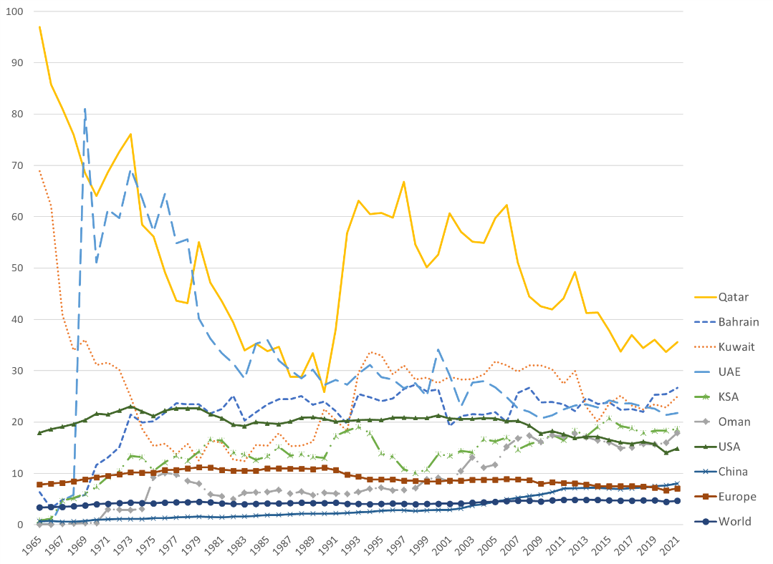

Figure 2: CO2-eq emission per capita (Our World in Data, 2022)

Zmami and Ben-Salha (2020) conduct a study on the determinants of CO2 emissions in GCC countries and revealed that energy consumption and foreign ‎direct investments (FDI) have been major causes of environmental degradation in the GCC countries but found urbanization to have a ‎positive impact on the environment. This study argued that FDI has been positively related to less ‎environmental pollution, whereas energy consumption has been found to be an important factor affecting the environment. Praveen et al. (2020) conduct a study on the utilization of renewable energy (RE) of GCC countries that highlighted the social, political, and economic factors towards RE adoption. The study investigates the scope, methods, and feasibility of generating energy from solar and wind resources and guides how GCC countries would be able to achieve their 2030 RE goals by proactively utilizing their abundant RE reserves.

However, the GCC countries would need to strategize some infrastructural and policy options to reach their CO2 emission goals of 25% reduction by 2030. Zmami and Ben-Salha (2020) recommend that ‎policymakers in GCC countries should focus on developing renewable energy sources (e.g., solar energy sources) ‎investing in the development of ‎renewable energy technologies. GCC countries should also emphasize strengthening ‎environmental regulations enforcing and ‎controlling the implementation of environmental laws. Praveen et al. (2020) suggest to utilize the solar and wind adopting solar photovoltaic technology because [concentrated solar power](https://www.sciencedirect.com/topics/engineering/concentrated-solar-power) plants with [thermal energy storage systems](https://www.sciencedirect.com/topics/engineering/thermal-energy-storage-system) would be able to offer fir power to the grid. Besides, generating energy from the wind in Oman, Kuwait, and Saudi Arabia more favorable both economically and in terms of return on investment (ROI). These options would not only contribute towards the reduction of CO2 emission but also these would help in curbing climate change and sustainable development goals in the region. The GCC policymakers would need to be united and work collectively while focusing on the reforms and innovative strategies at social and political levels in order to be successful in reaching their sustainable development goals by 2030.

**4. Results**

Focusing on CO2 reduction in Qatar this study has found some results which is worth mentioning. The study has analyzed data on CO2 emission in Qatar 2019 to 2022 CO2 which is presented as follows:

Figure 2: CO2 Emission (in million metric tons) (Our World in Data, 2022)

The country is working towards CO2 emission to adhere to the targets in the Qatar’s Vision 2023, which is aimed at bringing CO2 emission down to 76.97 million metric tons by 2030. This means Qatar would have to reduce 25.66 million metric tons of CO2 emissions by the next 8 years. Nevertheless, by the open-data sources and projects raised in this work, Qatar will be able to reduce:

* 1.04 million metric tons of CO2 emissions from 4000 electric buses operation in the public sector by 2030 (Atatullah, 2022), which accounts 4% of the total target emission of 25.66 million metric tons.
* 0.47 million metric tons CO2 emission from 3 Metro lines by 2030, which is around 2% of the total target emission reduction (Al-Thawadi and Al-Ghamdi, 2019).
* From the solar panels the country is currently producing 800MW of electricity, which would be able to reduce 14400 metric tons of CO2 emission by 2030, which is 0.45% of the total target emission (Ataullah, 2022).

All these adds up to 6.3% of the total emission until 2030, which leaves the country to achieve a staggering 93.7% to achieve from other means of CO2 emission.

**4. Conclusion**

This study highlights the pressing issue of greenhouse gas (GHG) emissions in the Gulf Cooperation Council (GCC) countries, notably Qatar. Rapid economic growth and population increase have surged energy demands, significantly elevating CO2 emissions. Despite Qatar's sustainable initiatives like electric buses, subway lines, and solar farms, they represent only 6.3% of the 25% CO2 reduction goal by 2030. The country faces a substantial 93.7% gap to meet its target. To bridge this gap, GCC policymakers must prioritize collaborative renewable energy investments, especially solar and wind power, reinforce environmental regulations, and foster collaborations. Achieving significant reductions hinges on comprehensive strategies, including technological advancements, robust policies, and a united front for sustainable development and emission mitigation in the region. Changes in energy policies and housing consumer behavior in the country or in the region are fundamental to reach the reduction targets.

References

Al-Thawadi, F. E., & Al-Ghamdi, S. G. (2019). Evaluation of sustainable urban mobility using comparative environmental life cycle assessment: A case study of Qatar. Transportation research interdisciplinary perspectives, 1, 100003.

Ataullah, S. (2022). *Electric vehicles help reduce 1.6 million kg CO2.* Available at:

[https://thepeninsulaqatar.com/article/11/12/2022/electric-vehicles-help-reduce-16-million-kg-co2#:~:text=“During%20the%20first%20part%20of,the%20Ministry%20of%20Transport%20tweeted](https://thepeninsulaqatar.com/article/11/12/2022/electric-vehicles-help-reduce-16-million-kg-co2#:~:text=).

Bekhet, H.A., Matar, A. and Yasmin, T., (2017). CO2 emissions, energy consumption, economic growth, and financial development in GCC countries: Dynamic simultaneous equation models. Renewable and sustainable energy reviews, 70, pp.117-132.

General Secretariat For Development Planning (2008). Qatar National Vision 2030. Available at: <https://www.gco.gov.qa/en/about-qatar/national-vision2030/>. Last Accessed:

Our world in Data (2021). Annual Co2 emission. Available at:

<https://ourworldindata.org/grapher/annual-co2-emissions-per-country>. Last accessed:

Praveen, R.P., Keloth, V., Abo-Khalil, A.G., Alghamdi, A.S., Eltamaly, A.M. and Tlili, I., (2020). An insight to the energy policy of GCC countries to meet renewable energy targets of 2030. Energy Policy, 147, p.111864.

World bank (2022). Population growth (annual %). Available at: <https://data.worldbank.org/indicator/SP.POP.GROW>. Last Accessed:

Zmami, M. and Ben-Salha, O., (2020). An empirical analysis of the determinants of CO2 emissions in‎ GCC countries. International Journal of Sustainable Development & World Ecology, 27(5), pp.469-480.

IEA (2022). <https://www.iea.org/reports/world-energy-outlook-2022/an-updated-roadmap-to-net-zero-emissions-by-2050>